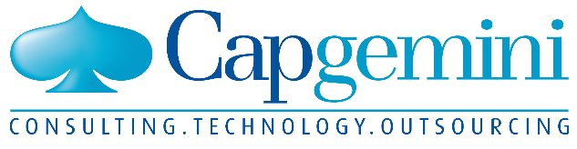 PEOPLE MATTER RESULTS COUNT

While technologies and platforms evolve almost daily, Capgemini’s strategy is still guided by two core ideas developed by its founder, Serge Kampf: a spirit of conquest and a passion for entrepreneurship. With the talent for delivery and the collective innovation of close to 200,000 employees, the Group is well-prepared for the exciting challenges that lie ahead.

Capgemini provides its clients with a wide range of services and digital expertise through its different business units. While the specific

market needs are varied, the transition toward a digital enterprise is a common objective for clients in areas such as financial services, consumer

products, retail and distribution, and the automotive sector. Capgemini meets those needs by continually enhancing its digital skills and by drawing

on its rich ecosystem of partners.

4 CORE BUSINESSES

  

Consulting Technology and Application Other managed

Engineering services Services Services

KEY OFFERS

* Application development and maintenance
* Business services
* Cloud choice
* Consulting services
* Cybersecurity
* Digital customer experience
* High tech engineering
* Infrastructure structure
* Insights & data
* Digital manufacturing
* Testing

6 sectors

* Manufacturing and automotive and life science
* Consumer products and retail distribution and transportation
* Energy utilities and chemicals
* Financial services
* Telecommunications and media and entertainment
* Public sector

Since its creation, in 1967, Capgemini has worked to facilitate the use of technology by people and for people. Serge Kampf, our founder, created a unique offer of services that combined technical and organizational consulting with customer proximity—a visionary approach that anticipated the growing

role that IT would play in the business world. Today, fifty years later, we continue to create value for our clients by remaining true to our convictions.

VISION

* PUTTING PEOPLE FIRST

The business value of technology comes from and through people. A philosophy summed up in our brand promise: “People matter, results count.”

* DRAWING ON OUR 7 VALUES

1. Honesty
2. Boldness
3. Trust
4. Freedom
5. Team spirit
6. Modesty
7. Fun

* BY CAPITALIZING ON THE STRENGTHS OF OUR MODEL

1. Our exclusive Collaborative Business Experience™ allows us to deliver lasting results more effectively, more quickly.
2. Our global production model Right shore® offers our clients, according to their needs, the best compromise between services carried out in centers culturally and/or geographically close to their operations (onshore or nearshore) and services carried out in more remote centers (offshore).
3. We offer unparalleled ways to spur innovation and competitiveness (Applied innovation exchange and agile production methods automation etc)
4. Backed by an ecosystem of partners and technological independence, to provide tailored solutions adapted to our clients needs.

In an era of digital transformation, Capgemini uses technology as a lever of performance across all areas of an organization, including IT infrastructure, business, governance and human resources.

* Agility
* Reliability
* Competitiveness
* Insights
* Operational excellence
* Innovative new products and services

BETTER GLOBAL SOURCING OF SERVICES

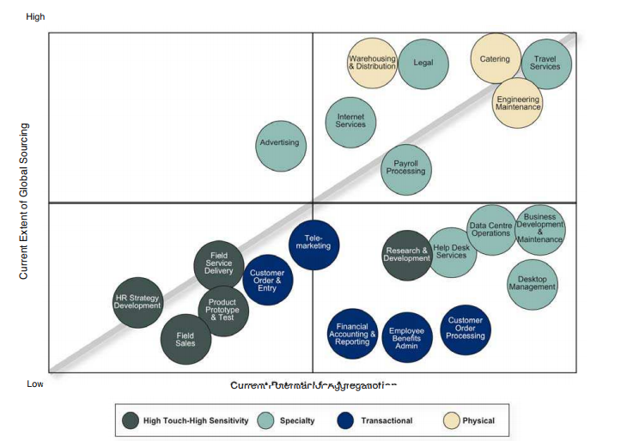

We follow the below global sourcing cube.

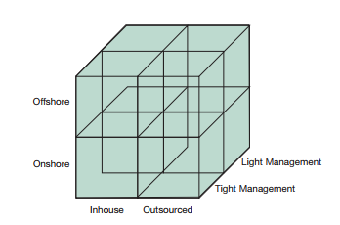

In this there are 8 different ways to handle our sourcing. They are as follows

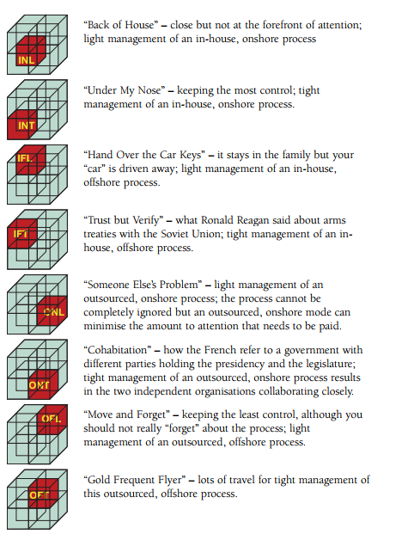

I – in-house O – Outsourced L – Light Management

N – onshore F – offshored T – Tight Management

STRENGTH

CONSULTING

Define and implement business strategies for industry leaders that will drive their growth and competitive edge.

OUTSOURCING

Our outsourcing teams build on 40 years of experience in working on some of the world’s largest IT outsourcing projects. Join a global workforce of 25,000 outsourcing professionals who solve leading companies’ most complex business problems.

TECHNOLOGY

From application integration to web services, you’ll design, develop and implement cutting-edge technical projects. Join our technology experts to find out how we combine our expertise with effective business leadership.

BANKING

We use

## **Architecture Transformation using BAIN**

## **Banking and financial services partnerships-**

In order to bring the best possible solution to our leading clients in banking and financial services we have established global and regional strategic relationships over many years with leading industry technology and financial services.

## **Capgemini uses Open banking solution.**

Today, thoughtfully conceived API strategies are transforming once tightly-closed banking systems into an ecosystem of connected institutions and individuals. 2017 World Retail Banking Report from Capgemini and EFMA assesses how the roles of banks, within this ecosystem environment, may change in the future and how banks can leverage APIs now to prepare strategic roadmaps

## **PSD2 open banking solutions**

By January 2018 banks must comply with the EU’s second Payment Services Directive (PSD2), intended to improve online payment protection, encourage payment services innovation, and make cross-border payments safer. Capgemini’s market-ready solution helps banks and PSPs meet compliance requirements and turn PSD2 into a business opportunity.

## **Capital markets and Wealth Management**

Regardless of the constant volatility within capital markets, investment banks, sell-side, buy-side and wealth management firms must strive for continued growth. Greater cost control and increased operational efficiency can deliver the consistent, profitable growth you need. Capgemini partners with global investment banks, wealth and asset managers, hedge funds, sell-side brokers, clearing houses, leading exchanges, and rating agencies to help them cost effectively streamline operations, improve agility and drive innovation. Our expertise covers the complete life cycle of investment management, trading, prime brokerage and back office systems. We are currently serving 10 of the 15 largest investment banks and providing solutions in derivatives trading, risk management, post trade processing, portfolio accounting, and wealth management.

## **Commercial Banking**

In the treasury management and trade finance areas of commercial banking, the recent trend is to merge multiple systems into a single online solution. An integrated online channel consolidates service offerings, improves customer service and simplifies the support and maintenance role of bank staff.

## **Connected Banking**

Capgemini Connected Banking is a hosted or utility-based ecosystem of banking products and services that enable banks to provide their customers with the best banking experiences regardless of channel. Its pre-integrated, digital ecosystem of best-in-class banking apps does not require a costly infrastructure.

## **CRM modernization for Financial Services**

With hundreds of implementations across multiple industries, our expertise in Siebel and Salesforce applications is unparalleled. Our structured approach enables accelerated processes, metadata, and data migration from Siebel to Salesforce for financial service firms.

As companies look to reinvent the way they connect to their customers, Capgemini’s CRM Modernization methodology can help lower migration risk and improves client confidence in migrating to the cloud. We’ve also taken the pain out of managing the CRM system, enabling sales, marketing and service organizations to focus on increasing sales and customer satisfaction.

## **INSURANCE**

Today’s insurers must put customers at the center of their business, bet products to market faster, and improve operational efficiency to lower costs. Partnering with over 70% of the world’s largest insurers*, Capgemini helps companies become more innovative and customer-centric to meet the future head on. Our partnership with [Pegasystems](https://www.capgemini.com/partner/pega/), Guidewire, Thunderhead and FirstBest and our proven IBAS business services for [Medicare](https://www.capgemini.com/service/medicare-supplement-insurance/) and [Long-Term Care](https://www.capgemini.com/service/long-term-care-insurance/) help our clients benefit from innovative technologies to become more competitive.

We help insurers across healthcare payer, property and casualty and life and annuities.

Proven experience as a chosen partner for a large insurer’s policy administration program. Strategic partner for four of the top five property & casualty insurers

Data management solutions focused on reporting, risk management and compliance.  
Latest thinking and world-class research through the [World Insurance Report](https://www.capgemini.com/service/world-insurance-report-2017) produced with Efma

DELIVERY MODELS

* **AGILE**

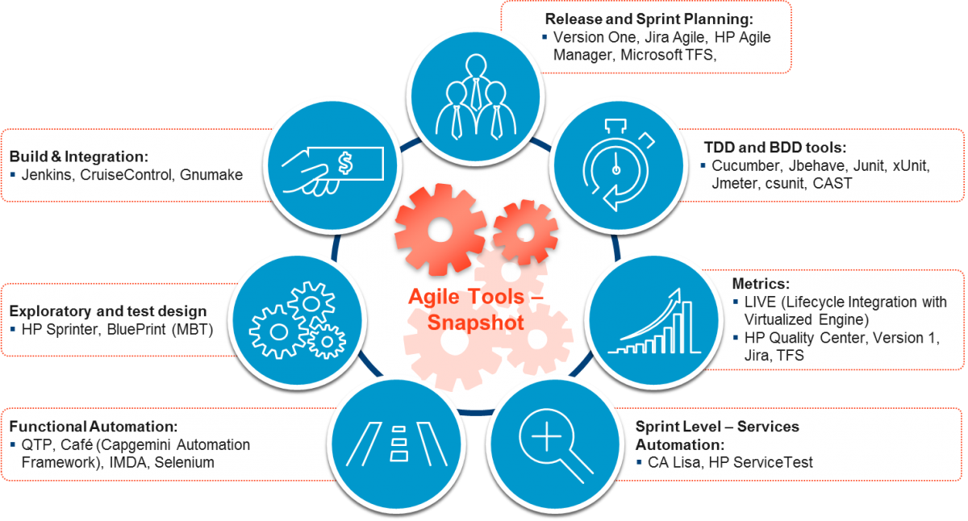

* **DevOps**

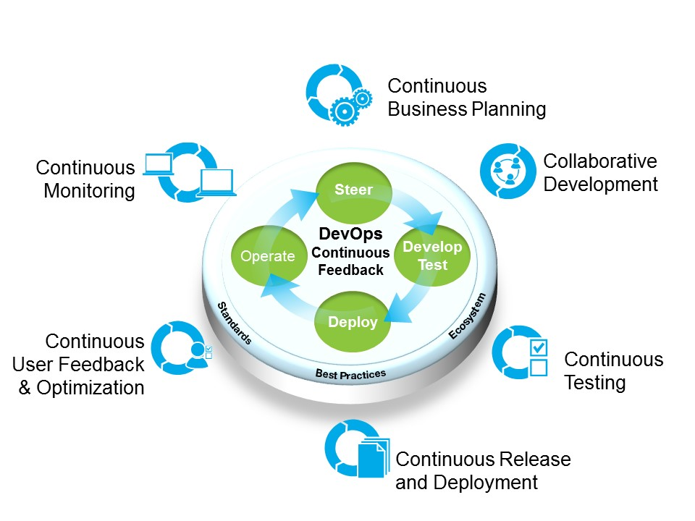

* **Two speed-IT**

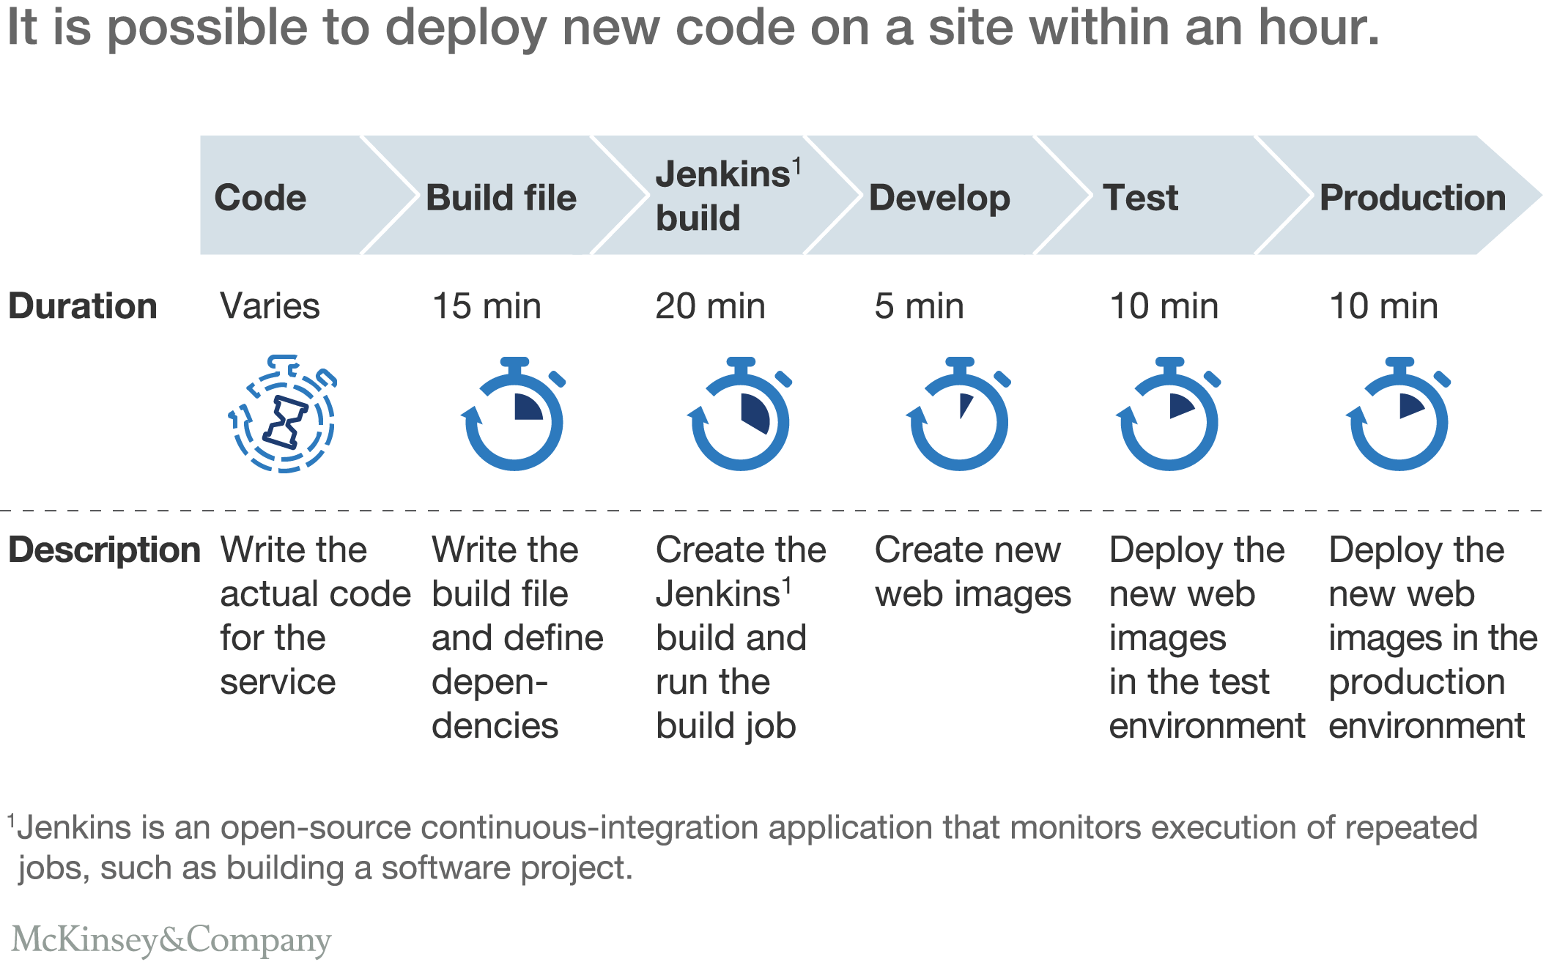

Competitiveness

You are right, we are about to pass a memorable milestone: 200,000 employees in more than 40 countries, including 100,000 in India which over time has become one of the main assets of the Group’s competitiveness. We recruited more than 53,000 new men and women during 2016, including 40% young graduates coming directly from universities. And while this is a significant accomplishment, we also consider it a great responsibility. In a service business like ours, success is about maintaining high standards in our Group and a passion for people. And let us share with you that Capgemini’s definition of leadership in our industry is not only a question of size, nor is it about only headcount—it’s about what we are able to do. Delivering the most demanding projects for the most demanding clients requires attracting and retaining the most demanding talent. To do so, we believe in finding the right combination of size, stature, and agility. This represents a substantial challenge for large organizations such as Capgemini. Our strong values, unchanged since our creation 50 years ago, and our multiculturalism, help us to attract top talent as well as grow our client base.

2016 was a successful year as we fulfilled all our commitments. Our revenue reached €12.5B, growing 7.9% year-on-year at constant exchange rates. Even more importantly, close to 30% of the revenue was rooted in priority activities of Digital and Cloud, which are growing at the fast pace of 29%. We can also be proud of the solid progression of our operating margin which grew from 10.6% to 11.5%. Lastly, I would like to highlight the progression of our net earnings and of our free cashflow which exceeded one billion euros. These results give us the financial muscle to consolidate our strengths, improve our competitiveness, and invest in the future. In addition, the several acquisitions we made in 2016 and in 2017 will help to strategically transition our business toward the “new” activities of Digital, Cloud, and Cybersecurity. To name a few, we on-boarded leading innovation consulting capabilities with Fahrenheit 212 in 2016. We continued earlier this year with Idean, a global strategy and design firm, and Itelios, an ecommerce specialist. We also reinforced our leadership position in the insurance sector with the acquisition of TCube Solutions in the U.S. Our challenge in 2017 is the battle for growth—a sustainable and profitable growth—especially in North America, now our largest regional market.

Today we are one of the international leaders in consulting and IT services. We serve more than 6,000 clients, often leaders on their industry. We need to continue to invest to be more agile and keep up with the fastest market evolutions that the business world has ever seen. For a long time, a group like Capgemini was a provider of IT solutions who essentially interacted with IT departments. Today many other clients—operations, marketing, and sales to name a few—also make use of our services. We are no longer only talking to IT specialists who want robust solutions

that will last ten to fifteen years, but also to other business people who want fast solutions that quickly generate a return on investment.

More competitiveness

Capgemini enhances its services

The Group Competitiveness department was launched in January 2016 to act as an integration layer ensuring seamless and efficient delivery across Capgemini. Supported by three functions—delivery, industrialization, and procurement—the new department maximizes the level of competitiveness in three strategic areas: Resource Management to optimize the management of resources around the world, ensuring that the right resources are available at the right time and the right price. Strategic Sourcing to harness the global procurement power of the Group, both in terms of spending and specifications. Automation to accelerate the automation of services and solutions—both as an integral part of Capgemini’s own delivery and as a productivity offering to clients—the main deployment of which takes the form of Automation Drive.

RANKING WITH COMPETITIVE COMPANIES

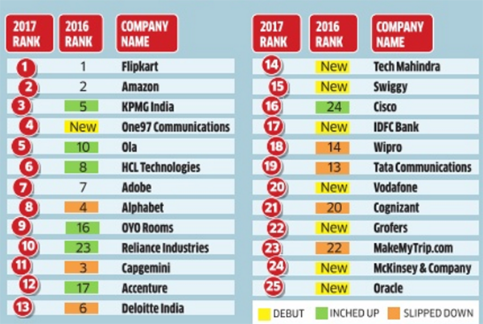

WHERE DO WE STAND

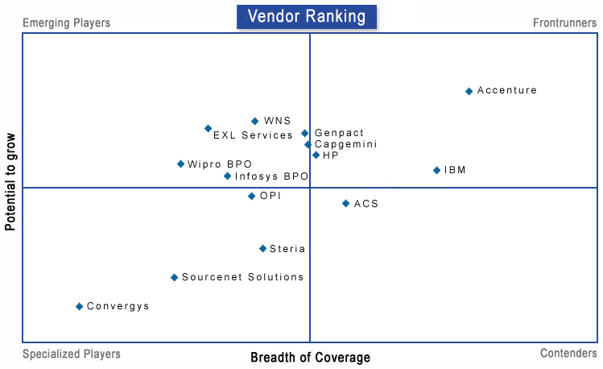

MAJOR BANKING CUSTOMERS WITH CAPGEMINI

BANK OF IRELAND

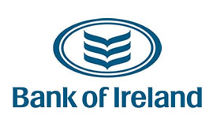

BARCLAYS BANK

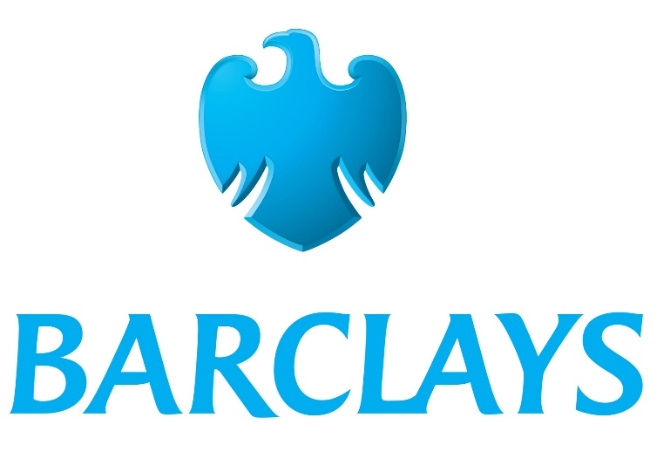

HSBC



COMPANY INFORMATION

**LEGAL NAME**

Capgemini SE, branded as Capgemini

**FORM OF ORGANIZATION**

CORPORATE

**INDUSTRY**

IT SERVICES AND IT COUNSULTING AND OUTSOURCING SERVICES

Application Lifecycle Services

Application Outsourcing Services

Capgemini's Business Process Management Solutions

BUSINESS PROCESS OUTSOURCING

FINANCE AND ACCOUNTING

GLOBAL ENGINEERING SERVICES

GREEN IT

INFRASTRUCTURE SERVICES

INSIGHTS AND DATA

LOCAL PROFESSIONAL SERVICES

MOBILE SOLUTIONS

PROCUREMENT

READY2SERIES

SERVICE INTEGRATION

SERVICE MANAGEMENT

SOCIAL BUSINESS

SUPPLY CHAIN MANAGEMENT

TESTING SERVICES

WORKFORCE MANAGEMENT

**ACQUISITIONS WITHIN A DECADE**

[Kanbay](https://en.wikipedia.org/wiki/Kanbay) International (2006)

Software Architects (2007)

[Maxeda](https://en.wikipedia.org/wiki/Maxeda) IT Services in the Netherlands (2008)

[Getronics](https://en.wikipedia.org/wiki/Getronics) PinkRoccade Business Applications Services BV (2008), developers of [Business Information Services Library](https://en.wikipedia.org/wiki/Business_Information_Services_Library)

Vizuri Ltd (2008)

Empire in [Czech Republic](https://en.wikipedia.org/wiki/Czech_Republic) (2009)

Nu Solutions in [Australia](https://en.wikipedia.org/wiki/Australia) (2009)

[IBX](https://en.wikipedia.org/wiki/IBX_Group_AB) in [Sweden](https://en.wikipedia.org/wiki/Sweden) (2010)

Strategic Systems Solutions Ltd in the [UK](https://en.wikipedia.org/wiki/UK) (2010), KSAak

CPM Braxis [Brazil] (2010)

Thesys Technologies (India) (2010)

CS Consulting GmbH (2010)

AIVE Group in [Italy](https://en.wikipedia.org/wiki/Italy) (2011)

Minneapolis-based BI Consulting Group (BICG)(2011)[[57]](https://en.wikipedia.org/wiki/Capgemini#cite_note-57)

Vengroff Williams & Associates (2011)

DTWO Solutions (2012) Japan based software and IT Staffing company

Strategic Systems & Products Corp. (SSP)(2014)

IGATE (2015)

TCube Solutions (2017)

**AWARDS**

2015

Capgemini won the SAP North America Partner Excellence Award 2015 for SAP Platform Solutions.

2014

Capgemini was named as a 2014 World’s Most Ethical Company by the Ethisphere Institute for the 2nd Year.

Capgemini was named a leader among Global SAP services providers by Forrester.

Capgemini was positioned as a leader in Global F&A BPO Magic Quadrant by Gartner.

Capgemini was positioned as a Leader in Software Testing Services by NelsonHall.

Capgemini Group was positioned in the “Leaders” Quadrant in Gartner’s Magic Quadrant for Application Testing Services 2014.

Capgemini was named a 'Leader’ amongst Global Infrastructure Outsourcing Providers in an independent report by Forrester Research, Inc.

Capgemini was positioned in “Leaders” Quadrant in Gartner’s Magic Quadrant for SAP Application Management Service Providers, Worldwide.

Capgemini was positioned in “Leaders” Quadrant in Gartner’s Magic Quadrant for SAP Implementation Service Providers, Worldwide.

Capgemini Consulting has been recognized by Source1 for the consistently high quality of its thought leadership content.

**FINANCIAL OVERVIEW**

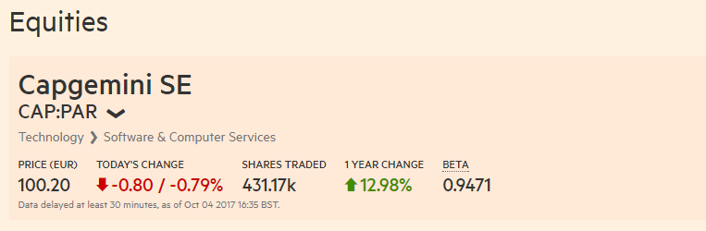

**5 YEARS COMPANY GROWTH**

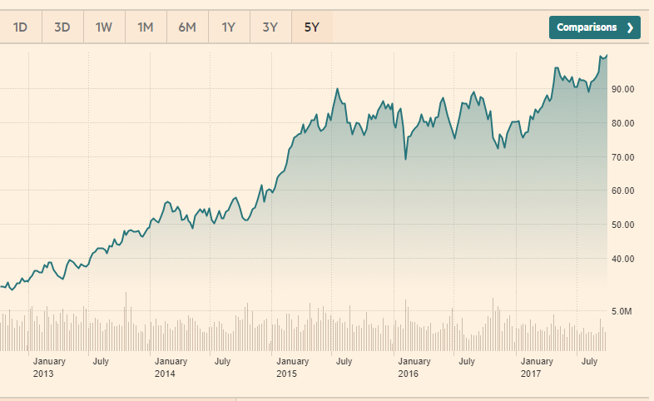

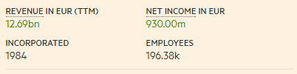

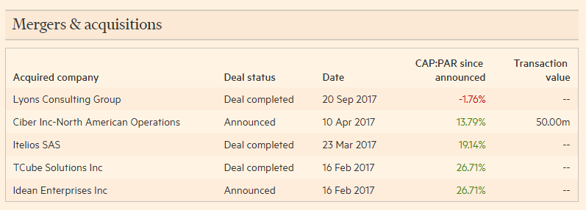

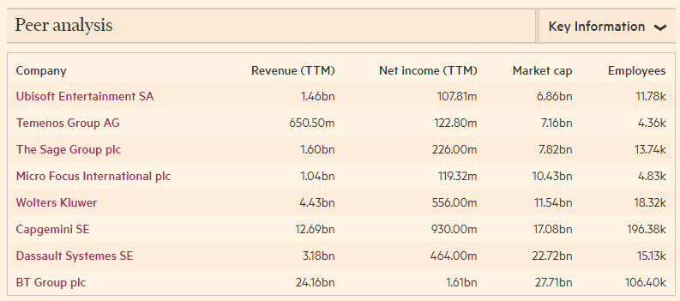

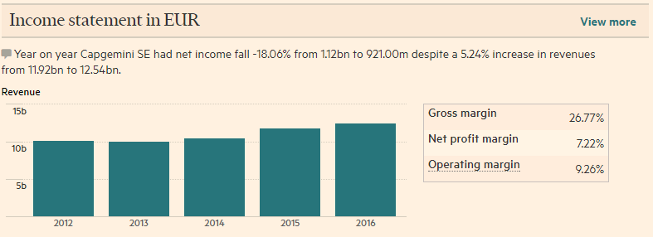

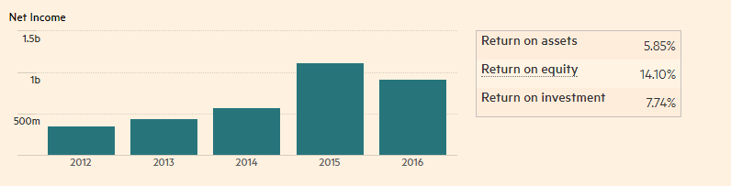

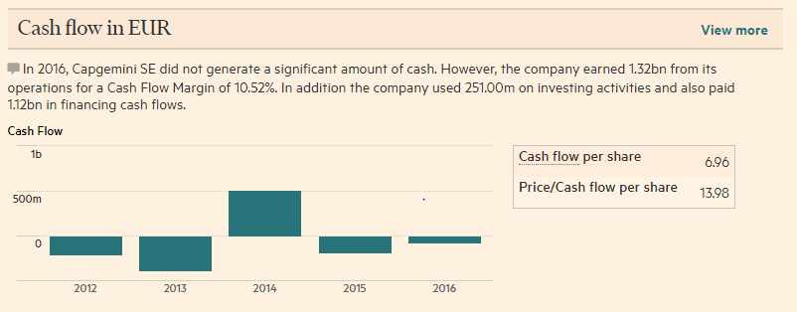

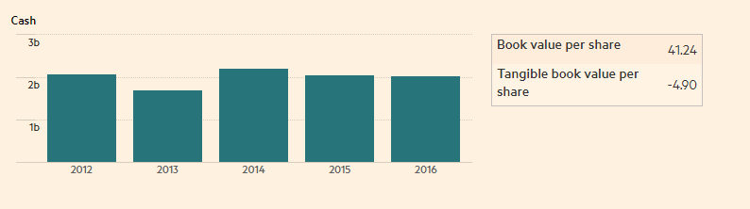

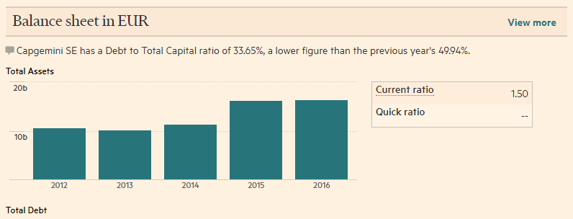

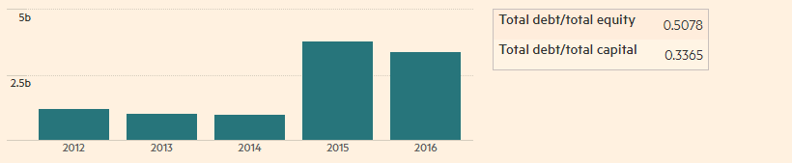

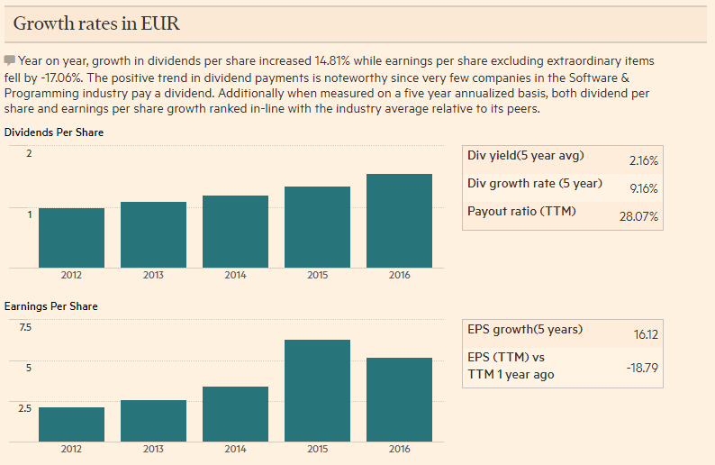

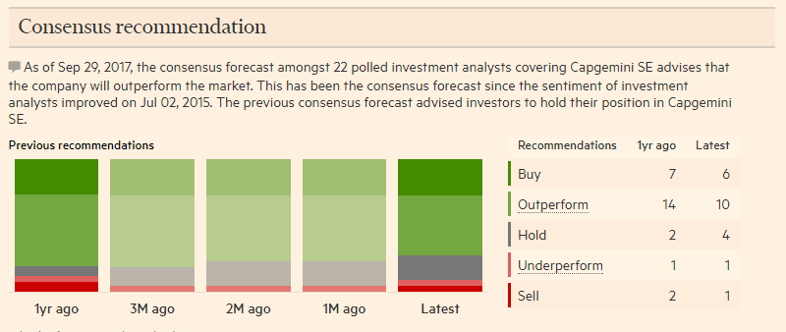

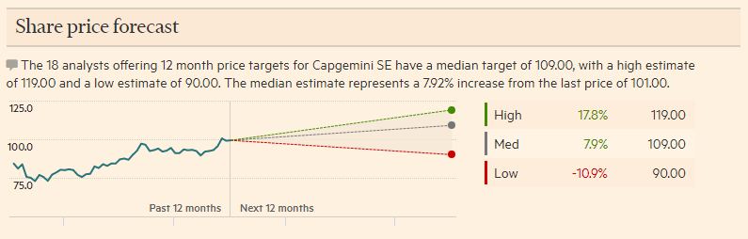

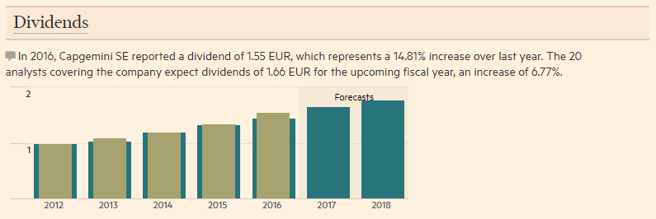

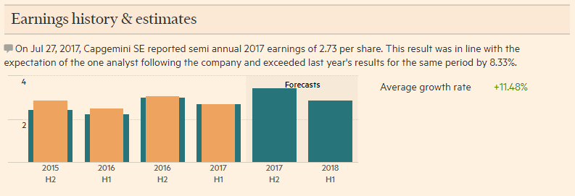

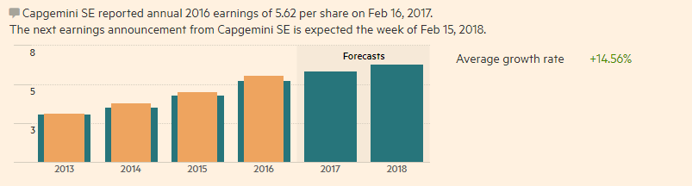

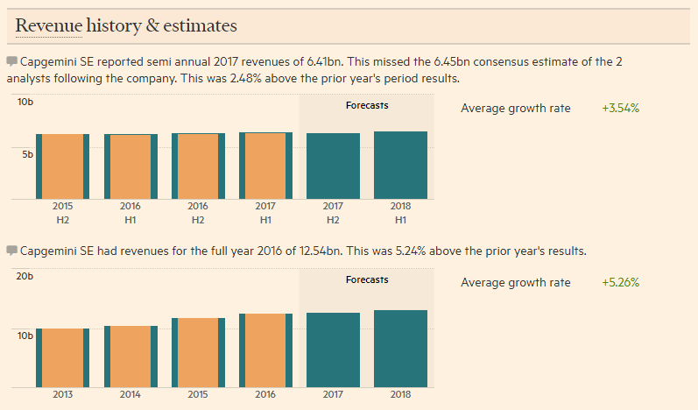

**PERFORMANCE WITH RESPECT TO THE COMPETITION (GARTNER MAGIC QUADRANT)**

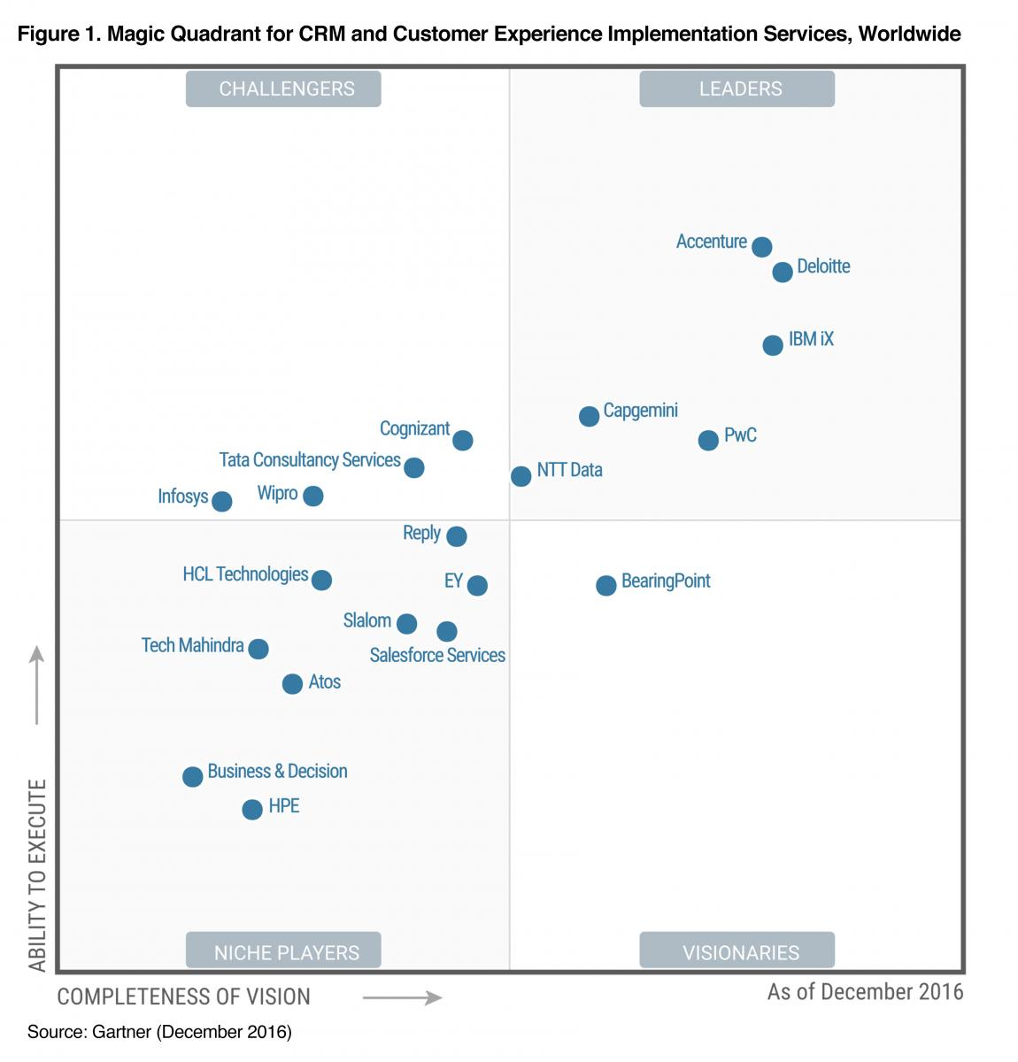

**GEO PRESENCE AND EMPLOYEE STRENTH AROUND THE WORLD**

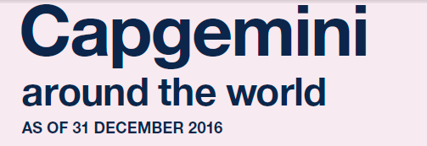**NORTH AMERICA**

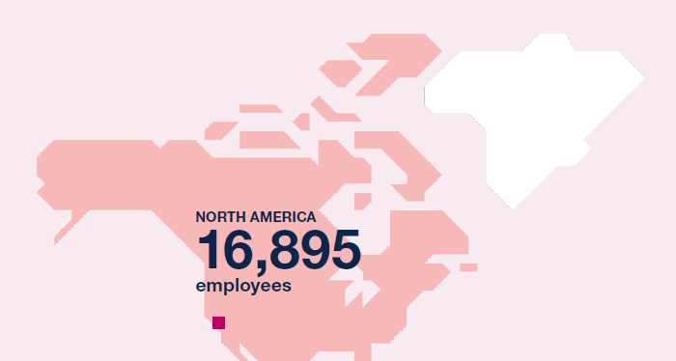

**SOUTH AMERICA**

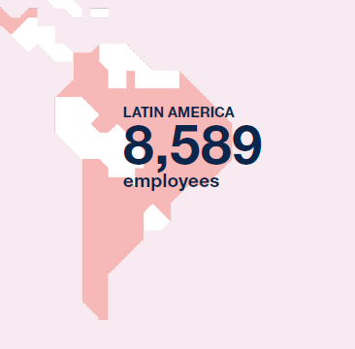

**EUROPE**

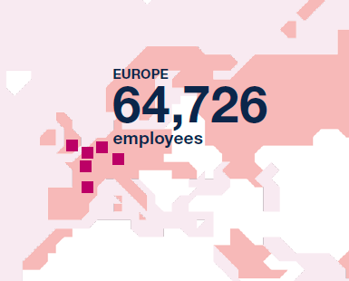

**APAC**

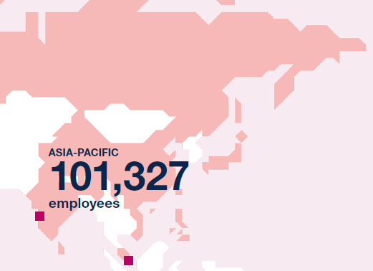

**AFRICA AND MIDDLE EAST**

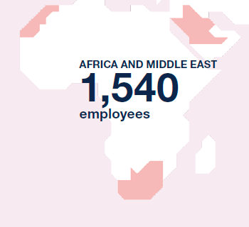

STAFF AUGMENTATION – Core competency

The speed of change is throwing traditional business methods into question and disrupting the relevance of entire industries. Fast evolution and adaptation are therefore key to business survival and growth. With close to 200,000 employees and nearly 100 business entities around the world, Capgemini has the resources to react quickly to client needs—a key asset in a digital era when deployment needs to be measured in weeks rather than months.

The integration of iGATE led to a series of significant joint client wins over the course of 2016. These include one of North America’s largest property and casualty companies, a leading global risk advisor, insurer and reinsurance broker, as well as an Enterprise Resource Planning (ERP) consolidation initiative for an industrial conglomerate. Thanks to the merger, Capgemini has strengthened its positions in the Financial Services, Consumer Products and Retail, Life Sciences and Manufacturing sectors.

IT CONSULTING SERVICES – Core competency

We provide the below consulting services

**Accelerated solution environments**

Capgemini Consulting’s Accelerated Solutions Environment and Network allows people across a company to work together across departments and functions, maximizing efficiency and profit.

**Big data and analytics consulting**

In the current climate, it is particularly difficult for organisations to make the right decisions, select the best options or gain competitive advantage.  
Big Data & Analytics enables our clients to approach problems and make decisions with the confidence that they are acting on evidence from logical and structured analysis.

**Business and technology innovation**

Our role is to support CIOs in their journey to becoming CDOs (Chief Digital Officers). To achieve this, we help them design new offerings and services within a digital universe and deliver the transformation of the related systems and operational models. We have also developed deep expertise in the industrialization of IT operations: globalization and off shoring strategies, leverage of cloud computing, improvement of operational excellence through lean IT. Finally, we help CIOs reinforce their interactions with other entities by reshaping strategic and financial governance of IT.

To support CIOs in their industrialization and Digital Transformation, we provide a global network of more than 300 experts. They provide innovative technological thinking combined with our culture of strategic ambition and operational excellence. We are the partner of choice to guide CIOs through the design and deployment of their most ambitious projects.

Application development – Core competency

Capgemini’s Application Services proposition delivers three times the commercial impact per Euro or Dollar of existing client spend in comparison with traditional outsourcing.

## **next generation Application Development and Maintenance Platform**

Capgemini’s next generation Application Development and Maintenance (next generation ADM) proposition is a business process- oriented, industrialized approach to ADM that delivers: • ‘Always-On’ availability to execute business transactions • Pervasive cost reduction • A ‘Business Aware’ and ‘Future Proof’ IT landscape Our next generation ADM proposition recaptures the essence of why applications were implemented in the first place — to deliver business transactions. It reduces the need for expensive external transformation which is often not based on practical insights from day-to-day execution. The Capgemini next generation ADM proposition enables clients simultaneously to capture business value from next-gen industrialization and transformation. It is implemented in accordance with Capgemini’ s Collaborative Business Experience™ model, which yields better, faster, and more sustainable results. Crucially, it does not adopt the ‘rip-and-replace’ approach to your existing investments. Capgemini’ s next generation ADM proposition has four pillars. The pillars incorporate a judicious blend of IT execution and business-IT strategy to ensure the optimum levels of industrialization and transformation in ADM engagements.

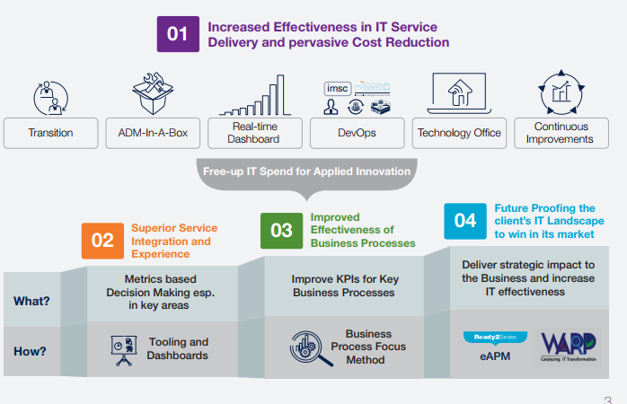

Speed-to-Value Levers The four pillars are backed-up by a broad range of Speed-to-Value levers that add substantial business benefit compared to the traditional Application Development and Maintenance approach. Our next generation ADM proposition deploys several Client Collaboration Assets that help us shape a value proposition, relevant to each client with depth and rigor. Capabilities of the Speed- to-Value Framework and tools span:

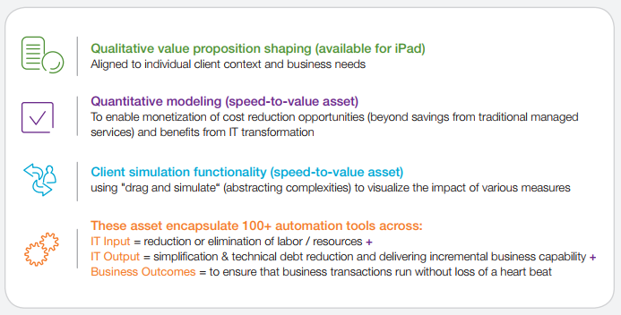

TESTING SERVICES- Meeting the challenge of software quality and maximizing return on investment

CORE COMPETENCY

Our Testing Services enable organizations to meet these challenges and maximize the return on their investment in IT systems through a proven, best-practice approach to highly industrialized and structured software testing.

Strategic Consultancy—working closely with you to design, develop, and deploy customized testing solutions that address the unique needs of your business and industry, such as QA, audits, and test organization strategy. In addition, we help you leverage cutting-edge thinking to further streamline your application test lifecycle, including Cloud, Virtualization, Simulation, and Model-based testing.

Managed Testing Service using Rightshore ® —a proven, incremental roadmap to test sourcing, whether onshore, nearshore or offshore, that provides the right skills, in the right locations, at the right time, to deliver the best value.

Test Process Consulting—test process maturity assessment plus performance improvement recommendations to fast-track implementation—this service uses our own industry standard TPI ® model and Quality Blueprint accelerators.

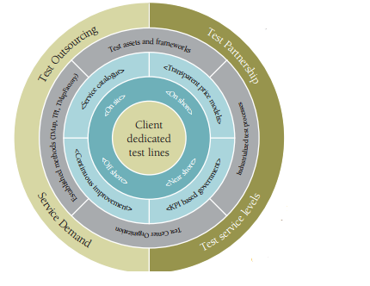

Test Management, Engineering and Execution—using our worldleading TMap® methodology, we provide ‘best of breed’ practices for comprehensive testing coverage— minimizing the business risk of production flaws, delivery delays, and operational defects. Our approach enables industrialization and automation across the delivery lifecycle. It includes functional, infrastructure, security, packaged applications, migration, and end-to-end testing, as well as our on-demand Software Testing as a Service.

Why Choose Capgemini?

**Extensive Track Record and Deep Domain Expertise**

* Our testing heritage stretches back over 20 years, making our accumulated technical and sector knowledge unparalleled— particularly in financial services, telecoms, and government. Over 500 clients from across the industry spectrum trust us to deliver consistently, time after time.

**Dedicated Resources**

* We are one of the largest dedicated professional testing practices in the industry providing expert global delivery.
* We have over 6,400 career test specialists worldwide and up to 11,000 further application testers available when you need them most.

**Global Delivery Network – Rightshore®**

* We have a global delivery capability and scalable testing resources. Our dedicated onshore/onsite client teams are balanced by an extensive offshore capability and 24x7 operations.

**World-leading ‘Best in Breed’ Intellectual Property**

* TMap®—the de facto industry standard for structured testing;
* TPI®—the world’s number one model for assessing and improving test processes;
* Quality Blueprint—marketintelligence benchmarking and accelerated implementation using the Group’s Innovation Lab techniques
* Our World Quality Report— data from over 400 organizations worldwide providing intelligence on market trends in testing technologies, processes, organizations, outsourcing, and economics.

**Continuous Investment in Testing Innovation**

* We make significant investment in the development of leading testing thinking and fund businessfocused research and development through our Solutions Innovation Centers across the globe.

**Partnering with the Market Leaders**

* We work in partnership with the world’s largest technology suppliers including HP, IBM, and Microsoft; their market-leading testing software suites help us streamline service delivery to clients, while our partners use our TMap® methodology as plug-ins to their tools.

Capgemini will offer ABC bank its brand new Banking Platform Solution, which will provide ABC bank with a full range high end and broader of features which will suits your specific requirements .