String[] men={"Victor","Wyatt","Xavier","Yancey","Zeus"};
String[] women={"Amy","Bertha","Clare","Diane","Erika"};

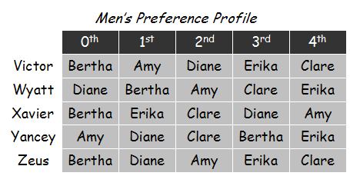
int[][] menPref={
{1,0,3,4,2},
{3,1,0,2,4},
{1,4,2,3,0},
{1,3,0,4,2}
};
