*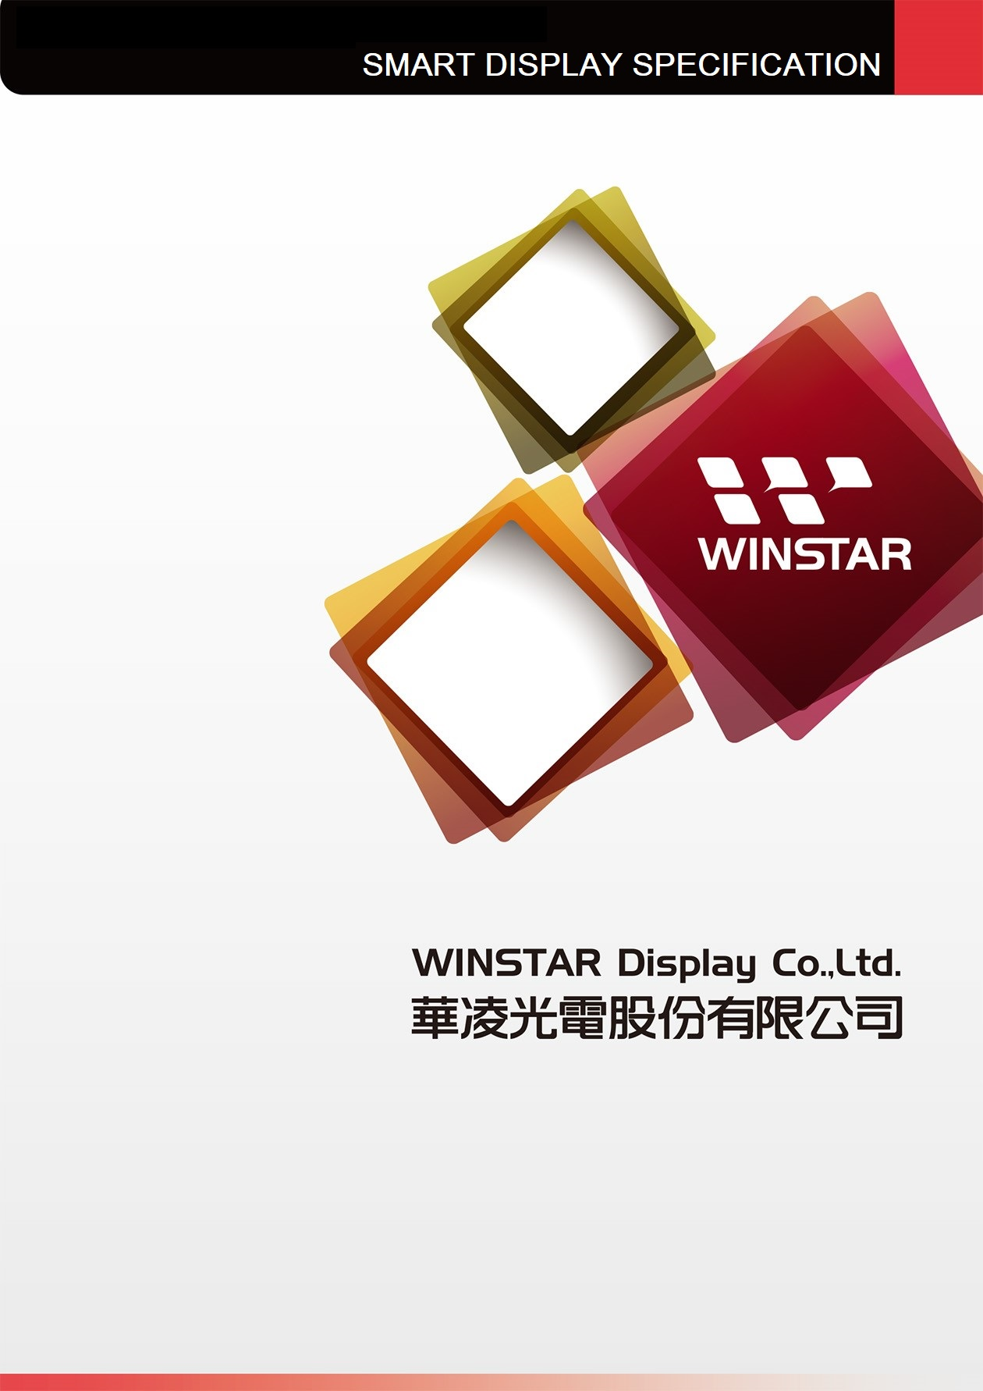 Winstar Display Co., LTD*

***華凌光電股份有限公司***

|  |  |
| --- | --- |
| *WEB:* [*https://www.winstar.com.tw*](https://www.winstar.com.tw) | *E-mail: sales@winstar.com.tw* |

|  |
| --- |
|  |

**SPECIFICATION**

|  |  |
| --- | --- |
| **CUSTOMER :** | **Winstar** |
| **MODEL NO. :** | **WL0F00043000UGFAAEA00** |

|  |  |
| --- | --- |
| APPROVED BY:  ( FOR CUSTOMER USE ONLY ) |  |

|  |  |  |  |
| --- | --- | --- | --- |
| **SALES BY** | **APPROVED BY** | **CHECKED BY** | **PREPARED BY** |
|  |  | TingWei Lee  Erick Chung | Kyra Chen |

|  |  |  |  |
| --- | --- | --- | --- |
| VERSION | DATE | REVISED  PAGE NO. | SUMMARY |
| 1 | 2022/12/20 | P.6, P.7 | Increase external flash size into 16M |

TFT Display Inspection Specification: <https://www.winstar.com.tw/technology/download.html>

Precaution in use of TFT module: <https://www.winstar.com.tw/technology/download/declaration.html>

|  |  |  |  |
| --- | --- | --- | --- |
| 未命名 - 4*Winstar Display Co., LTD*  ***華凌光電股份有限公司*** | | | MODLE NO：  WL0F00043000UGFAAEA00 |
| RECORDS OF REVISION | | | DOC. FIRST ISSUE |
| VERSION | DATE | REVISED  PAGE NO. | SUMMARY |
| 0 | 2022/07/14 |  | First issue |
| 1 | 2022/12/20 | P.6, P.7 | Increase external flash size into 16M |

Contents

1. Smart Display Classification Information
2. Summary
3. Product information
4. Contour Drawing
5. Absolute Maximum Ratings
6. Electrical Characteristics
7. BOM
8. Block diagram
9. Interface
10. Reliability
11. Product inspection check list
12. Display Usage & References
13. **Smart Display Classification Information**

|  |  |  |  |  |  |  |  |  |  |  |
| --- | --- | --- | --- | --- | --- | --- | --- | --- | --- | --- |
| W | L | 0F | 000430 | 00U | G | F | AA | **E** | A | 00 |
|  |  |  |  |  |  |  |  |  |  |  |

|  |  |  |  |  |
| --- | --- | --- | --- | --- |
|  | W: WINSTAR products | | | |
|  | Type: L:Standard K:Customization | | | |
|  | Display Type: | Standard: | 0H: Character STN  0X: Graphic STN (TAB/COF)  0F: TFT  EH: Character OLED  EX: OLED (TAB/COF) | 0G: Graphic STN  0P: Graphic STN (COG)  EG: Graphic OLED  EP: OLED (COG) |
| Customization: | DH: Character  DN: Graphic  ED: OLED | DG: Graphic STN  0J: TFT |
|  | Display size:  (diagonal) /  Display format:  (resolution) | Character STN:  Graphic STN: | e.g., 8x1: 000801 16x2: 001602 24x4: 002404  e.g., 128x64: 012864 320x240: 320240 | |
| TFT Size (inch): | 000096-0.96” / 000350-3.5” / 000430-4.3” / 000570-5.7”  000700-7.0” / 000800-8.0” / 001020-10.2” / 001210-12.1”  (The last two digits are two digits after the decimal point) | |
| OLED: | e.g., 128x64: 012864 Customization: 0001XX | |
|  | Serial No: | 0A1 ~ 0ZZ | Customization STN: 000 | |

|  |  |  |  |  |
| --- | --- | --- | --- | --- |
|  | Touch Panel Type: | N: Without TP T: RTP G: CTP | | |
|  | Model Interface: | A: CAN  B: Bluetooth  C:Controller Specified  D: RS485  E: RS232  F: USART  G: Logic I/O | H: HDMI  R: Memory Specified  P: RS422  N: Ethernet  J: Analog I/O  K: USB  L: WIFI  M: Zigbee | X: Combined  Y: Proprietary interface |
|  | Interface Serial No.: | AA ~ ZZ | | |
|  | Control Category: | S: Smart Display N: Non-specified E: Entry | | |
|  | Special Code: | A ~ Z | | |
|  | Model code: | 00 ~ ZZ | | |

1. **Summary**

**WL0F00043000UGFAAEA00 is built in TFT 4.3” TN display with capacitive touch. The features describe as below:**

**4.3 Inch Smart Display Feature**

1. DC 5V working voltage.
2. UART Interface with customized UART protocol, default baud rate at 19200 bit/Sec.
3. Built in 16M flash memory.
4. Supports PCAP touch screen.
5. WL0F00043000UGFAAEA00 is defined as a slave device, which is controlled by master device via customized command to render display content on the display screen and return touch event position.
6. **Product information**

**General information**

|  |  |  |
| --- | --- | --- |
| **Item** | **Standard Value** | **Unit** |
| Operating voltage | 5 | Vdc |
| Communication Interface | UART | N/A |
| MCU | ITE9866 | N/A |
| Flash Memory | 16 | MB |
| SDRAM Frequency | Up to 800MHz internal MCU | MHz |
| LCD display size | 4.3 | inch |
| Dot Matrix | 480 x RGBx272(TFT) | dot |
| Module dimension | 125.5(W)\*67.2(H)\*9.35(D) | mm |
| Active area | 95.04 x 53.856 | mm |
| Dot pitch | 0.066 x 0.198 | mm |
| Brightness | 400min, 480typ | cd/m2 |
| LCD type | TFT, Normally White, Transmissive | |
| View Direction | 12 o’clock | |
| Aspect Ratio | 16:9 | |
| With /Without TP | With CTP | |
| Surface | Glare | |

1. **Contour Drawing**

C:\Users\Welcome\Documents\WXWork\1688851340998400\Cache\File\2022-07\WL0F00043000UGFAAEA00_20220714.wmf

1. **Absolute Maximum Ratings**

|  |  |  |  |  |  |
| --- | --- | --- | --- | --- | --- |
| **Item** | **Symbol** | **Min** | **Typ** | **Max** | **Unit** |
| Operating Temperature | TOP | -20 | － | +70 | ℃ |
| Storage Temperature | TST | -30 | － | +80 | ℃ |

Note: Device is subject to be damaged permanently if stresses beyond those absolute maximum ratings listed above

1. Temp. ≦60℃, 90% RH MAX. Temp.＞60℃, Absolute humidity shall be less than 90% RH at 60℃

1. **Electrical Characteristics**

|  |  |  |  |  |  |
| --- | --- | --- | --- | --- | --- |
| **Item** | **Symbol** | **Min** | **Typ** | **Max** | **Unit** |
| Supply Voltage | VCC | 4.5 | 5- | 5.5 | V |
| Supply current | ICC | - | 340 |  | mA |

1. **BOM**

|  |  |  |
| --- | --- | --- |
| **Item** | **Description** | **Remark** |
| LCM | WF43UTIAEDNGB# |  |
| PCBA | SV10004R300UA00N0100 |  |

1. **Block diagram**

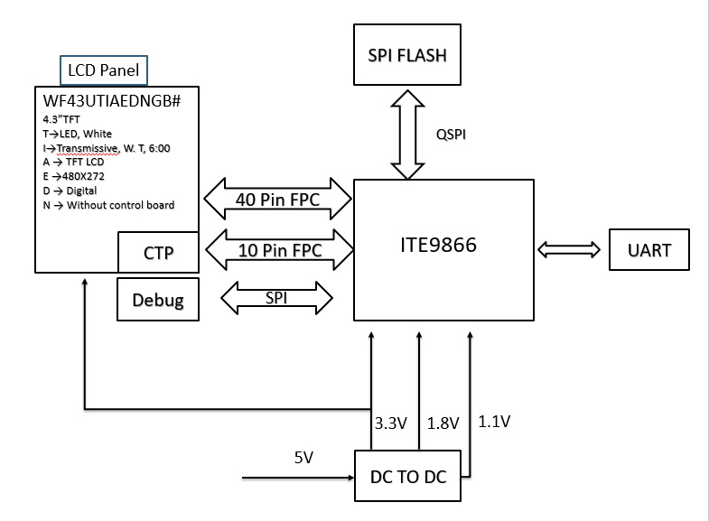

1. **Interface**

**CON2 definition:**

|  |  |  |  |
| --- | --- | --- | --- |
| **Pin** | **Symbol** | **Function** | **Remark** |
| 1 | GND | Power Ground |  |
| 2 | UART\_TX | UART TX |  |
| 3 | UART\_RX | UART RX |  |
| 4 | +5V | Power supply 5V |  |
| 5 | D+ | USB Data+ |  |
| 6 | D- | USB Data- |  |
| 7 | GND | Power Ground |  |
| 8 | /REST | Reset (active Low) |  |
| 9 | GND | Power Ground |  |
| 10 | PWM | Pulse width modulation |  |
| 11 | GND | Power Ground |  |
| 12 | +5V | Power supply : 5V |  |

**CON3 definition:**

|  |  |  |  |
| --- | --- | --- | --- |
| **Pin** | **Symbol** | **Function** | **Remark** |
| 1 | GND | Power Ground |  |
| 2 | SW1 | Switch ( active low) |  |
| 3 | SW2 | Switch ( active low) |  |
| 4 | SW3 | Switch ( active low) |  |
| 5 | SW4 | Switch ( active low) |  |
| 6 | GND | Power Ground |  |
| 7 | NC | Reserved |  |
| 8 | NC | Reserved |  |
| 9 | NC | Reserved |  |
| 10 | NC | Reserved |  |
| 11 | INT | Interrupt output for CTP or external switch |  |
| 12 | +5V | Power supply : 5V |  |

1. **Reliability**

|  |  |  |  |  |
| --- | --- | --- | --- | --- |
| Environmental Test | | | | |
| Test Item | Content of Test | | Test Condition | Note |
| High Temperature storage | Endurance test applying the high storage temperature for a long time. | | 80℃  96hrs | 2 |
| Low Temperature  storage | Endurance test applying the low storage temperature for a long time. | | -30℃  96hrs | 1,2 |
| High Temperature  Operation | Endurance test applying the electric stress (Voltage & Current) and the thermal stress to the element for a long time. | | 70℃  240hrs | —— |
| Low Temperature  Operation | Endurance test applying the electric stress under low temperature for a long time. | | -20℃  240hrs | 1 |
| High Temperature/  Humidity Operation | The module should be allowed to stand at 40℃,90%RH max | | 40℃,90%RH  96hrs | 1,2 |
| Thermal shock resistance | The sample should be allowed stand the following 10 cycles of operation  -20℃ 25℃ 70℃    30min 5min 30min  1 cycle | | -20℃/70℃  10 cycles | —— |
| Vibration test | Endurance test applying the vibration during transportation and using. | | Total fixed amplitude : 1.5mm  Vibration Frequency : 10~55Hz  One cycle 60 seconds to 3 directions of X,Y,Z for Each 15 minutes | 3 |
| Static electricity test | Endurance test applying the electric stress to the terminal. | VS=±2KV~±6KV(contact),±2KV~±8KV (air),  RS=330Ω  CS=150pF  10 times | | —— |

Content of Reliability Test (Wide temperature, -20℃~70℃)

Note1: No dew condensation to be observed.

Note2: The function test shall be conducted after 4 hours storage at the normal

Temperature and humidity after remove from the test chamber.

Note3: The packing have to including into the vibration testing.

1. **Product inspection check list**

**Check samples by meter VIN, Isystem**

|  |  |  |  |  |
| --- | --- | --- | --- | --- |
| **Item** | **No 1** | **No 2** | **No 3** | **Note** |
| VIN (V) | 4.82 | 4.79 | - |  |
| I System(mA) | 341 | 346 | - |  |

**Check sample Reliability Test**

|  |  |  |
| --- | --- | --- |
| **Item** | **Result** | **Note** |
| Thermal shock | PASS\_2021 | -20℃/70℃ 20 cycles |
| High Temperature  Operation | PASS\_2021 | 70℃  96hrs |
| Low Temperature  Operation | PASS\_2021 | -20℃  96hrs |
| Static electricity test | PASS\_2021 | VS=±2KV~±6KV(contact),±2KV~±8KV (air),  RS=330Ω  CS=150pF  10 times |
| Vibration test | \_ | Total fixed amplitude : 1.5mm  Vibration Frequency : 10~55Hz  One cycle 60 seconds to 3 directions of X,Y,Z for Each 15 minutes |

* Prepare sets for testing

1. **Display Usage**

Please refer to ***SmartDisplay Entry User Guide*** for the details of UART commands and Clever System User API.