Reliance Industries Limited
(RELIANCE - 1D)

📊 WAIT - Low R:R ratios

Current Price | ₹1518.40
Volume | 1,080,854
Sector | Energy
Analysis Date | 2025-11-17 05:22 IST
Execution Time | 21.53s

Executive Summary
Technical analysis shows mixed signals. Monitor key support and resistance levels for clearer direction. Exercise caution and proper risk management. ---

Key Metrics
Technical Bias | STRONG BULLISH
Signal Strength | 56.67/100
Trend | STRONG BULLISH
Market Structure | STRONG

Technical Analysis

Overall Assessment
The technical analysis shows a STRONG BULLISH bias with a signal strength of 56.67/100.

Key Price Levels
Level | Price (₹)
Current | ₹1518.40
Sma 50 | ₹1425.29
Sma 200 | ₹1370.05
Pivot | ₹1515.10
Resistance 1 | ₹1524.70
Support 1 | ₹1509.30

🧭 Scenario Playbook
Trade scenarios with entry, stop loss, and target levels:

Scenario | Entry | Stop | Target | R:R | Confidence | WarrenAI Take
Bullish (Aggressive) | ₹1518.40 | ₹1509.30 | ₹1524.70 | 0.69 | Moderate | Enter near current levels if bias holds
Bullish (Conservative) | ₹1519.05 | ₹1489.80 | ₹1524.70 | 0.19 | High | Wait for dip to support before entering
Bearish (Counter-trend) | ₹1518.40 | ₹1544.20 | ₹1509.30 | 0.35 | Low | Counter-trend trade - high risk

💡 Insights
• Recommended Position Size: 3-5%
• Rationale: Low volatility can handle larger position
• Max Risk per Trade: 2% of capital

🧩 Pattern Analysis
Market Structure: STRONG
Confidence: MODERATE

Patterns Identified
- • Bullish Structure

⚖️ Risk Metrics
Average R:R Ratio | 0.41
Volatility Level | LOW
Risk Grade | B (Moderate Risk)
Expected Range | ₹1488.03 - ₹1548.77 (daily)

📈 Backtest Results
Estimated Success Rate: 73.5%
Lookback Period: 6 months
Note: Estimated based on technical bias and strength

📊 Technical Chart
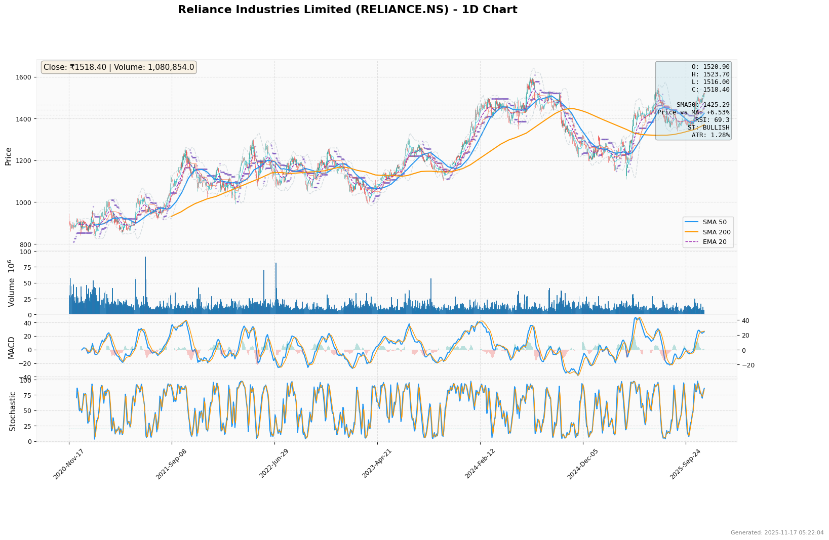

⚠️ Disclaimer
This analysis is for educational and informational purposes only. It is NOT financial advice,
investment advice, or a recommendation to buy or sell any securities.
All trading and investment decisions should be made based on your own research, risk tolerance,
and financial situation. Past performance does not guarantee future results.
Technical analysis and AI-generated insights are tools to assist in decision-making but should
not be relied upon as the sole basis for trading decisions.
Always consult with a qualified financial advisor before making investment decisions.
The creators of this analysis are not responsible for any losses incurred from trading decisions
made based on this information.

Generated on 2025-11-17 05:22:24 IST

