# Header 1

This is some very basic text.

## Header 2

This is some other text in a sub-heading. You can go on until level 6.

Newlines are interpreted as new paragraphs.

I can emphasize text like *this* or like **this**.

Unordered lists are created with symbols like *, -, +... but the first item of the list needs to be preceded by an empty line:

* I like cooking
* I also like languages
* and I like folk music
  + especially Blackbeard's Tea Party!

Ordered lists are created with numbers and dots. Even if you mess up the numbering, MD will fix it for you:

1. Item 1
2. Item 2
3. Item 3

Links can be added in text like this: [click here](http://www.blackbeardsteaparty.com/) or like this: <http://www.blackbeardsteaparty.com/>

Images are basically links, but they have to be also separated from the main text by an empty line before and after:

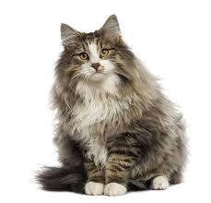

A super fluffy cat

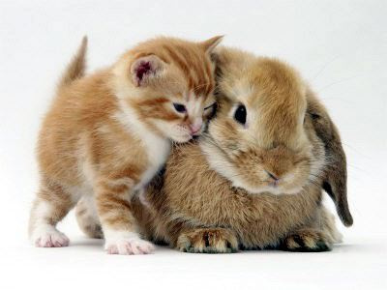

Kitty and bunny

Tables can be written with -- and || symbols:

|  |  |  |
| --- | --- | --- |
| Tables | Are | Cool |
| col 3 is | right-aligned | $1600 |
| col 2 is | centered | $12 |
| zebra stripes | are neat | $1 |