this is the project work made for the Aeronautical Informatics
the participants are:
- Pilotin Thedy, Dzodjou Chendjou (512224)
- Daniel Randy, Azmhau (511962)
- Eric Junior, Tchassem Ngounou (509561)

1) 03 screenshots of the gazebo world

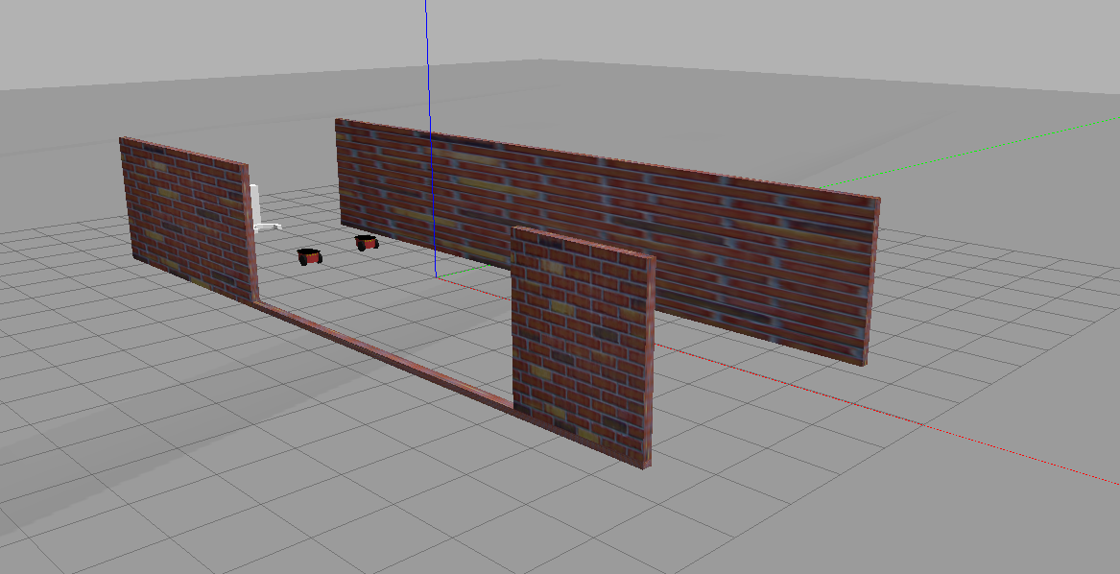
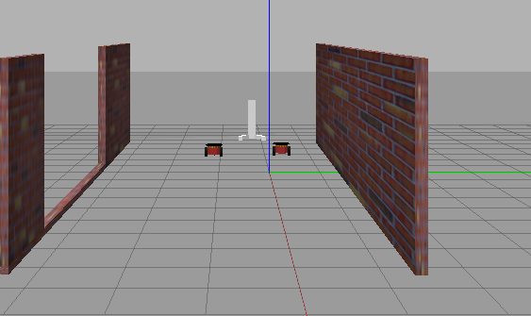

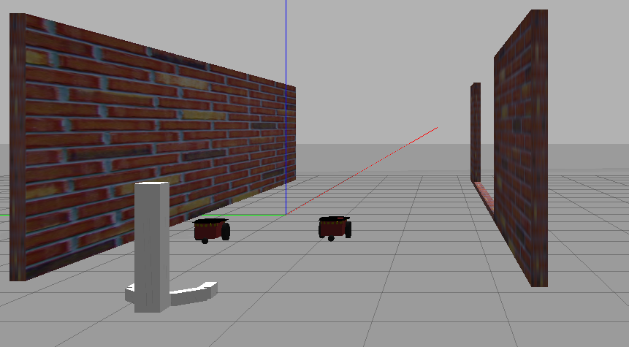

2) Terminal output screenshot when you launch

