# Technical documentation for Developers

## APP Hosting and Installation

To publish an Android app on the Google Play Store, you will need to create a Google Play developer account and pay a one-time fee of $25. After that, you can follow these steps:

1. Open the Google Play Console, sign in with your Google account, and click "Create Application."
2. Enter the details for your app, including its name, description, and category. You will also need to upload a high-resolution app icon and at least two screenshots of your app.
3. In the "Pricing & Distribution" section, choose whether you want to charge for your app or make it available for free. If you choose to charge for your app, you will need to set up a merchant account and select a pricing model.
4. In the "Content Rating" section, you will need to provide information about the content of your app and its target audience. This will help Google determine the appropriate age rating for your app.
5. In the "App Releases" section, you can create a new release for your app. This is where you will upload the APK file for your app and provide details about its features and changes.
6. After you have completed all of the necessary information and uploaded your app, you can submit it for review. Google will review your app to ensure that it meets their quality standards and doesn't violate any of their policies.

Once your app has been approved, it will be published on the Google Play Store, where users can download and install it on their Android devices.

Note: You will need to sign your app with a unique key before you can upload it to the Google Play Store. This is a security measure that helps prevent others from impersonating your app. You can find more information about signing your app on the Android Developers website.

## How to review and update the source code

To update source code using system design diagrams, a mobile developer should follow these steps:

1. Review the current system design diagrams to understand the overall architecture and flow of the system. This will help the developer identify which components of the system will be affected by the code update.
2. Identify the specific source code files that need to be updated. The developer can use the system design diagrams to trace the flow of data and control through the system and determine which files are responsible for the functionality that needs to be modified.
3. Make a copy of the source code files that will be updated. This will allow the developer to test the changes without affecting the live system.
4. Make the necessary changes to the source code files. The developer should ensure that the changes are well-documented and that the code is clean and easy to read.
5. Test the updated source code using the copied files. The developer should ensure that the changes have the desired effect and do not introduce any new errors or issues.
6. If the updated source code passes the tests, the developer can then merge the changes into the live system. It is generally a good idea to perform this update during a period of low usage or to roll out the update gradually to minimize the impact on users.
7. Once the update has been merged into the live system, the developer should review the system design diagrams again to ensure that the updated code fits into the overall architecture and flow of the system as intended.

## System Diagrams

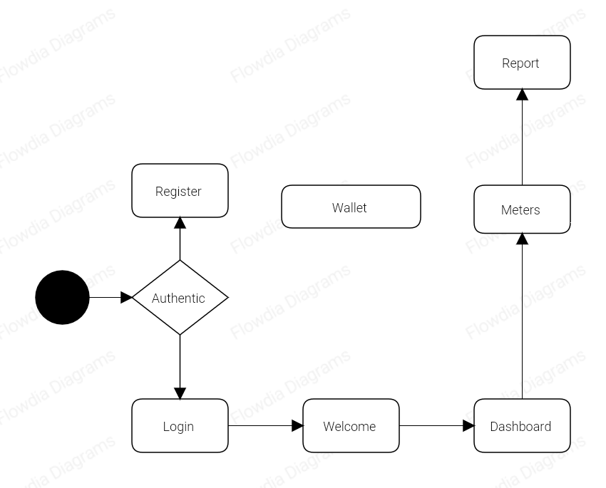

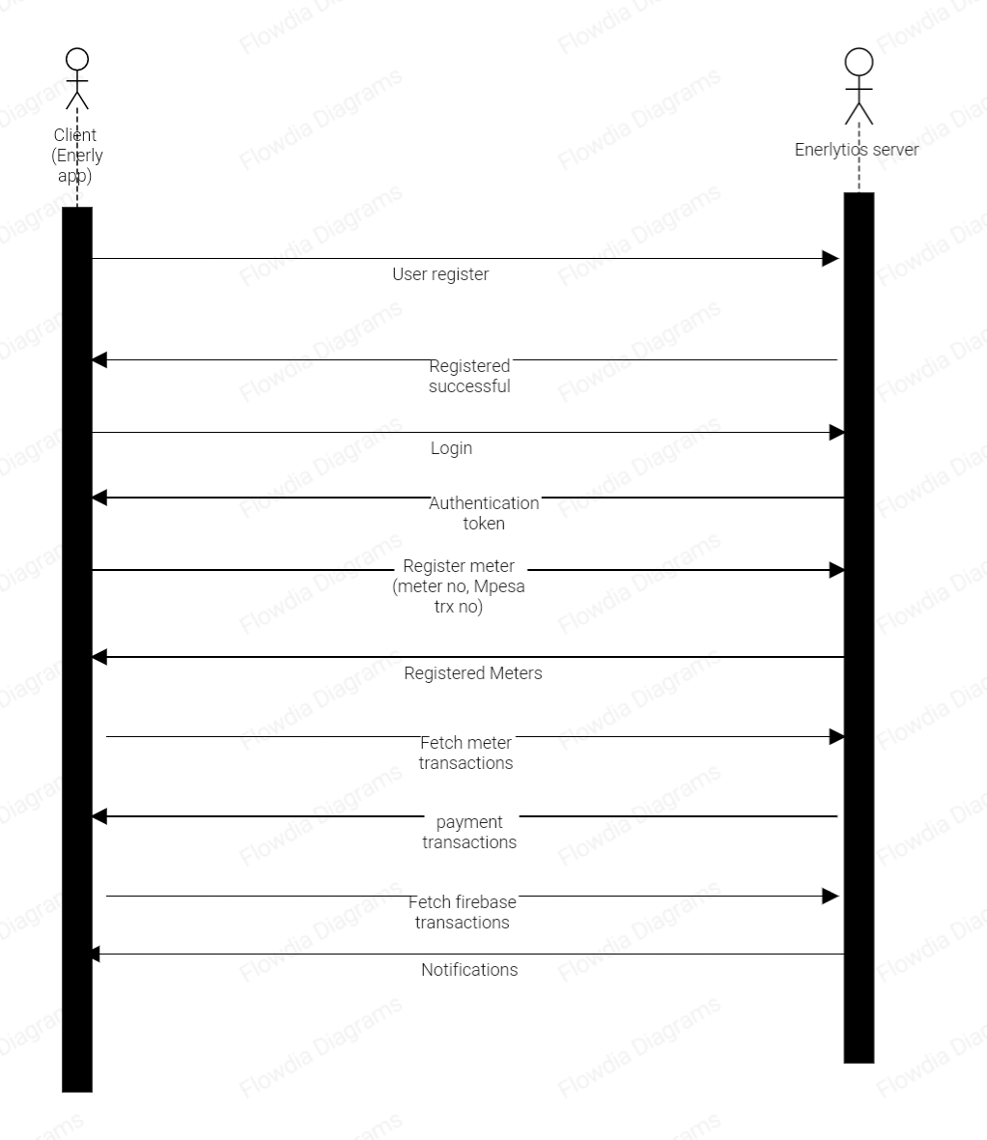

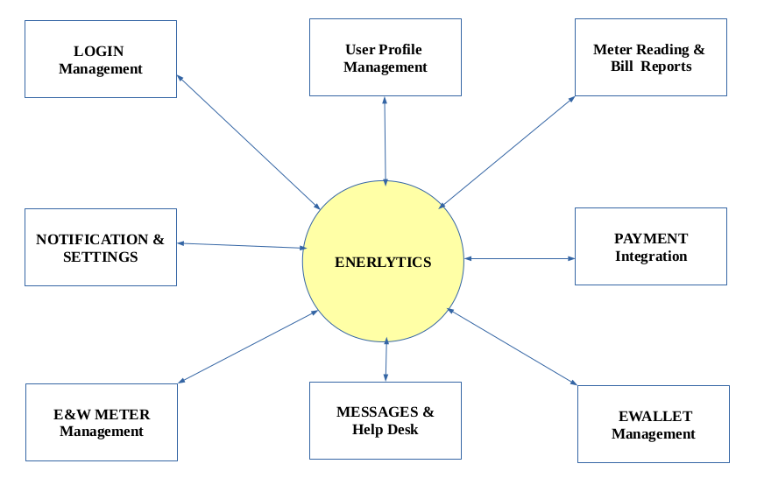

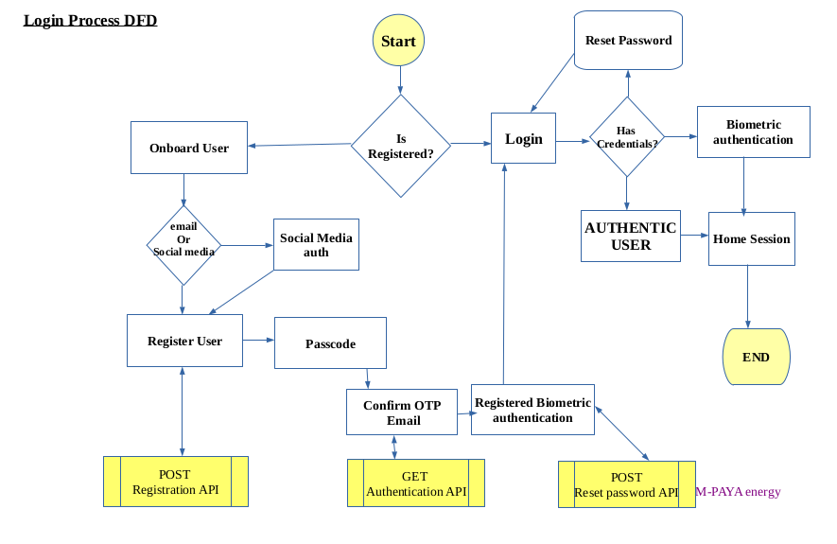

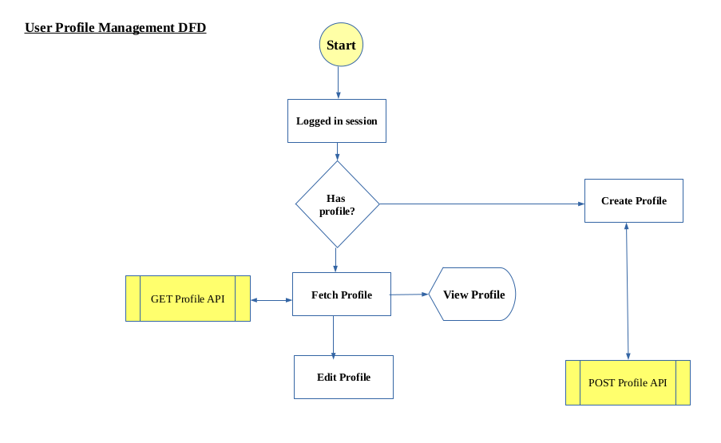

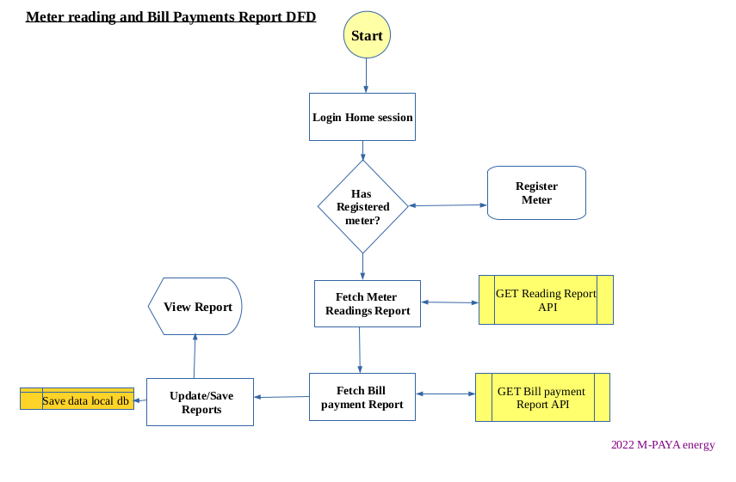

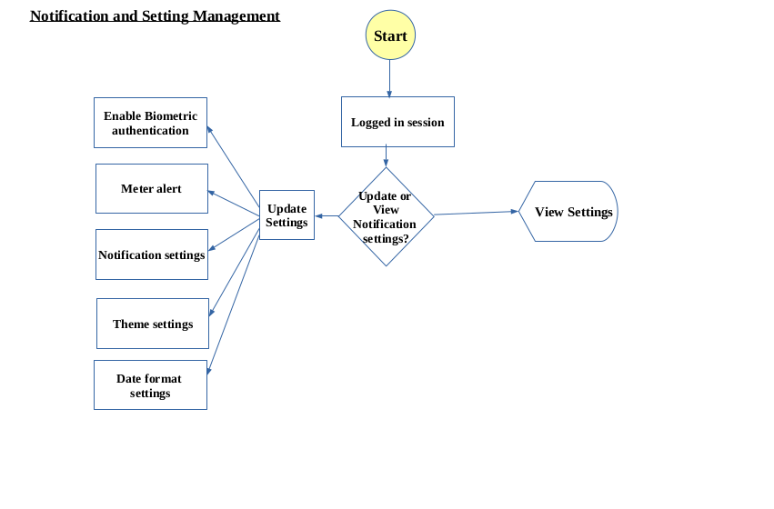

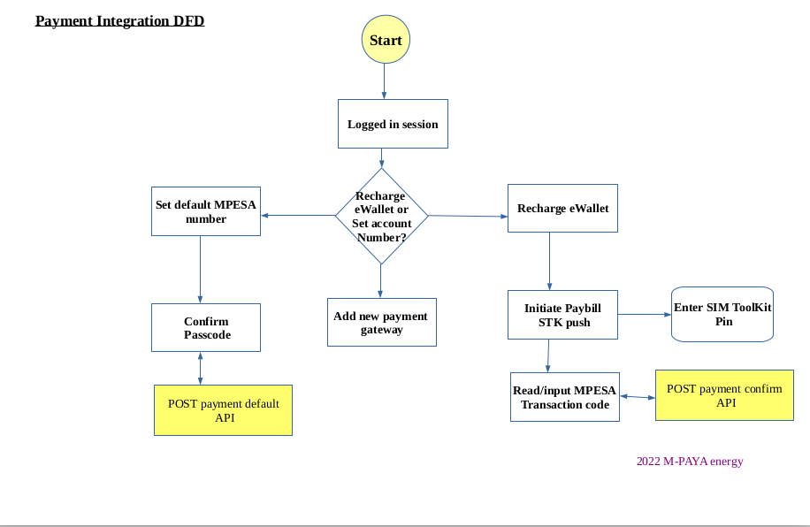

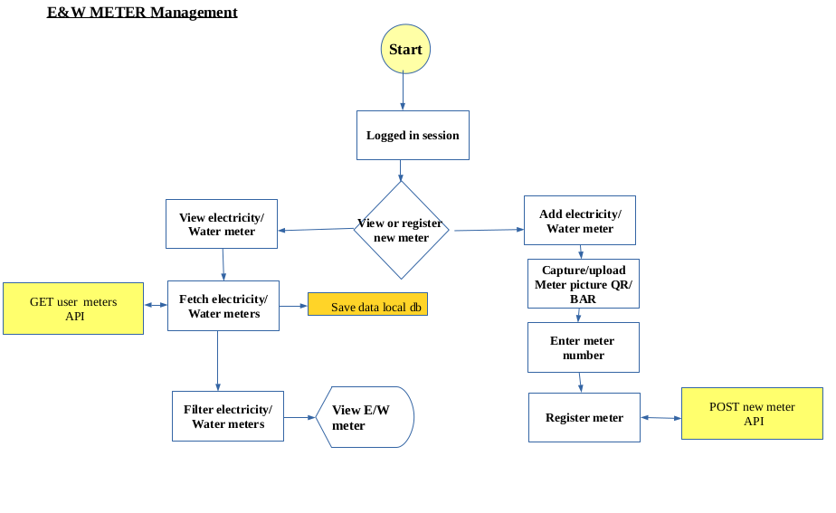

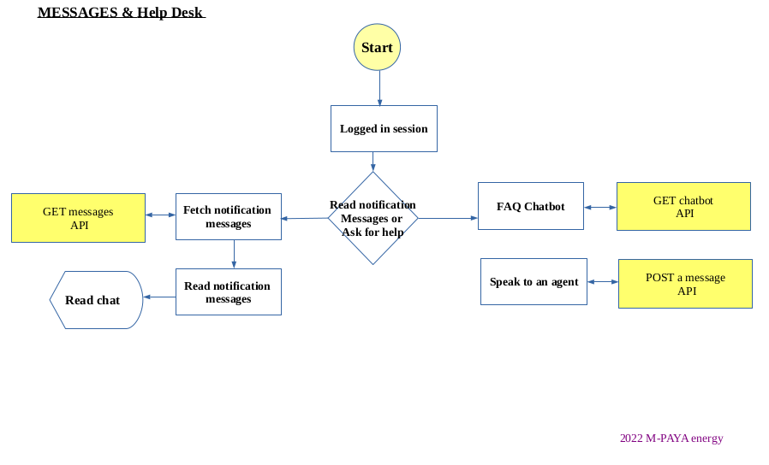

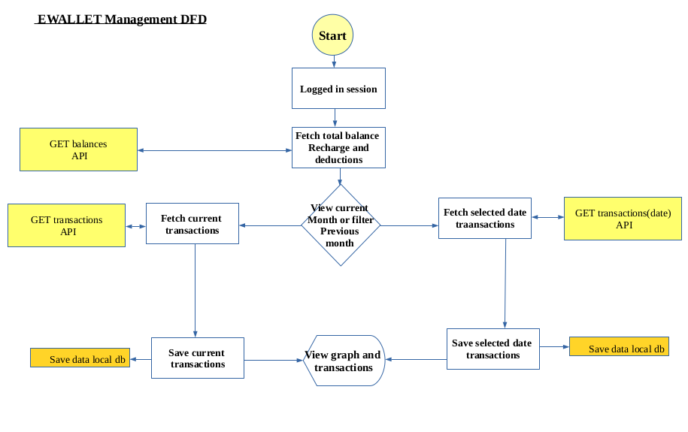

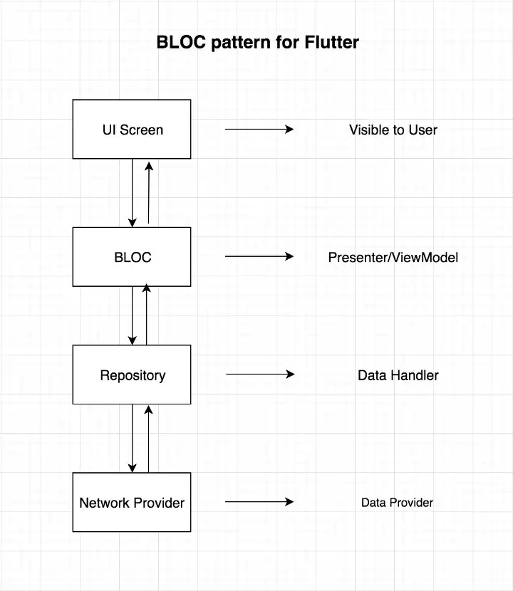

## Maintenance

### Unimplemented Features and Functions

1. Payment and Recharging E-wallet via MPESA STK PUSH API
2. Testing on IOS and Windows platform
3. Monitoring Real-time usage using Smart Meters
4. User two-factor authentication
5. Reset User Password feature
6. User Opting out feature

### Well-Known Bugs

1. Accurately calculating the remaining units and alert user when to recharge e-Wallet.