Computer Concept and Practice Midterm-1 2016-04-03

Dept: Student #: Name:

1.
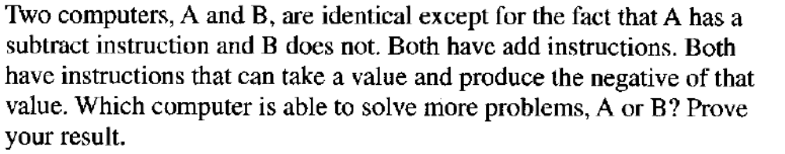

2.
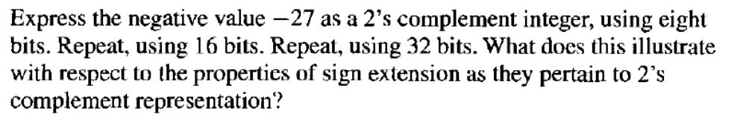

3.
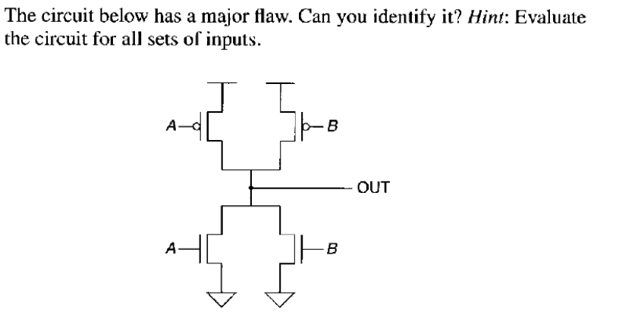

4.
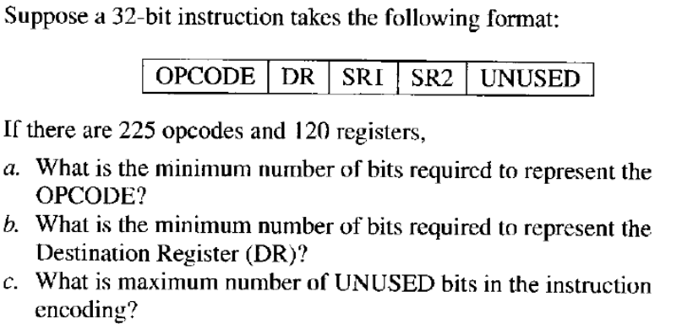

5. (You can give instructions in a symbolic form)
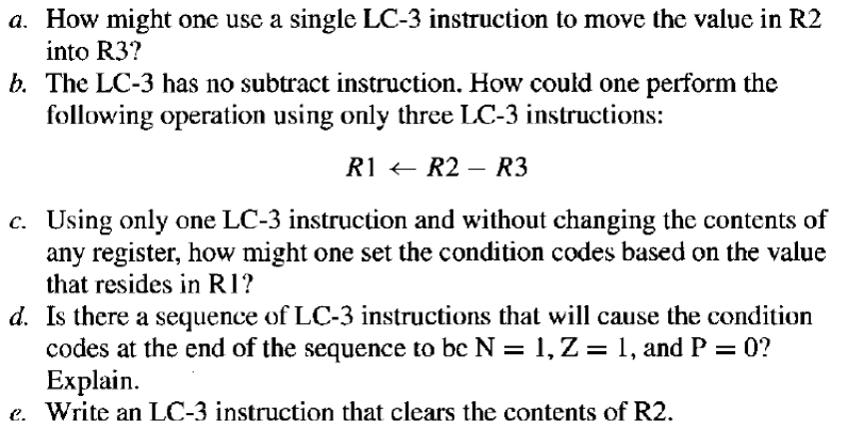

6.
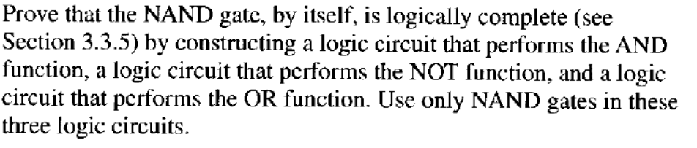

7.
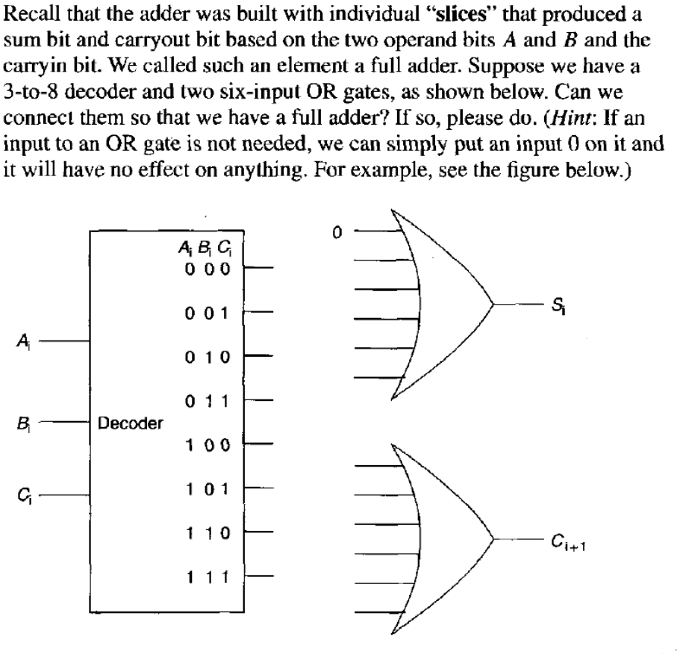

8.
Using n-type and p-type transistors

- Implement NOT gate
- Implement AND gate

9. List at least four key features that a debugger should provide.

10.
Construct a finite state machine that has as
- Inputs
- Clock
- Data
- Output
- Out which is “1” when the number of “1”’s in Data is even, “0” otherwise.
You should construct the finite state machine using two states (i.e., 1 bit) give
- Truth table for the next state
- Truth table for Out
in the following format.

====================================================
|| Current state | Data || Next state | Out ||
=====================================================
|| 0 | 0 || □ | □ ||
|| 0 | 1 || □ | □ ||
|| 1 | 0 || □ | □ ||
|| 1 | 1 || □ | □ ||
=====================================================

