1. SLAM (Simultaneous Localization and Mapping)

SLAM consists of 4 main nodes running on the ROS environment.

- realsense2_camera
- imu_filter_madgwick
- rtabmap_ros
- robot_localization
The realsense2_camera node is a part of the ROS wrapper for the used Intel RealSense cameras (https://github.com/IntelRealSense/realsense-ros). It controls the communication between the PC and the camera itself. This node publishes topics with the raw camera data. The other nodes subscribe to the realsense2_camera topics in order to get access to the raw data and to do the further computation.
Running SLAM on one single device is very straight forward. You have to start all 4 nodes via one single launch file “opensource_tracking.launch”. This launch file will also automatically launch the rviz visualization tool. You can turn the automatic rviz launch off by going into to opensource_tracking.launch file and changing the argument rviz value into false.
Our approach is to forward all important information from one or multiple devices with connected RealSense cameras (slave device) to one central control unit (master device). In the ROS environment this is very simply done. Basically you just have to specify the master IP address on all slave devices. The nodes on the slave devices will automatically publish there topics to the master. As a connection between master and slave we tested Ethernet and WLAN. (https://github.com/ut-ims-robotics/tutorials/wiki/Running-ROS-over-multiple-computers)
In order to get SLAM running on multiple devices we created a new launch file for the realsense2_camera node which runs on the slave. This launch file only consists of a exact copy of a part of the opensource_tracking.launch file. On the master you can run the opensource-tracking.launch file with an additional argument which turns the launch of the realsense2_camera node off. This way all the computation is centralized on the master while the slave forwards the raw data.

2. Commands

- Setup ROS on multiple devices

- In every new terminal on the slave specify the ROS Master

export ROS_MASTER_URI=http://<IP-Address>:11311

- In case you set up a new connection between master and slave specify on each machine its own IP-Address

export ROS_IP=<IP-Address>

- On the slave change the “hosts” file by adding the following line in the format of
“mastersIpAddress mastersName”

sudo gedit /etc/hosts

- Start SLAM

- Specify the masters own IP-Address on the master and run the roscore on the master

export ROS_MASTER_URI=http://<IP-Address>:11311
roscore
- Run the commands in the folder of the launchfile

- Camera node on slave

roslaunch slave.launch

- Start computation nodes on the master

roslaunch opensource_tracking.launch offline:=true

- Recording into bag file

Run the following command on the computer with the running computation nodes on it

rosbag record -O my_bagfile_1.bag /camera/aligned_depth_to_color/camera_info camera/aligned_depth_to_color/image_raw /camera/color/camera_info /camera/color/image_raw /camera/imu /camera/imu_info /tf_static

- Replay recorded bag files

Make sure you change in “/opt/ros/kinetic/share/realsense2_camera/launch/rs_camera.launch” the parameter compressed to false befor starting the replay. The recording itself can be done with compressed set to true.

roscore >/dev/null 2>&1 &
rosparam set use_sim_time true
rosbag play my_bagfile_1.bag --clock
roslaunch realsense2_camera opensource_tracking.launch offline:=true

- Localization

In order to use the Localization mode it is important that you did a normal SLAM run befor. After ending the SLAM run the created map will be stored automitcally. In order to start the localization mode use the command:

roslaunch realsense2_camera opensource_tracking.launch offline:=true loc:=true

In Rviz you have to select MapCloud and click on “Download map”. This will load the previously created map. Now rtabmap search for a loop closure in order to combine its new created map with the older downloaded map.

3. Optimization Settings

3.1 Change Resolution and Frame Rate

On the slave you can change in “/opt/ros/kinetic/share/realsense2_camera/launch/rs_camera.launch” the parameters depth_width, depth_height, color_width, color_height as well as depth_fps and color_fps to one of the following settings (Intel RealSense D435i) in order to get performance improvements:

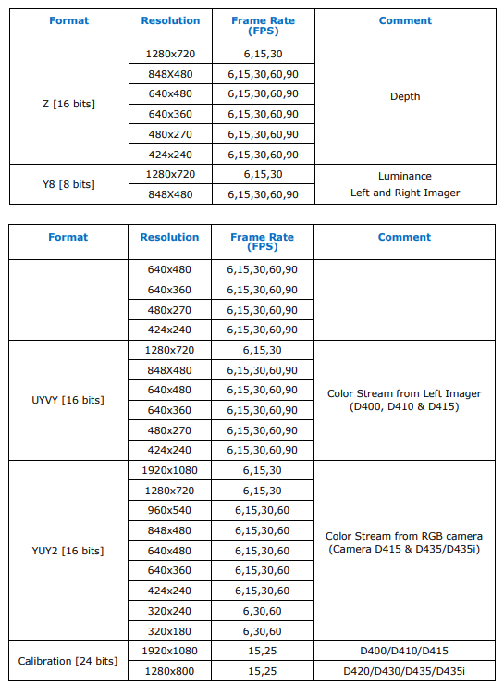

3.2 Change Queue Size

On the Master you can change in “/opt/ros/kinetic/share/rtabmap_ros/launch/rtabmap.launch” the parameter queue_size. It depends where the camera node is running and over which medium the data is sent to the master. For WLAN a queue size of 100 or above seems to work fine. When Ethernet is used you can go down.

3.3 Use compressed Topics

In order to reduce the bandwidth and increase the performance you can go to “/opt/ros/kinetic/share/rtabmap_ros/launch/rtabmap.launch” and change the parameter compressed to true. This has an heavy impact. In the current setup you can reduce the used bandwidth from 2,1 Mbyte/s to 180Kbyte/s. Also the rtabmap computation seems to work smoother.

3.4 Change Detection Rate

In “/opt/ros/kinetic/share/rtabmap_ros/launch/rtabmap.launch” the parameter DetectionRate can be configured. Default is 1Hz which means the Map is updated every second. It seems that a higher DetectionRate gives better results.

1. Computation nodes on Slave

- Master only subscribes to topics of interest f.e. rtabmap/cloud_map
- In this case rviz node runs on the master and subscribes to rtabmap/cloud_map

1.1 WLAN

- iperf bandwidth between Master and Slave ca. 20Mbits/s

 | CPU | RAM in Mb | Connection Bandwidth
Master | 4% | 40 (Only Rviz) | TX 40KBit/s  RX 320KBit/s
Slave | 40% | 130

1.2 Ethernet

- iperf bandwidth between Master and Slave ca. 715Mbit/s

 | CPU | RAM in Mb | Connection Bandwidth
Master | 4% | 60 (Only Rviz ) | TX 150KBit/s  RX 420KBit/s
Slave | 40% | 150

2. Computation nodes on Master (Calculation on Master)

2.1 WLAN

- iperf bandwidth between Master and Slave ca. 20Mbits/s

 | CPU | RAM in MB | Connection Bandwidth
Master | 7-9% | 100 | TX 240KBit/s  RX 24MBit/s
Slave | 12% | 85

2.2 Ethernet

- iperf bandwidth between Master and Slave ca. 715Mbit/s

 | CPU | RAM in Mb | Connection Bandwidth
Master | 30% | 100 | TX 2MBit/s  RX 680MB/s
Slave | 10% | 90

