ROS 2 - How to run RTABMAP?

Installation

As a operating system Ubuntu 18.04 is required. The recommended RAM size is 8GB. When you have only 4GB you should create a SWAP file with at least 2GB. An installation script for x86 architectures is provided in the Google Drive Lidar folder. It is possible that it will not run through correctly. In that case follow the following instructions step by step in the right order:
- https://github.com/IntelRealSense/realsense-ros/tree/eloquent
- Step 2: Install librealsense2 → Install from Debian Debian Package
- You can check if the installation of Step2: Install librealsese2 was succesfull by running “realsense-viewer”
- https://docs.ros.org/en/eloquent/Installation/Linux-Development-Setup.html
- Get ROS 2 code → Do not create a new directory! Just go into the in 1. creates ros2_ws directory
- Build the code in the workspace→ colcon build command will need a lot of resources. Therefor you can use the following options. Append the colcon build command with “--executor sequential” or run in advance “export MAKEFLAGS=”-j1 -l1”
- https://github.com/introlab/rtabmap_ros/tree/ros2#rtabmap_ros
- “make -j4” → use -j1 if it fails
- before colcon build → download additionaly needed packages run:
◦ cd ~/ros2_was/src
◦ git clone --branch eloquent-devel https://github.com/ros-perception/perception_pcl.git
◦ git clone --branch ros2 https://github.com/ros-perception/pcl_msgs.git
◦ git clone --branch eloquent https://github.com/ros-perception/vision_opencv.git
- instead of colcon build → run:
◦ MAKEFLAGS="-j1 -l1" colcon build --packages-up-to rviz_common -- symlink-install
◦ . ~/ros2_ws/src/install/setup.bash
◦ MAKEFLAGS="-j1 -l1" colcon build --packages-up-to rviz_default_plugins --symlink-install
◦ . ~/ros2_ws/src/install/setup.bash
◦ MAKEFLAGS="-j1 -l1" colcon build --packages-up-to rtabmap_ros --symlink-install
◦ . ~/ros2_ws/src/install/setup.bash
In case you use a Raspberry Pi 4 replace Step 2 with the instructions from here
“https://github.com/acrobotic/Ai_Demos_Rpi/wiki/Raspberry-Pi-4-and-Intel-RealSense-D435”.
Also notice that on every new terminal you have to run “. install/setup.bash” inside the ros2_ws directory in order to run ros2 commands.

Running RTAB Map and Camera Nodes on different PC
Camera Node

Google Drive → rs_launch.py → place file into “/home/nuc/ros2_ws/install/realsense2_camera/share/realsense2_camera/launch”
Start Camera Node:
ros2 launch realsense2_camera rs_launch.py
In the mentioned file you can change the resolution and fps of the desired camera streams. For our purpose only depth and image topics are relevant. It is important that the align_depth option is set to true.
RGBD_Sync Node
Google Drive → rgbd_sync.launch.py → place file into /home/nuc/ros2_ws/install/rtabmap_ros/share/rtabmap_ros/launch
Start RGBD_Sync Node:
ros2 launch rtabmap_ros rgbd_sync.launch.py
Run this node on the same PC as the camera node. This ensures a better synchronization of depth and image streams. The compressed method of this node does not seem to work properly. Compression would allow us to heavily reduce the used bandwidth.
RTAB-Map Node
Google Drive → rtabmap.launch.py → place file into /home/nuc/ros2_ws/install/rtabmap_ros/share/rtabmap_ros/launch
Start RGBD_Sync Node:
ros2 launch rtabmap_ros rtabmap.launch.py

Run this node on any other PC in the same network as the Camera Node PC. Due to the usage of ROS 2 no additional IP address specifying is needed. When you call this launch file two different nodes will start up. Odometry and RTAB-Map. Odometry will subscribe onto the synchronized depth and image topic (“\rgbd_image”). It uses the Visual Odometry method. It will try to localize the incoming pictures relative to the the last keyframe (F2F) or to a local map of features (F2M). The odometry thread doesn't have a rate parameter, as it just try to process received images as fast as possible (yes, it will use 100% of a CPU if the camera rate is higher than the time to compute odometry). For example running all nodes on the Raspberry Pi 4 we can achieve a odom rate of ca. 5 Hz using ca. 100% CPU usage while our rgbd_image topic has a rate of ca. 20Hz. When we forward the rgbd_image to a computer with better CPU performance we achieve a odom rate of 25Hz (Higher than rgbd_image??) using ca. 60% CPU usage. To reduce Odometry CPU usage, you may reduce the camera rate at the cost of less good odometry. The RTAB-Map node will than use the rgbd_image as well as the odom information for updating the map and publishing it to the topic /mapData. The detection rate in which this map can be uploaded can not be higher than the rate in which the other topics are published. In addition to that the detection rate is dependent on the CPU. All of those parameters and many more can be set in the following file:

“.../rtabmap/corelib/include/rtabmap/core/Parameters.h”
After changing a parameter you have to remake the whole library. Therfore repeat the steps from Installation Step 3:
RTAB-Map library:
$ cd ~
$ git clone https://github.com/introlab/rtabmap.git rtabmap
$ cd rtabmap/build
$ cmake ..
$ make -j4
$ sudo make install
$ sudo ldconfig
Whole Topology
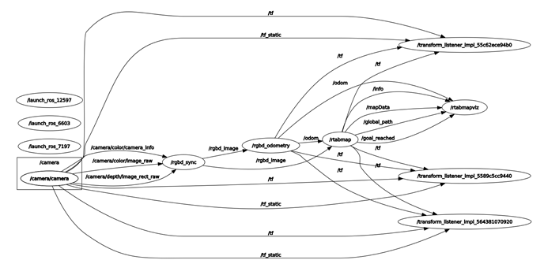

Useful tools

Always use “. install/setup.bash” inside the ros2_ws directory first!
• ros2 topic list
- Prints out all available topics
• rqt_graph
- Graphical representaion of all nodes and published/subscribed topics
• ros2 topic hz topic_name
- Prints the published rate of a specified topic
- Normally used on the same PC which publishes the topic of interest. When it is used on a other PC the topic will be published to it again which leads to a increase of bandwidth usage no matter if it is already subscribed on this PC
• ros2 topic echo topic_name
- Prints the published data of a specified topic

