simr : an R Package for Power Analysis of Linear Mixed Models by Simulation

Introduction

Why we want to do power analysis.

If we are going to invest in the collection of monitoring data, it is important that we know that our design is suitable for making the inferences we need. Does the design have sufficient power to detect what we are trying to find? Are our parameter estimates going to be precise enough for our purposes?
When the design is complicated, e.g. in a mixed-effects model, simulation provides a general way of answering these questions. The simr package provides tools that make it simple to set up and run simulation experiments.
Need to make sure our monitoring programme can find what we’re looking for.
Want our study to be cost effective.
Talk about Field’s stuff on power analysis.

What simr does.
With simr you can perform a power analysis based on a linear mixed model fitted with the lmer command in the lme4 package. You can also use linear models fitted with lm from base R. This is not strictly necessary, but allow for a shallower learning curve, especially since these models can be fitted much faster than mixed models.
This paper runs through two tutorials. The first uses lm and guides the user through a very simple posthoc power analysis. The second uses lmer and uses some of the more flexible features of the package.

Why we’re using mixed models.
Linear mixed models allow us to model the random variation among units as well as the effect of explanatory variables [Bolker 2008].

Why we want to use simulation.
Simulation is a general procedure for determining the properties of a statistical method or design [ref]. With simulation we do not need to find an analytical approach specialised to our particular analysis, and we do not need to rely on an approximation that may not be robust to departures from its assumptions. This can be especially important with mixed models where the sampling distributions of parameter estimates are difficult to work with [ref Bates?].

Why we need an R package.
Simulation studies can be difficult or time consuming to set up. They would normally involve some degree of programming by the investigator. Depending on their comfort level, this might be beyond their current ability or might simply take longer than they might like.
Usually done with a one-off script [ref simFrame] – coordination btw researchers (replication?)
Having a ready-made package available could make power analyses accessible to a wider range of scientists. Investigators who might otherwise be limited to fitting a model in R [ref] could supplement their study with a power analysis without much additional effort. For scientists comfortable with R coding, a turnkey package could save them time and let them focus their efforts on a more advanced analysis.

Other packages
longpower [ref] uses an analytical approximation [describe, ref] to calculate power for longitudinal studies. [include calculations as an option in simr?]. pamm is a package for doing similar simulations, but with a restricted set of models [ref]. Packages simSummary [ref] and simFrame [ref]

Tutorial One: Post-hoc power analysis.

The example dataset has response variable y measured at ten levels of the explanatory variable x for three groups g.

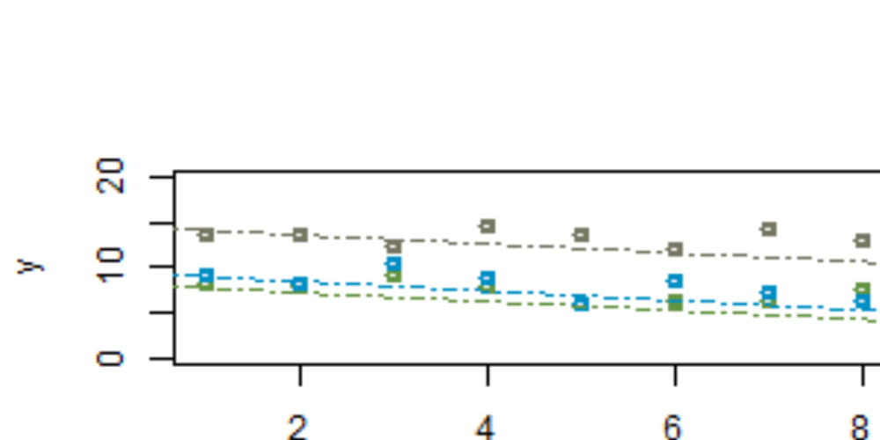
We can fit a simple random intercepts model as follows
library(simr) # note that this will also load lme4
fit <- lmer(y ~ x + g, data=example)
Figure [one?] shows a scatterplot of the data with these fitted lines. If we were to repeat this experiment, what would be our power to detect a trend this size?
power(fit)

- Fit a model.
- Modify the model’s parameters.
- Simulate from the model.
- Analyse the simulated data.
- Plot a power curve.

Tutorial Two: Calculate a power curve
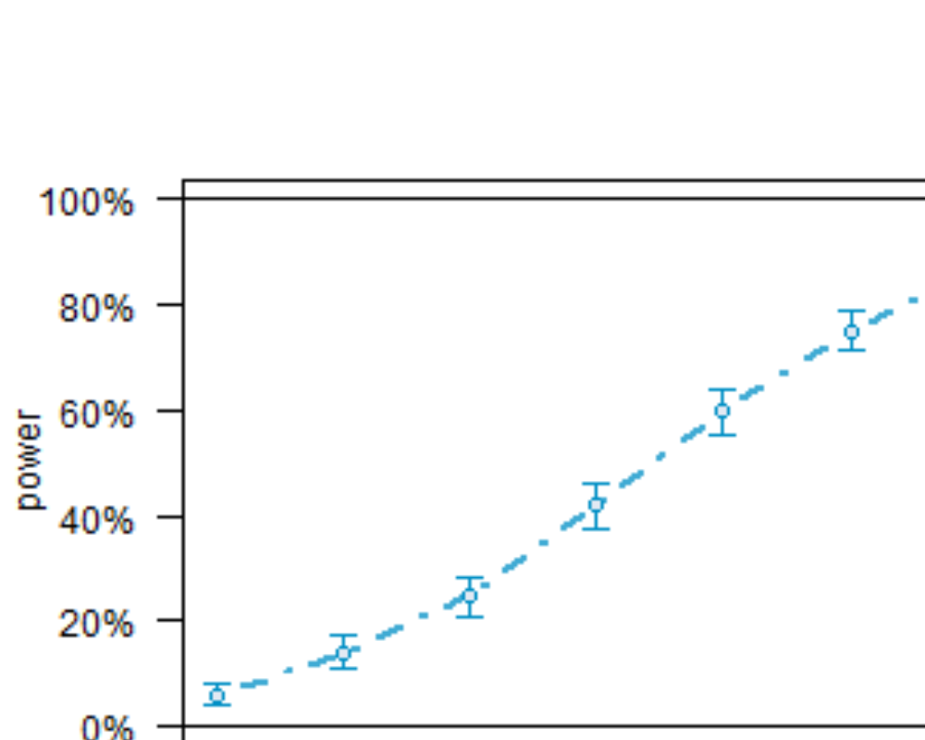

Tutorial Three: Specify the sample and effect sizes.
- Fit a linear mixed model with lmer.
- Adjust the parameters.
- Simulate from the model.
- Analyse the simulated data (in parallel if available).
- Plot some more power curves.
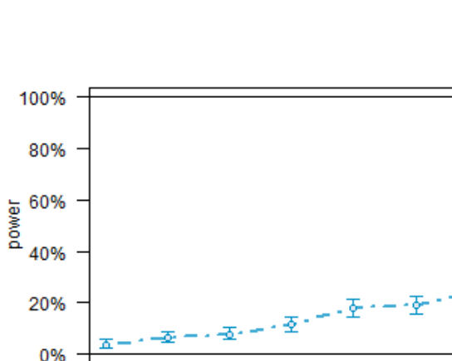
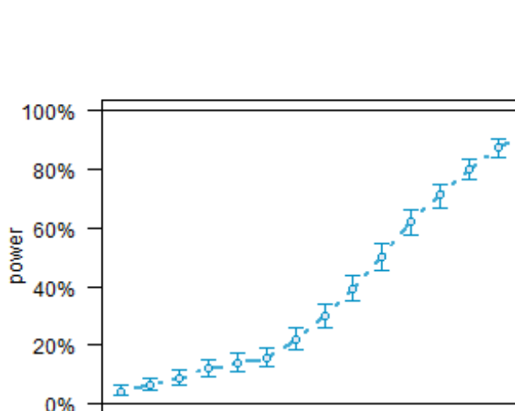

Tutorial Four: Include Type I error calculations.

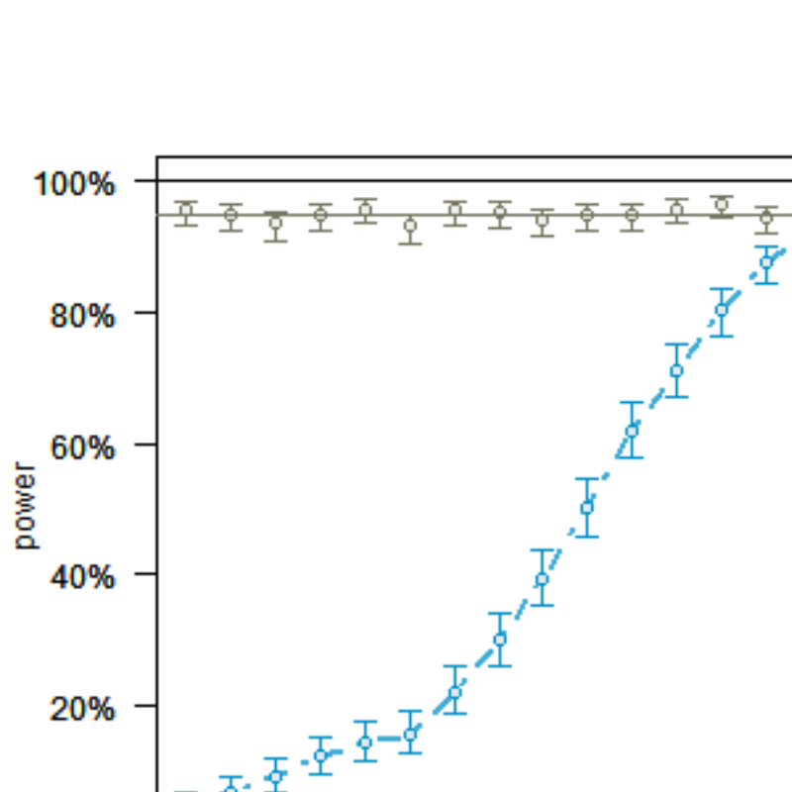

Further Work.

As currently implemented, simr uses data from a pilot study to inform the power analysis, with the structure of the pilot data providing defaults for the simulation settings. Future versions will also include the ability to create data sets from scratch; this will not require a pilot study, but will require some domain expertise to select sensible parameters.
Version 1.0 of simr is designed for linear mixed models using lmer in lme4. The next version will add support for generalised linear models (glm in base) and generalised linear mixed models (glmm in lme4). At some point tools will be added to make it simple to create interfaces to arbitrary R packages.

