

**LRFD T**

**LUGAZI RURAL FINANCE DEVELOPMENT TRUST [LRFDT]**

**P.O. BOX 101, LUGAZI E-MAIL:** [**l****ugazirfdt@gmail.com**](mailto:lugazirfdt@gmail.com) **TEL: +256704372685/+267772697875**

**STAFF CAPACITY BUILDING**

**Saturday 16th Sept. 2023**

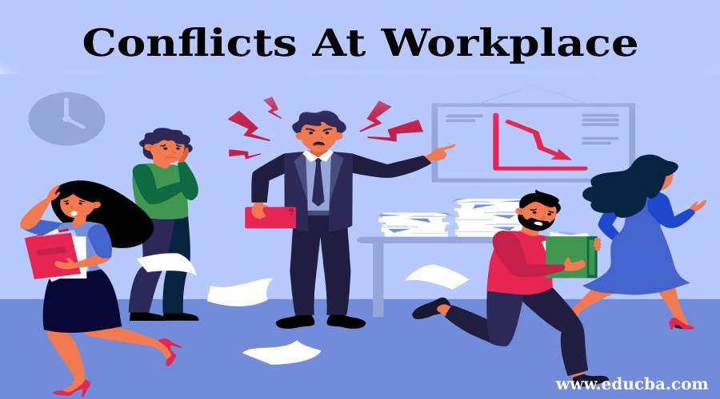**PREVENTING CONFLICTS AT WORKPLACES**

**What happens when the boss arrives?**

**What is a conflict?**

Conflict can be defined as a serious disagreement and argument about something important.

**Causes of conflicts at work places**

There are several causes of conflicts at work places, but the following stand out

1. **poor management.**

Poor management creates a negative impact on employees and the organization, examples of poor management include

* Micro management.
* Unwilling to listen or adjust
* Failure to put to use employees’ skills
* Poor communication skills
* Poor/unfair facilitation
* Failure to work with your juniors but instead make them work for you
* Building the institution and demotivate human resource
* Spot-on supervisions



**Results of poor management - Killing the Team spirit by Dividing it**

1. **Unfair Treatment.**

This can be in many forms such as;

* Belittling your juniors in the presence of others
* Keeping staff in fear of losing their jobs
* Unfair comparisons
* paying differently employees with the same job description
* unfair/discriminating disciplinary measures
* Too much criticisms
* Dismissing an employee without a fair disciplinary process.
* Firing or laying off older workers for the organization to hire younger, cheaper workers to do their jobs with lower pay



**Results of fair and poor Facilitation**

1. **Unclear job roles**

This is a situation where everyone is engaged and busy with work, but some employees are left idle with no room of helping those who are busy.

* When new recruits are not shown what to do



**In a Confusion state of what to and not to do**

1. **Inadequate Training**

Learning on job at times is inevitable, but such employees should be given resourceful supervisors to guide them instead of leaving them on their own and blame them in cases of mistakes.

It is true that at some point in time during project implementation, you may lack time for training yet there is a gap to fill. In such a situation, if any employee is recruited, an orientation of the entire staff must be conducted before the new employee is exposed to the institution environment by him/herself.

**Different wave lengths, different frequency**



**Same wave lengths, same frequency**

1. **poor communication.**

This a disconnect between what is said and what is understood.

Leaders with poor communication skills often fail to acknowledge and congratulate employees when they exceed expectations but are the first to criticize them when they don't. Focusing on the negative will lead top-performing employees to feel unvalued by their organization, and to seek employment with an organization who will.



**Comment on the picture.....**

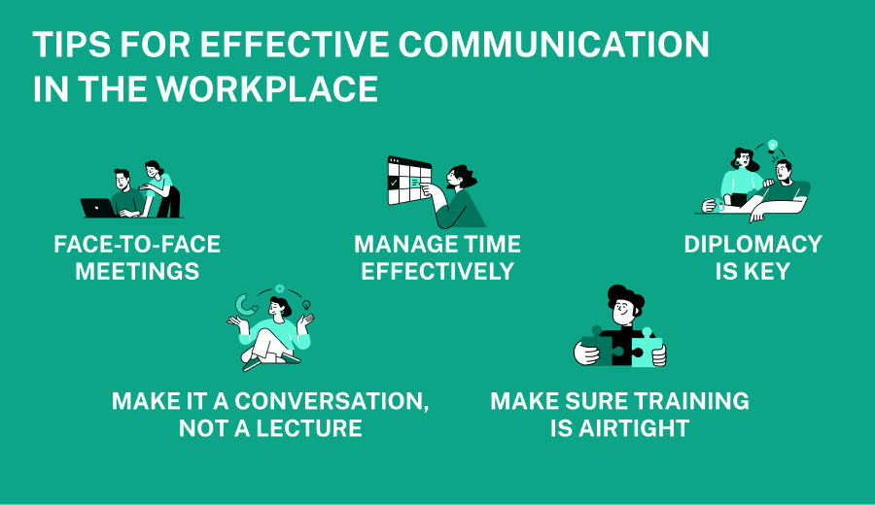

1. **poor work environment.**

A poor workplace environment can include a lack of motivation, unfair competition, lots of workplace politics, harassment by coworkers, unusually high stress, lack of recognition for achievements. If employees feel unsafe or uncomfortable, this can lead to reduced morale and productivity and ultimately to employee resignations or lawsuits filed against the workplace.



**What do you see in the picture?**

Improving the workplace environment is an ongoing process, especially if it has been poor for a while. Some measures that might help include:

* Encouraging healthy competition by introducing performance-based rewards.
* Tackling politics at the management level
* Introducing initiatives to help workers manage stress
* Implementing strong policies to prevent harassment and discrimination
* Creating a simple process for employees to express concerns and file complaints about any issues

It’s important to remember that any efforts to improve your workplace environment starts with the leadership team. A strong set of company values and a clear vision help employees feel a part of the bigger picture. So, the organization’s leadership team should first establish these and then model and communicate them to the rest of the organization.

**PREVENTING WORKPLACE CONFLICTS**

1. Being positive
2. Give clear job descriptions
3. Communicating respectfully
4. Knowing what is important
5. Fair and equal treatment of staff
6. Constant staff orientation and capacity building
7. Acting faster
8. Conduct exit interviews
9. Improve the working environment
10. Avoid carrying your personal problems to work places

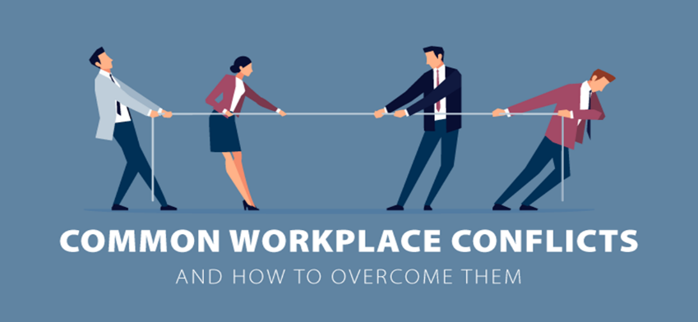

**Presented By**

………………………………….

**MBOGGA ROBERT**

**ORGANIZATION COORDINATOR**