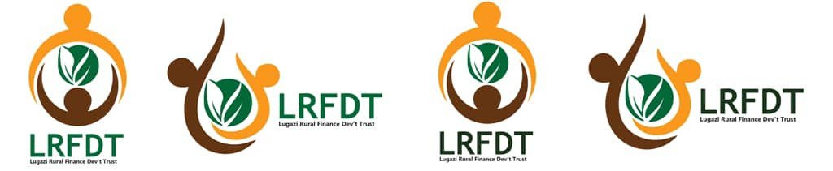 **LUGAZI RURAL FINANCE DEVELOPMENT TRUST [LRFDT]**

**P.O. BOX 101, LUGAZI TEL: +256704372685/+267772697875**

**E-MAIL:** [lugazirfdt@gmail.com](mailto:lugazirfdt@gmail.com) Website:

**STAFF CAPACITY BUILDING**

**Saturday 27th Jan. 2024**

**TOPIC: HUMAN RESOURCE MANAGEMENT**

***A calm working environment will improve wellness, reduce absenteeism, and increase productivity. With such compelling benefits, introducing calmness into the working day should be a priority.***

In an organization set up, the human resource Department is entirely responsible for this

**What is human resource management (HRM)?**

Human Resource Management (HRM) is the practice of recruiting, hiring, deploying and managing an organization's employees.

HRM is employee management with an emphasis on employees as assets of the business. As with other business assets, the goal is to make effective use of employees, reducing risk and maximizing return on investment.

**The importance of HRM**

The purpose of HRM practices is to **manage the people within a workplace to achieve the organization's mission and reinforce the**[**corporate culture**](https://www.techtarget.com/whatis/definition/corporate-culture)**.**

When people management is done effectively, HR managers can help recruit new employees who have the skills to further the company's goals. HR managers also aid in the training and professional development of employees to meet the organization's objectives.

**Objectives of human resource management**

HRM can be broken down into the following four category objectives:

1. **Societal objectives.**These are measures put in place to respond to the ethical and social needs or challenges of the company and its employees. This includes legal issues such as equal opportunity and equal pay for equal work.
2. **Organizational objectives.** These are actions taken to ensure organizational efficiency, including providing the appropriate training, hiring the right number of employees for a given task and maintaining high [employee retention](https://www.techtarget.com/searchhrsoftware/definition/employee-retention) rates.
3. **Functional objectives.** These are the guidelines used to keep HR functioning properly within the organization. They include ensuring all HR resources are allocated to their full potential.
4. **Personal objectives.** These are the resources used to support the personal goals of each employee. They include opportunities for education and career development, as well as maintaining employee satisfaction.

**Can small businesses use HRM?**

Small businesses might have limited resources and a smaller workforce compared to larger companies, making HRM more difficult to implement. However, HRM principles and capabilities can be advantageous for small businesses in the following ways:

* **Effective hiring.** Small businesses can use HRM practices to identify and attract the right talent, ensuring each employee contributes significantly to the company's success.
* **Compliance.** Employment laws apply to businesses of all sizes. HRM can help small businesses navigate the complex legal landscape, reducing the risk of costly legal issues.
* **Employee development.** HRM encourages investment in employee development, which can give small businesses a competitive advantage. Carefully designed training and development programs enhance employee skills and contribute to the company's growth.
* **Conflict resolution.** Small teams are especially vulnerable to conflicts and disruptions. HRM practices provide structured methods to address and resolve conflicts and maintain a harmonious work environment.
* **Retention and engagement.**HRM helps small businesses with employee engagement reducing turnover and recruitment costs.
* **Strategic planning.** HRM aligns HR strategies with business goals.
* **Scalability.** As small businesses grow, their HR needs evolve. HRM practices can [scale](https://www.techtarget.com/searchdatacenter/definition/scalability) to accommodate changing workforce requirements and the demands of new organizational structures.

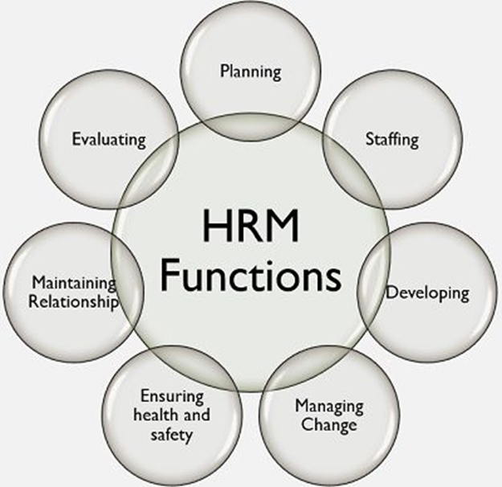

**Presented By**

………………………………….

**MBOGGA ROBERT**

**ORGANIZATION COORDINATOR**