Report: Optimising NYC Taxi Operations
Include your visualisations, analysis, results, insights, and outcomes. Explain your methodology and approach to the tasks. Add your conclusions to the sections.

Data Preparation
  - Loading the dataset
    - Sample the data and combine the files
All the trip files was uploaded in the google colab eda folder
an output path was defined and cleared any preexisting file
loop was run with each file as iteration
The record count was taken for each file.
dataframe was made from the file as per iteration
pickup_date and pickup_hour columns was added in the dataframe
sampled the data from datafram grouped by pickup_date and pickup_hour
sampled dataframe was then appended in a csv file in output path defined. The same loop was run for all all trip files.
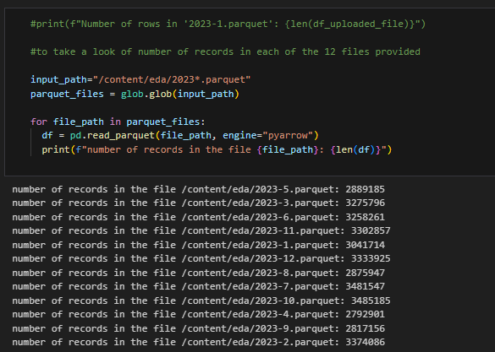
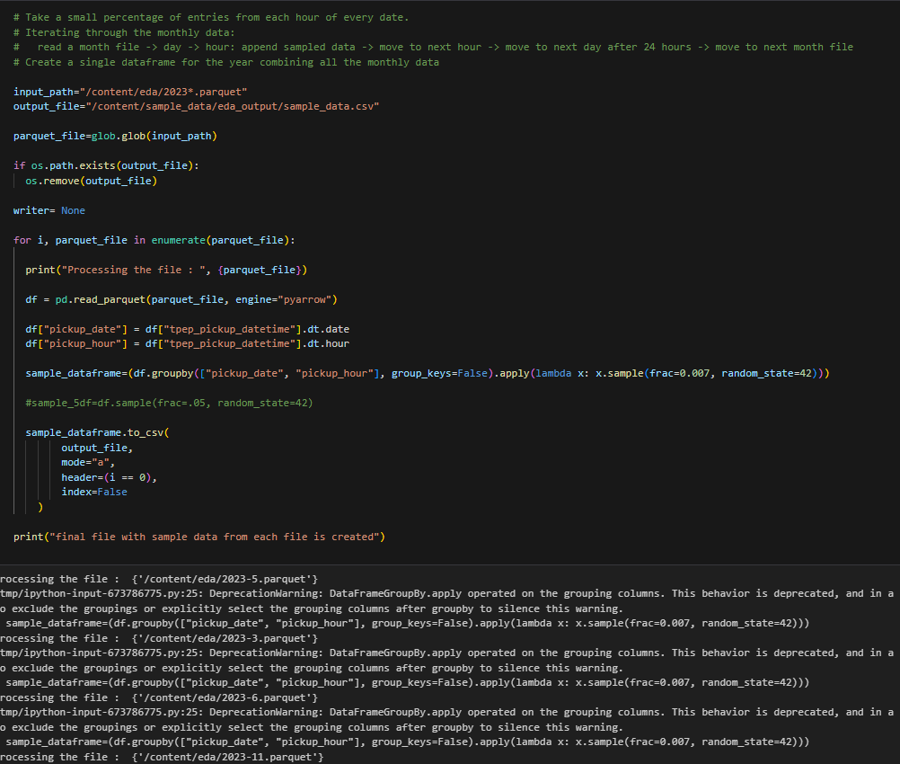

Data Cleaning

Fixing Columns
    - Fix the index
the data was clean initialy hence no action was taken to to perform data cleaning. At later point of time, if required, the data cleansing would be done.
    - Combine the two airport_fee columns
Based on the method used to read each file one at a time and sample the data .007 fraction at a time then writing the same into the csv file. This way the first file header is used in the csv file. we see that 2023-1.parquet file has airtpot_fee in small and all other files have Airport_fee. Hence the csv contains only Airport_fee column only. so no action is required to merge the columns and we see only 1 Airport_fee column created in the sampled data.
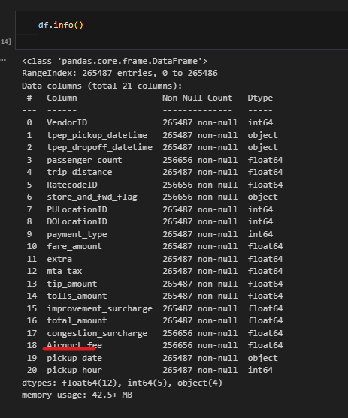

Handling Missing Values
    - Find the proportion of missing values in each column
Isnull function in dataframe was used to identify the missing values in each column of the dataframe. There was columnwise null values counted and then its percentage was derived on the total number of records in the column.
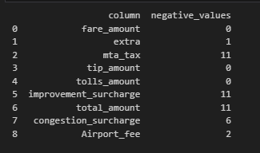
    - Handling missing values in passenger_count
Missing value in the passenger_count was replaced with MODE value of the passenger_count. The passenger_count is categorical variable hence the missing value is replaced with MODE value to maintain datasize and prevent algorithm errors.
passenger_count value 0 was replaced with 1 as minimum 1 passenger would be present in any ride.
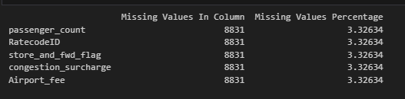
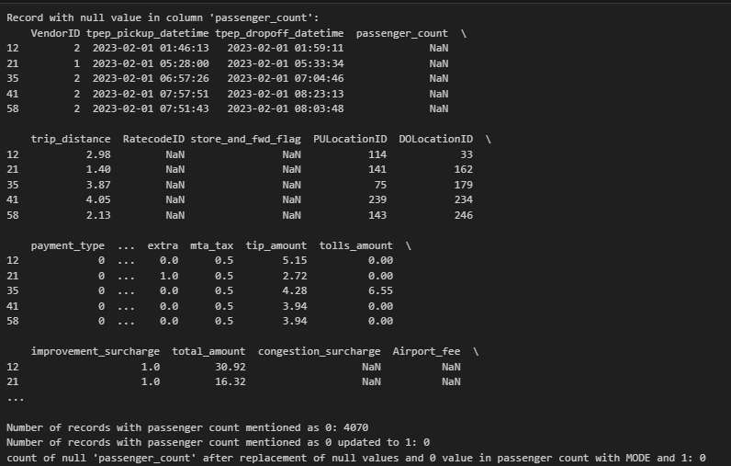
    - Handle missing values in RatecodeID
replacing the missing value in RateCodeId by MODE as it defines the mathematical support to replace the NULL values in the column.
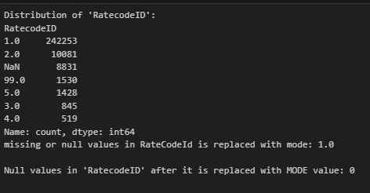
    - Impute NaN in congestion_surcharge
with respect to surcharge Nan may infer to no surcharge. hence it can be replaced with 0
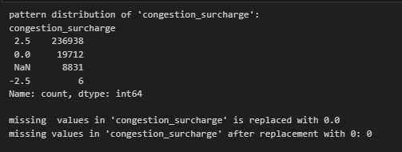

Handling Outliers and Standardising Values
    - Check outliers in payment type, trip distance and tip amount columns
count, mean, standard deviation, minimum, maximum and quartiles were calculated on the sample dataframe. 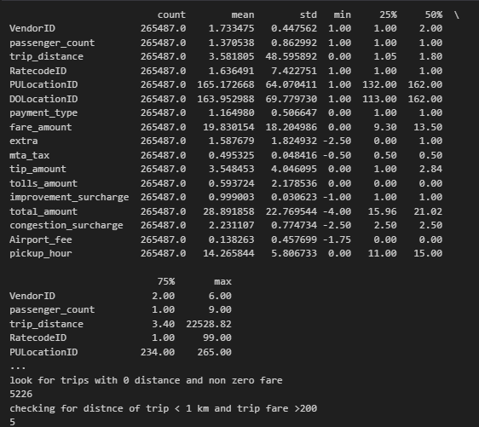

Exploratory Data Analysis

General EDA: Finding Patterns and Trends
Classify variables into categorical and numerical
Categorise the varaibles into Numerical or Categorical.

Categorise the varaibles into Numerical or Categorical.
VendorID: Categorical
tpep_pickup_datetime:Numerical
tpep_dropoff_datetime:Numerical
passenger_count:Numerical
trip_distance:Numerical
RatecodeID:Categorical
PULocationID:Categorical
DOLocationID:Categorical
payment_type:Categorical
pickup_hour:Categorical
trip_duration:Numerical
The following monetary parameters belong in the same category, is it categorical or numerical?
fare_amount - Numerical
extra - Numerical
mta_tax - Numerical
tip_amount - Numerical
tolls_amount - Numerical
improvement_surcharge - Numerical
total_amount - Numerical
congestion_surcharge - Numerical
airport_fee - Numerical
    - Analyse the distribution of taxi pickups by hours, days of the week, and months
The sampled data was analyzed for hourly pickup, trips distribution over the days of the week and month.
The dataframe was analyzed to identify the number of 0 in fare_amount, tip_amount, total-amount, trip-distance.
      - Filter out the zero/negative values in fares, distance and tips
Data with 0 as fare_amount, 0 as tip_amount and 0 as trip distance was removed from the dataframe.
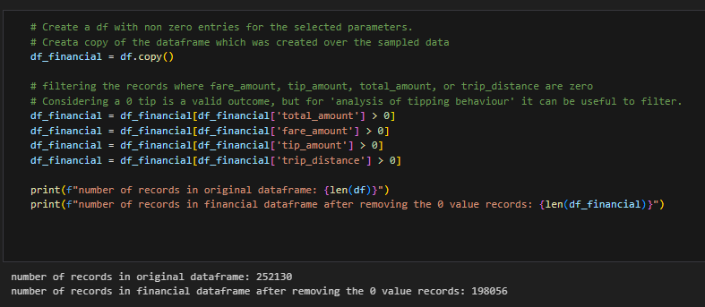
    - Analyse the monthly revenue trends
Bar chart was plotted to see the month wise revenue distribution.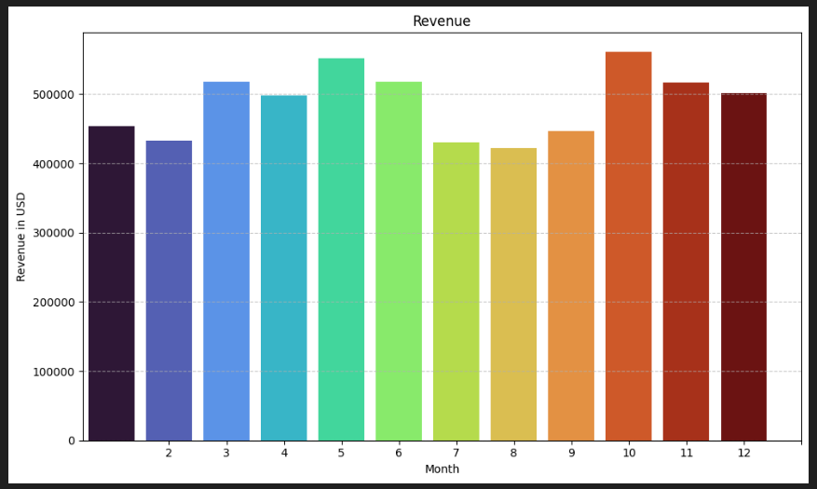
    - Find the proportion of each quarter’s revenue in the yearly revenue
Annual revenue spread over the quarter was plotted in a pie chart to see the % share in total revenue.
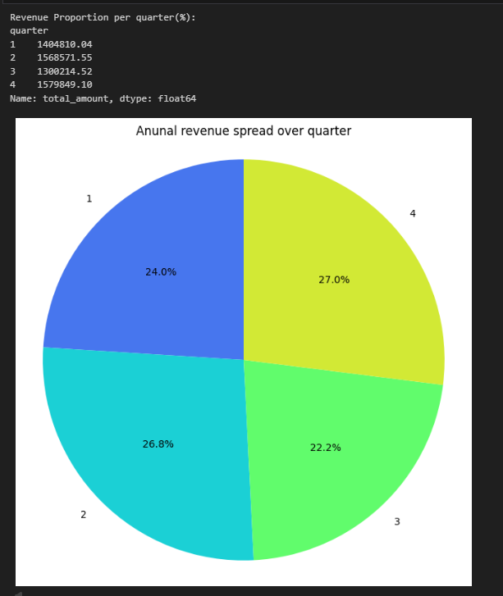
    - Analyse and visualise the relationship between distance and fare amount
distance vs fare was plotted and correlation was established to be .95
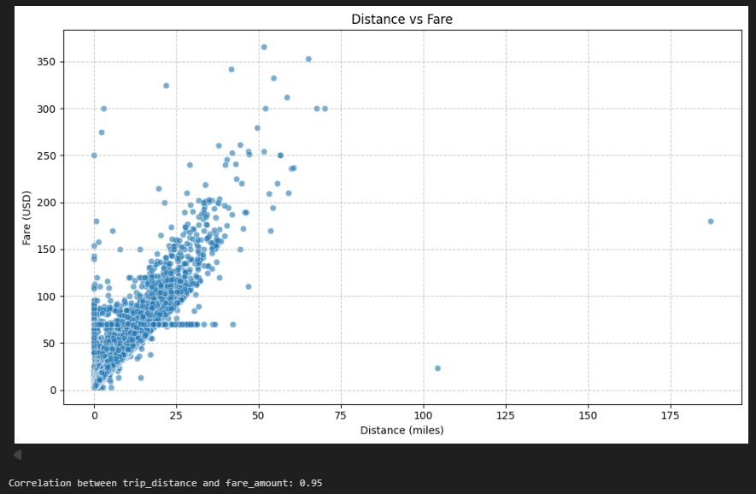
    - Analyse the relationship between fare/tips and trips/passengers
distance was plotted with tip value and a .8 correlation was found to exist
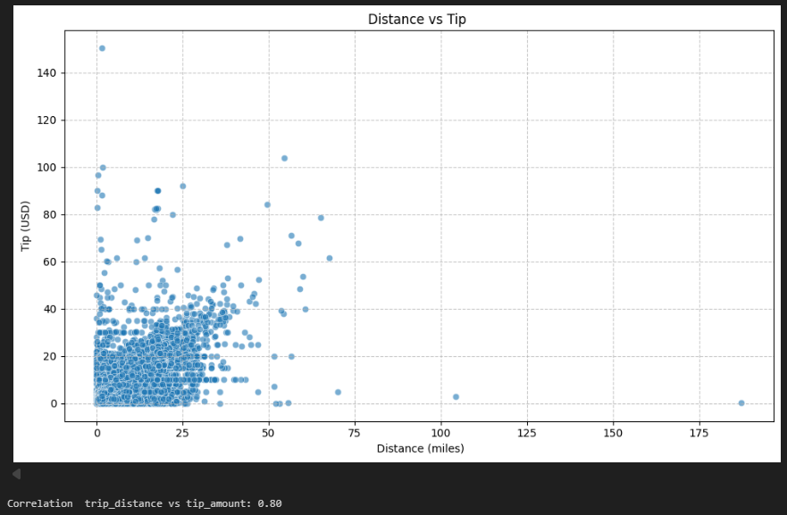
    - Analyse the distribution of different payment types
revenue with payment type was plotted in bar graph and an observation was made that most payments were made from credit card. Credit card came out to be most favorable method of payment.
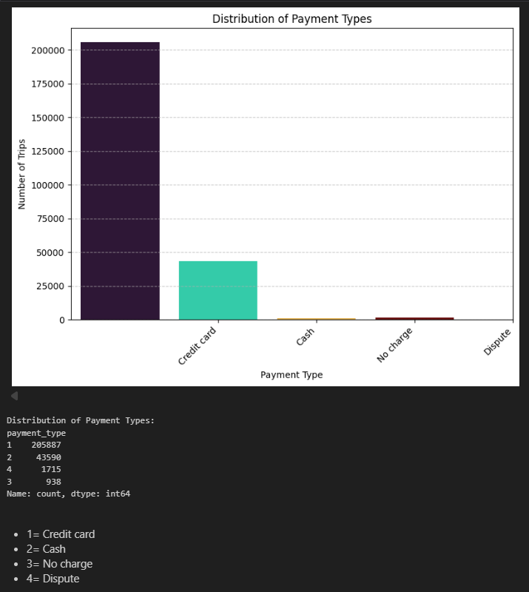
    - Load the taxi zones shapefile and display it
pickup zone wise dta was plotted to see the most favorable zone of pickup.
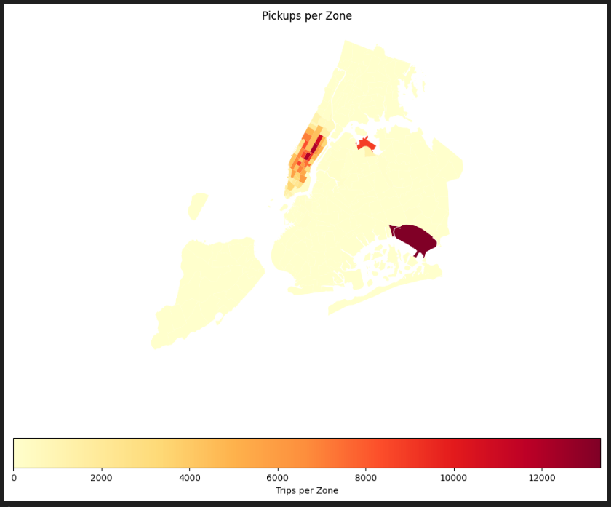
    - Merge the zone data with trips data
the trips data was merged with the zone data based on the locationId and PULocationID.
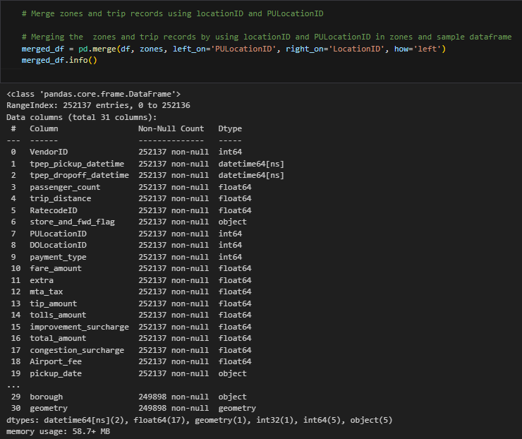
    - Find the number of trips for each zone/location ID
the number of trips with location id has been charted in descending order to see top 10 location id.
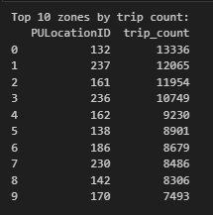
    - Add the number of trips for each zone to the zones dataframe
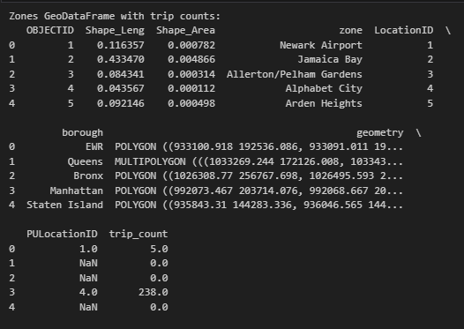
    - Plot a map of the zones showing number of trips
the heat map was plotted for the above ask
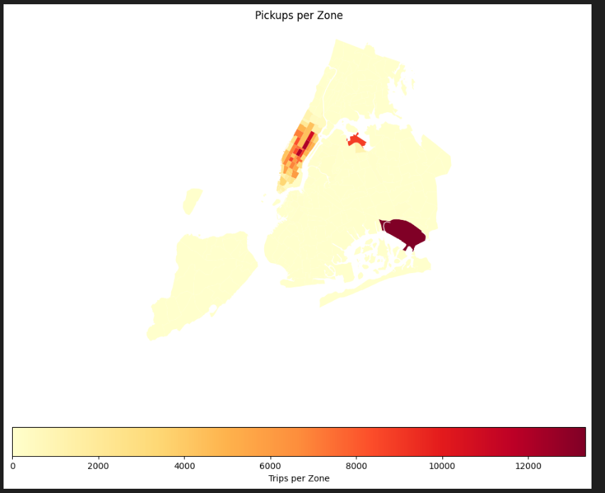
Conclude with results
* Busiest hours, days and months
Busy Hour – 2-7 PM
Busy Day – Fri/Sat/Sun forms the busiest days with trips
Busy Month – pickup count wise Mar/Apr/May/Jun/Oct/Nov/Dec forms the busiest month
* Trends in revenue collected
Revenue wise Mar/May/June/Oct/Nov gives high revenue. Plot attached above for reference and conclusion
* Trends in quarterly revenue
Q2 and Q4 contribute high towards revenue
* How fare depends on trip distance, trip duration and passenger counts
Based on the correlation chart of the distance vs fare we see that it is positively correlated.
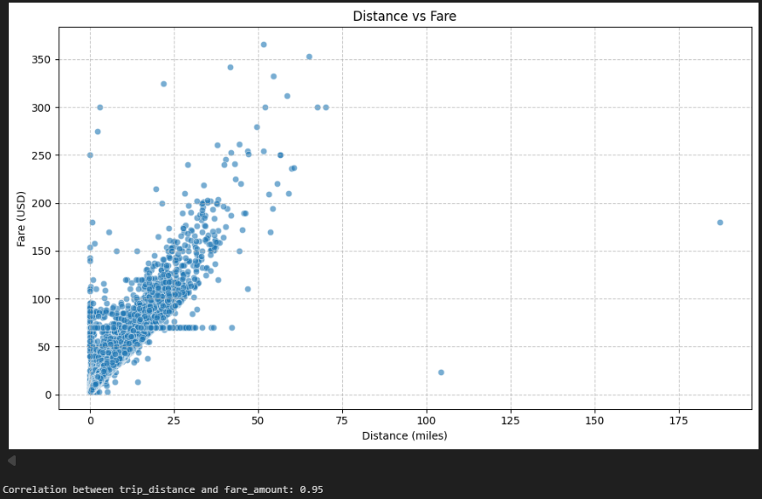
Based on the plot trip duration and fare a positive correlation was observed.
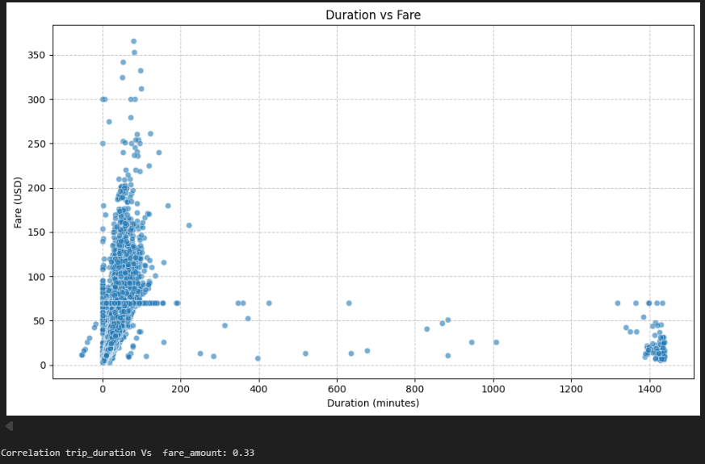
Based on the correlation between passenger count and fare amount, a very small correlation was observed.
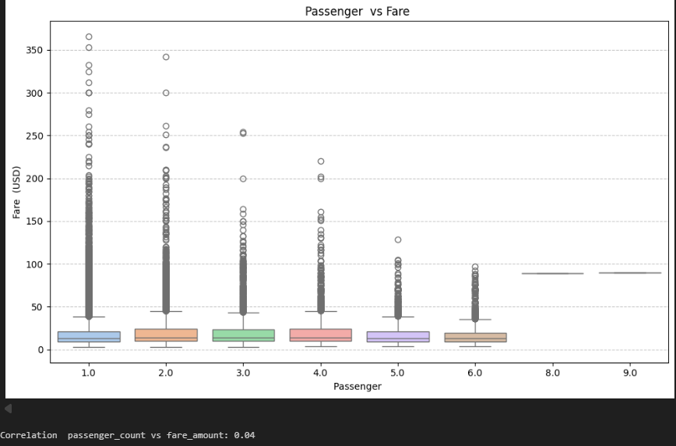
* How tip amount depends on trip distance
Plotting the trip distance with tip value we see a strong correlation between them. Short is the trip high is the tip given.
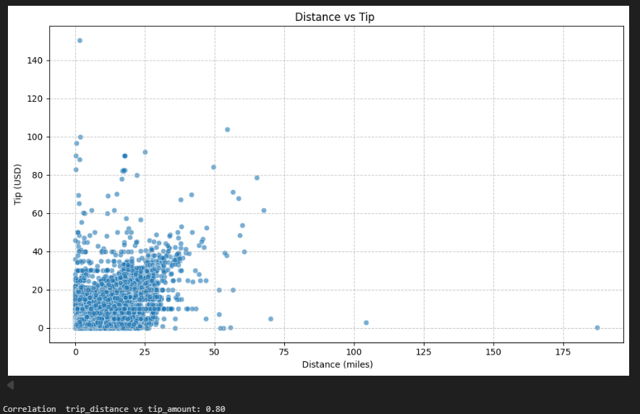
* Busiest zones
Heat map was plotted to get the busiest zone as per the pickup points.
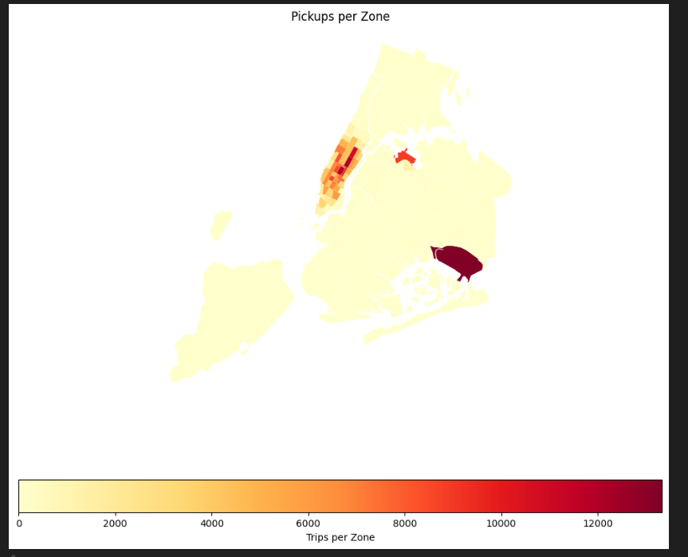

Detailed EDA: Insights and Strategies
    - Identify slow routes by comparing average speeds on different routes
route with the average speed was arranged in descending order to identify the slow moving routes.
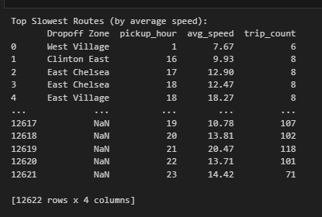
    - Calculate the hourly number of trips and identify the busy hours
based on the sampled data a bar graph was plotted to see the number of pickups and hour of the day. We find that 2-7 PM gets the maximum pickups in each day.
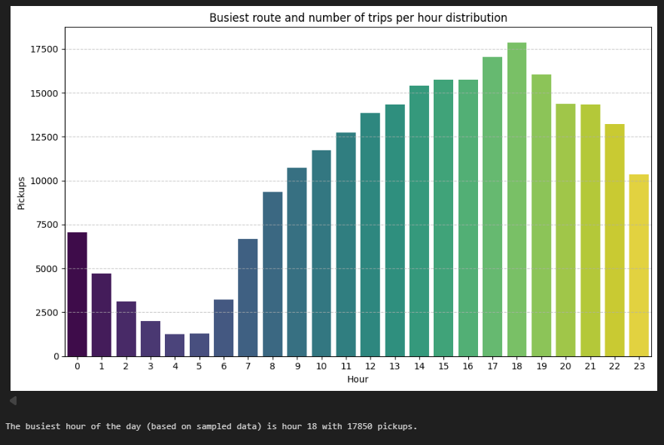
    - Scale up the number of trips from above to find the actual number of trips
Count of number of pickups was plotted against the hour of the day to identify the busiest hours.
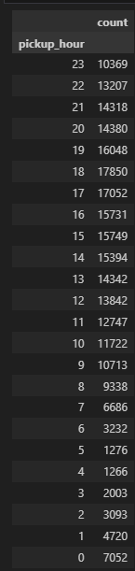
    - Compare hourly traffic on weekdays and weekends
based on the datavisualiztion, we see that the weekdays are busy compared to weekend. People sit back and relax ver the weekends and hence less pickup counts on weekday.
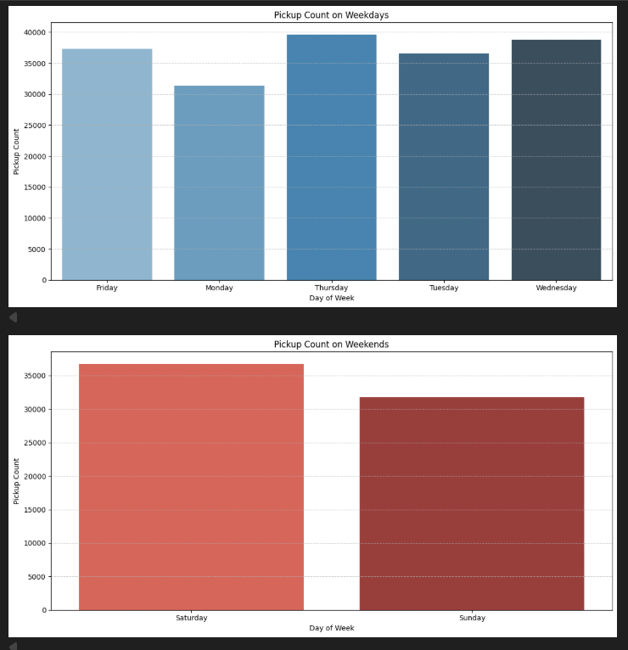
    - Identify the top 10 zones with high hourly pickups and drops
below table shows the relation between hourly pickup and drops
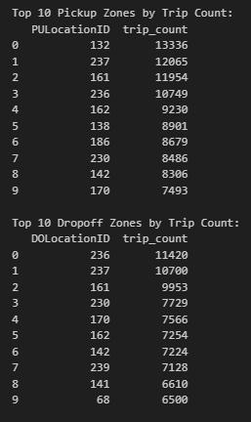
    - Find the ratio of pickups and dropoffs in each zone
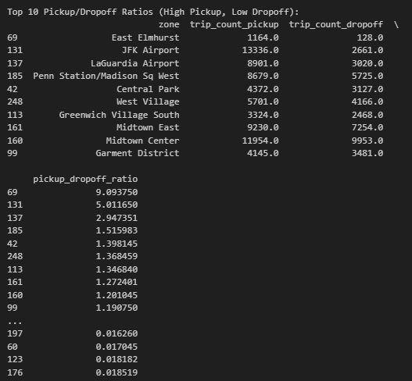
    - Identify the top zones with high traffic during night hours
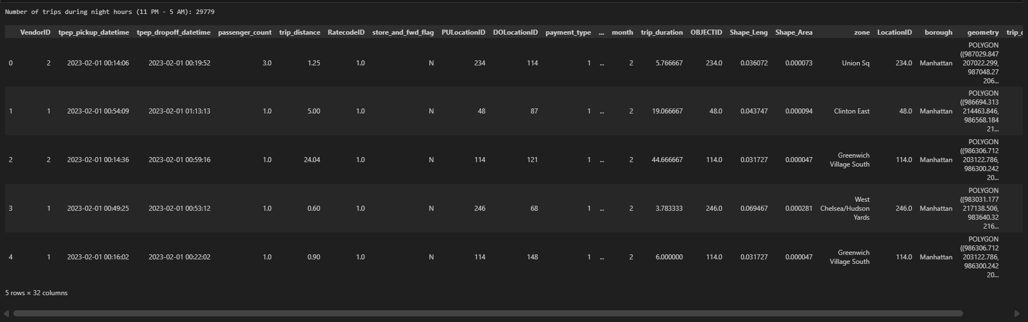
    - Find the revenue share for nighttime and daytime hours
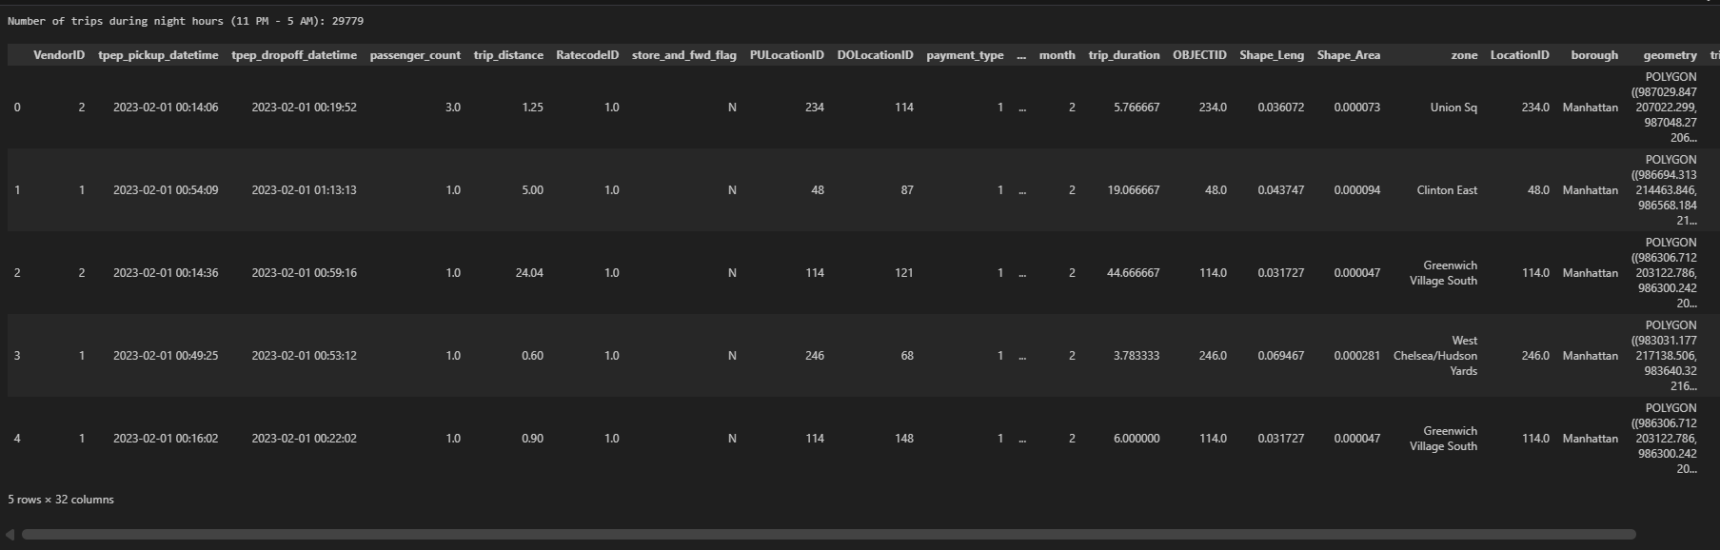
    - For the different passenger counts, find the average fare per mile per passenger
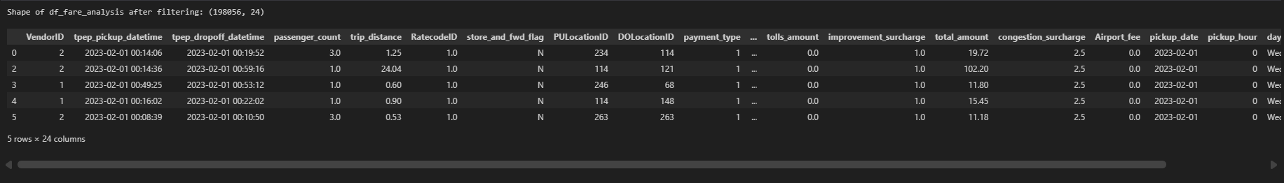
    - Find the average fare per mile by hours of the day and by days of the week
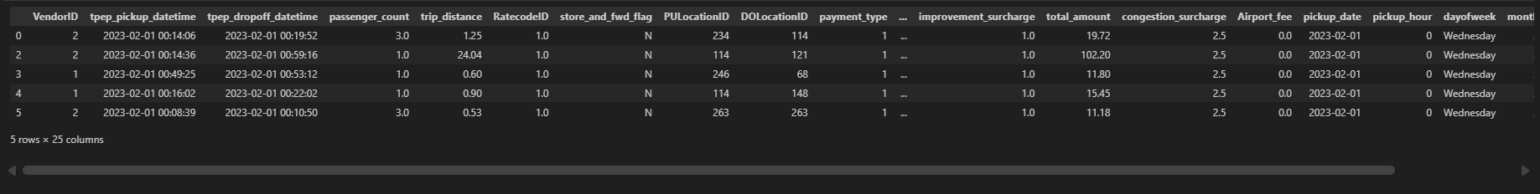
    - Analyse the average fare per mile for the different vendors
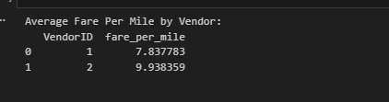
    - Compare the fare rates of different vendors in a distance-tiered fashion
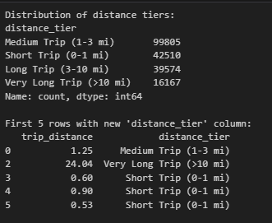
    - Analyse the tip percentages
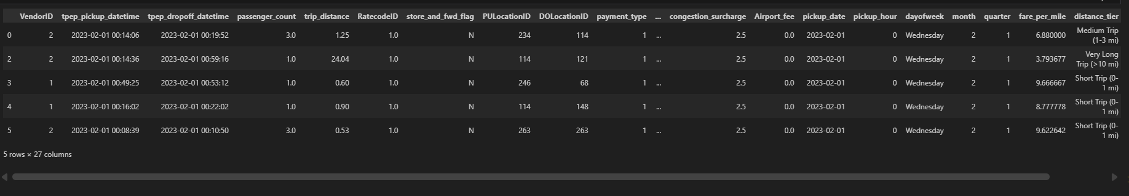
    - Analyse the trends in passenger count
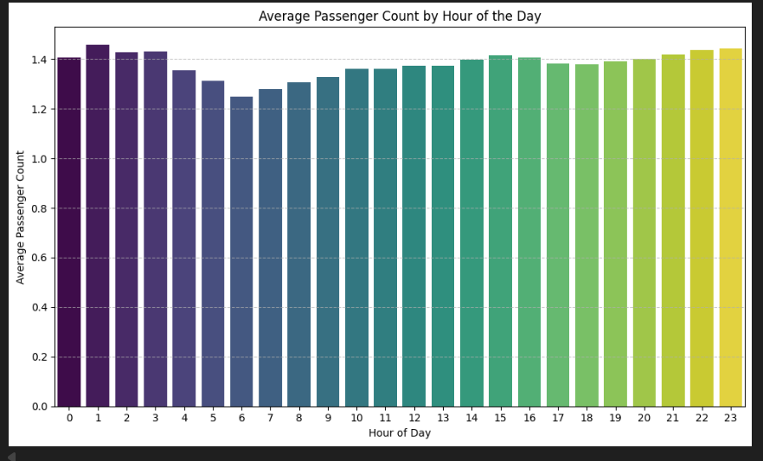
    - Analyse the variation of passenger counts across zones
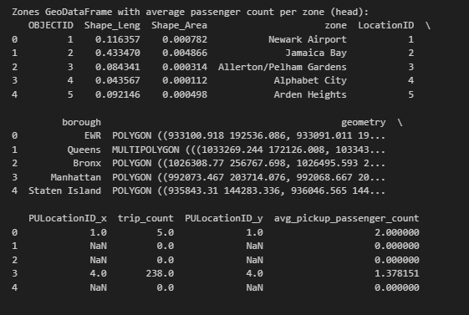
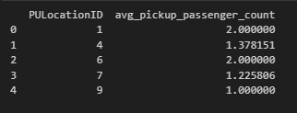
    - Analyse the pickup/dropoff zones or times when extra charges are applied more frequently.
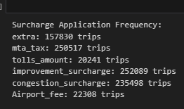

Conclusions

Final Insights and Recommendations
Recommendations to optimize routing and dispatching based on demand patterns and operational inefficiencies.
Taxi Routing and Dispatch Optimization
- Taxi demand is highest during morning (7–10 AM) and evening (4–8 PM) hours.
- Late-night demand is lower but concentrated in airports, hotels, and nightlife areas.
- Business districts, transport hubs, and entertainment zones are the busiest locations.
- Some areas face taxi shortages, while others have idle taxis, causing imbalance.
- Certain routes are consistently slow, especially during rush hours.
- Passenger numbers are higher for airport and night trips and lower during weekday mornings.
Key Recommendations
- Place taxis in high-demand areas before peak hours.
- Move taxis from low-demand zones to high-demand zones.
- Avoid slow routes during busy periods.
- Match vehicle size to passenger demand.
- Use different dispatch strategies for peak, night, and off-peak hours.
Benefits
- Shorter wait times
- Better taxi utilization
- Less fuel waste
- Improved driver earnings
- More reliable service

Suggestions on strategically positioning cabs across different zones to make best use of insights uncovered by analysing trip trends across time, days and months.
Strategic Cab Positioning
- Place more cabs during peak hours (morning and evening) in business areas and transport hubs.
- Focus cab availability in high-demand zones like city centers and airports.
- At night, concentrate cabs near nightlife areas, hotels, and airports.
- On weekends, shift cabs from office areas to entertainment and tourist zones.
- Move cabs dynamically from low-demand areas to high-demand areas.
- Use demand patterns to reposition cabs before shortages occur.

Propose data-driven adjustments to the pricing strategy to maximize revenue while maintaining competitive rates with other vendors.
Data-Driven Pricing Strategy
- Raise prices during peak hours and in high-demand locations.
- Apply surge pricing carefully to avoid customer dissatisfaction.
- Offer lower prices during off-peak hours to boost demand.
- Review and simplify surcharges to keep pricing fair and transparent.
- Adjust fares based on trip distance, duration, and time of day.
- Use tipping behavior to understand customer willingness to pay.

