AuthLDAPExtended   
plugin for   
LimeSurvey 6

version 1.0.0

Implemented by Sixto Martin Garcia   
[sixto.martin.garcia@gmail.com](mailto:sixto.martin.garcia@gmail.com)

**Description 2**

**How does it work? 3**

**Installation 4**

Dropping the Files 4

Plugin Manager 4

**Settings 5**

# 

# 

# 

# 

# 

# Description

This is a LimeSurvey extension that extends the LDAP support offered by the core plugin.

It allows you to update full name/email on each login action.

The extension supports Groups. If the LDAP provides a group name, you can enable Sync group option to update the user group. If the group name provided does not exist yet, you can enable Auto-create groups field to generate it automatically.

The same applies to roles.

It also allows for auditing LDAP actions by enabling a logger.

# How does it work?

It works in the same way as the [LDAP core plugin](https://www.limesurvey.org/manual/Authentication_plugins#LDAP), but adds extra features.  
  
Pre-requisites

* Verify that phpinfo.php shows that LDAP is enabled. The location of LimeSurvey's built-in phpinfo.php is: Upper Right Menu -- Configuration -- Settings -- Global Settings.   
  Then, below the table, you will have a link for "Show PHPInfo".
* Enable LDAP in php.ini.

See PHP LDAP [docs](https://www.php.net/manual/en/book.ldap.php).

You don’t need to activate the LDAP core plugin; instead, activate the AuthLDAPExtended plugin.

# Installation

The AuthLDAPExtended extension requires the same requisites as the core LDAP extension:  
  
There are 2 ways to install the extension:

* Unzip and drop the files in the plugins folder
* Use the plugin Manager

## Dropping the Files

Copy the AuthLDAPExtended folder, which you will find after unzip the provided file, inside the plugins folder of LimeSurvey.  
Now go to the Admin panel, Settings > Plugin Manager then click on   
Scan files, AuthLDAPExtended should appear, click on its install icon.

## **Plugin Manager**

In order to install the plugin go to the Admin panel. Then, access Settings > Plugin Manager, click on the Upload & Install button and select the provided zip file.

# Settings

To configure the plugin go to the Admin panel. Then access to Settings > Plugin Manager, and you will see the AuthLDAPExtended listed.  
If it is not listed, click on Scan Files and a view will appear where you will be able to install the extension to be recognized.

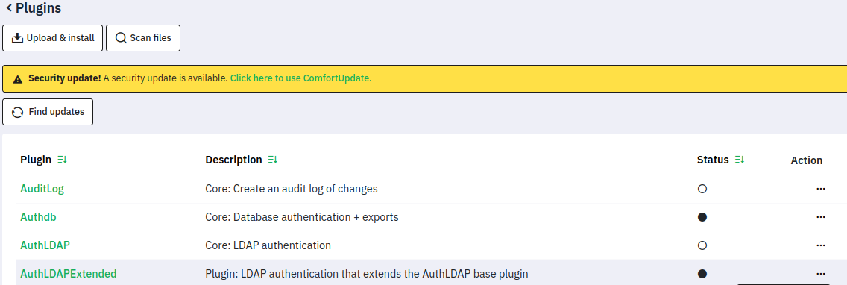

If you see the extension on the list, click on its name to access its settings configuration panel. After this process, we can go back to this list and click on the dots and select “Activate” to enable the extension.

Settings will include all settings parameters available on the LDAP core, plus new settings available at the “Extended Settings” section.

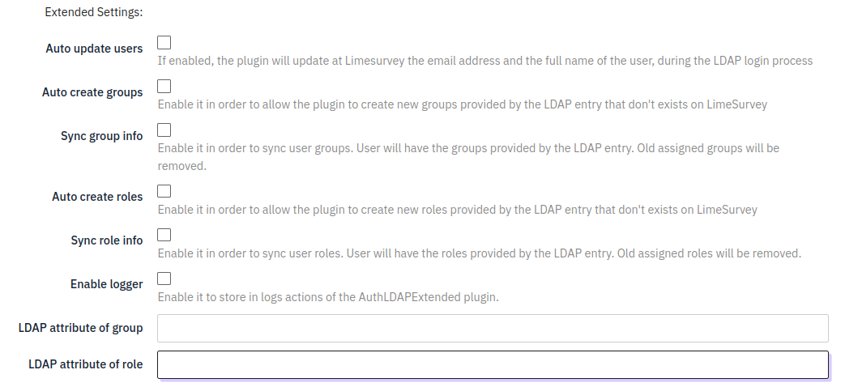

If you want to sync the user data hosted on the IdP in the LimeSurvey user account, then enable the Auto update users field settings.

The extension supports Groups. If the IdP provides a group name that does not exist yet, you can enable Sync group info field to generate it automatically. It also supports Roles, which can also be autocreated and synchronized.

To be able to sync group/roles, you will need to provide information on how to identify that data at the LDAP entry by filling in the fields LDAP Attribute of group and LDAP Attribute of role.

If Enable Logger is enabled, then any action executed by the AuthLDAPExtended plugin gonna be registered in the logs.