**High Level Design Document**

|  |  |
| --- | --- |
| **Project Name** | **5StarGlobalEntertainment-TKCS** |
| **Client Name** | **Zachary Criss**  **Chyna Hobbs** |

##### Chetu Contacts

This section should list all Chetu team members.

Note: All Chetu emails are of the format: FirstnameLastnameinitial@chetu.com

Note: Chetu (US) team works normal hours EDT and can be reached at: 954 342 5676.

Note: Chetu (India) team works 5am-2pm EDT and can be reached at: 954 862 3901.

|  |  |  |  |
| --- | --- | --- | --- |
| Name | Role | Location | Responsibility |
| Amit Sinha | Project Manager | USA | Project Management |
| Sanjeev Kota | Director Operations | USA | Project Delivery and Operations |
| Surendra Prasad | Team Leader | India | Technical Architect and Communication |
| Anurag Pathak | Developer | India | Application Development |

##### Client Contacts

This section should list all customer contacts including project champion and business users.

|  |  |  |  |  |
| --- | --- | --- | --- | --- |
| Name | Email | | Entity | Responsibility |
| Zachary Criss | | [zzcriss@yahoo.com](mailto:zzcriss@yahoo.com) | CEO |  |
| Chyna Hobbs | | [admin@5starglobalent.com](mailto:admin@5starglobalent.com) | Director of Operations |  |

##### Revision Chart

A new record should be added every time a user updates this document.

|  |  |  |  |
| --- | --- | --- | --- |
| Ver. # | Date | Author | Change |
| V.05022022 | 05/02/2022 | Amit Sinha | Initial draft |
|  |  |  |  |
|  |  |  |  |
|  |  |  |  |
|  |  |  |  |
|  |  |  |  |
|  |  |  |  |

##### Document Conventions

* *Notations in Italics contain Document instructions and should be preserved*.
* Sections highlighted in **yellow** shall be provided by Client.
* Sections highlighted in **grey** are questions or open items that need to be discussed further.

Contents

1.0 Introduction 5

1.1 Overview 5

1.2 Project Objectives 5

1.3 References 5

1.3.1 Industry Specific 5

1.3.2 Project Specific 5

2.0 Requirements recap 6

2.1 Overview 6

2.2 Details 6

3.0 Glossary of Terms 7

3.1 Industry Specific 7

3.2 Project Specific 7

4.0 System Architecture 8

5.0 Functional architecture 9

5.1 Overview 9

5.2 [Functional Module Name] 9

5.2.1 Overview 9

5.2.2 Component level details for this module 9

6.0 Project Guidelines 10

6.1 Environment 10

6.1.1 Description 10

6.2 N-Tier Architecture 10

6.2.1 Overview 10

6.2.2 Description 10

6.3 Coding Module Hierarchy and Breakdown 10

6.3.1 Description 10

6.4 Coding Standards 11

6.4.1 Description 11

6.5 RAD components 11

6.5.1 Overview 11

6.5.2 Description 11

# Introduction

## Overview

5StarGlobalEntertainment is the world's largest event technology platform, powering millions of events in multiple countries and territories. We’re building intuitive technology to help you create, manage, and sell tickets to virtual and in-person events – so you can spend less time focusing on online ticket sales and more time creating meaningful live experiences.

5StarGlobalEntertainment is a global self-service ticketing platform for live experiences that allows anyone to create, share, find and attend events that fuel their passions and enrich their lives. Our mission is to bring the world together through live experiences.

## Project Objectives

Initially, we have an objective to create mockups for landing page to finalize theme and PHP team will implement functionality according to the discussed document.

## References

### Industry Specific

<https://en.wikipedia.org/wiki/Electronic_ticket>

### Project specific

<https://en.wikipedia.org/wiki/Event_management>

# Requirements recap

## Overview

5StarGlobalEntertainment is the world's largest event technology platform, powering millions of events in multiple countries and territories. We’re building intuitive technology to help you create, manage, and sell tickets to virtual and in-person events – so you can spend less time focusing on online ticket sales and more time creating meaningful live experiences.

5StarGlobalEntertainment is a global self-service ticketing platform for live experiences that allows anyone to create, share, find and attend events that fuel their passions and enrich their lives. Our mission is to bring the world together through live experiences.*.*

## Details

**Phase -1 Development**

**Live Site-End User**

1. Login Module

* Login
* Registration
* Forget/Reset password

1. Landing Page
2. Search Event
3. Event List
4. Event Detail
5. Buy Ticket/Reserve table
6. Contact Us
7. Terms & Condition
8. Privacy Policy

**Administrator Role**

1. Events (Add/Update/Delete/List)
2. Tickets (Add/Update/Delete/List)
3. Setup Referral Amount
4. Event Preview & launch
5. My Account
   1. My Events
   2. Earning
   3. Order
6. Payment Integration
7. Ticket Batch Amount Setup
8. Reporting

# Glossary of Terms

## Industry Specific

<https://en.wikipedia.org/wiki/Electronic_ticket>

## Project Specific

<https://en.wikipedia.org/wiki/Event_management>

# System Architecture

Buy Tickets

Add New Events

Schedule Events

Promote Event



Payment Gatewey Integration

Customer

Application server

Database

Seat Map API

Table Reservation

Referral Amount

Reporting

# Functional architecture

## Overview

Currently UI/UX team is creating mockups to finalize theme then after approval we will create templates and implement functionality for web application.

## Site Page

#### Home Page

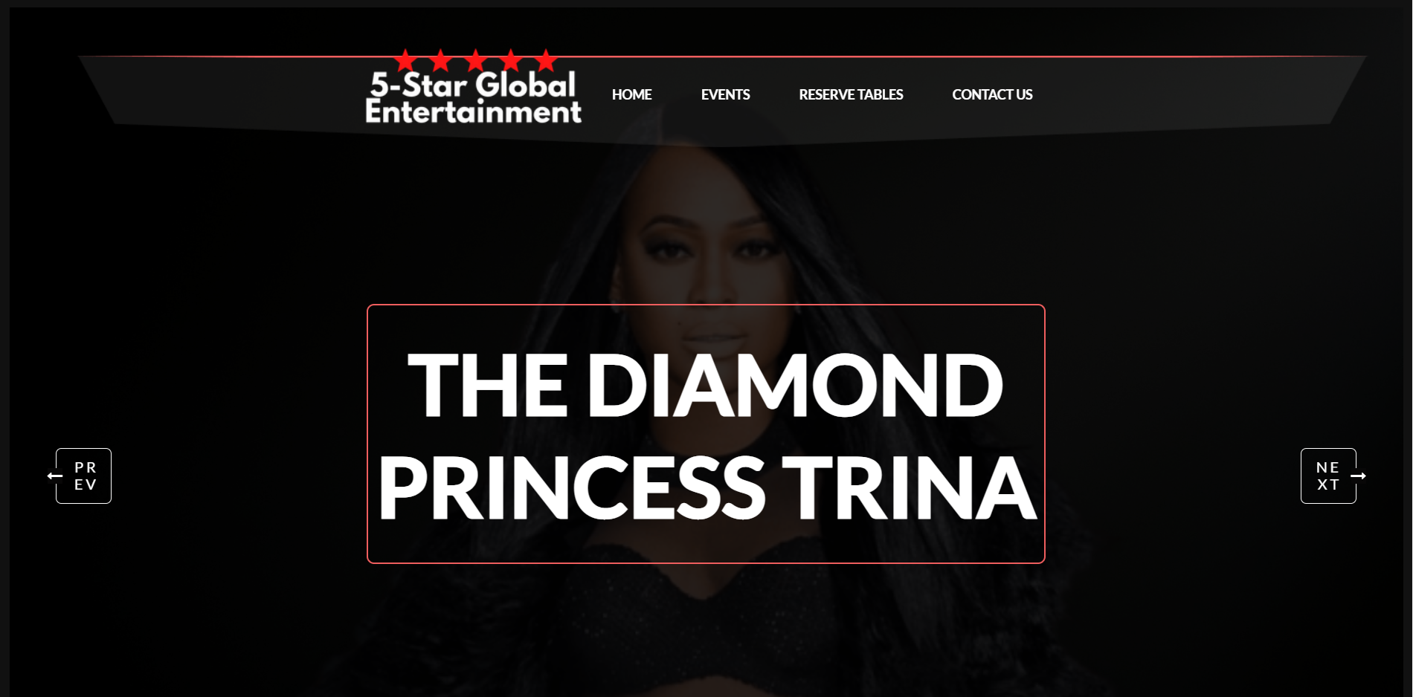

#### Event Page



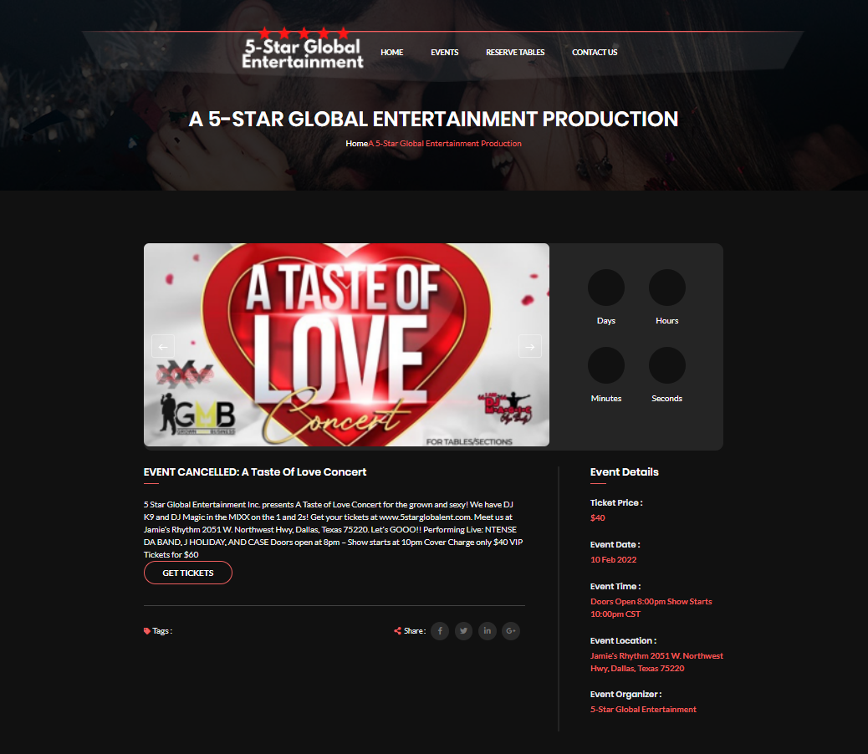

#### Contact Page

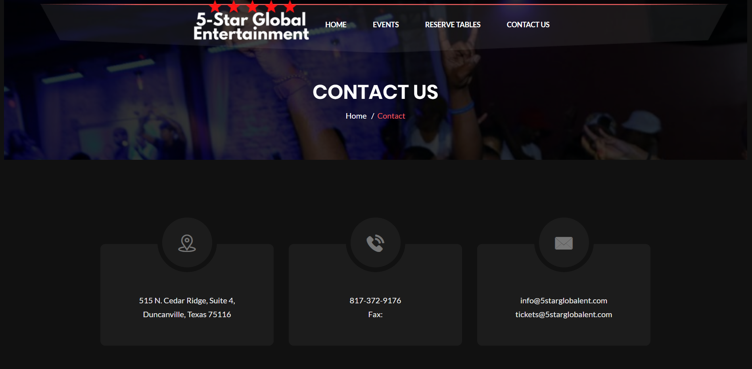

# Project Guidelines

## Environment

### Description

* *Development framework* 
  + *Language: HTML5, CSS3, Bootstrap, PHP*
  + *Database: MySQL*
  + *RAD: VSCode*
  + *Framework: Laravel*
* *Browser & O/S compatibility* 
  + *Browsers: Chrome, Safari, Edge and Firefox.*
  + *Web Server: Apache*

## Coding Module Hierarchy and Breakdown

### Description

*In-Progress*

## Coding Standards

### Description

*Chetu Coding Standards.*

## RAD components

### Overview

*VSCode*