Detailed Design Document

Project Name | 5StarGlobalEntertainment-TKCS
Client Name | Chyna Hobbs,  Zachary Criss

Chetu Contacts
This section should list all Chetu team members.
Note: All Chetu emails are of the format: FirstnameLastnameinitial@chetu.com
Note: Chetu (US) team works normal hours EDT and can be reached at: 954-342-5676.
Note: Chetu (India) team works 5am-2pm EDT and can be reached at: 954-862-3901.

Name | Role | Location | Responsibility
Sanjeev Kota | DO | USA | Managing project delivery and operations & Escalation point for any delivery/ quality issues
Amit Sinha | PM | USA | Managing overall project & Main point of contact
Surendra Prasad | TL | India | Design & development & guiding TM
Anurag Pathak | Developer | India | Laravel Software Developer

Client Contacts
This section should list all customer contacts including project champion and business users.
Name | Email | Entity | Responsibility
Zachary Criss | zzcriss@yahoo.com | CEO
Chyna Hobbs | admin@5starglobalent.com | Director of Operations

Revision Chart
A new record should be added in this section every time a user updates this document.

Ver. # | Date | Author | Change
v.05102022 | 05/10/2022 | Surendra Prasad | Initial Draft

Document Conventions
- Notations in Italics contain Document instructions and should be preserved.
- Sections highlighted in yellow shall be provided by Client.
- Sections highlighted in grey are questions or open items that need to be discussed further.

Contents
1.0 Introduction 4
1.1 Overview 4
1.2 Project Objectives 4
1.3 Approach Summary 4
2.0 FUDs [Fears, Uncertainties and Doubts] 5
3.1 Overview 6
3.2 Development Environment 6
3.2.1 QA Testing Environment 6
3.3 Staging Environment 7
3.4 Production Environment 7
4.0 Requirements recap 8
4.1 Overview 8
4.2 Details 8
5.0 Design Details 9
Diagrams 9
5.1 Use Case Diagram 9
5.1.1 Use Case Detail Description 9
5.1.2 <Use-case 1: GroupCheck-In> 10
5.1.3 <Use-case 2: Name> 10
5.2 Activity Diagram 12
5.3 Class Diagram 13
5.4 Sequence Diagram 14
6.0 User Interface 15
6.1 Overview 15
6.2 Main Page 15
6.2.1 Interface 15
6.2.2 Description 15
6.3 Results Page 15
6.3.1 Interface 15
6.3.2 Description 15
7.0 Database 1
7.1 Overview 16
7.2 ER Diagram 16
8.0 Future Considerations 21
9.0 Change/Update Track Record. (According to Date) 22

Introduction

Overview
5StarGlobalEntertainment is the world's largest event technology platform, powering millions of events in multiple countries and territories. We’re building intuitive technology to help you create, manage, and sell tickets to virtual and in-person events – so you can spend less time focusing on online ticket sales and more time creating meaningful live experiences.

5StarGlobalEntertainment is a global self-service ticketing platform for live experiences that allows anyone to create, share, find and attend events that fuel their passions and enrich their lives. Our mission is to bring the world together through live experiences.

Project Objectives
5StarGlobalEntertainment is a global self-service ticketing platform for live experiences that allows anyone to create, share, find and attend events that fuel their passions and enrich their lives. Our mission is to bring the world together through live experiences.

References

Industry Specific
https://en.wikipedia.org/wiki/Electronic_ticket

Project specific
https://en.wikipedia.org/wiki/Event_management

FUDs [Fears, Uncertainties and Doubts]
N/A
2.0 FUDS [FEARS, UNCERTAINTIES AND DOUBTS]

Environment

Overview
We need to build a complete Event Management and ticketing platform from scratch. It will have a Role based access for Promoters and Venues to add/manage Events. The application will have ticketing, QR Codes, Payment processing features. The users can search and purchase tickets from this platform.

Project needs MySql, Laravel(latest version), JavaScript and Jquery.

Development Environment
Below are the Technologies and platform used for development:

- Language/ Framework – PHP Laravel, HTML5, CSS3, JQuery, Javascript.
- Tools/Web component- N/A
- IDE – Visual Studio, Photoshop, Adobe XD
- Database - MySql.
- Operating System – Windows
- QA Environment:
  - We would setup for Internal QA testing.
  - We would use the staging environment provided by the client.
- Production Environment:
  - Need to get from client.

QA Testing Environment
We have our enternal QA environment. First, we developed the feature then we verified the functionality to our internal QA.

OS Systems
- Window

Browsers
Please specify targeted browsers
- Chrome latest
- Firefox latest

Devices only if provided by client. Simulator otherwise
NA

Staging Environment
To be provided by client.

Production Environment
To be provided by client.

Requirements recap

Overview
Customer is looking to build a complete Event Management and ticketing platform from scratch. It will have a Role based access for Promoters and Venues to add/manage Events. The application will have ticketing, QR Codes, Payment processing features. The users can search and purchase tickets from this platform.

Details
Phase -1 Development
Live Site-End User
- Login Module
- Login
- Registration
- Forget/Reset password
- Landing Page
- Search Event
- Event List
- Event Detail
- Buy Ticket/Reserve table
- Contact Us
- Terms & Condition
- Privacy Policy
Administrator Role
- Events (Add/Update/Delete/List)
- Tickets (Add/Update/Delete/List)
- Setup Referral Amount
- Event Preview & launch
- My Account
  - My Events
  - Earning
  - Order
- Payment Integration
- Ticket Batch Amount Setup
- Reporting

MVC Architecture

Overview
As the application is the web-based application, we agreed on using the MVC architecture.

Description
Model–view–controller (MVC) is a software architecture pattern that separates the representation of information from the user's interaction with it. The model consists of application data, business rules, logic, and functions. A view can be any output representation of data, such as a chart or a diagram. Multiple views of the same data are possible, such as a pie chart for management and a tabular view for accountants. The controller mediates input, converting it to commands for the model or view. The central ideas behind MVC are code reusability and separation of concerns.

Controller: A controller can send commands to its associated view to change the view's presentation of the model (e.g., by scrolling through a document). It can also send commands to the model to update the model's state (e.g., editing a document).
Model: A model notifies its associated views and controllers when there has been a change in its state. This notification allows the views to produce updated output, and the controllers to change the available set of commands. A passive implementation of MVC omits these notifications, because the application does not require them or the software platform does not support them.
View: A view requests from the model the information that it needs to generate an output representation.

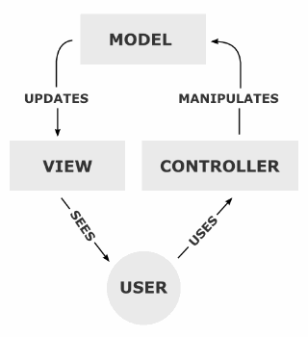

Design Details

Diagrams
Activity and Class.

Use Case Diagram
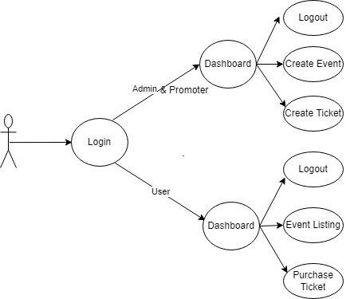

Use Case Detail Description

Admin and Promoter login with their credentials and able to view its dashboard and can create Events and Tickets . User/Buyer can login with their credentials and can only purchase the tickets of the events. The admin and promoter can fill their form as per the requirements. All the changes made by admin will be visible into the users screen .Currently we are working onto the admin and user panel also.

Class Diagram

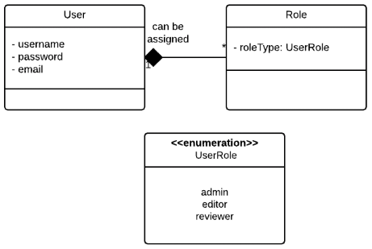

Class Diagram for relationship between users and roles
er Interface

Overview
User has one to many relationship with Role class
Attributes of User class: username, password, email
Attributes of Role class: roleType

Main Page

Admin Login Page Interface

There will be also login page. Here user can login to system based on his email address and password. Based on his email address and password, application will identify his Admin dashboard. Super admin can see details of all users and manage their events.

- Login using username & password

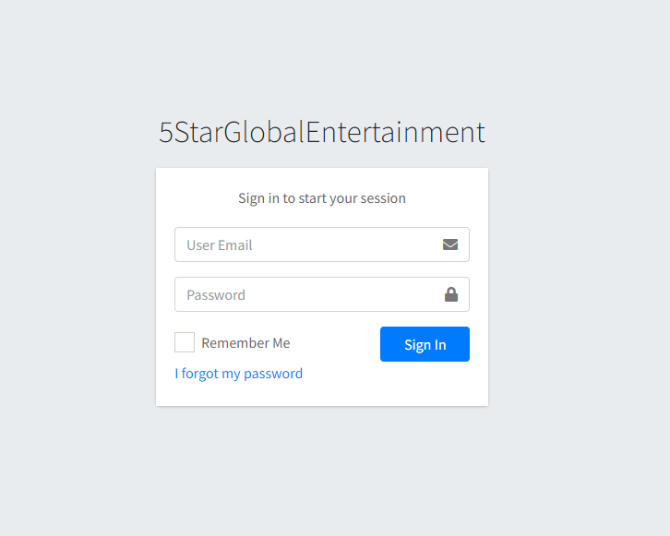

Admin Registration Page
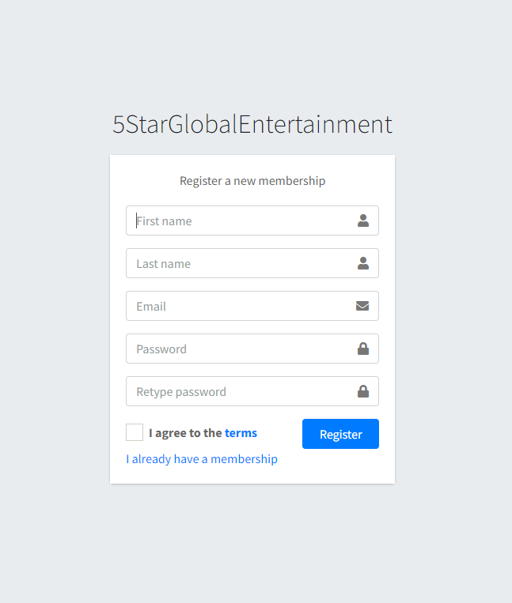

Admin Forget Password

There will be a forgot password screen. If user somehow forgot his password then he can click on forgot password button. He need to enter his registered email id then a verification code will be sent to that email. He need to provide that verification code for further processing.

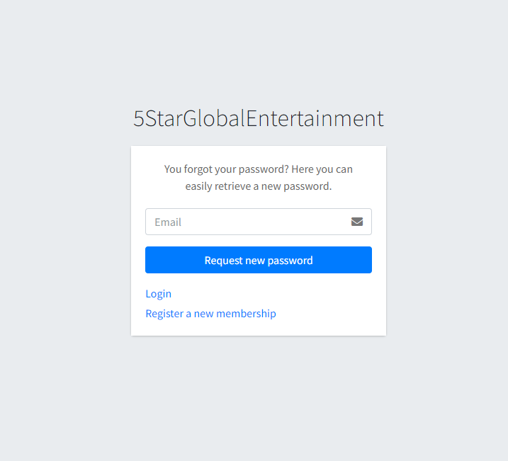

Admin Reset Password

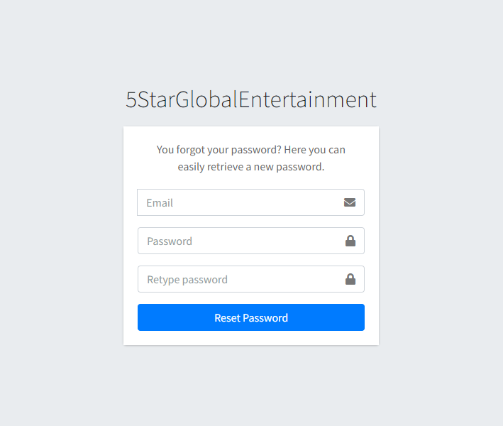

Results Page

Administrator Dashboard

.
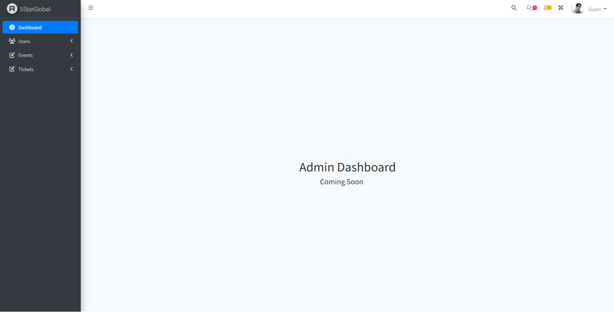

Dashboard Screen

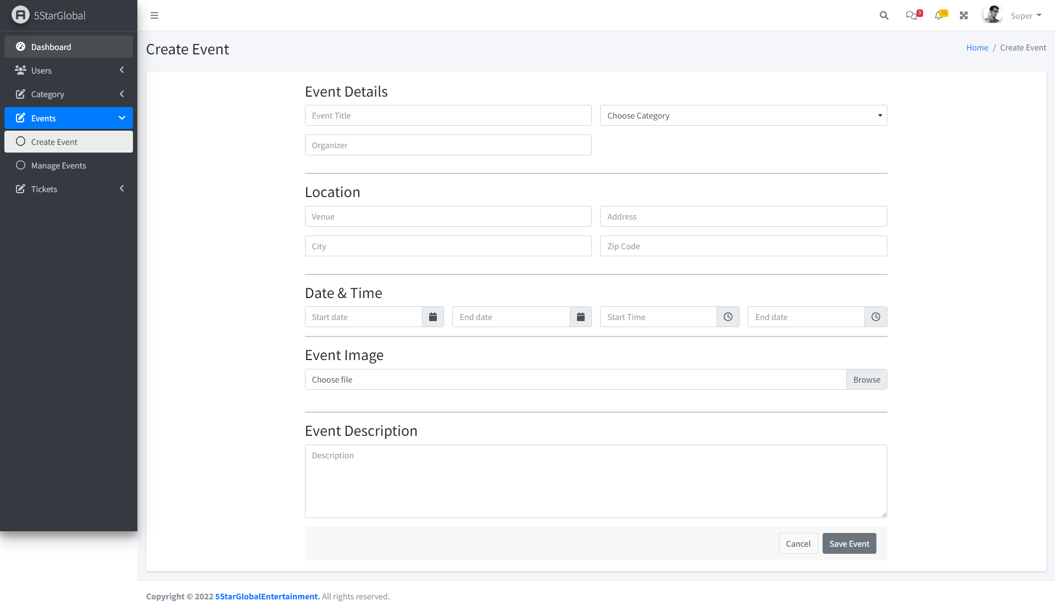
Create Event Screen

Description
There will be Admin Dashboard where super-admin can log in to the system based on his email address and password after that admin dashboard page will open. Here is a header, left sidebar, right-sidebar, and footer. The left sidebar shows the module and sub-modules list and when we click on any of them it shows the page related to selected modules in the right sidebar. In the Left sidebar basically, there are Manage Users, Manage Events, etc.

Database

Overview
At this section we are going to demonstrate the E-R diagram of the project having flow diagram and storage procedure of data from one table to another table.

Server: Mysql DBMS

ER Diagram
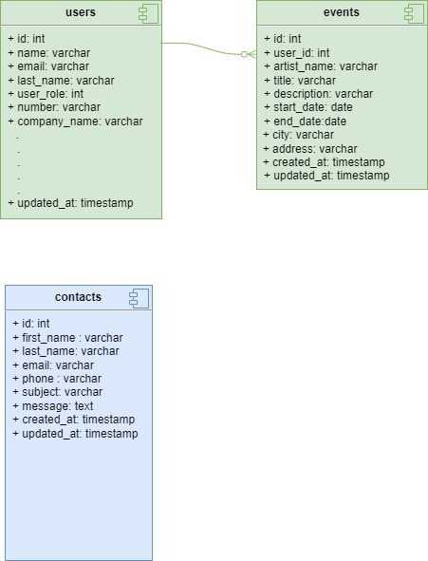

Future Considerations
We will show following things.
- Table Reservation
- Tickets Module
- QR Code
- Payment Gateway
- Record. (According to Date)
Administrator Role
- Newsletters (Add/Update/Delete/List)
- Seat Chart Creation
- Clover Integration-Suggested by Chyna
Promotor Role
- Events (Add/Update/Delete/List)
- Tickets (Add/Update/Delete/List)
- Setup Referral Amount
- Event Preview & launch
- Newsletters Subscription
- My Account
  - My Earning
  - My Event

Change/Update Track Record. (According to Date)
05/10/2022 – Changed By Surendra Prasad

