Docker file



Created image in local

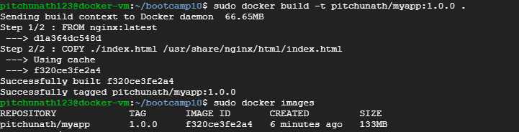

Pushed to docker hub:

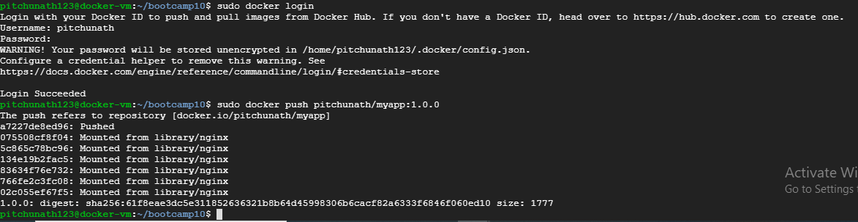

Pulling the image:

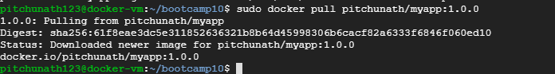

Run the image:



Accessing app via browser

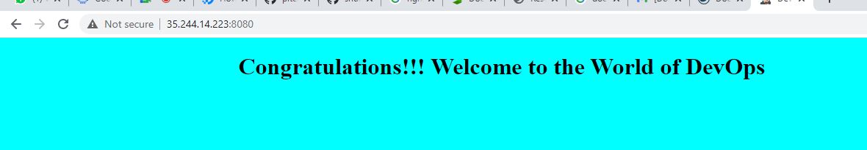

Docker compose File:

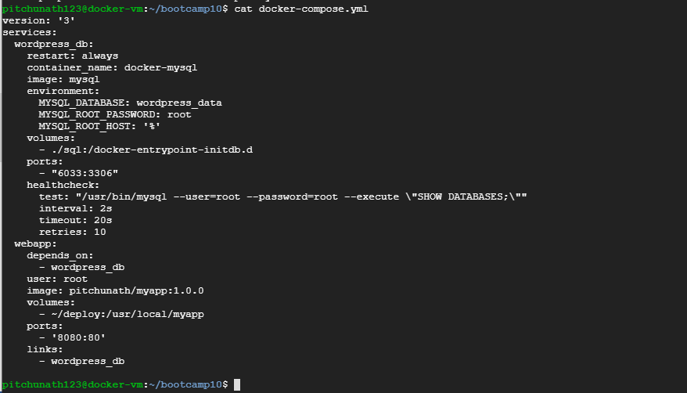

Docker-compose up

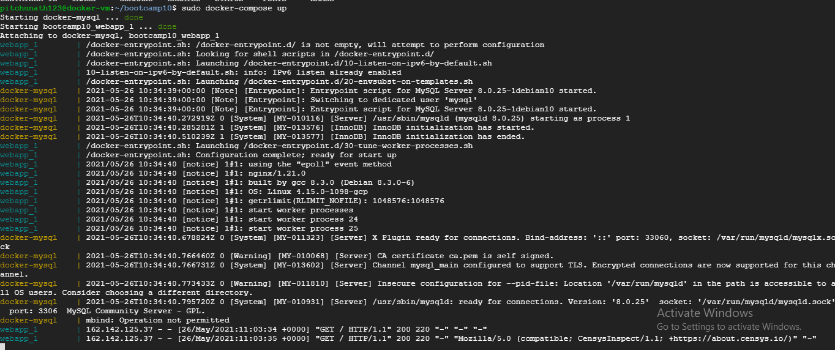

Interactive mode for container

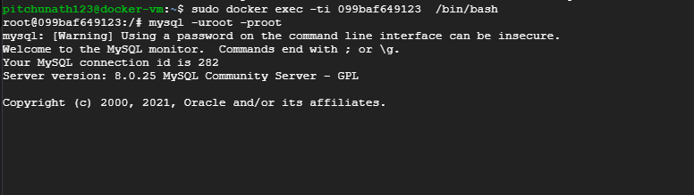

SQL commands

