Ansible playbook execution:

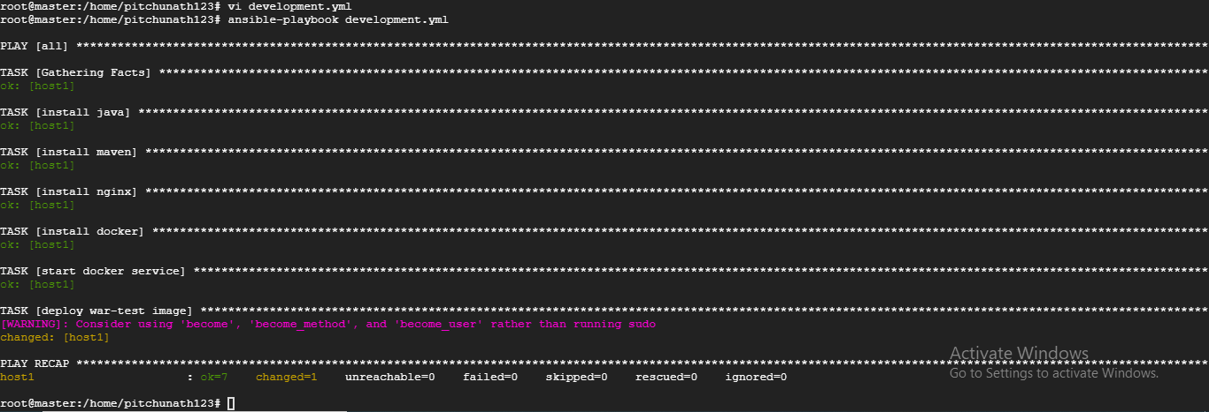

Playbook development.yml

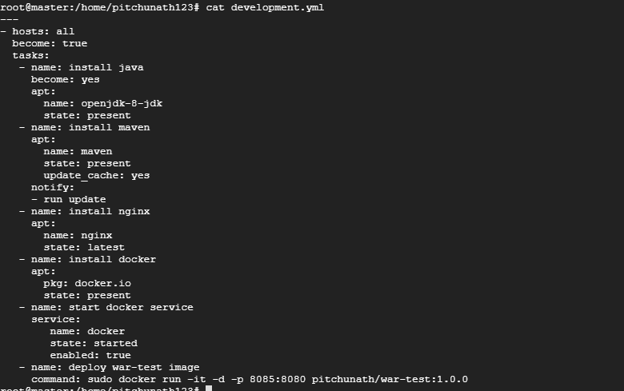

Deployed as container in slave node by playbook

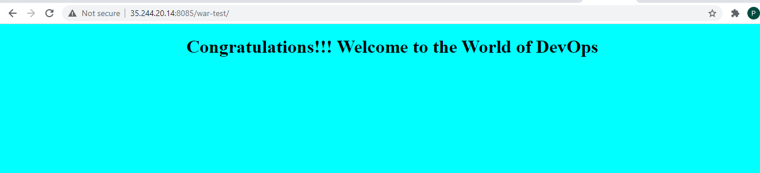

Checking installed softwares in slave:

