Name : Devngi Borad
Subject : Data Structure (2CS501)
Practical no.: 2A
AIM : Create a singly linked list and perform following operations using menu driven approach:
  - Create a linked list
  - Delete a node if it is found, otherwise display an appropriate message
  - Search a given integer value in the list
  - Display the linked list

INPUT :
#include <stdio.h>
#include <stdlib.h>
struct node {
int roll;
struct node *link;};
struct node* creatList(struct node* head){
int n;
printf("Enter n: ");
scanf("%d", &n);
struct node *new, *temp = NULL;
for (int i = 0; i < n; i++) {
new = (struct node *)malloc(sizeof(struct node));
printf("Enter roll number %d: ", i + 1);
scanf("%d", &new->roll);
new->link = NULL;
if (i == 0) {
head = new;
temp = new;
} else {
temp->link = new;
temp = new;
} }
return head;
}
struct node* addNode(struct node* head){
struct node *temp=head,*newNode;
newNode = (struct node *)malloc(sizeof(struct node));
printf("Enter roll number to be inserted : ");
scanf("%d", &newNode->roll);
newNode->link=NULL;
int pos;
printf("Enter the position after which you want to insert the node : ");
scanf("%d", &pos);
if(pos==1){
newNode->link=head;
head=newNode;
}
else{
temp=head;
for(int i=1;i<pos;i++){
temp=temp->link;
}
newNode->link=temp->link;
temp->link=newNode;
}
return head;};
struct node* deleteNode(struct node* head){
struct node *temp;
int pos,p;
printf("Enter the position at which you want to delete the node : ");
scanf("%d", &pos);
if(pos==1){
p=head;
head=head->link;
free(p);
}
else{
temp=head;
for(int i=1;i<pos-1;i++){
temp=temp->link;
}
p=temp->link;
temp->link=temp->link->link;
free(p);
}
return head;
};
struct node* searchchNode(struct node* head){
struct node *temp;
int find,count=1;
printf("Enter the roll number to be found out: ");
scanf("%d", &find);
temp = head;
int found = 0;
while (temp != NULL) {
if (temp->roll == find) {
printf("Found the given integer! at node %d\n",count);
found = 1;
break;
}
temp = temp->link;
count++;
}
if (!found) {
printf("Required number is not in the list!\n");
}
return head;
};
struct node* printList(struct node* head){
struct node* temp;
printf("\nLinked list contents:\n");
temp = head;
while (temp != NULL) {
printf("%d\n", temp->roll);
temp = temp->link;
}
return head;
}
int main() {
struct node *head=NULL;
while(1){
int fun;
printf("\nchoose from the following :\n1. Creat link list\n2. Insert a Node\n3. Delete a node\n4. Search a node\n5. Print Link List\n6.Exit\n");
scanf("%d",&fun);
switch(fun){
case 1:
head=creatList(head);
break;
case 2:
if(head==NULL){
printf("Link List Doesn't exit!");
break;
}
head=addNode(head);
break;
case 3:
if(head==NULL){
printf("Link List Doesn't exit!");
break;
}
head=deleteNode(head);
break;
case 4:
if(head==NULL){
printf("Link List Doesn't exit!");
break;
}
head=searchchNode(head);
break;
case 5:
if(head==NULL){
printf("Link List Doesn't exit!");
break;
}
head=printList(head);
break;
case 6:
exit(0);
default:
printf("invalid input!");
} }
return 0;
}
OUTPUT :
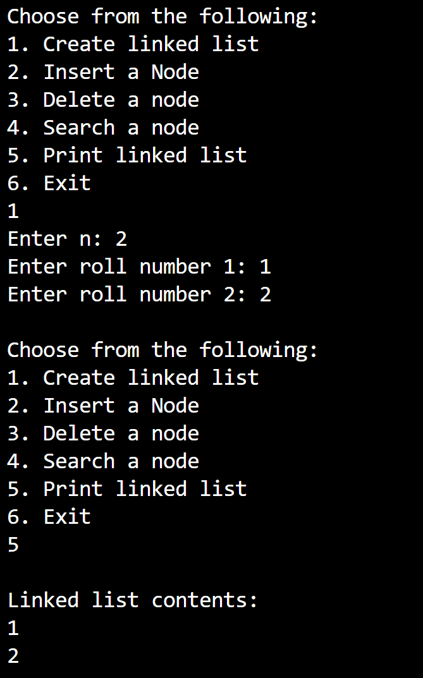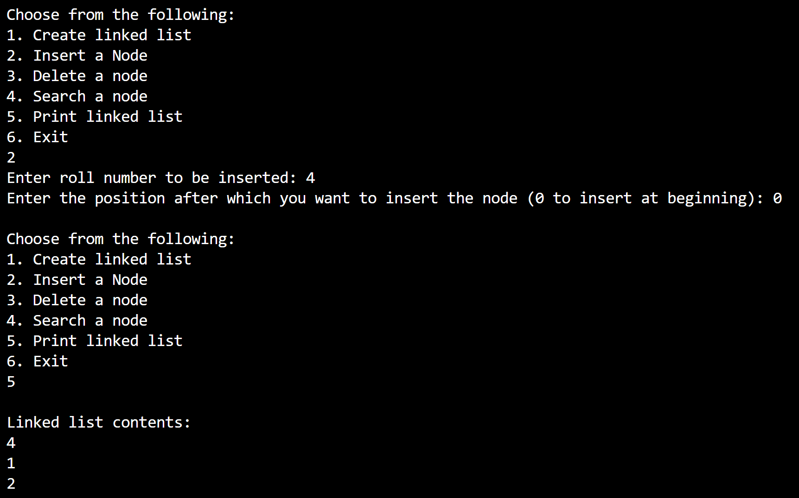

Practical no.: 2B
AIM : Write a program to implement polynomial addition using linked list.

INPUT :
#include <stdio.h>
#include <stdlib.h>
typedef struct node {
int coeff;
int exp;
struct node* next;
} node;
node* createnodes(int coeff, int exp) {
node* newnode = (node*)malloc(sizeof(node));
newnode->coeff = coeff;
newnode->exp = exp;
newnode->next = NULL;
return newnode;}
node* insert(node* head, int coeff, int exp) {
node* newnode = createnodes(coeff, exp);
if (head == NULL) return newnode;
node* temp = head;
while (temp->next) {
temp = temp->next; }
temp->next = newnode;
return head;}
void display(node* poly) {
while (poly) {
printf("%dx^%d", poly->coeff, poly->exp);
poly = poly->next;
if (poly)
printf(" + "); }
printf("\n");}
node* add(node* poly1, node* poly2) {
node* result = NULL;
while (poly1 && poly2) {
if (poly1->exp > poly2->exp) {
result = insert(result, poly1->coeff, poly1->exp);
poly1 = poly1->next;
} else if (poly1->exp < poly2->exp) {
result = insert(result, poly2->coeff, poly2->exp);
poly2 = poly2->next;
} else {
int sum = poly1->coeff + poly2->coeff;
if (sum != 0)
result = insert(result, sum, poly1->exp);
poly1 = poly1->next;
poly2 = poly2->next;
}
}
while (poly1) {
result = insert(result, poly1->coeff, poly1->exp);
poly1 = poly1->next;
}
while (poly2) {
result = insert(result, poly2->coeff, poly2->exp);
poly2 = poly2->next;
}
return result;
}
int main() {
node* poly1 = NULL;
node* poly2 = NULL;
node* result = NULL;

// polynomial 1: 5x^3 + 6x^2 + 4x + 8
poly1 = insert(poly1, 5, 3);
poly1 = insert(poly1, 6, 2);
poly1 = insert(poly1, 4, 1);
poly1 = insert(poly1, 8, 0);

// polynomial 2: 7x^3 + x^2 + 2x + 3
poly2 = insert(poly2, 7, 3);
poly2 = insert(poly2, 1, 2);
poly2 = insert(poly2, 2, 1);
poly2 = insert(poly2, 3, 0);
printf("Polynomial 1 is: ");
display(poly1);
printf("Polynomial 2 is: ");
display(poly2);
result = add(poly1, poly2);
printf("Sum: ");
display(result);
return 0;
}

OUTPUT :
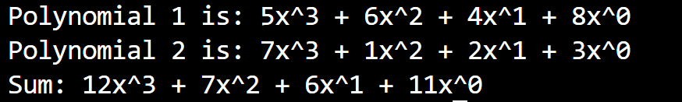

LEETCODE
- Reversed Linked List
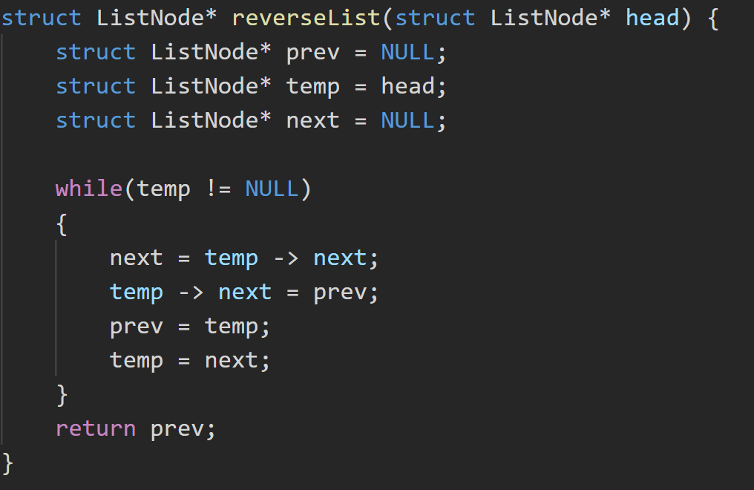

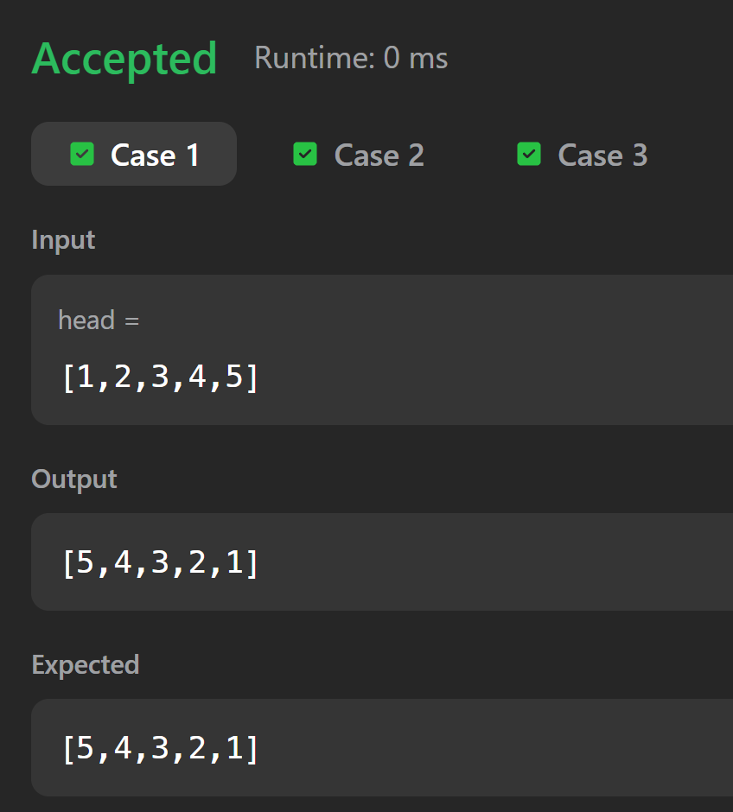

- Linked List Cycle
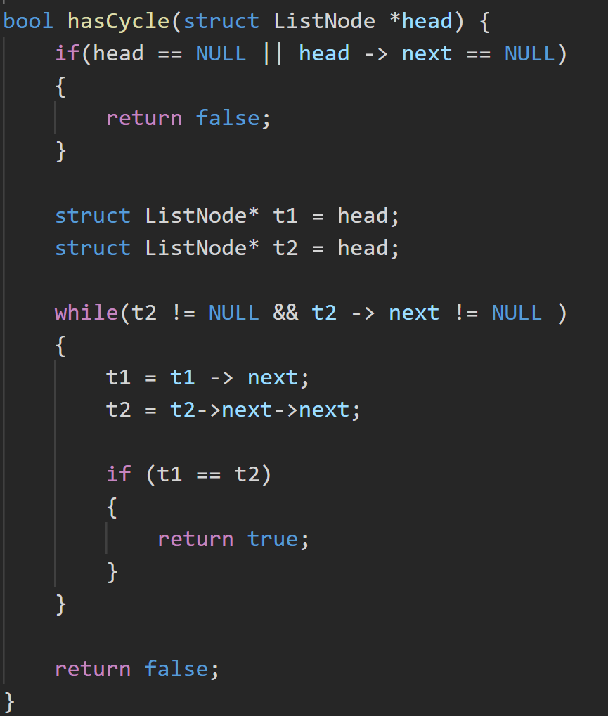
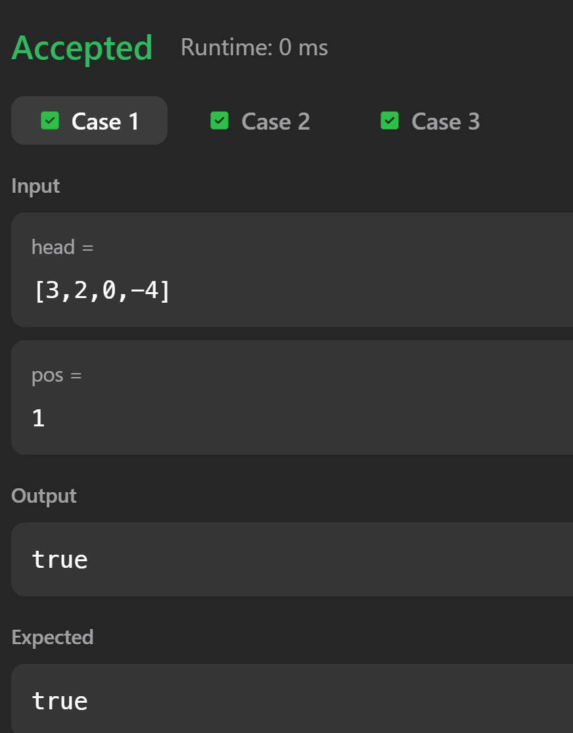

- Add Two Numbers