Name : Devngi Borad
Subject : Data Structure (2CS501)
Practical no.: 3A
AIM : Create Stack data structure using Array and implement following functions:
i. Push ii. Pop iii. Peek

INPUT :
#include<stdio.h>
# define MAX 100
int stack[MAX];
int top = -1;
void push(int value)
{
if(top == MAX-1)
{
printf("Stack is overflow!!\n");
return;
}
top++;
stack[top] = value;
}
int pop()
{
if(top == -1)
{
printf("stack is underflow!!\n");
return 1;
}
int value = stack[top];
top--;
return value;
}
int peek()
{
if(top == -1)
{
printf("stack is empty!!\n");
return 1;
}
return stack[top];
}
int main()
{
int n, value[MAX];
printf("Enter the number of elements to be pushed: ");
scanf("%d",&n);
for(int i=0; i<n; i++)
{
printf("Enter the value %d: ",i+1);
scanf("%d", &value[i]);
push(value[i]);
}
printf("Top element is %d\n", peek());
printf("Popped element is %d\n", pop());
printf("Top element is now %d\n", peek());
return 0;}
OUTPUT :
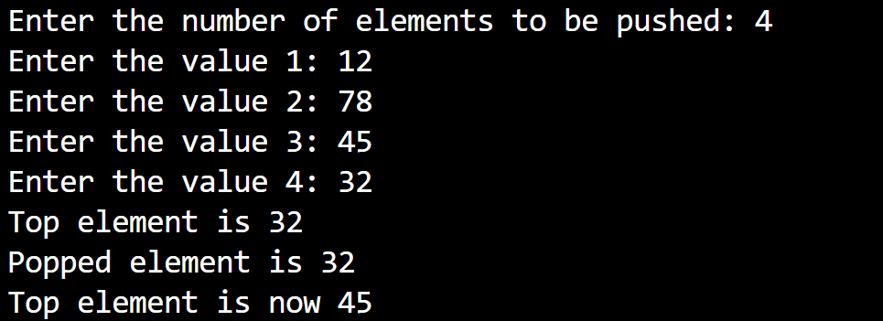

Practical no.: 3B
AIM : Write a program to convert fully parenthesised infix expression into postfix expression. Show all the intermediate results in the table format.

INPUT :
#include <stdio.h>
#include <stdlib.h>
#include <string.h>
#include <ctype.h>
#define SIZE 100
char operandStack[SIZE][SIZE];
char operatorStack[SIZE];
int topOperand = -1, topOperator = -1;
void pushOperand(char *str) {
strcpy(operandStack[++topOperand], str);
}
char* popOperand() {
return operandStack[topOperand--];
}
void pushOperator(char op) {
operatorStack[++topOperator] = op;
}
char popOperator() {
return operatorStack[topOperator--];
}
void printStacks(int step, char symbol) {
printf("%-5d %-7c ", step, symbol);
if (topOperand == -1) printf("Empty");
else {
for (int j = 0; j <= topOperand; j++)
printf("%s ", operandStack[j]);
}
printf("\t\t");
if (topOperator == -1) printf("Empty");
else {
for (int j = 0; j <= topOperator; j++)
printf("%c ", operatorStack[j]);
}
printf("\n");
}
int main() {
char infix[SIZE];
printf("Enter fully parenthesized infix expression: ");
fgets(infix, SIZE, stdin);
infix[strcspn(infix, "\n")] = '\0';
printf("\nStep Symbol Operand Stack Operator Stack\n");
printf("----------------------------------------------------\n");
int step = 1;
for (int i = 0; i < strlen(infix); i++) {
char symbol = infix[i];
switch (symbol) {
case '(': // Ignore '('
break;
case '+':
case '-':
case '*':
case '/': {
pushOperator(symbol);
break;
}
case ')': {
char op = popOperator();
char operand2[SIZE], operand1[SIZE], result[SIZE];
strcpy(operand2, popOperand());
strcpy(operand1, popOperand());
sprintf(result, "%s%s%c", operand1, operand2, op);
pushOperand(result);
break;
}
default: // Operand (A, B, C, … or digit)
if (isalnum(symbol)) {
char temp[2] = {symbol, '\0'};
pushOperand(temp);
}
break;
}
printStacks(step++, symbol);
}
printf("\nFinal Postfix Expression: %s\n", operandStack[topOperand]);
return 0;
}
OUTPUT :
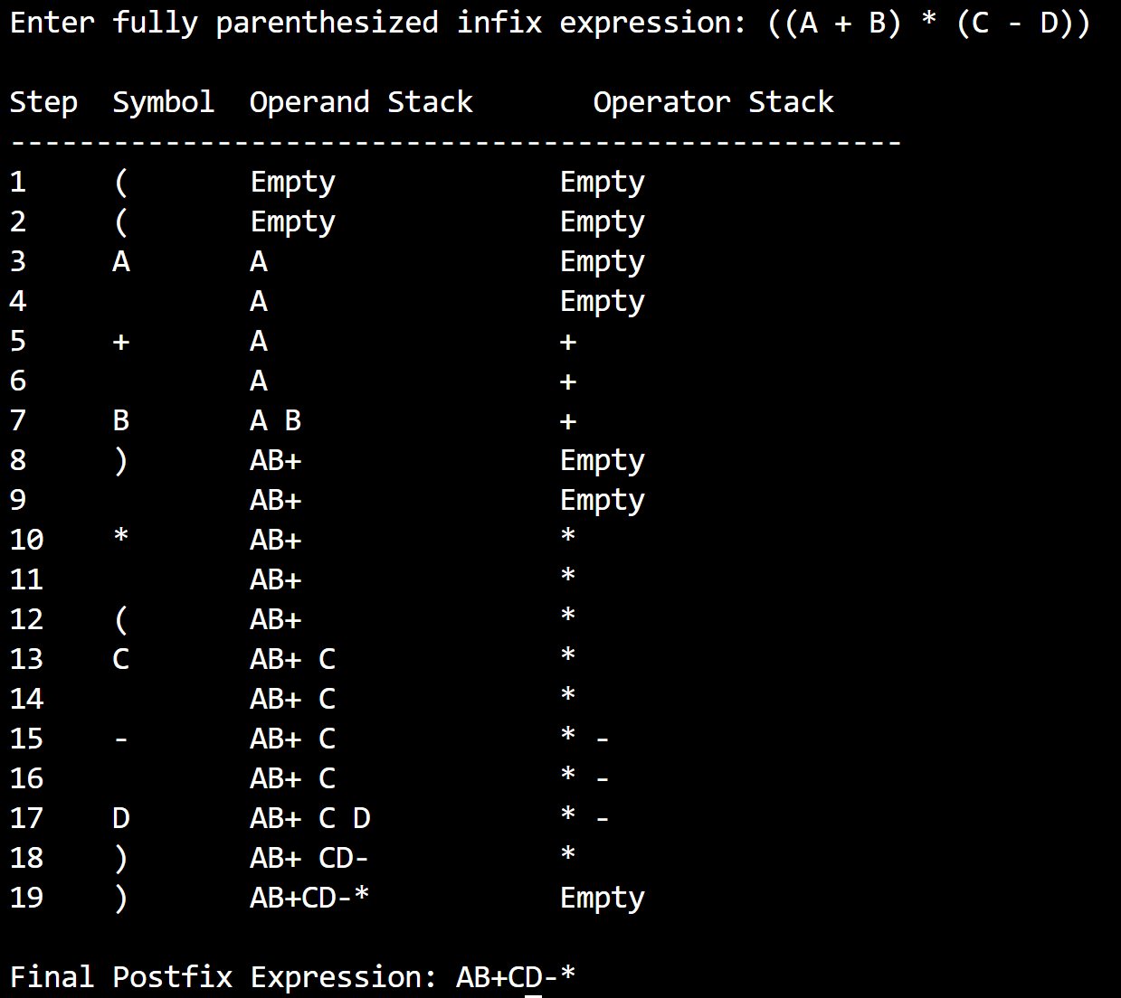

LEETCODE
- Valid Parentheses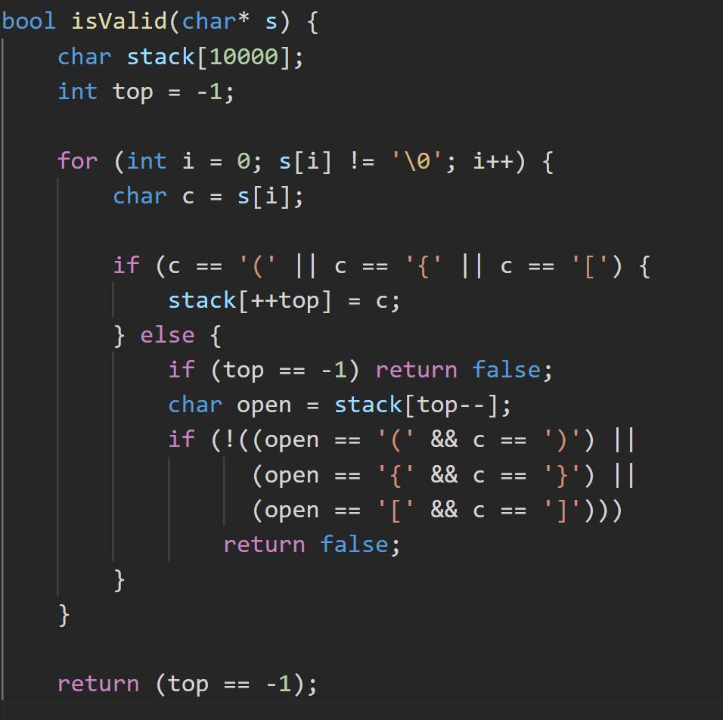 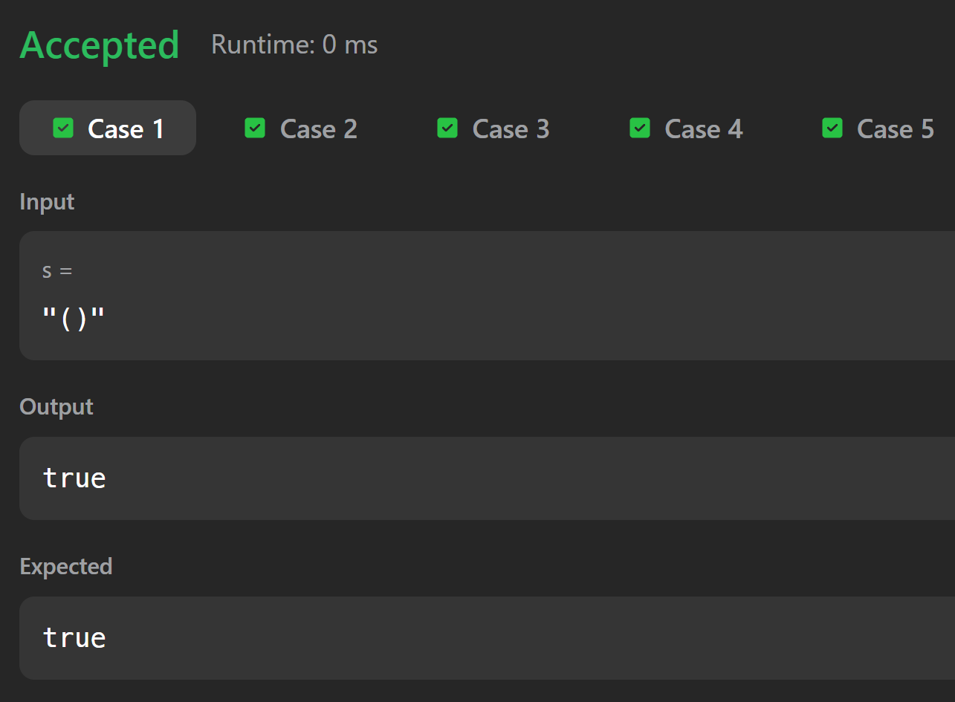

- Baseball Game
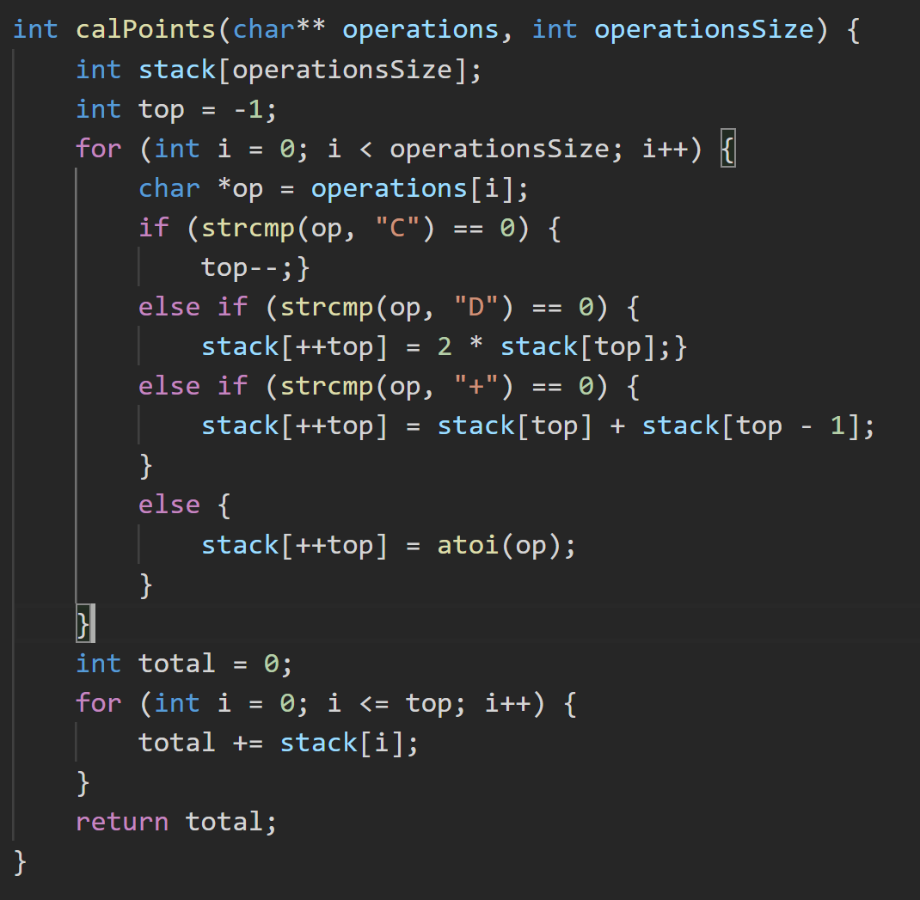
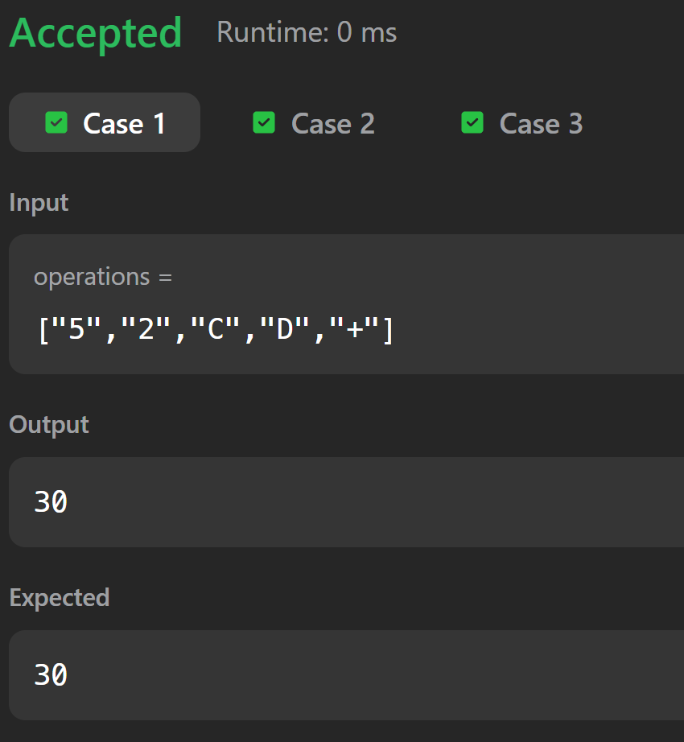

- Remove all adjacent duplicates in string 