Name : Devngi Borad
Subject : Data Structure (2CS501)
Practical no.: 4A
AIM : Create simple Queue data structure using Array/Linked List and implement following functions:
i. Enque ii. Dequeue iii. Display
INPUT :
#include<stdio.h>
#define MAX 100
int queue[MAX], front=-1, rear=-1,n;
int enqueue(int value, int n){
if(rear == n-1) {
printf("Queue is full!!\n");
return -1; }
front = 0;
rear++;
queue[rear] = value;}
int dequeue(){
if(rear == -1) {
printf("Queue is empty!!\n");
return -1; }
int value = queue[front];
front++;
return value;}
void display(){
for(int i = front; i<n; i++) {
printf("%d ", queue[i]); }}

int main(){
int value[MAX];
printf("Enter the number of elements to be pushed: ");
scanf("%d",&n);
for(int i=0; i<n; i++) {
printf("Enter the value %d: ",i+1);
scanf("%d", &value[i]);
enqueue(value[i], n); }
printf("Popped element is %d\n", dequeue());
printf("next element is now %d\n", queue[front]);
printf("Elements in the queue are: ");
display();
return 0;}
OUTPUT :
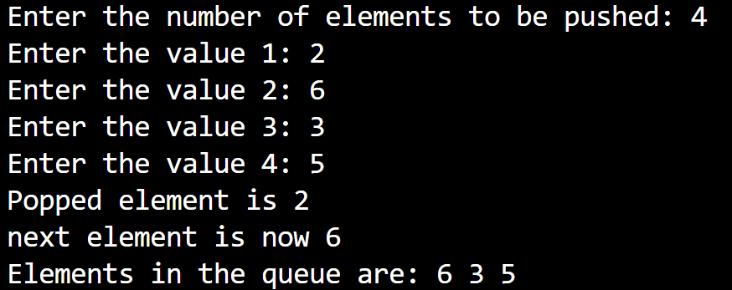

Practical no.: 4B
AIM : Create double ended queue data structure using Linked List and implement following functions:
i. Insert front ii. Insert rear iii. Delete front iv. Delete rear v. Display
Implement following programs related to Queue data structure

INPUT :
#include<stdio.h>
#include<stdlib.h>
typedef struct node{
int data;
struct node* next;
struct node* prev;
}node;
node* front = NULL;
node* rear = NULL;
node* createNode(int value){
node* newNode = (node*)malloc(sizeof(node));
if(!newNode){
printf("memory allocation is failed!!");
exit(1);}
newNode -> data = value;
newNode -> next = newNode -> prev = NULL;
return newNode;}
void insertfront(int value){
node* newNode = createNode(value);
if(front == NULL){
front = rear = newNode;
front -> next = rear -> next = NULL;
front -> prev = rear -> prev = NULL;
return;}
newNode -> next = front;
front -> prev = newNode;
front = newNode;}
void insertend(int value){
node* newNode = createNode(value);
if (rear == NULL){
front = rear = newNode;
front -> next = rear -> next = NULL;
front -> prev = rear -> prev = NULL;
return;}
newNode -> prev = rear;
rear -> next = newNode;
rear = newNode;}
void deletefront(){
if(front == NULL){
printf("queue is empty!!");
return;}
node* temp = front;
front = front -> next;
if(front)
front -> prev = NULL;
else
rear = NULL;
free(temp);}
void deleteend(){
if(rear == NULL){
printf("queue is empty!!");
return;}
node* temp = rear;
rear = rear -> prev;
if(rear)
rear -> next = NULL;
else
front = NULL;
free(temp);}
node* printList(){
node* temp;
printf("Linked list contents:\n");
temp = front;
while (temp != NULL) {
printf("%d ", temp->data);
temp = temp->next; }
printf("\n \n");
return front;}
int main(){
while(1) {
int n,value;
printf("enter the choice : \n1. insert at front\n2. insert at end\n3. delete from front\n4. delete from end\n5. print deque\n6. exit\n");
scanf("%d",&n);
switch(n) {
case 1:
printf("enter the value to be inserted : ");
scanf("%d", &value);
insertfront(value);
break;
case 2:
printf("enter the value to be inserted : ");
scanf("%d", &value);
insertend(value);
break;
case 3:
deletefront();
printf("deletation from front is sucessfully excuted!!\n ");
break;
case 4:
deleteend();
printf("deletation from end is sucessfully excuted!!\n ");
break;
case 5:
if(front==NULL){
printf("Link List Doesn't exit!\n");
break; }
front=printList();
break;
case 6:
exit(0);
default:
printf("invalid input!!"); } }
return 0;}

OUTPUT :
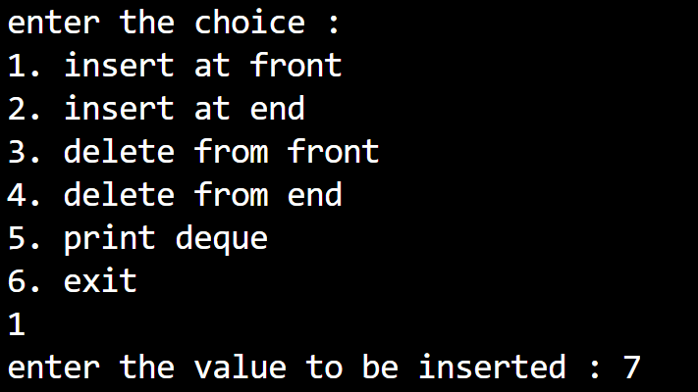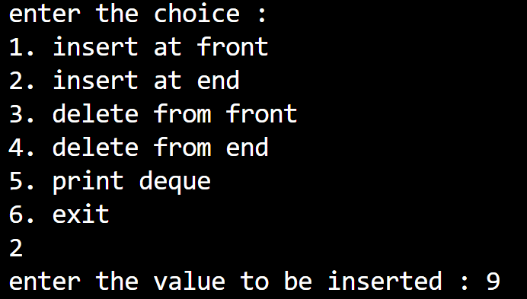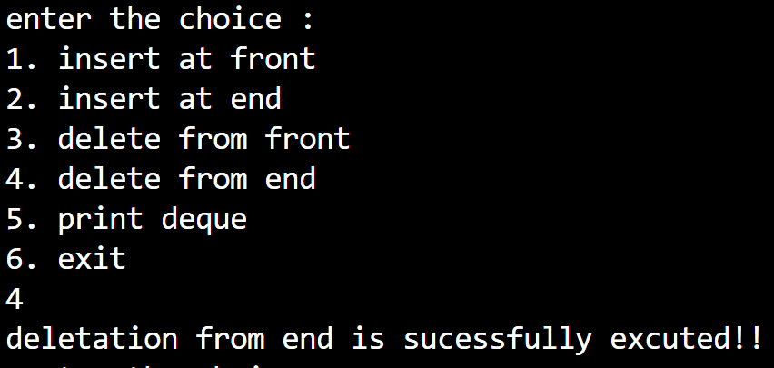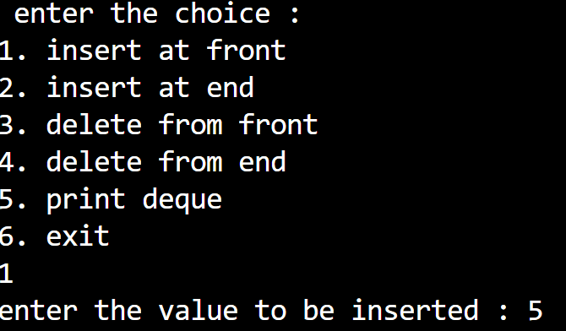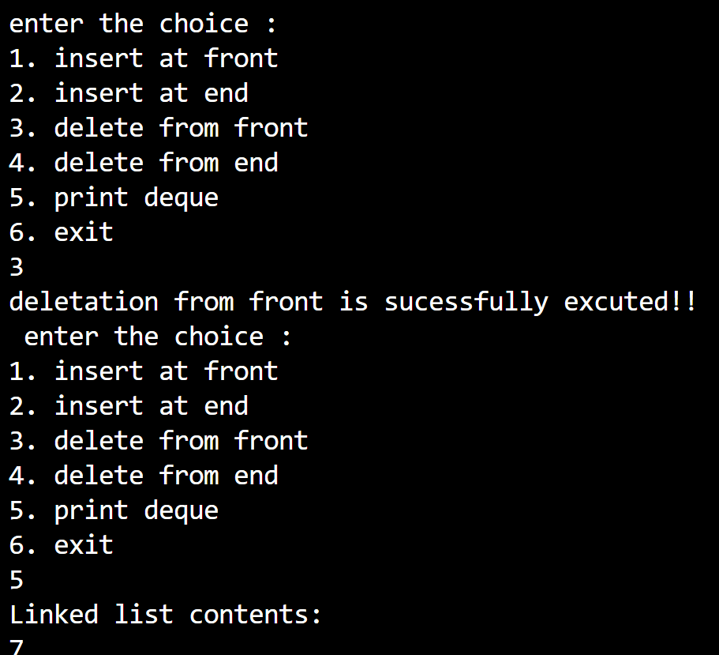

LEETCODE
- Design Circular Queue
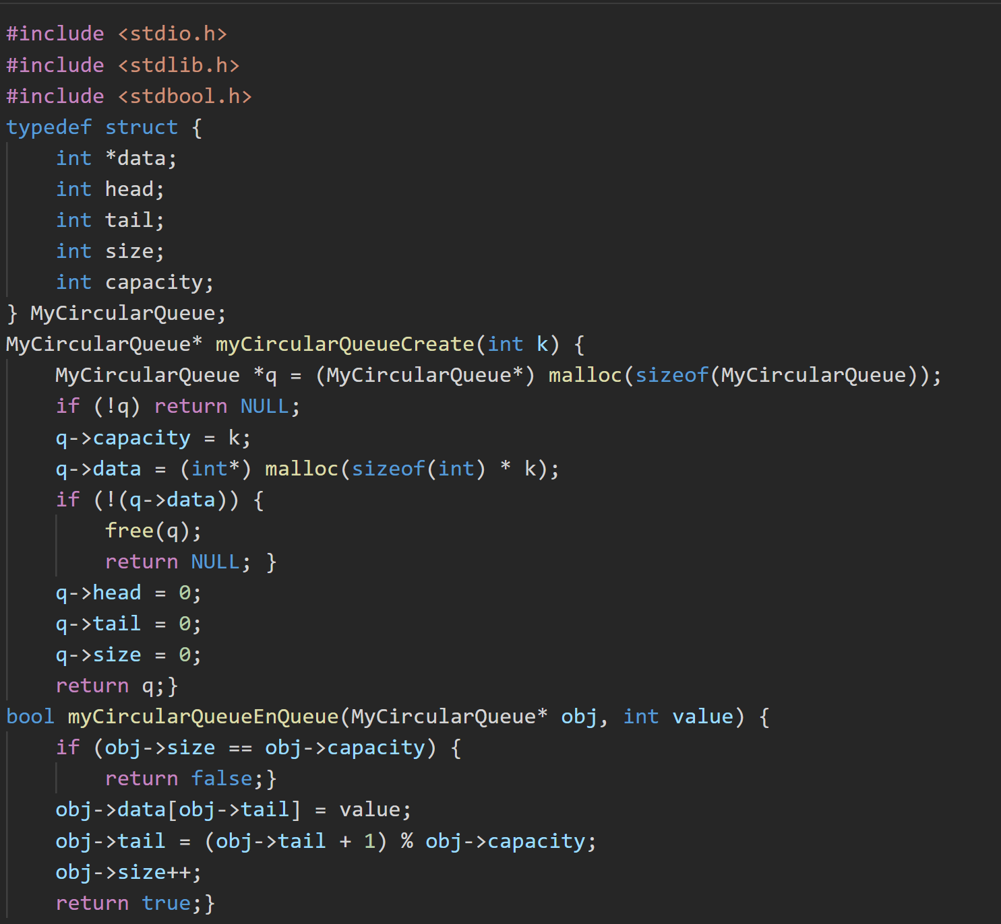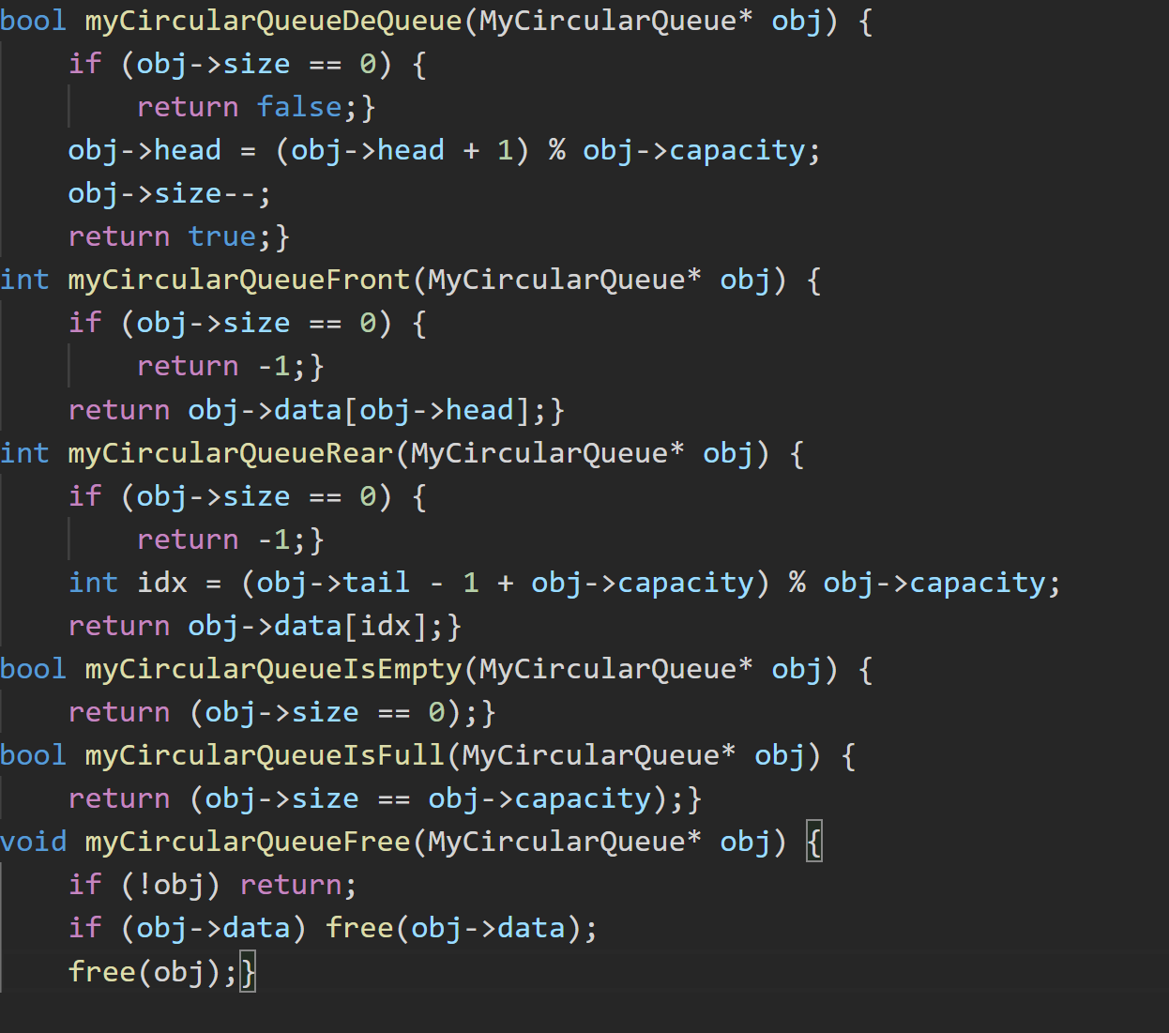
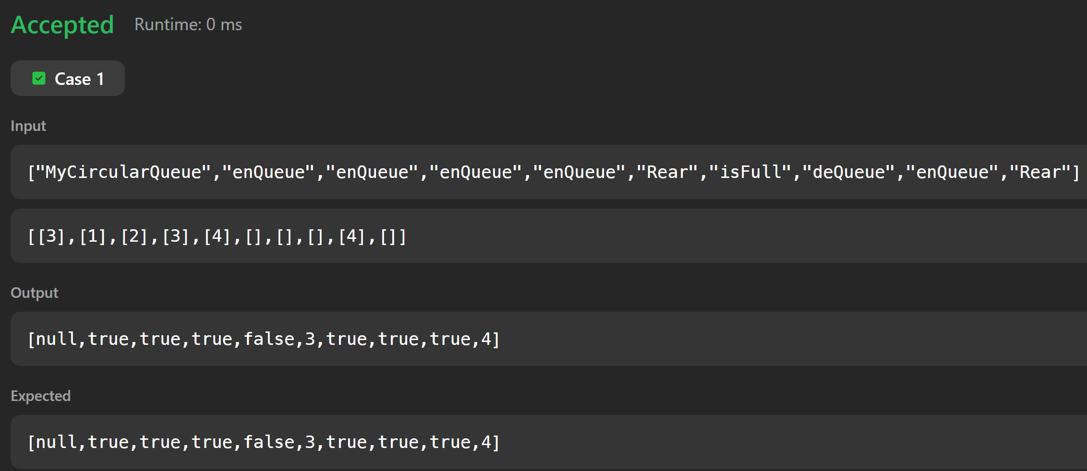
- First Unique Character in a String
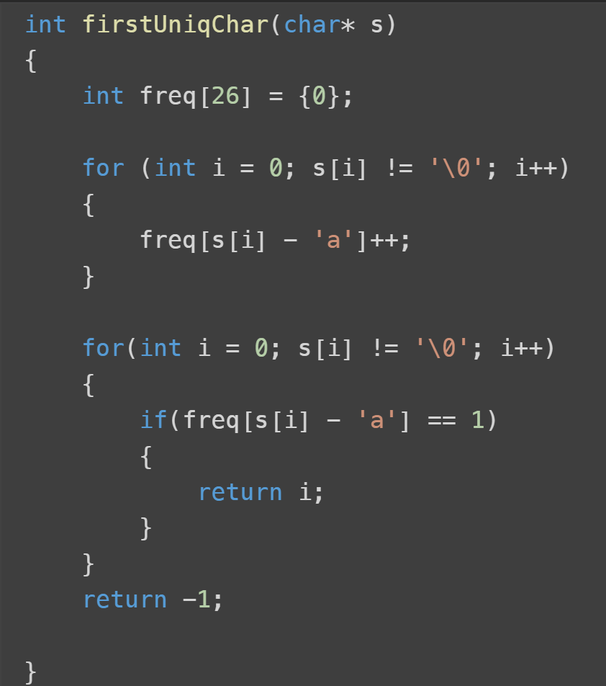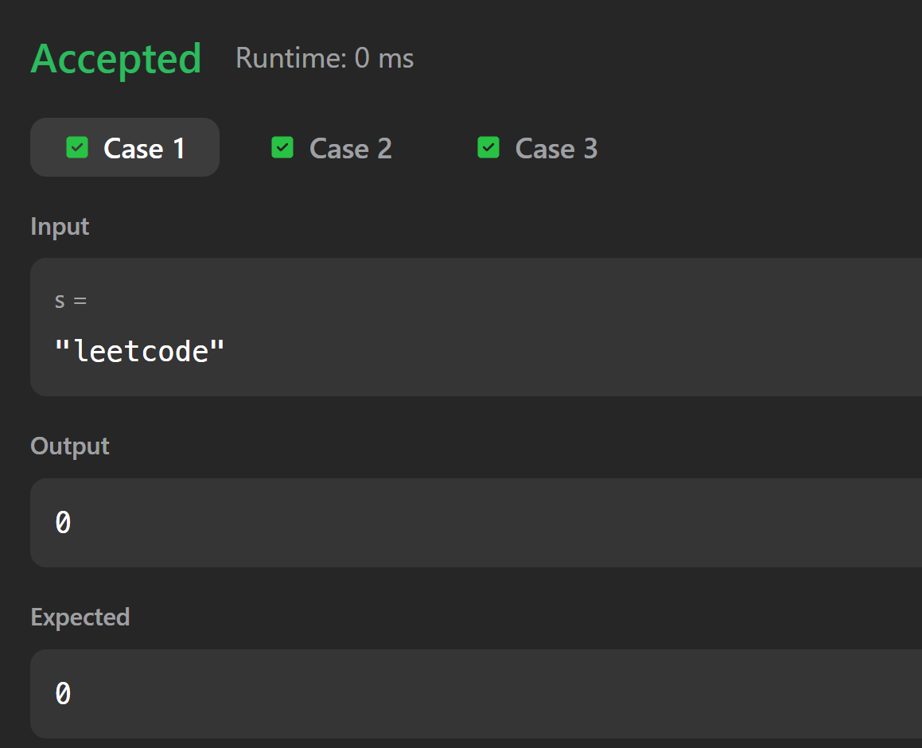

- Number of Students unable to eat Lunch
