Name : Devngi Borad
Subject : Data Structure (2CS501)
Roll no : 24BAM032
---------------------------------------------------------------------------------------------- a. Write a program to create a binary tree and traverse it using the traversal techniques(Preorder, Inorder, Postorder).

Code:
#include <stdio.h>
#include <stdlib.h>

struct node{
int data;
struct node* left;
struct node* right;
};

struct node* createnode(int val){
struct node* newnode=(struct node*)malloc(sizeof(struct node));
if (newnode == NULL) {

return NULL;
}
newnode->data=val;
newnode->left=NULL;
newnode->right=NULL;
return newnode;
}

void addleft(struct node* root,int val){
if(root->left!=NULL){
printf("u can not add");
return;
}
root->left=createnode(val);

}
void addright(struct node* root,int val){
if(root->right!=NULL){
printf("u can not add");
return;
}
root->right=createnode(val);

}

void preorder(struct node* tree){
if(tree==NULL){

return;
}
printf("%d",tree->data);
preorder(tree->left);
preorder(tree->right);

}
void inorder(struct node* tree){
if(tree==NULL){

return;
}

inorder(tree->left);
printf("%d",tree->data);
inorder(tree->right);

}
void postorder(struct node* tree){
if(tree==NULL){

return;
}

postorder(tree->left);
postorder(tree->right);
printf("%d",tree->data);

}
void printtree(struct node* tree) {
if (tree == NULL) {
return;
}
printf("%d ", tree->data);
printtree(tree->left);
printtree(tree->right);
}
int main(){

struct node* tree = createnode(1);
addleft(tree,2);
addleft(tree,3);
addright(tree,4);
//printtree(tree);
printf("\n inorder");
inorder(tree);
printf("\n preorder");
preorder(tree);
printf("\n postorder");
postorder(tree);

return 0;
}

Output:
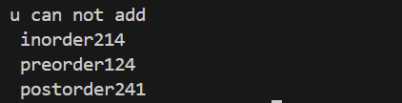
b. Write a program to construct a binary tree from the given preorder and inorder traversal sequence.

Code:
#include <stdio.h>
#include <stdlib.h>

struct TreeNode {
int val;
struct TreeNode *left;
struct TreeNode *right;
};

struct TreeNode* createNode(int value) {

struct TreeNode* newNode = (struct TreeNode*)malloc(sizeof(struct TreeNode));
if (newNode == NULL) {
printf("Memory allocation failed!\n");
exit(1);
}
newNode->val = value;
newNode->left = NULL;
newNode->right = NULL;
return newNode;
}

int findPosition(const int* inorder, int start, int end, int value) {
for (int i = start; i <= end; ++i) {
if (inorder[i] == value) {
return i;
}
}
return -1;
}

struct TreeNode* buildTree(const int* preorder, const int* inorder,int* preorderIndex, int inorderStart, int inorderEnd) {

if (inorderStart > inorderEnd) {
return NULL;
}

int rootValue = preorder[(*preorderIndex)];

(*preorderIndex)++;

struct TreeNode* root = createNode(rootValue);

int positionInorder = findPosition(inorder, inorderStart, inorderEnd, rootValue);

root->left = buildTree(preorder, inorder, preorderIndex, inorderStart, positionInorder - 1);

root->right = buildTree(preorder, inorder, preorderIndex, positionInorder + 1, inorderEnd);

return root;
}

void printPostorder(struct TreeNode* node) {
if (node == NULL) {
return;
}
printPostorder(node->left);
printPostorder(node->right);
printf("%d ", node->val);
}

void deleteTree(struct TreeNode* node) {
if (node == NULL) {
return;
}
deleteTree(node->left);
deleteTree(node->right);
free(node); // Use free() in C
}

int main() {

int preorder[] = {3, 9, 20, 15, 7};
int inorder[] = {9, 3, 15, 20, 7};

int n = sizeof(preorder) / sizeof(preorder[0]);

printf("Given Preorder: ");
for (int i = 0; i < n; i++) printf("%d ", preorder[i]);
printf("\n");

printf("Given Inorder: ");
for (int i = 0; i < n; i++) printf("%d ", inorder[i]);
printf("\n");

int preorderIndex = 0;
struct TreeNode* root = buildTree(preorder, inorder, &preorderIndex, 0, n - 1);

printf("\nPostorder traversal of the constructed tree: ");
printPostorder(root);
printf("\n");

deleteTree(root);

return 0;
}

Output:
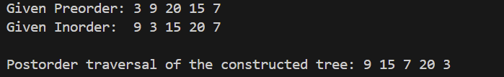

LEETCODE
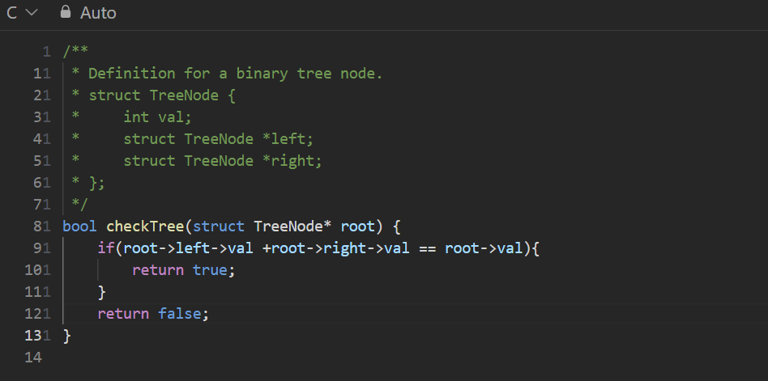
- Roots equals number of children

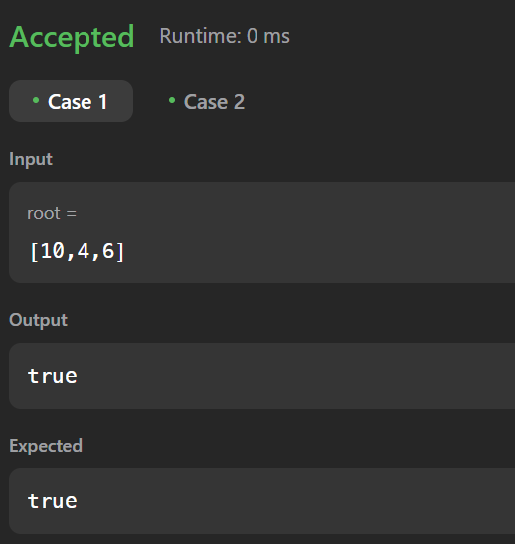

- Count complete tree nodes
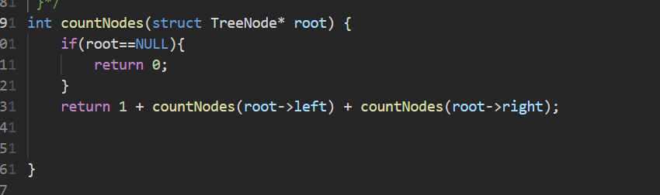

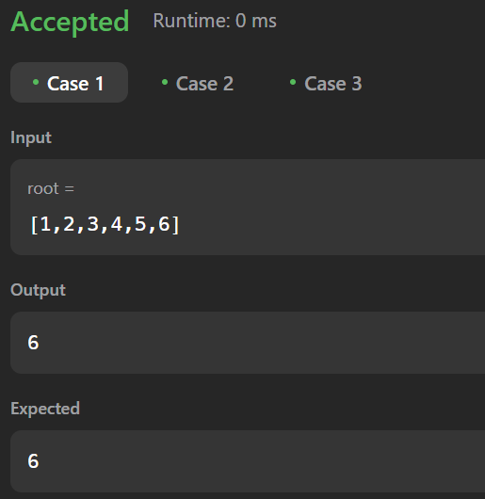

- Flatten binary tree to linked list
