TUTORIAL 10- TREES AND GRAPH

1) Consider the following rooted m-ary Tree as shown in Figure 1. Is the rooted tree above a full m-ary tree for some positive integer m?

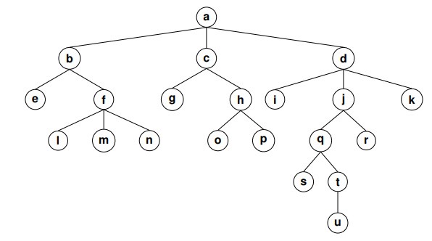
Figure 1

2) Prove that the sum of the degrees of all the vertices of the tree with n vertices is 2n-2.

3) Use Prim’s algorithm to find a minimum spanning tree for the given weighted graph
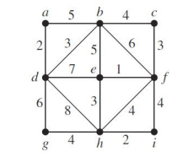
Figure 3

4) Use Kruskal’s algorithm to find a minimum spanning tree for the weighted graph given above

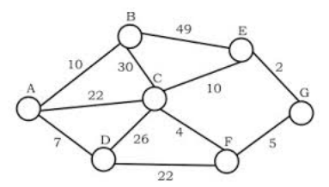
Figure 4

5. Show that if G is a bipartite simple graph with v vertices and e edges, then e ≤ v2/4.
6. Determine whether the given pair of graphs is isomorphic. Exhibit an isomorphism or provide a rigorous argument that none exists.
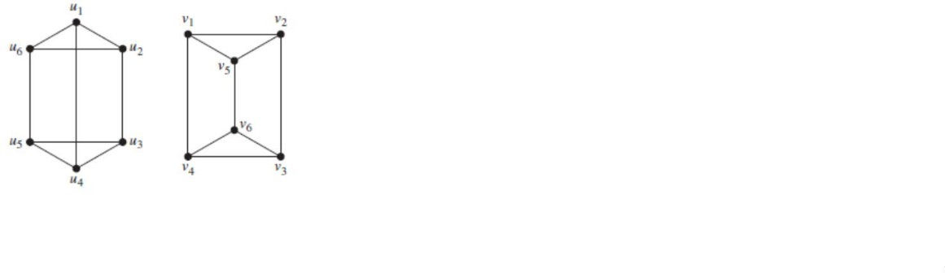

7. Do the graphs given below have a Hamilton path? If so, find such a path. If it does not, give an argument to show why no such path exists.
