2CS502CC25 – OBJECT ORIENTED PROGRAMMING

Name : Khush Pithva
Roll no.: 24BCE174
Semester: III
Practical no.: 8
AIM:Write a program to demonstrate type conversion between basic and user-defined data types
Code:
#include <iostream>
using namespace std;

class Complex {
float real;
float imag;

public:
Complex(float r = 0.0, float i = 0.0) {
real = r;
imag = i;
}

void display() {
cout << real << " + " << imag << "i" << endl;
}

operator float() {
return real;
}
};

int main() {
int a;
float b;

cout << "Enter an integer: ";
cin >> a;

b = a;
cout << "Implicit conversion from int to float: b = " << b << endl;

float c;
cout << "Enter a float: ";
cin >> c;

int d = (int)c;
cout << "Explicit conversion from float to int: d = " << d << endl;

float r, i;
cout << "Enter real part of complex number: ";
cin >> r;
cout << "Enter imaginary part of complex number: ";
cin >> i;

Complex comp1(r, i);
cout << "Complex number entered: ";
comp1.display();

float realPart = comp1;
cout << "Conversion from Complex to float (real part): " << realPart << endl;

return 0;
}
Output:
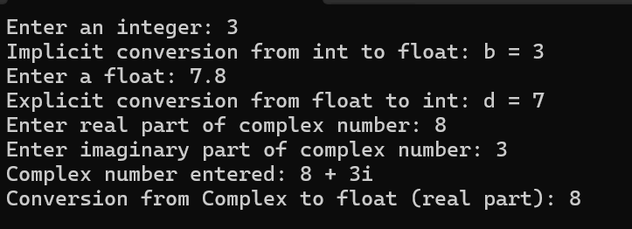
Conclusion:
In this program, we explored how C++ lets us convert between basic types and our own custom types. Some conversions happen automatically, while others we do manually. Using constructors and type conversion operators, we can switch between basic and user-defined types easily. Taking input from the user made these conversions clear and practical.

