2CS502CC25 – OBJECT ORIENTED PROGRAMMING

Name: Khush Pithva
Roll no.: 24BCE174
Semester: III
Practical no.: 9
9(a):Create a base class 'Person' and a derived class 'Student' to demonstrate single inheritance.
Code:
#include <iostream>
#include <string>
using namespace std;
class Person {
protected:
string name;
int age;
public:
void getData() {
cout << "Enter Name: ";
getline(cin, name);
cout << "Enter Age: ";
cin >> age;
cin.ignore();
}
void display() {
cout << "Name: " << name << "\nAge: " << age << endl;
}
};
class Student : public Person {
private:
int rollNumber;
public:
void getData() {
Person::getData();
cout << "Enter Roll Number: ";
cin >> rollNumber;
}
void display() {
cout << "\n=== Student Information ===" << endl;
Person::display();
cout << "Roll Number: " << rollNumber << endl;
}
};
int main() {
Student s;
s.getData();
s.display();
return 0;
}
Output:
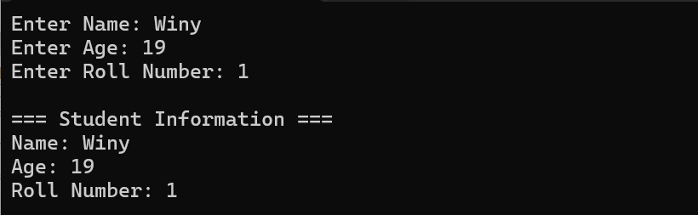
9(b):Write a program with two base classes 'Person' and 'Marks', and a derived class 'Result' using multiple inheritance.
Code:
#include <iostream>
#include <string>
using namespace std;

class Person {
protected:
string name;
int age;
public:
void getPersonData() {
cout << "Enter Name: ";
getline(cin, name);
cout << "Enter Age: ";
cin >> age;
cin.ignore();
}
void displayPerson() {
cout << "Name: " << name << "\nAge: " << age << endl;
}
};

class Marks {
protected:
float marks[6];
public:
void getMarks() {
cout << "Enter marks of 6 subjects: ";
for (int i = 0; i < 6; i++) {
cin >> marks[i];
}
}
void displayMarks() {
cout << "Marks: ";
for (int i = 0; i < 6; i++) {
cout << marks[i] << (i < 5 ? ", " : "");
}
cout << endl;
}
};

class Result : public Person, public Marks {
float percentage, cgpa;
string grade, meaning;
int gradePoint;
public:
void calculate() {
float sum = 0;
for (int i = 0; i < 6; i++) {
sum += marks[i];
}
percentage = sum / 6;
cgpa = percentage / 9.5;

if (percentage >= 91) { grade = "O"; meaning = "Outstanding"; gradePoint = 10; }
else if (percentage >= 81) { grade = "A+"; meaning = "Excellent"; gradePoint = 9; }
else if (percentage >= 71) { grade = "A"; meaning = "Very Good"; gradePoint = 8; }
else if (percentage >= 61) { grade = "B+"; meaning = "Good"; gradePoint = 7; }
else if (percentage >= 51) { grade = "B"; meaning = "Above Average"; gradePoint = 6; }
else if (percentage >= 46) { grade = "C"; meaning = "Average"; gradePoint = 5; }
else if (percentage >= 40) { grade = "P"; meaning = "Pass"; gradePoint = 4; }
else { grade = "F"; meaning = "Fail"; gradePoint = 0; }
}

void displayResult() {
cout << "\n=== Result ===" << endl;
displayPerson();
displayMarks();
cout << "Percentage: " << percentage << "%" << endl;
cout << "CGPA: " << cgpa << endl;
cout << "Grade: " << grade
<< " (" << meaning << ")" << endl;
cout << "Grade Point: " << gradePoint << endl;
}
};

int main() {
Result r;
r.getPersonData();
r.getMarks();
r.calculate();
r.displayResult();
return 0;
}
Output:
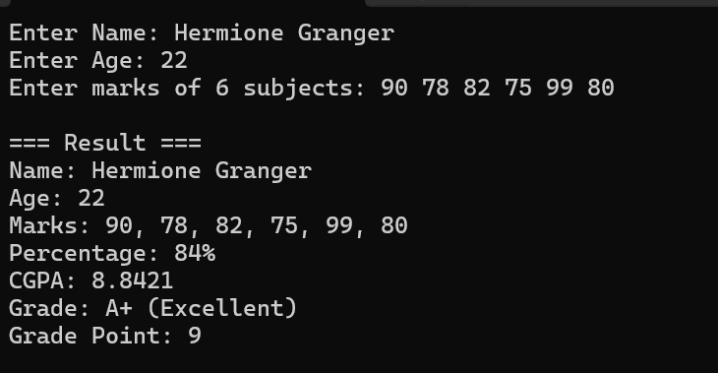

9(c):Develop a program with a base class 'Shape' and derived classes 'Circle', 'Square' to demonstrate hierarchical inheritance
Code:
#include <iostream>
#include <cmath>
using namespace std;
class Shape {
protected:
float length;
public:
virtual void getData()=0;
virtual void area()=0;
};
class Circle:public Shape {
public:
void getData() {
cout<<"Enter radius of Circle: ";
cin>>length;
}
void area() {
cout<<"Area of Circle: "<<3.14159*length*length<<endl;
}
};
class Square:public Shape {
public:
void getData() {
cout<<"Enter side of Square: ";
cin>>length;
}
void area() {
cout<<"Area of Square: "<<length*length<<endl;
}
};
int main() {
Circle c;
Square s;
cout<<"--- Circle ---"<<endl;
c.getData();
c.area();
cout<<"\n--- Square ---"<<endl;
s.getData();
s.area();
return 0;
}

Output:
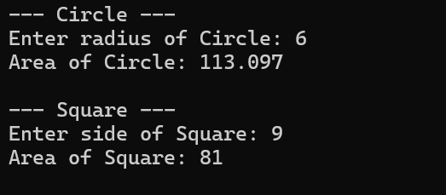
9(d):Define an abstract class 'Shape' with a pure virtual function area(), and derive classes 'Triangle', 'Rectangle' to implement it.
Code:
#include <iostream>
using namespace std;

class Shape {
public:
virtual double computeArea() = 0;
virtual ~Shape() {}
};

class Triangle : public Shape {
double b, h;
public:
Triangle(double x, double y) : b(x), h(y) {}
double computeArea() override { return 0.5 * b * h; }
};

class Rectangle : public Shape {
double w, l;
public:
Rectangle(double x, double y) : w(x), l(y) {}
double computeArea() override { return w * l; }
};

int main() {
double tb, th, rw, rl;

cout << "Enter base and height of triangle: ";
cin >> tb >> th;

cout << "Enter width and length of rectangle: ";
cin >> rw >> rl;

Shape* tri = new Triangle(tb, th);
Shape* rec = new Rectangle(rw, rl);

cout << "Triangle Area: " << tri->computeArea() << "\n";
cout << "Rectangle Area: " << rec->computeArea() << "\n";

delete tri;
delete rec;
return 0;
}
Output:
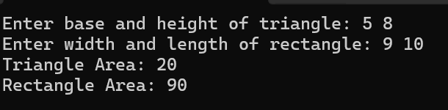

9(e):Implement the concept of virtual base classes.
Code:
#include <iostream>
using namespace std;

class Person {
public:
string name;
Person(string n) : name(n) {}
void showName() { cout << "Name: " << name << endl; }
};

class Student : virtual public Person {
public:
int roll;
Student(string n, int r) : Person(n), roll(r) {}
void showRoll() { cout << "Roll: " << roll << endl; }
};

class Employee : virtual public Person {
public:
int empId;
Employee(string n, int id) : Person(n), empId(id) {}
void showEmpId() { cout << "Employee ID: " << empId << endl; }
};

class WorkingStudent : public Student, public Employee {
public:
WorkingStudent(string n, int r, int id)
: Person(n), Student(n, r), Employee(n, id) {}
};

int main() {
string name;
int roll, empId;

cout << "Enter name: ";
cin >> name;

cout << "Enter roll number: ";
cin >> roll;

cout << "Enter employee ID: ";
cin >> empId;

WorkingStudent ws(name, roll, empId);
ws.showName();
ws.showRoll();
ws.showEmpId();

return 0;
}

Output:
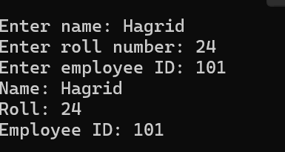

Conclusion:
These programs show how inheritance makes C++ organized and flexible. Single inheritance reuses features, multiple inheritance combines them, and hierarchical inheritance shares a base with many derived classes. Abstract classes define common interfaces, and virtual base classes prevent duplicates, making code cleaner and easier to manage.

