2CS502CC25 – OBJECT ORIENTED PROGRAMMING

Name: Khush Pithva
Roll no.: 24BCE174
Semester: III
Practical no.: 10
10(a):Create a class 'Employee' and use a pointer to object to access and display its data members.
Code:
#include <iostream>
using namespace std;

class Employee {
private:
int id;
string name;
float salary;

public:
void setData() {
cout << "Enter Employee ID: ";
cin >> id;
cout << "Enter Employee Name: ";
cin >> name;
cout << "Enter Employee Salary: ";
cin >> salary;
}

void displayData() {
cout << "\n--- Employee Details ---\n";
cout << "ID: " << id << endl;
cout << "Name: " << name << endl;
cout << "Salary: " << salary << endl;
}
};

int main() {
Employee emp;
Employee *ptr;
ptr = &emp;

cout << "Enter details of the employee:\n";
ptr->setData();

cout << "\nDisplaying employee details using pointer:\n";
ptr->displayData();

return 0;
}
Output:
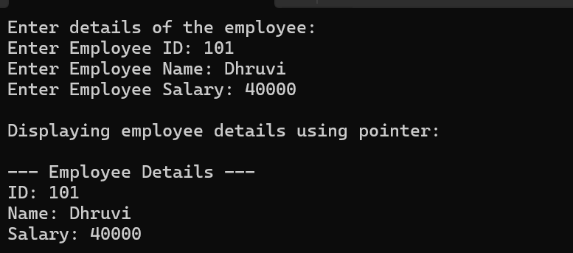
10(b): Write a program to access private members of a class using pointer to member function.
Code:
#include <iostream>
using namespace std;

class Employee {
private:
int id;
string name;

public:
void setData(int i, string n) {
id = i;
name = n;
}

void display() {
cout << "\nEmployee ID: " << id;
cout << "\nEmployee Name: " << name << endl;
}
};

int main() {
Employee emp;
Employee *ptr = &emp;

void (Employee::*setPtr)(int, string) = &Employee::setData;
void (Employee::*showPtr)() = &Employee::display;

(ptr->*setPtr)(101, "Harshi");
(ptr->*showPtr)();

return 0;
}
Output:
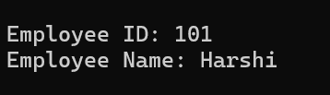

10(c): Create a base class with a virtual function and derive class to override it, demonstrating runtime polymorphism
Code:
#include <iostream>
using namespace std;

class Shape {
public:
virtual void area() {
cout << "Calculating area of a generic shape" << endl;
}
};

class Circle : public Shape {
public:
void area() override {
cout << "Area of Circle = π * r * r" << endl;
}
};

class Rectangle : public Shape {
public:
void area() override {
cout << "Area of Rectangle = length * breadth" << endl;
}
};

int main() {
Shape *ptr;

Circle c;
Rectangle r;

ptr = &c;
cout << "Using base pointer to Circle object:\n";
ptr->area(); // Calls Circle’s version

ptr = &r;
cout << "\nUsing base pointer to Rectangle object:\n";
ptr->area(); // Calls Rectangle’s version

return 0;
}
Output:
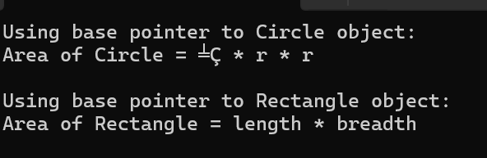

10(d): Write a program to demonstrate virtual function behavior when called through base class pointer pointing to derived class object.
Code:
#include <iostream>
using namespace std;

class Base {
public:
virtual void show() {
cout << "Base class show() function called" << endl;
}
};

class Derived : public Base {
public:
void show() override {
cout << "Derived class show() function called" << endl;
}
};

int main() {
Base *ptr;
Derived d;

ptr = &d;

cout << "Calling function using base class pointer pointing to derived object:\n";
ptr->show();

return 0;
}
Output:
Conclusion:
Virtual functions let a base class pointer automatically call the right function from a derived class, even when we don’t know the exact type at compile time. This happens behind the scenes using a table of function addresses, making the program smart enough to pick the correct function at runtime. Without virtual, it would always call the base class version. In short, virtual functions make C++ programs more flexible, reusable, and truly object-oriented.

