Date: 12/9/2025
Roll No. and Name: 24BCE174 and Khush Pithva
Course Code and Name: 2CS502CC25 and Object Oriented Programming
Practical No: 6(a)
AIM: Create a class 'Counter' with a default constructor initializing count to zero, then increment and display the count.

Methodology followed:

#include <iostream>
using namespace std;

class Counter {
int count;
public:

Counter() : count(0) {}

void increment() {
count++;
}

void display() const {
cout << "Count: " << count << endl;
}
};

int main() {
Counter c;
c.increment();
c.display();
return 0;
}

Output:

Practical No: 6(b)
AIM:Develop a class 'Box' that uses a parameterized constructor to initialize length, breadth, and height, and display volume.

Methodology followed:
#include <iostream>
using namespace std;

class Box {
double length;
double breadth;
double height;

public:

Box(double l, double b, double h) : length(l), breadth(b), height(h) {}

double volume() const {
return length * breadth * height;
}

void displayVolume() const {
cout << "Volume of box: " << volume() << endl;
}
};

int main() {
double l, b, h;
cout << "Enter length, breadth and height of box: ";
cin >> l >> b >> h;

Box b1(l, b, h);
b1.displayVolume();

return 0;
}

Output:

Practical No: 6(c)

AIM: Write a program to define a class 'Point' and implement a copy constructor to initialize one object with another.

Methodology followed:
#include <iostream>
using namespace std;

class Point {
public:
int x;

Point(int val = 0) : x(val) {}

Point(const Point &p) {
x = p.x;
}
};

int main() {
Point p1(10);
cout << "p1 x: " << p1.x << endl;

Point p2(p1);
cout << "p2 x: " << p2.x << endl;

return 0;
}

Output:

Practical No: 6(d)

AIM: Create a class with a static variable to count how many objects were created using the constructor.

Methodology followed:
#include <iostream>
using namespace std;

class CountObjects {

static int count;

public:

CountObjects() {
count++;
}

static int getCount() {
return count;
}
};

int CountObjects::count = 0;

int main() {
CountObjects c1;
CountObjects c2;
CountObjects c3;

cout << "Number of objects created: " << CountObjects::getCount() << endl;

return 0;
}

Output:

Practical No: 6(e)

AIM: Develop a class with a constructor and destructor that display messages to show the order of their execution.

Methodology followed:

#include <iostream>
using namespace std;

class C {
public:

C() {
cout << "Constructor called" << endl;
}

~C() {
cout << "Destructor called" << endl;
}
};

int main() {
cout << "Program started." << endl;

C obj1;

cout << "Entering a new block..." << endl;
{
C obj2;
}

cout << "Back to main function." << endl;

return 0;
}

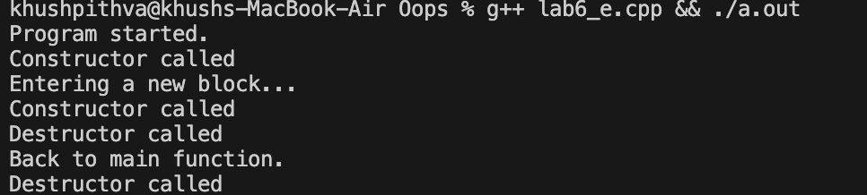
Output:
Conclusion:
This practical helped us understand the use of constructors, destructors, copy constructors, and static members in C++. It improved our logic for designing classes, managing objects, and demonstrating the order of execution in OOP.

