SPINEWELL DISC & JOINT CENTERS
Side by side: Dr. Dudum’s “Regain Grip Strength” and the SpineWell version
Left: what Dr. Dudum’s Short does, frame by frame. Right: the video Dr. Nathans can record, with a sketch of every shot. Vertical 9:16, 30 seconds, with a 15-second cut marked below.
Reference video: youtube.com/shorts/TL5PV3zk6uM · “Regain Grip Strength with Spinal Decompression for Neck Nerve Pain”
THE IDEA IN ONE LINE
Same story shape as Dudum: symptom, scan, fix, proof, ask. Told in Dr. Nathans’ words, on his own scan, with his own drawing and his own equipment.

1 · HOOK  0:00–0:06 | 2 · PROBLEM  0:06–0:13 | 3 · SOLUTION  0:13–0:20 | 4 · PROOF  0:20–0:27 | 5 · ASK  0:27–0:30
Orange = the 15-second cut (Beats 1 + 2 + 5). Same recording, just drop Beats 3 and 4.
WHAT WE CHANGE FROM DUDUM
- Dr. Nathans draws on the scan live. Dudum only points at it.
- Real SpineWell footage (the DRX9000 and the console) replaces the 3D animation.
- The proof is a measurement and a steady coffee cup, not a promise.
- The ask is a share plus one keyword, with a SpineWell end card.
The sketches are reference drawings of what to shoot, not final footage. Anything in [brackets] comes from the chart and is filled in by Dr. Nathans.

BEFORE RECORDING  - Neck MRI of the chosen patient loaded, taskbar hidden, screen glare off.  - Follow-up scan of the same patient and the measurement from the chart.  - A coffee cup and a staff hand for the grip B-roll.  - DRX9000 cervical session on video (consented patient or staff demo).  - Phone on a tripod. Vertical. Captions on, one keyword in orange #FF6F3C. | CONFIRM WITH DR. NATHANS  - Written patient authorization for the scans and the clip. Remove name, date of birth and record number from every image.  - The wording of every result: “designed to”, “results vary”. No cure or guarantee language.  - The keyword and number for the end card.  - If no follow-up scan exists, skip the numbers and use Beat 4 without the split screen.

BEAT 1 · HOOK
DR. DUDUM · 0:00–0:07 | SPINEWELL · 0:00–0:06
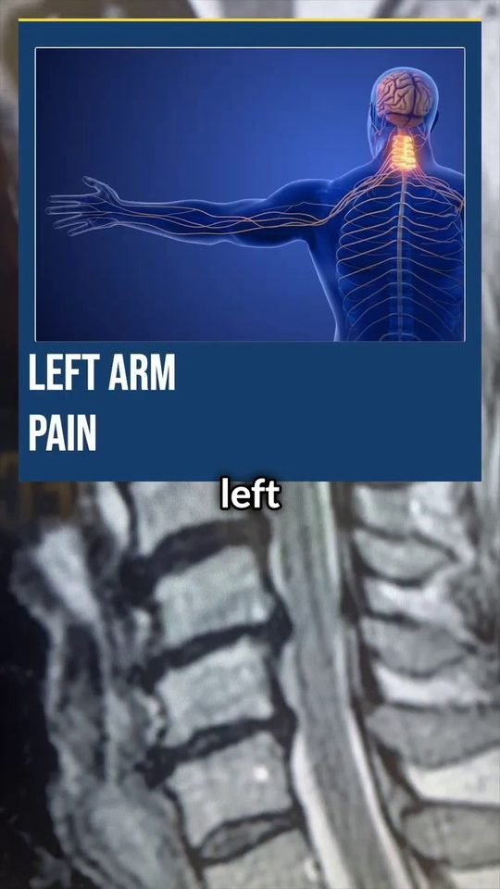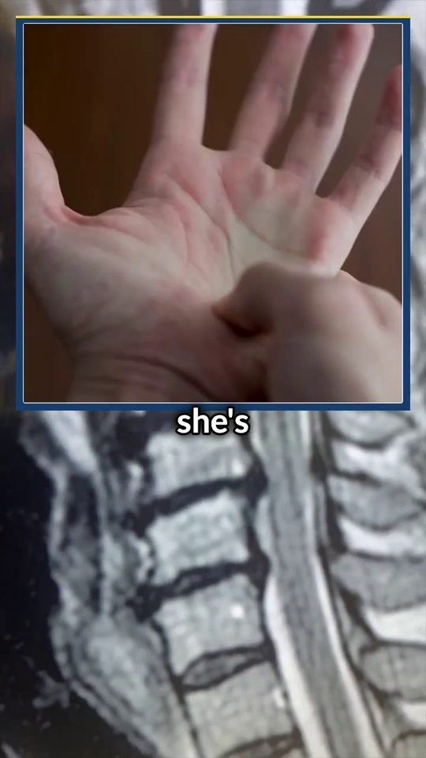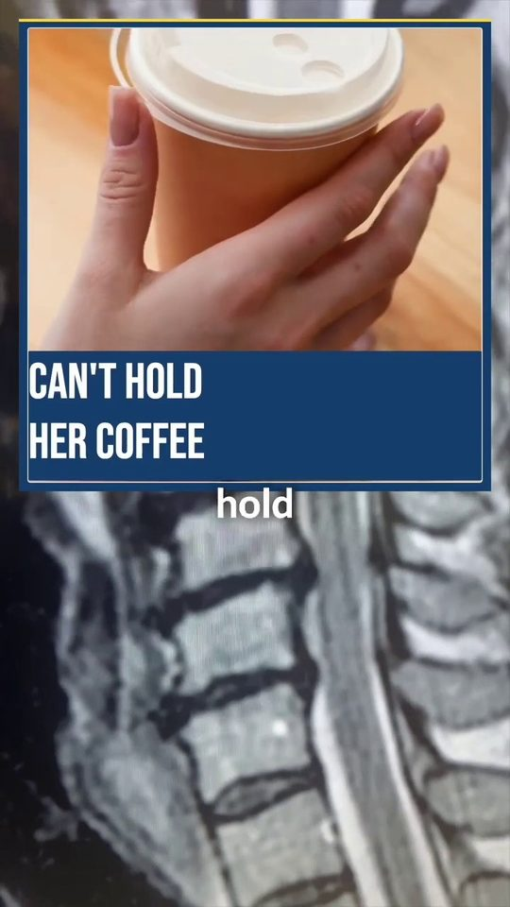 | 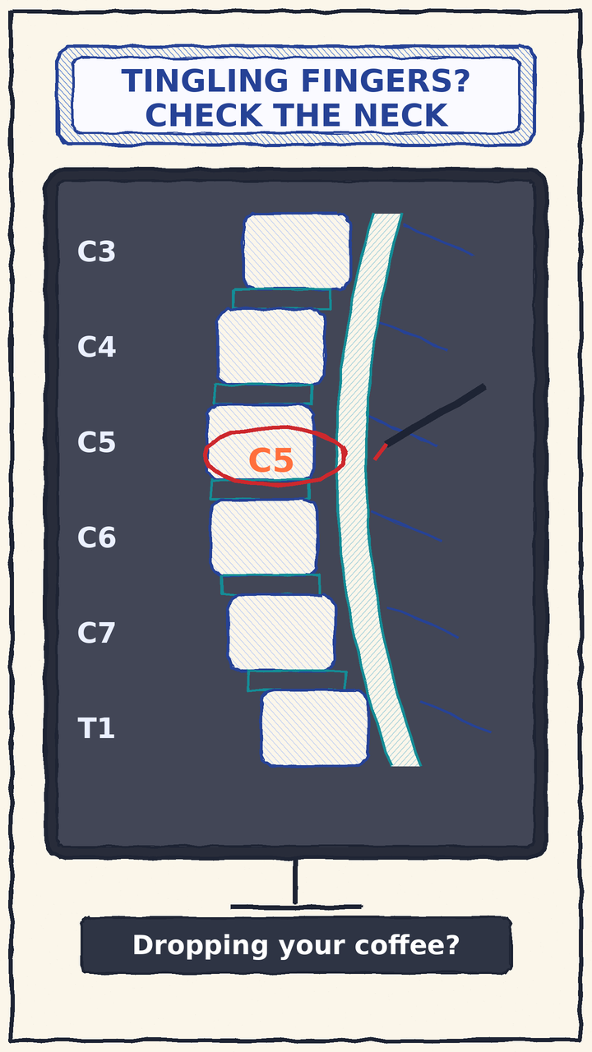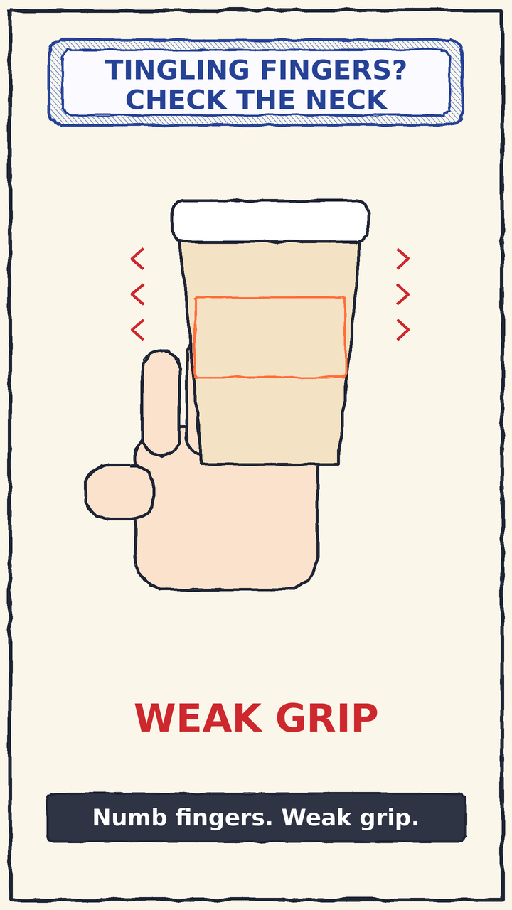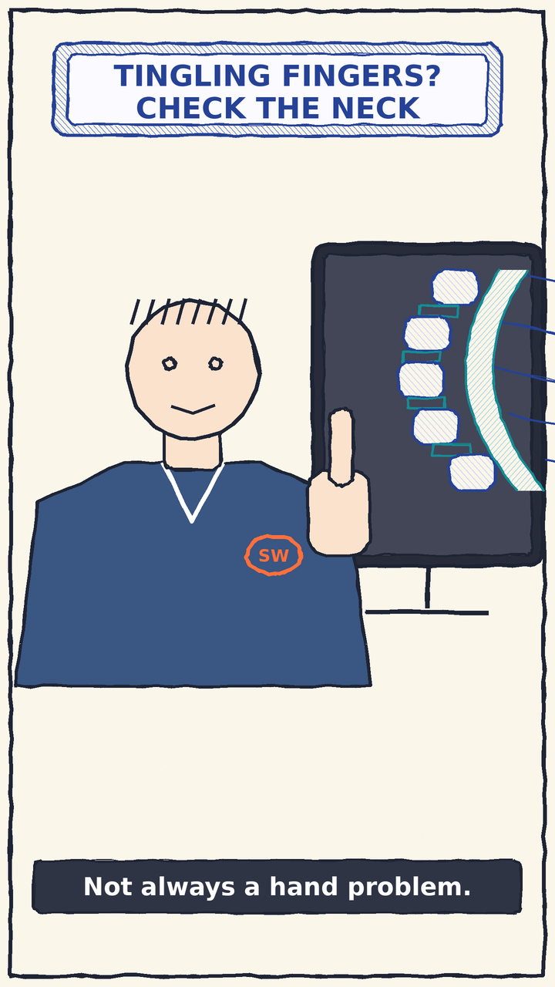
ON SCREEN  Three quick cuts over the same neck MRI: a 3D body graphic “LEFT ARM PAIN”, a weak hand “LOSING HER GRIP”, a trembling hand with a coffee cup “CAN’T HOLD HER COFFEE”. Word-by-word captions.  WHAT HE SAYS  Names the symptoms (left arm pain, shoulder-blade pain, weak grip) and the everyday moment: not being able to hold a coffee.  WHY IT WORKS  Opens on the patient’s daily life, not on the doctor. On-screen text works with the sound off. | ON SCREEN  Shot 1: a real neck MRI, pen already mid-stroke on C5, pinned pill on from frame 1. Shot 2: B-roll of a hand fumbling a coffee cup. Shot 3: Dr. Nathans at the monitor, finger raised.  LINE  “Dropping your coffee? Weak grip and numb fingers aren’t always a hand problem.”  YOU NEED  Neck MRI loaded · a coffee cup and a staff hand · phone on tripod

BEAT 2 · THE PROBLEM
DR. DUDUM · 0:08–0:13 | SPINEWELL · 0:06–0:13
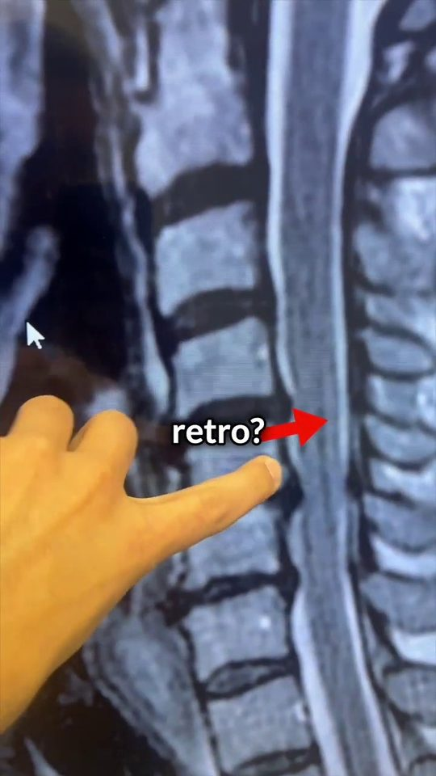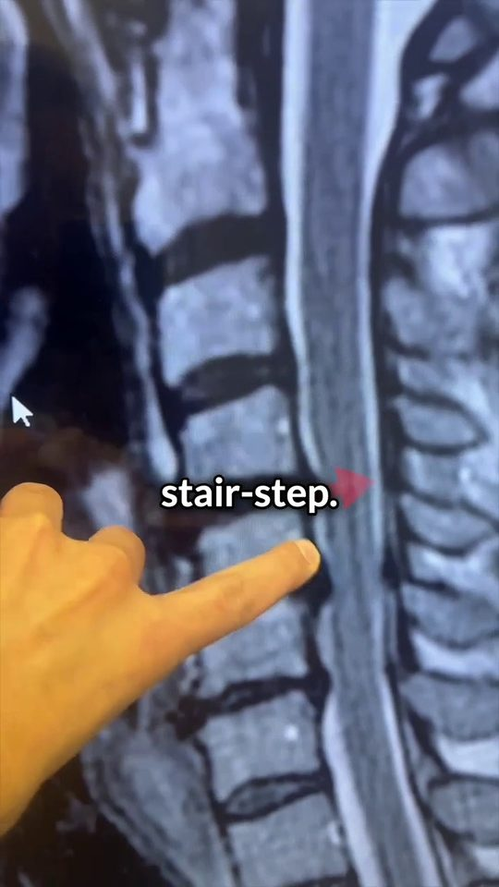 | 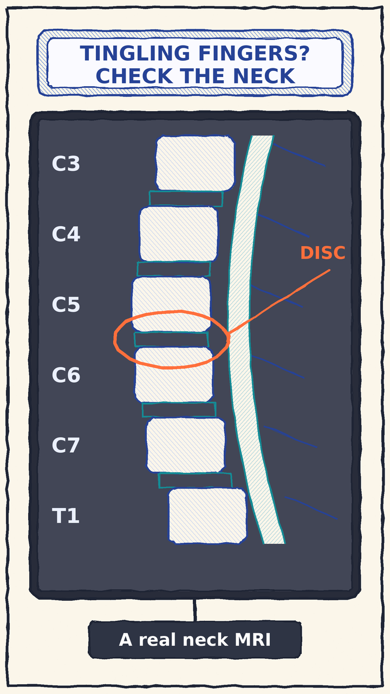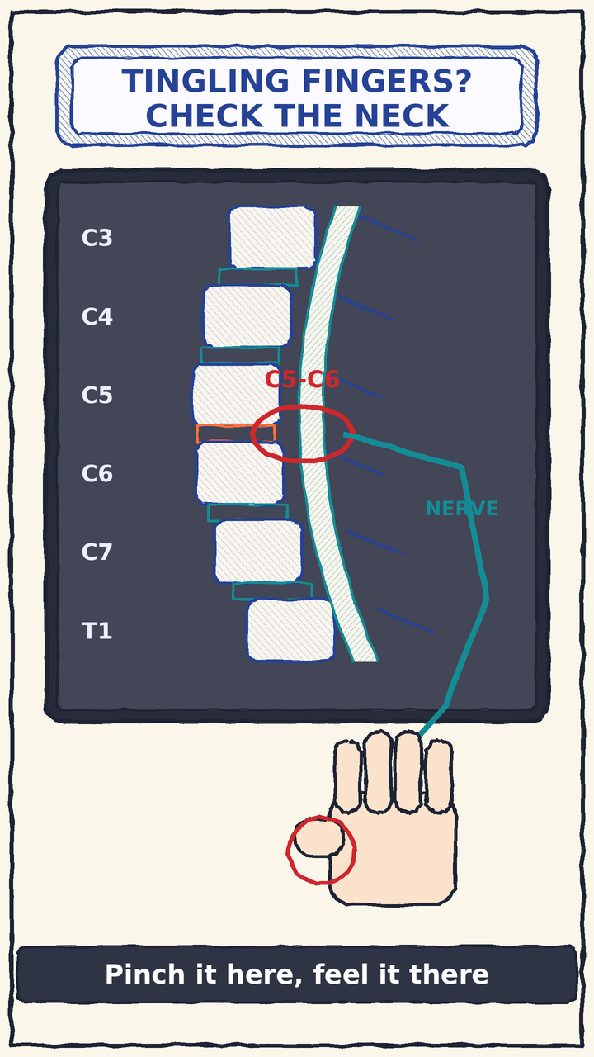
ON SCREEN  The doctor’s hand points at a real neck MRI. Captions “retro?” and “stair-step”, with a red arrow.  WHAT HE SAYS  Explains the finding: a vertebra sitting back out of line (retrolisthesis), described as a “stair-step”.  WHY IT WORKS  A real scan builds authority. “Stair-step” turns a medical term into a picture anyone can see. | ON SCREEN  Dr. Nathans draws live on the MRI: labels C3–T1 in blue, circles the disc in orange, then traces the nerve in teal down to the thumb. He draws; Dudum only points.  LINE  “This is a real neck MRI. At C5-C6, a bulging disc presses the nerve that runs to your hand.”  YOU NEED  Same neck MRI · marker or stylus · pre-load the scan

BEAT 3 · THE SOLUTION
DR. DUDUM · 0:14–0:19 | SPINEWELL · 0:13–0:20
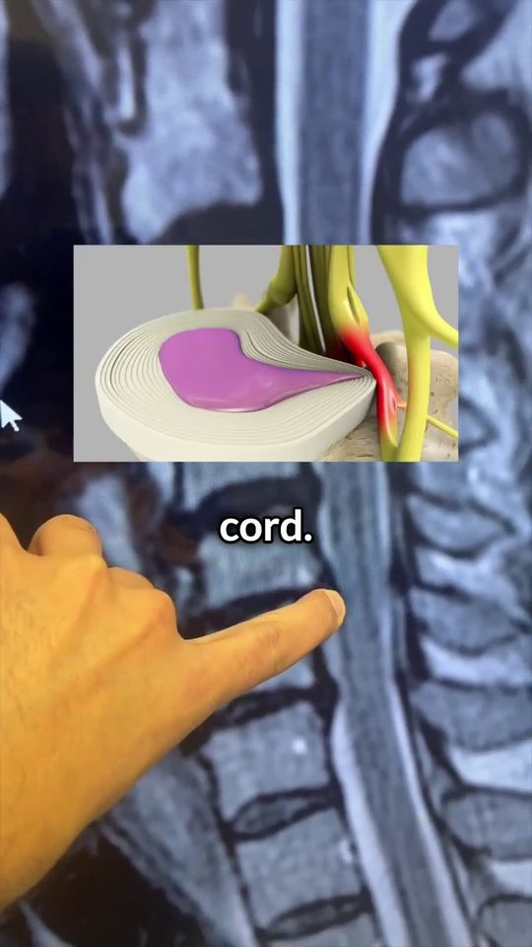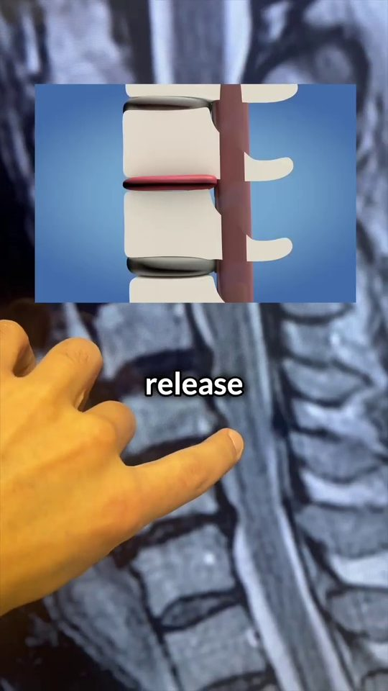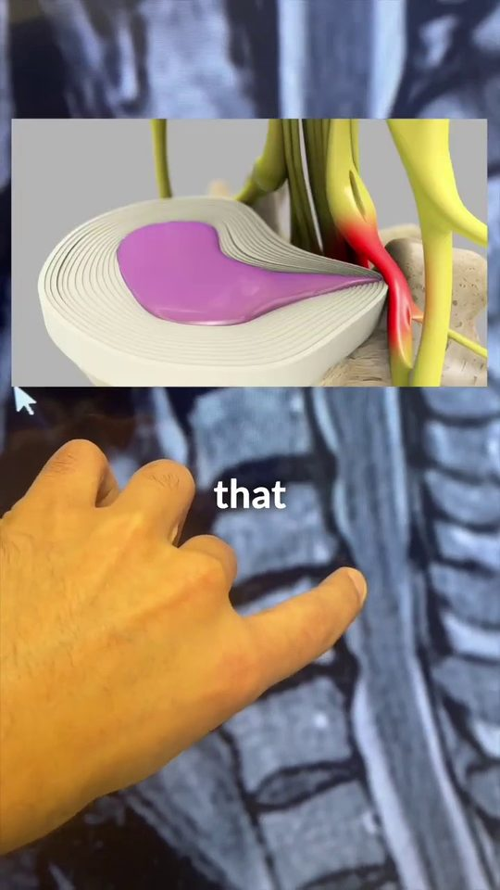 | 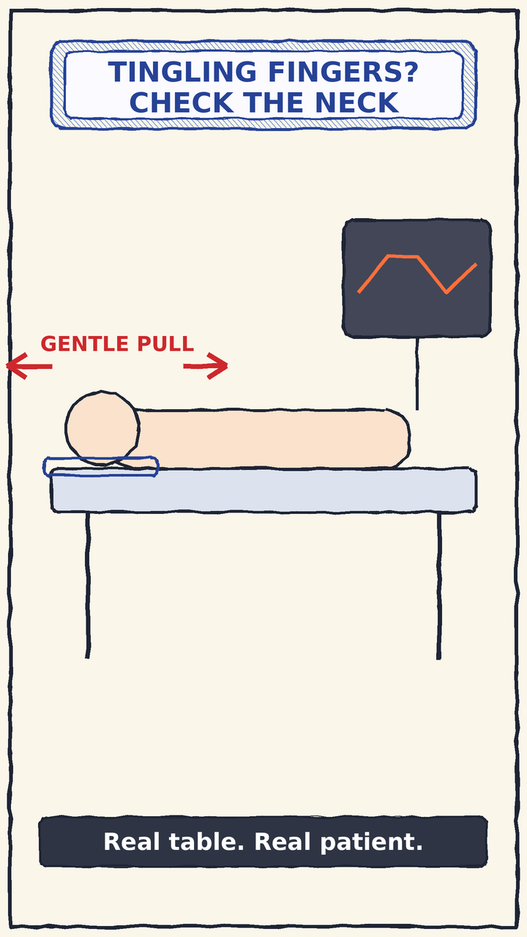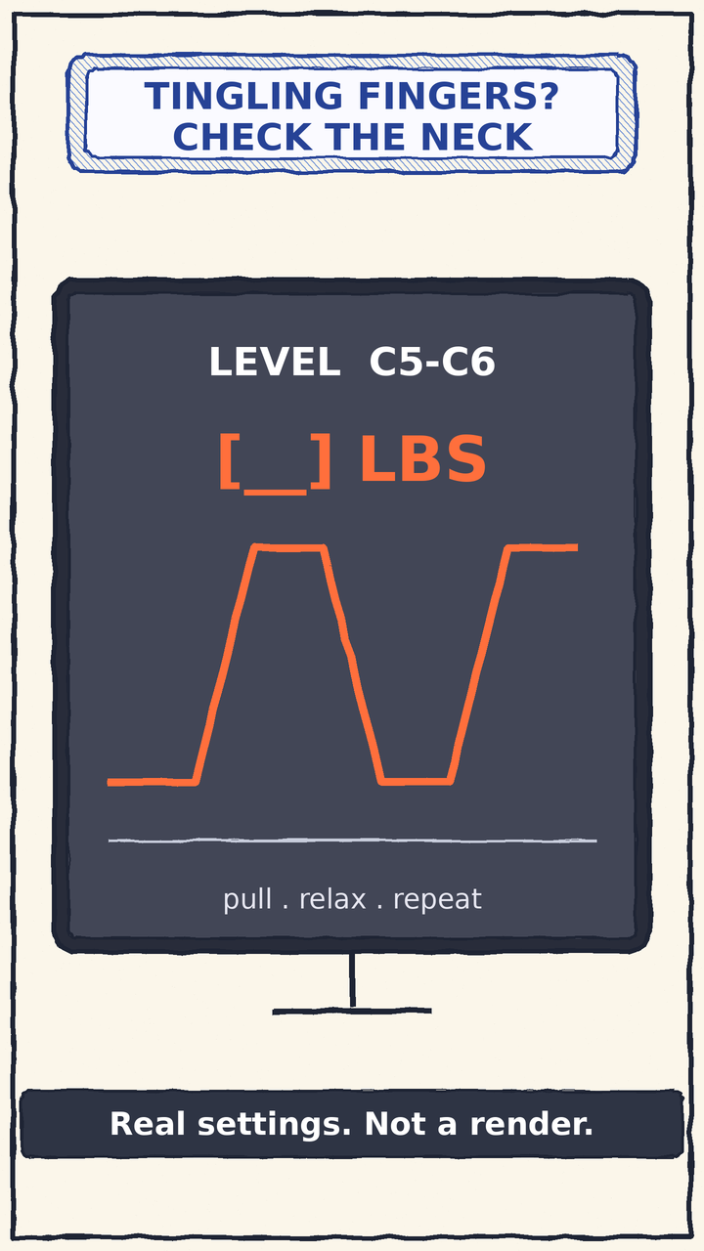
ON SCREEN  Three 3D animation inserts over the MRI: a disc pressing the nerve, the spine opening up, the disc letting go of the nerve. The analysis also notes a brief shot of the decompression machine.  WHAT HE SAYS  Pressure comes off the disc and the nerve.  WHY IT WORKS  Shows the fix without showing pain. The 3D animation is generic, so it is the easiest part to beat with real footage. | ON SCREEN  Real DRX9000 cervical setup with the patient lying comfortably, then a close-up of the console: level C5-C6 and the real pull reading. No stock 3D.  LINE  “Gentle decompression is designed to take pressure off that disc and nerve. Slow, controlled. No cracking.”  YOU NEED  DRX9000 cervical session (consented patient or staff demo) · phone on tripod

BEAT 4 · THE PROOF
DR. DUDUM · 0:20–0:30 | SPINEWELL · 0:20–0:27
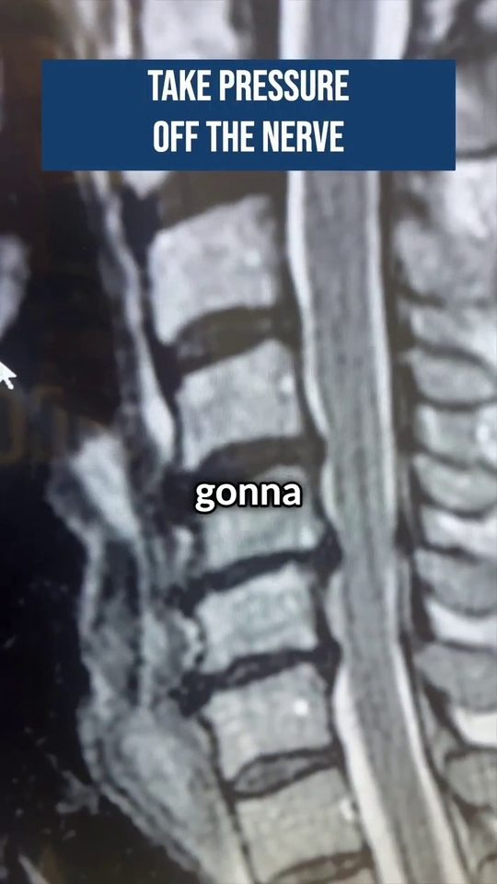 | 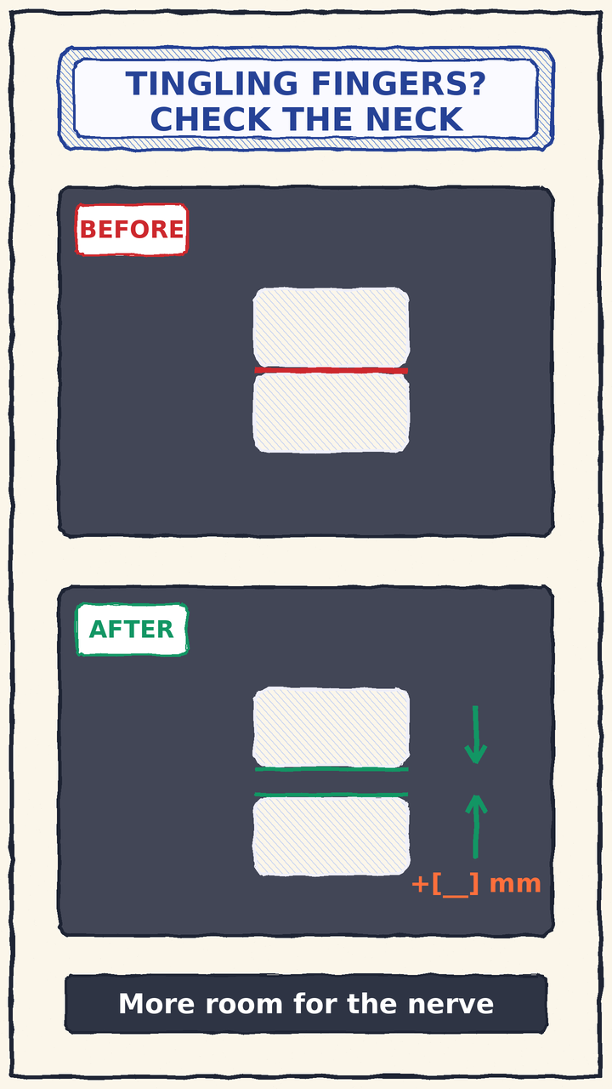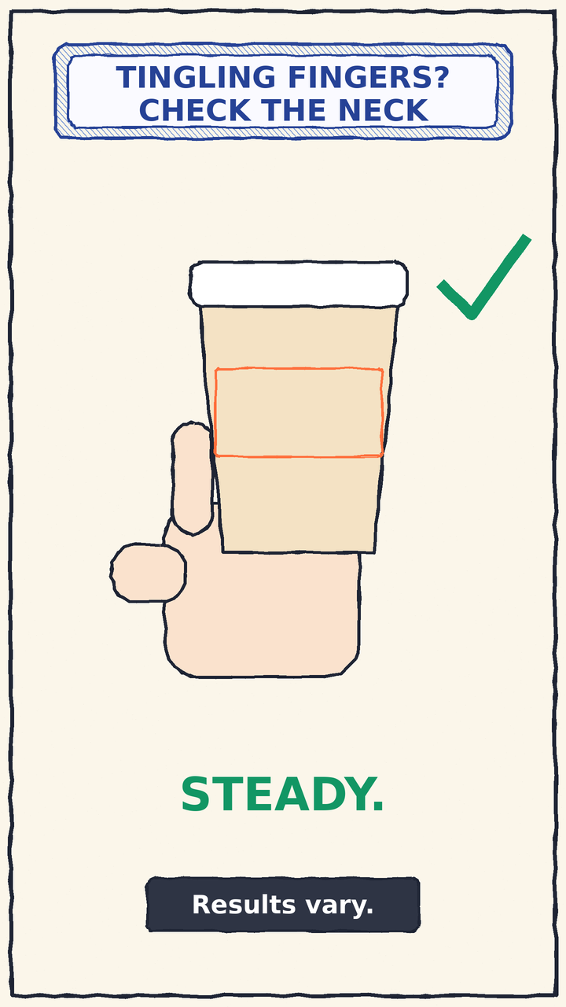
ON SCREEN  Back to the MRI. A blue pill reads “TAKE PRESSURE OFF THE NERVE” while the doctor points at the space that opens.  WHAT HE SAYS  Repeats the benefit: holding the coffee again, no pain, no numbness.  WHY IT WORKS  Closes the loop the hook opened (the coffee cup). Weak spot: no before/after, no measurement. | ON SCREEN  Split screen: the same level before and after on follow-up scans, with Dr. Nathans writing the difference. Cut to the patient holding a coffee cup, steady.  LINE  “On this follow-up scan, the space opened about [__] millimeters. And the coffee cup? Steady. Results vary.”  YOU NEED  Follow-up MRI of one patient · written consent · the measurement from the chart

BEAT 5 · THE ASK
DR. DUDUM · 0:31–end | SPINEWELL · 0:27–0:30
 | 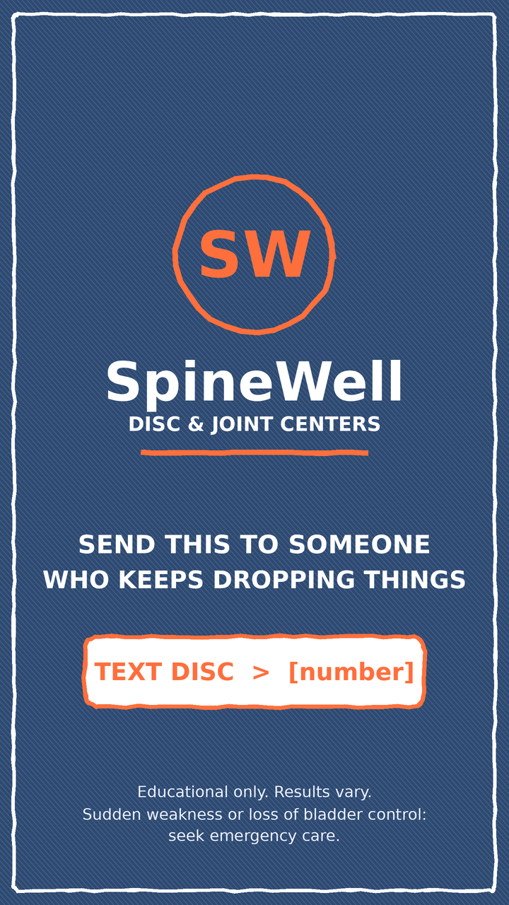
ON SCREEN  Blurred clinic. Dudum Chiropractic logo, phone number, and “DM us DECOMP”.  WHAT HE SAYS  “DM us DECOMP.”  WHY IT WORKS  One keyword is an easy first step. Weak spot: it only asks for a message, not a share. | ON SCREEN  SpineWell end card: logo, one call to action, a small legal line. Nothing else on screen.  LINE  “Send this to someone who’s dropping things.” On screen: TEXT DISC → [number].  YOU NEED  SpineWell logo card · current number or link (not the old 904 number)

