《操作系统原理》
实 验 报 告 书

学 生 姓 名 王宇卿
学 号 16180110065
班 级 1618011

2017 — 2018 学年 第二学期

《操作系统原理》实验报告
实验名称 | Unix系统shell实现和历史特性 | 实验序号
实验日期 | 2018-4-15 |  | 实验人
一、实验题目
写一个c程序实现以下特性：
类似shell终端，可以支持基本Linux，Unix，Mac OS的基本命令
每个命令执行时，使用fork()启动一个新的进程
程序实现history特性可以查看历史命令，并通过!符号执行历史命令

二、相关原理与知识
了解C程序库unistd.h
对Linux基本知识的了解
熟悉进程相关知识

三、实验过程
基本命令实现：
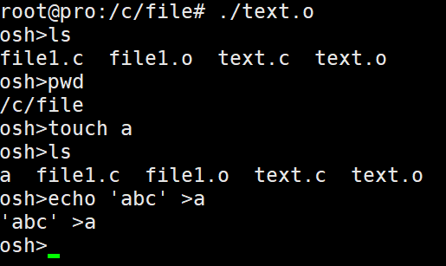
History特性实现：
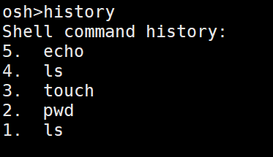

四、实验结果与分析
完成了实验要求，实现了Linux基本命令的支持，实现了history的特性。

五、问题总结
History的实现特性，本来实现怎么复用操作系统本身的history，但是遇到了问题
后期实现程序自定义保存历史命令
六、源代码
#include <stdio.h>
#include <unistd.h>
#include <stdlib.h>
#include <string.h>

#define MAX_LINE 80 /* The maximum length of a command */
#define BUFFER_SIZE 50
#define buffer "\n\Shell Command History:\n"

//declarations
char history[10][BUFFER_SIZE]; //history array to store history commands
int count = 0;

//function to display the history of commands
void displayHistory()
{

printf("Shell command history:\n");

int i;
int j = 0;
int histCount = count;

//loop for iterating through commands
for (i = 0; i<10;i++)
{
//command index
printf("%d. ", histCount);
while (history[i][j] != '\n' && history[i][j] != '\0')
{
//printing command
printf("%c", history[i][j]);
j++;
}
printf("\n");
j = 0;
histCount--;
if (histCount == 0)
break;
}
printf("\n");
}

//Fuction to get the command from shell, tokenize it and set the args parameter

int formatCommand(char inputBuffer[], char *args[],int *flag)
{
int length; // # of chars in command line
int i; // loop index for inputBuffer
int start; // index of beginning of next command
int ct = 0; // index of where to place the next parameter into args[]
int hist;
//read user input on command line and checking whether the command is !! or !n

length = read(STDIN_FILENO, inputBuffer, MAX_LINE);

start = -1;
if (length == 0)
exit(0); //end of command
if (length < 0)
{
printf("Command not read\n");
exit(-1); //terminate
}

//examine each character
for (i=0;i<length;i++)
{
switch (inputBuffer[i])
{
case ' ':
case '\t' : // to seperate arguments
if(start != -1)
{
args[ct] = &inputBuffer[start];
ct++;
}
inputBuffer[i] = '\0'; // add a null char at the end
start = -1;
break;

case '\n': //final char
if (start != -1)
{
args[ct] = &inputBuffer[start];
ct++;
}
inputBuffer[i] = '\0';
args[ct] = NULL; // no more args
break;

default :
if (start == -1)
start = i;
if (inputBuffer[i] == '&')
{
*flag = 1; //this flag is the differentiate whether the child process is invoked in background
inputBuffer[i] = '\0';
}
}
}

args[ct] = NULL; //if the input line was > 80

if(strcmp(args[0],"history")==0)
{
if(count>0)
{

displayHistory();
}
else
{
printf("\nNo Commands in the history\n");
}
return -1;
}

else if (args[0][0]-'!' ==0)
{ int x = args[0][1]- '0';
int z = args[0][2]- '0';

if(x>count) //second letter check
{
printf("\nNo Such Command in the history\n");
strcpy(inputBuffer,"Wrong command");
}
else if (z!=-48) //third letter check
{
printf("\nNo Such Command in the history. Enter <=!9 (buffer size is 10 along with current command)\n");
strcpy(inputBuffer,"Wrong command");
}
else
{

if(x==-15)//Checking for '!!',ascii value of '!' is 33.
{ strcpy(inputBuffer,history[0]); // this will be your 10 th(last) command
}
else if(x==0) //Checking for '!0'
{ printf("Enter proper command");
strcpy(inputBuffer,"Wrong command");
}

else if(x>=1) //Checking for '!n', n >=1
{
strcpy(inputBuffer,history[count-x]);

}

}
}
for (i = 9;i>0; i--) //Moving the history elements one step higher
strcpy(history[i], history[i-1]);

strcpy(history[0],inputBuffer); //Updating the history array with input buffer
count++;
if(count>10)
{ count=10;
}
}

int main(void)
{
char *args[MAX_LINE/2 + 1];/* max arguments */
int should_run =1;
char inputBuffer[MAX_LINE]; /* buffer to hold the input command */
int flag; // equals 1 if a command is followed by "&"

pid_t pid,tpid;
int i;

while (should_run) //infinite loop for shell prompt
{
flag = 0; //flag =0 by default
printf("osh>");
fflush(stdout);
if(-1!=formatCommand(inputBuffer,args,&flag)) // get next command
{
pid = fork();

if (pid < 0)//if pid is less than 0, forking fails
{

printf("Fork failed.\n");
exit (1);
}

else if (pid == 0)//if pid ==0
{

//command not executed
if (execvp(args[0], args) == -1)
{

printf("Error executing command\n");
}
}

// if flag == 0, the parent will wait,
// otherwise returns to the formatCommand() function.
else
{
i++;
if (flag == 0)
{
i++;
wait(NULL);
}
}
}
}
}

