《操作系统原理》
实 验 报 告 书

学 生 姓 名 王宇卿
学 号 16180110065
班 级 1618011

2017 — 2018 学年 第二学期

《操作系统原理》实验报告
实验名称 | Producer-Consumer Problem | 实验序号
实验日期 | 2018-4-22 |  | 实验人
一、实验题目
编写一个C程序，包含buffer.h、两个源程序，实现信号量控制程序解决生产者消费者的经典问题。
二、相关原理与知识
了解C程序库pthread.h
对Linux基本知识的了解
熟悉线程相关知识
对生产者-消费者模型有一定了解
程序中使用到了Makefile编译程序

三、实验过程
程序目录如下：
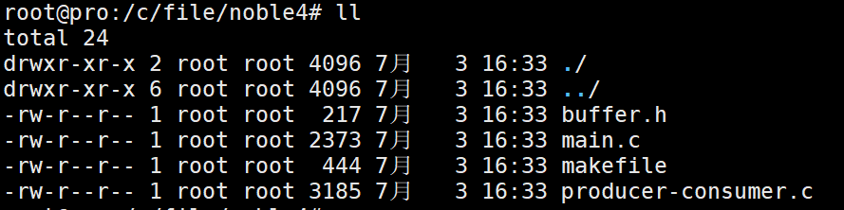

编译实现方法：

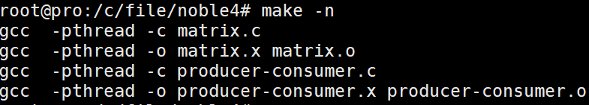

Main.c程序的运行结果
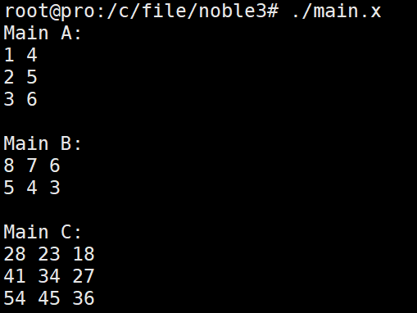

producer-consumer.c程序运行：
这个程序接受3个参数，第一个是睡眠时间sleep time.
第二个是生产者的线程个数，第三个是消费者的线程个数
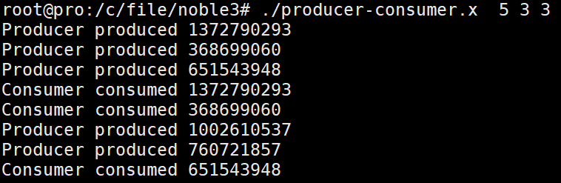

问题解决。

四、实验结果与分析
基本完成实验要求，实现了生产者和消费者线程搭配运作的模式。
五、问题总结
在编译源代码时遇到问题。出现如下错误：
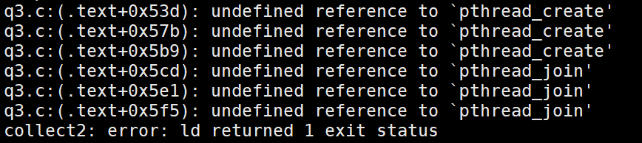
通过查阅相关资料，发现带有ptread.h头文件的C程序源代码需要在
编译时加上-pthread参数。

六、源代码
Main.c:
#include <stdlib.h>
#include <stdio.h>
#include <pthread.h>
#define M 3
#define K 2
#define N 3
int A [M][K] = { {1,4}, {2,5}, {3,6} };
int B [K][N] = { {8,7,6}, {5,4,3} };
int C [M][N];

struct v {
int i; // Row
int j; // Column
};

void *multiply(void *arg){
struct v* param = (struct v *)arg;
int i = param->i;
int j = param->j;
C[i][j] = 0;

int k;
for (k = 0; k < K; k++)
C[i][j] += A[i][k] * B[k][j];

free(arg); // Free data that was malloc'd earlier?
pthread_exit(NULL);
return 0;
}

int main(){
// Perform multiplication
int i, j, rc;
pthread_t threads[M*N];
for (i = 0; i < M; i++){
for (j = 0; j < N; j++){
struct v *data = (struct v *) malloc(sizeof(struct v));
data->i = i;
data->j = j;
rc = pthread_create(&threads[i*N + j], NULL, multiply, (void *)data);
if (rc){
printf("* ERROR: pthread_create() abnormal return value.\n");
exit(1);
}
}
}

for (i = 0; i < M*N; i++)
pthread_join(threads[i], NULL); // Wait for the previous threads to finish

// Print the matrices
printf("Matrix A:\n");
for(i = 0; i < M; i++){
for (j = 0; j < K; j++){
if (j != K-1)
printf("%d ", A[i][j]);
else
printf("%d", A[i][j]);
}
printf("\n");
}

printf("\nMatrix B:\n");
for(i = 0; i < K; i++){
for (j = 0; j < N; j++){
if (j != N-1)
printf("%d ", B[i][j]);
else
printf("%d", B[i][j]);
}
printf("\n");
}

printf("\nMatrix C:\n");
for(i = 0; i < M; i++){
for (j = 0; j < N; j++){
if (j != N-1)
printf("%d ", C[i][j]);
else
printf("%d", C[i][j]);
}
printf("\n");
}

pthread_exit(NULL);
return 0;
}

producer-consumer.c：
#include <stdlib.h>
#include <stdio.h>
#include <string.h>
#include <unistd.h>
#include <pthread.h>
#include <semaphore.h>
#include <time.h>
#include "buffer.h"

// Global variables
buffer_item buffer[BUFFER_SIZE];
pthread_mutex_t mutex;
sem_t full, empty;
int count, in, out;

// Function prototypes
int insert_item(buffer_item item);
int remove_item(buffer_item *item);
void *consumer(void *param);
void *producer(void *param);

int main(int argc, char **argv){
if (argc != 4){
printf("ERROR: Provide exactly three arguments.\n");
exit(1);
}

// Retrieve command line arguments
const long int stime = strtol(argv[1], NULL, 0);
const long int num_producer = strtol(argv[2], NULL, 0);
const long int num_consumer = strtol(argv[3], NULL, 0);

// Initialize
int i;
srand(time(NULL));
pthread_mutex_init(&mutex, NULL);
sem_init(&empty, 0, BUFFER_SIZE); // All of buffer is empty
sem_init(&full, 0, 0);
count = in = out = 0;

// Create the producer and consumer threads
pthread_t producers[num_producer];
pthread_t consumers[num_consumer];
for(i = 0; i < num_producer; i++)
pthread_create(&producers[i], NULL, producer, NULL);
for(i = 0; i < num_consumer; i++)
pthread_create(&consumers[i], NULL, consumer, NULL);

// Sleep before terminating
sleep(stime);
return 0;
}

// Insert item into buffer.
//Returns 0 if successful, -1 indicating error
int insert_item(buffer_item item){
int success;
sem_wait(&empty);
pthread_mutex_lock(&mutex);

// Add item to buffer
if( count != BUFFER_SIZE){
buffer[in] = item;
in = (in + 1) % BUFFER_SIZE;
count++;
success = 0;
}
else
success = -1;

pthread_mutex_unlock(&mutex);
sem_post(&full);

return success;
}

// Remove an object from the buffer, placing it in item.
// Returns 0 if successful, -1 indicating error
int remove_item(buffer_item *item){
int success;

sem_wait(&full);
pthread_mutex_lock(&mutex);

// Remove item from buffer to item
if( count != 0){
*item = buffer[out];
out = (out + 1) % BUFFER_SIZE;
count--;
success = 0;
}
else
success = -1;

pthread_mutex_unlock(&mutex);
sem_post(&empty);

return success;
}

void *producer(void *param){
buffer_item item;
while(1){
sleep(rand() % 5 + 1); // Sleep randomly between 1 and 5 seconds

item = rand();
if(insert_item(item))
printf("Error occured\n");
else
printf("Producer produced %d\n", item);
}
}

void *consumer(void *param){
buffer_item item;
while(1){
sleep(rand() % 5 + 1); // Sleep randomly between 1 and 5 seconds

if(remove_item(&item))
printf("Error occured\n");
else
printf("Consumer consumed %d\n", item);
}
}

