I N D U R

INSTITUTE OF ENGINEERING AND TECHNOLOGY

SIDDIPET, MEDAK DIST. – 502277

LABORATORY MANUAL



SKILL DEVELOPMENT COURSE

(NODE JS/ REACT JS/ DJANGO LAB)
II B.Tech. I Semester CSE(AIML)
(As per R22 Academic Regulation)

Department of Computer Science and Engineering

Course Objectives:
● To implement the static web pages using HTML and do client side validation using JavaScript.
● To design and work with databases using Java
● To develop an end to end application using java full stack.
● To introduce Node JS implementation for server side programming.
● To experiment with single page application development using React.
Course Outcomes:
At the end of the course, the student will be able to,
● Build a custom website with HTML, CSS, and Bootstrap and little JavaScript.
● Demonstrate Advanced features of JavaScript and learn about JDBC
● Develop Server – side implementation using Java technologies like
● Develop the server – side implementation using Node JS.
● Design a Single Page Application using React.

I N D E X

EXP. NO | NAME OF THE EXPERIMENT | PAGE NO’S
1 | Build a responsive web application for shopping cart with registration, login, catalog and cart pages using CSS3 features, flex and grid. | 4-7
2 | Make the above web application responsive web application using Bootstrap framework | 8-9
3 | Use JavaScript for doing client – side validation of the pages implemented in experiment 1 and experiment 2. | 10-12
4 | Explore the features of ES6 like arrow functions, callbacks, promises, async/await. Implement an application for reading the weather information from openweathermap.org and display the information in the form of a graph on the web page.. | 13-20
5 | Develop a java stand alone application that connects with the database (Oracle / mySql) and perform the CRUD operation on the database tables. | 21-24
6 | Create an xml for the bookstore. Validate the same using both DTD and XSD | 25-27
7 | Design a controller with servlet that provides the interaction with application developed in experiment 1 and the database created in experiment 5 | 28-30
8 | Maintaining the transactional history of any user is very important. Explore the various session tracking mechanism (Cookies, HTTP Session) | 31-35
9 | Create a custom server using http module and explore the other modules of Node JS like OS path, event. | 36-42
10 | Develop an express web application that can interact with REST API to perform CRUD operations on student data. (Use Postman) | 43-49
11 | For the above application create authorized end points using JWT (JSON Web Token). | 50-53
12 | Create a react application for the student management system having registration, login, contact, about pages and implement routing to navigate through these pages. | 54-60
13 | Create a service in react that fetches the weather information from openweathermap.org and the display the current and historical weather information using graphical representation using | 61-65
14 | Create a TODO application in react with necessary components and deploy it into github. | 66-82

PROGRAM1: write a responsive web application for shopping cart with registration, login, catalog and cart pages using CSS3 features, flex and grid

index.html

<!DOCTYPE html>
<html lang="en">
<head>
<link rel="stylesheet" href="./style.css">
<title>Shopping Cart</title>
</head>
<body>
<div class="wrapper">
<div class="container">
<header>
<table width="100%" align="center" cellpadding="0" cellspacing="2">
<tr>
<th width="20%"><img src="fbs.png" alt="FBS LOGO" width="130" height="100"/></th>
<th colspan=4>
<h1 style="color:white;">FBS - WORLD BEST ONLINE EBOOKS WEBSITE</h1>
</th>
</tr>
</table>
</header>
<nav>
<table width="100%" align="center" cellpadding="0" cellspacing="2">
<tbody align="center" style="font-weight:bold;font-size:18px;"">
<tr>
<td width="20%"><hr><a href="index.html">Home</a><hr></td>
<td width="20%"><hr><a href="login.html">Login</a><hr></td>
<td width="20%"><hr><a href="registration.html">Registration</a><hr></td>
<td width="20%"><hr><a href="cart.html" >Cart</a><hr></td>
</tr>
</tbody>
</table>
</nav>
</div>
<div class="container1">
<div class="sidebar1"></div>
<div class="container2">
<main>
<center>
<h2>Welcome to FBS e-Book's Website</h2>
<p>Shopping at <font size=5>FBS</font> can be both <font size=5>fun</font>
and <font size=5>savings</font>.</br>Shop with us in this special <font
size=5>discount</font> season and save upto <font size=5>90%</font> on all your
purchases.</br></p>
<br/><br/><br/><br/><br/><br/><br/><br/>
</main>
</div>

<div class="sidebar2"></div>
</div>
<footer><font color="white">(C) 2024 All rights reserved by FBS ebooks</font></footer>
</div>
</body>
</html>
registration.html
<!DOCTYPE html>
<html lang="en">
<head>
<link rel="stylesheet" href="./style.css">
<title>Registration - FBS</title>
</head>
<body>
<div class="wrapper">
<div class="container">
<header>
<table width="100%" align="center" cellpadding="0" cellspacing="2">
<tr>
<th width="20%"><img src="fbs.png" alt="FBS LOGO" width="130" height="100"/></th>
<th colspan=4>
<h1 style="color:white;">FBS - WORLD BEST ONLINE EBOOKS WEBSITE</h1>
</th>
</tr>
</table>
</header>
<nav>
<table width="100%" align="center" cellpadding="0" cellspacing="2">
<tbody align="center" style="font-weight:bold;font-size:18px;"">
<tr>
<td width="20%"><hr><a href="index.html">Home</a><hr></td>
<td width="20%"><hr><a href="login.html">Login</a><hr></td>
<td width="20%"><hr><a href="registration.html">Registration</a><hr></td>
<td width="20%"><hr><a href="cart.html" >Cart</a><hr></td>
</tr>
</tbody>
</table>
</nav>
</div>
<div class="container1">
<div class="sidebar1"></div>
<div class="container2">
<main>
<center><br>
<h3>Registration Form </h3>
<br/>
<form name="f1">
<table cellpadding="1" align="center" >
<tr><td> Name:*</td>

<td><input type="text" name="username"></td></tr>
<tr><td>Password:*</td>
<td><input type="password" name="password"></td></tr>
<tr><td>Email ID:*</td>
<td><input type="text" name="email"></td></tr>
<tr><td>Phone Number:*</td>
<td><input type="text" name="phno"></td></tr>
<tr><td valign="top">Gender:*</td>
<td><input type="radio" name="radio" value="1">Male &nbsp;&nbsp;
<input type="radio" name="radio" value="2">Female</td></tr>
<tr> <td valign="top">Language Known:*</td>
<td> <input type="checkbox" name="checkbox" value="English">English<br/>
<input type="checkbox" name="checkbox" value="Telugu">Telugu<br>
<input type="checkbox" name="checkbox" value="Hindi">Hindi<br>
<input type="checkbox" name="checkbox" value="Tamil">Tamil
</td></tr>
<tr> <td valign="top">Address:*</td>
<td><textarea name="address"></textarea></td>
<tr><td></td><td><input type="submit" value="submit" hspace="10">
<input type="reset" value="reset"></td></tr>
<tr> <td colspan=2 >*<font color="#FF0000">fields are mandatory</font>
</td>
</tr>
</table>
</form>
</center>
</main>
</div>
<div class="sidebar2"></div>
</div>
<footer><font color="white">(C) 2024 All rights reserved by FBS ebooks</font></footer>
</div>
</body>
</html>
cart.html
<!DOCTYPE html>
<html lang="en">
<head>
<link rel="stylesheet" href="./style.css">
<title>Cart - FBS</title>
</head>
<body>
<div class="wrapper">
<div class="container">
<header>
<table width="100%" align="center" cellpadding="0" cellspacing="2">
<tr>
<th width="20%"><img src="fbs.png" alt="FBS LOGO" width="130" height="100"/></th>
<th colspan=4>

<h1 style="color:white;">FBS - WORLD BEST ONLINE EBOOKS WEBSITE</h1>
</th>
</tr>
</table>
</header>
<nav>
<table width="100%" align="center" cellpadding="0" cellspacing="2">
<tbody align="center" style="font-weight:bold;font-size:18px;"">
<tr>
<td width="20%"><hr><a href="index.html">Home</a><hr></td>
<td width="20%"><hr><a href="login.html">Login</a><hr></td>
<td width="20%"><hr><a href="registration.html">Registration</a><hr></td>
<td width="20%"><hr><a href="cart.html" >Cart</a><hr></td>
</tr>
</tbody>
</table>
</nav>
</div>
<div class="container1">
<div class="sidebar1"></div>
<div class="container2">
<main>
<center>
<h3>Cart</h3>
<table width="100%" align="center" >
<tbody>
<tr>
<th width="40%"><hr>BookName<hr></th>
<th width="20%"><hr>Price<hr></th>
<th width="20%"><hr>Quantity<hr></th>
<th width="20%"><hr>Amount<hr></th> </tr>
</tbody>
<tbody align=center>
<tr> <td>Java Programming </td>
<td>Rs. 2300/-</td>
<td>2</td>
<td>Rs. 4600/-</td></tr>
<tr><td>Web Technologies</td>
<td>Rs. 3000/-</td>
<td>1</td>
<td>Rs. 3000/-</td></tr>
<tr><td></td>
<td><hr><font color="#996600">Total Amount:</font><hr></td>
<td><hr>3<hr></td>
<td><hr>Rs. 7600/-<hr></td> </tr>
</tbody>
</table>
</center>

</main>
</div>
<div class="sidebar2"></div>
</div>

<footer><font color="white">(C) 2024 All rights reserved by FBS ebooks</font></footer>
</div>
</body>
</html>
login.html

<!DOCTYPE html>
<html lang="en">
<head>
<link rel="stylesheet" href="./style.css">
<title>Login - FBS</title>
</head>
<body>
<div class="wrapper">
<div class="container">
<header>
<table width="100%" align="center" cellpadding="0" cellspacing="2">
<tr>
<th width="20%"><img src="fbs.png" alt="FBS LOGO" width="130" height="100"/></th>
<th colspan=4>
<h1 style="color:white;">FBS - WORLD BEST ONLINE EBOOKS WEBSITE</h1>
</th>
</tr>
</table>
</header>
<nav>
<table width="100%" align="center" cellpadding="0" cellspacing="2">
<tbody align="center" style="font-weight:bold;font-size:18px;"">
<tr>
<td width="20%"><hr><a href="index.html">Home</a><hr></td>
<td width="20%"><hr><a href="login.html">Login</a><hr></td>
<td width="20%"><hr><a href="registration.html">Registration</a><hr></td>
<td width="20%"><hr><a href="cart.html" >Cart</a><hr></td>
</tr>
</tbody>
</table>
</nav>
</div>
<div class="container1">
<div class="sidebar1"></div>
<div class="container2">
<main>
<center><br>
<h3> Login Details</h3> <br/>

<form name="f1">
<table width="100%" align="center" >
<tr>
<td> User Name : </td>
<td> <input type="text" name="username"></td>
</tr>

<tr><td><br></td></tr>
<tr>
<td> Password : </td>
<td> <input type="password" name="password"></td>
</tr>
<tr><td><br></td></tr>
<tr><td></td>
<td><input type="submit" value="SUBMIT">
<input type="reset" value="RESET"></td>
</tr>
</table>
</form>
</center>
</main>
</div>
<div class="sidebar2"></div>
</div>
<footer><font color="white">(C) 2024 All rights reserved by FBS ebooks</font></footer>
</div>
</body>
</html>
styles.css
body{
font-family: monospace;
}

main {
background-color: #efefef;
color: #330000;
margin-left: 10px;
height: 60vh;
}

header, footer {
background-color: #000d57;
color: #fff;
padding: 1rem;
height: 50px;
}

header, nav{
margin-bottom: 10px;
flex-basis: 50%;
}

footer{
margin-top: 10px;
}
nav {
background-color: #fff;
color: #000;
padding: 1rem;
height: 20px;
}

.sidebar1, .sidebar2 {
flex-basis: 10%;
background-color: #fff;
color: #000;
}

.sidebar2{
margin-left: 10px;
}

.container1{
display: flex;
}

.container2 {
display: flex;
flex-direction: column;
flex: 1;
}

header, nav, main, .sidebar1, .sidebar2, footer{
display: flex;
align-items: center;
justify-content: center;
border-radius: 10px;
}

.wrapper {
display: flex;
flex-direction: column;
font-weight: 600;
}

OUTPUT:

index.html
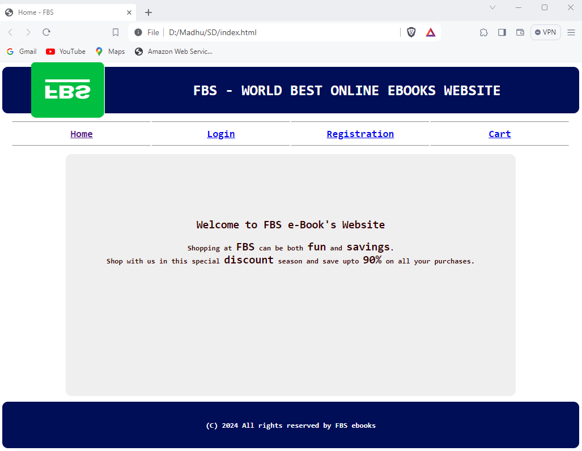

login.html
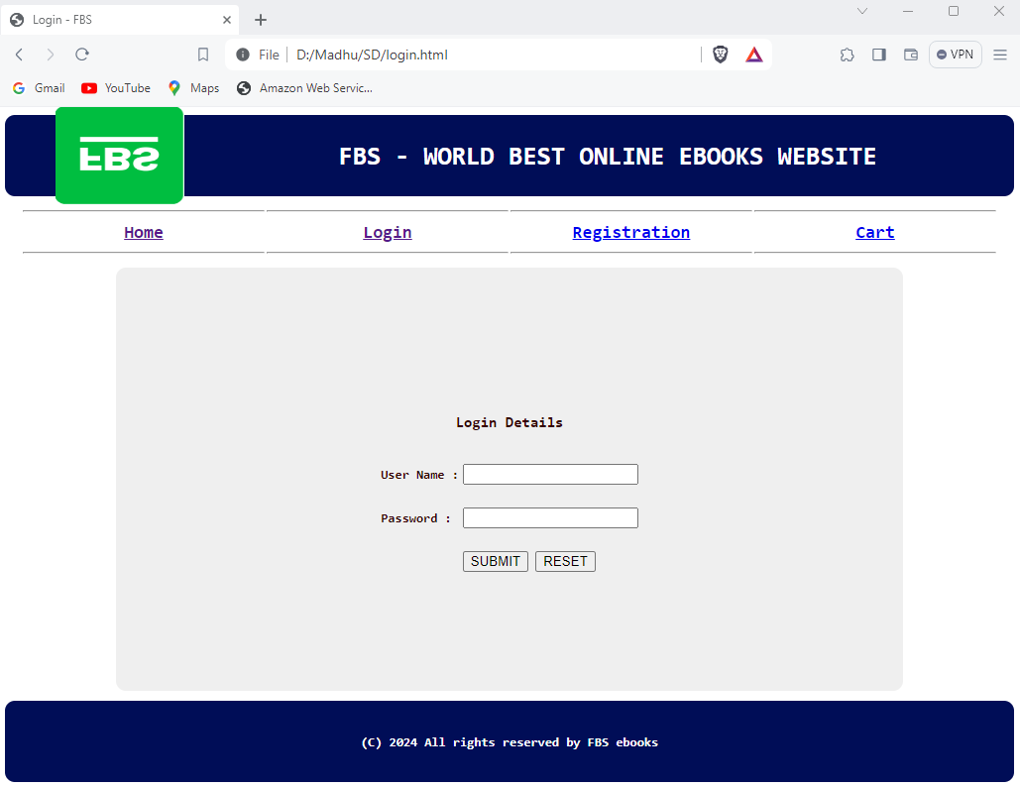
registration.html
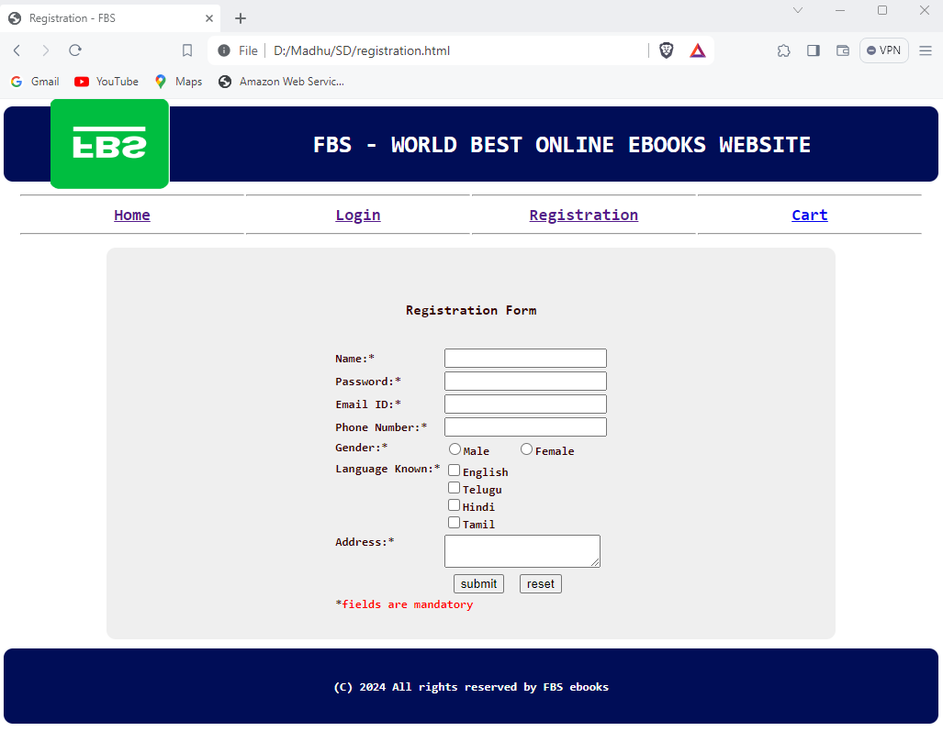

cart.html
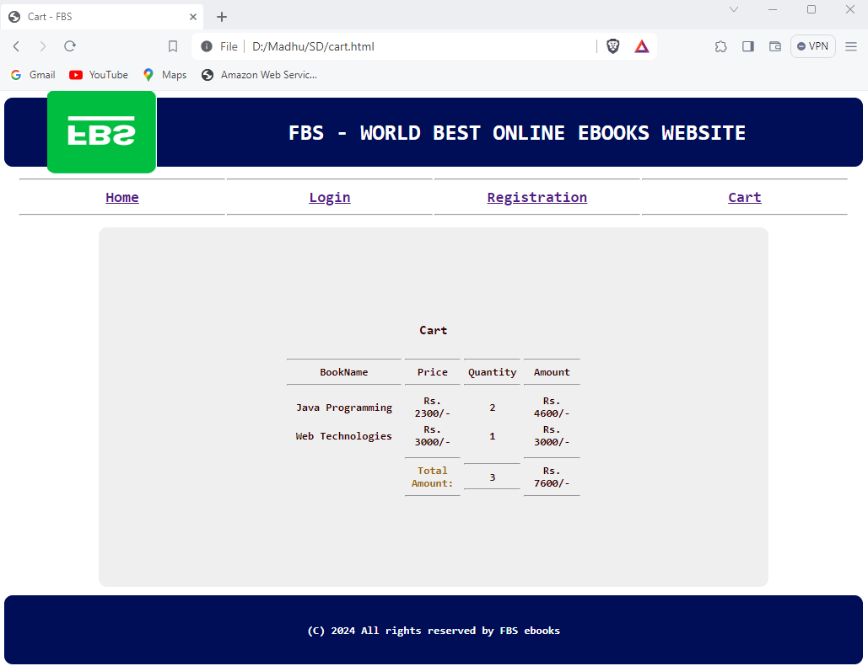

PROGRAM 2: write a html program to Make the above web application responsive web application using Bootstrap framework

Index.html

<!DOCTYPE html>
<html>
<head>
<title>Shopping Cart</title>
<link rel="stylesheet" href="https://stackpath.bootstrapcdn.com/bootstrap/4.5.2/css/bootstrap.min.css">
</head>
<body>
<header class="bg-dark text-white">
<div class="container">
<h1>Shopping Cart</h1>
<nav>
<ul class="nav">
<li class="nav-item"><a class="nav-link" href="index.html">Home</a></li>
<li class="nav-item"><a class="nav-link" href="catalog.html">Catalog</a></li>
<li class="nav-item"><a class="nav-link" href="cart.html">Cart</a></li>
<li class="nav-item"><a class="nav-link" href="login.html">Login</a></li>
<li class="nav-item"><a class="nav-link" href="register.html">Register</a></li>
</ul>
</nav>
</div>
</header>
<main class="container mt-4">
<h2>Shopping Cart</h2>
<div class="row">
<div class="col-lg-8">
<div class="card mb-3">
<div class="card-body">
<h5 class="card-title">Product 1</h5>
<p class="card-text">Price: $10</p>
<a href="#" class="btn btn-primary">Remove</a>
</div>
</div>
<div class="card mb-3">
<div class="card-body">
<h5 class="card-title">Product 2</h5>
<p class="card-text">Price: $20</p>
<a href="#" class="btn btn-primary">Remove</a>
</div>
</div>
</div>
<div class="col-lg-4">
<div class="card mb-3">
<div class="card-body">
<h5 class="card-title">Cart Summary</h5>
<p class="card-text">Total: $30</p>
<a href="#" class="btn btn-primary">Checkout</a>

</div>
</div>
</div>
</div>
</main>
<footer class="bg-dark text-white text-center py-2">
<p>&copy; 2021 Shopping Cart. All rights reserved.</p>
</footer>
<script src="https://code.jquery.com/jquery-3.5.1.slim.min.js"></script>
<script src="https://cdn.jsdelivr.net/npm/bootstrap@4.5.2/dist/js/bootstrap.min.js"></script>
</body>
</html>

OUTPUT:

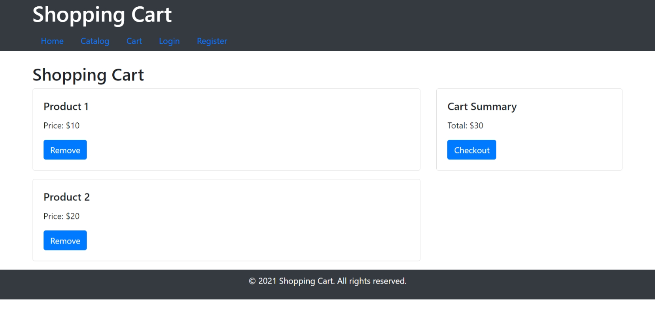

Program 3: Use JavaScript for doing client – side validation of the pages implemented in experiment 1 and experiment 2

index.html
<!DOCTYPE html>
<html lang="en">
<head>
<link rel="stylesheet" href="./style.css">
<title>Shopping Cart</title>
</head>
<body>
<div class="wrapper">
<div class="container">
<header>
<table width="100%" align="center" cellpadding="0" cellspacing="2">
<tr>
<th width="20%"><img src="fbs.png" alt="FBS LOGO" width="130" height="100"/></th>
<th colspan=4>
<h1 style="color:white;">FBS - WORLD BEST ONLINE EBOOKS WEBSITE</h1>
</th>
</tr>
</table>
</header>
<nav>
<table width="100%" align="center" cellpadding="0" cellspacing="2">
<tbody align="center" style="font-weight:bold;font-size:18px;"">
<tr>
<td width="20%"><hr><a href="index.html">Home</a><hr></td>
<td width="20%"><hr><a href="login.html">Login</a><hr></td>
<td width="20%"><hr><a href="registration.html">Registration</a><hr></td>
<td width="20%"><hr><a href="cart.html" >Cart</a><hr></td>
</tr>
</tbody>
</table>
</nav>
</div>
<div class="container1">
<div class="sidebar1"></div>
<div class="container2">
<main>
<center>
<h2>Welcome to FBS e-Book's Website</h2>
<p>Shopping at <font size=5>FBS</font> can be both <font size=5>fun</font>
and <font size=5>savings</font>.</br>Shop with us in this special <font
size=5>discount</font> season and save upto <font size=5>90%</font> on all your
purchases.</br></p>
<br/><br/><br/><br/><br/><br/><br/><br/>
</main>
</div>
<div class="sidebar2"></div>
</div>
<footer><font color="white">(C) 2024 All rights reserved by FBS ebooks</font></footer>

</div>
</body>
</html>

Registrationjs.html
<html>
<head>
<title> Welcome to NNRG e-Book's website</title>
<script language="javascript">
function validate() {
// username validation
var uname = f1.username.value;
if (uname.length<=0)
{
alert("Please Enter UserName");
f1.username.focus();
return false;
}
if (uname.length < 8)
{
alert("Please enter UserName not less than 8");
f1.username.focus();
return false;
}
//password validation
var pwd = f1.password.value;
if (pwd.length<=0)
{
alert("Please Enter password");
f1.password.focus();
return false;
}
if (pwd.length < 6)
{
alert("Please enter Password not less than 6");
f1.password.focus();
return false;
}
// email validation
var email = f1.email.value;
if (email.length<=0)
{
alert("Please Enter email");
f1.email.focus();
return false;
}
else {
let eflag=false;
for(i=0;i<email.length;i++) {
if(email.charAt(i)=="@")
{
eflag=true;
}
}
if(!(eflag))
{

alert("Please enter a valid Email ID");
f1.email.focus();
return false;
}
}
// phone number validation
var phno = f1.phno.value;
if (phno.length<=0)
{
alert("Please Enter Phone Number");
f1.phno.focus();
return false;
}
if (isNaN(phno))
{
alert("Please Enter Valid Phone Number");
f1.phno.focus();
return false;
}
if (phno.length != 10)
{
alert("Please Enter Valid Phone Number");
f1.phno.focus();
return false;
}
// gender validation
let flag=false;
for(i=0;i<f1.gen.length;i++)
if(f1.gen[i].checked)
flag=true;
if(!(flag))
{
alert("Please choose a Gender");
return false;
}
// Language validation
flag=false;
for(i=0;i<f1.lang.length;i++)
if(f1.lang[i].checked)
flag=true;
if(!(flag))
{
alert("Please select at least one of the Language options.");
return false;
}
// address validation
var addr = f1.address.value;
if (addr.length<=0)
{
alert("Please Enter address");
f1.address.focus();
return false;
}
// to display Success message
alert("Registration Successful");
}
</script>
</head>
<body>
<center><br>
<h3>Registration Form </h3>
<br/>
<form name="f1">
<table cellpadding="1" align="center" >
<tr><td> User Name:*</td>
<td><input type="text" name="username"></td></tr>
<tr><td>Password:*</td>
<td><input type="password" name="password"></td></tr>
<tr><td>Email ID:*</td>
<td><input type="text" name="email"></td></tr>
<tr><td>Phone Number:*</td>
<td><input type="text" name="phno"></td></tr>
<tr><td valign="top">Gender:*</td>
<td><input type="radio" name="gen" value="Male">Male &nbsp;&nbsp;
<input type="radio" name="gen" value="Female">Female</td></tr>
<tr> <td valign="top">Language Known:*</td>
<td> <input type="checkbox" name="lang" value="English">English<br/>
<input type="checkbox" name="lang" value="Telugu">Telugu<br>
<input type="checkbox" name="lang" value="Hindi">Hindi<br>
<input type="checkbox" name="lang" value="Tamil">Tamil
</td></tr>
<tr> <td valign="top">Address:*</td>
<td><textarea name="address"></textarea></td>
<tr><td></td><td><input type="button" value="SUBMIT" hspace="10" onclick="validate()">
<input type="reset" value="RESET"></td></tr>
<tr> <td colspan=2 >*<font color="#FF0000">fields are mandatory</font>
</td>
</tr>
</table>
</form>
</center>
</body>
</html>

OUTPUT:

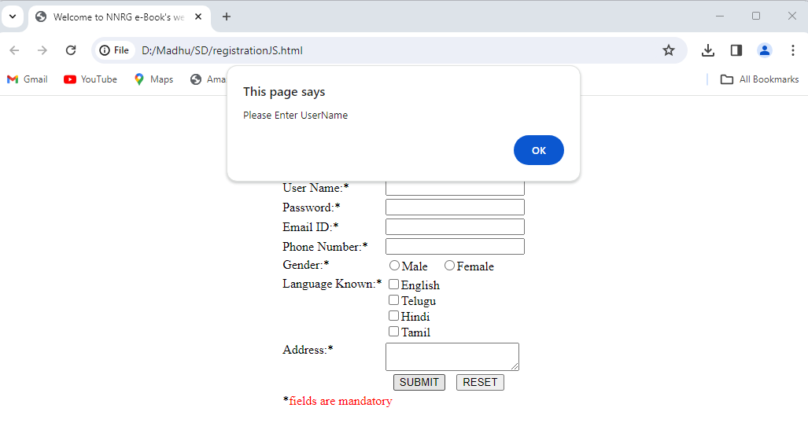

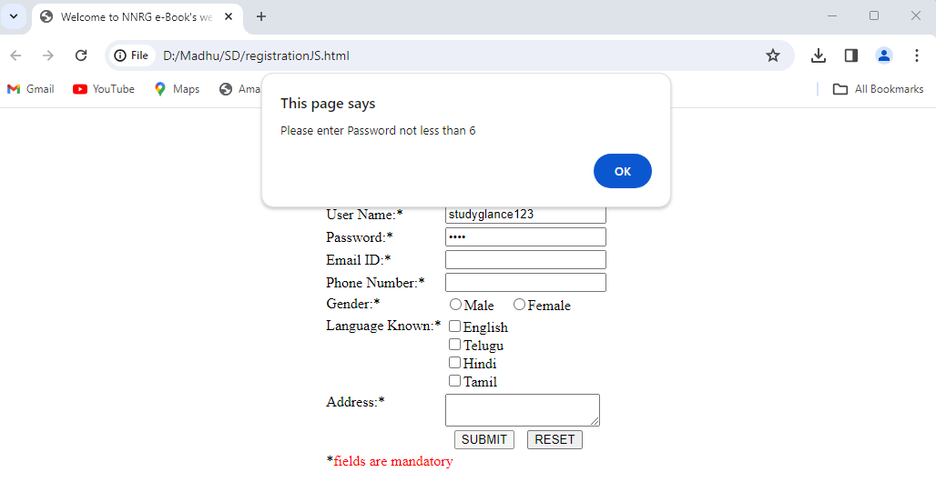
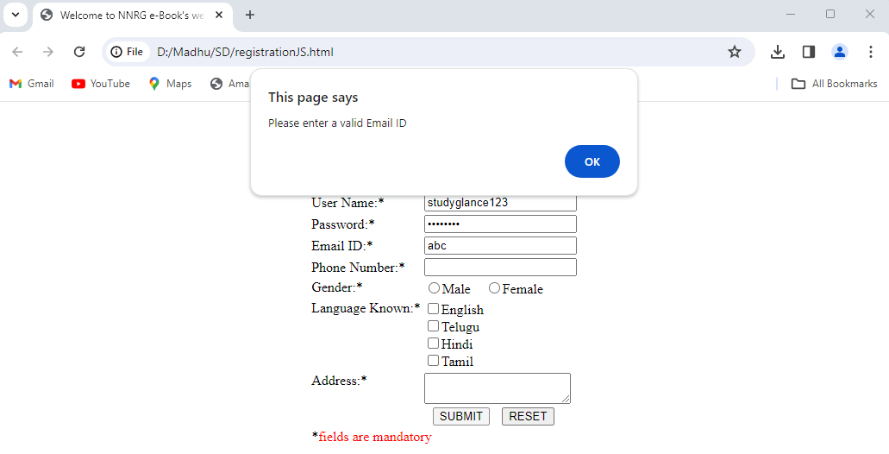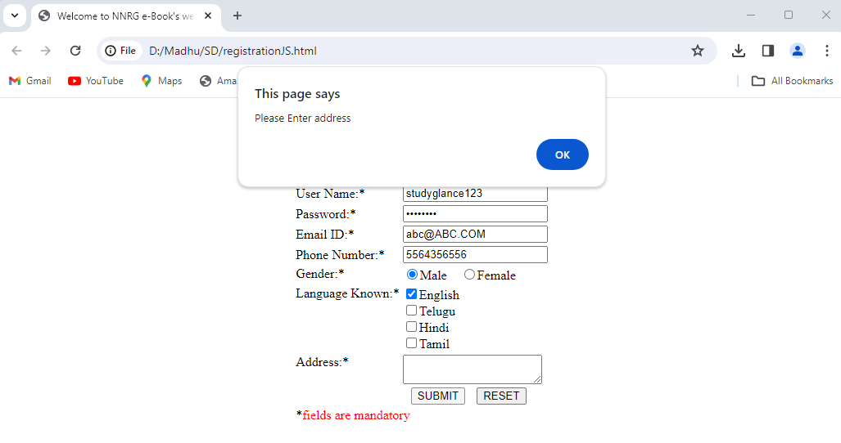

Program4. Explore the features of ES6 like arrow functions, callbacks, promises, async/await. Implement an application for reading the weather information from open weathermap.org and display the information in the form of a graph on the webpage.

MainPage.html
<!DOCTYPEhtml>
<html>
<head>
<title>WeatherReport</title>
<linkrel="icon"href="favicon.png">
<linkrel="stylesheet"href="PageStyle.css">
<linkhref=
'https://fonts.googleapis.com/css?family=DeliusSwashCaps' rel='stylesheet'>
</head>
<body>
<pid="data"class="styleIt"></p>
<scriptsrc="JSPage.js"></script>
</body>
</html>
PageStyle.css

p.styleIt
{
background-color:rgb(182,182,182);
border:2pxsolidrgb(182,182,182);border-radius:8px;
text-align:center;
box-shadow:6px5px2pxrgb(182,182,182),0025pxrgb(0,0,0),005px
rgb(182,182,182);
font-family:'DeliusSwashCaps';
}
body{
background:rgb(120,120,120);
margin:0;
position:absolute
top:50%;
left:50%;
margin-right:-50%;
transform:translate(-50%,-50%)
}

JSPage.js

vardata=document.getElementById(data");
varLatitude;varLongitude;
varkey="------PutYourOwnKey";
varurl="http://api.openweathermap.o rgdata/2.5/weather?";
functiongetLocation(){
if(navigator.geolocation){
navigator.geolocation.getCurrentPosition(showPosition);
}
else{
data_of_Lat_Lon.innerHTML="Geolocationisnotsupportedbythisbrowser.SORRY!";
}

}
functionshowPosition(position){Latitude=position.coords.latitude;
Longitude=position.coords.longitude;getData(Latitude,Longitude);
}
functiongetData(Lat,Lon){constreadyToSent=
(url+"lat="+Lat+"&lon="+Lon+"&appid="+key);fetch(readyToSent)
.then(response=>response.json())
.then(data=>{
console.log(data);fetchData(data)
})
}

functionfetchData(data){consticon=
"http://openweathermap.org/img/wn/"+data.weather[0].icon+"@2x.png"
document.getElementById("data").innerHTML="<b>TheweatherreportofyourLocationis:-</b><br>"+"<imgsrc="+icon+">
<br>"+"<b>Country:</b>"+data.sys.country+"
<br><b>LocalAreaName:</b>"+data.name+"
<br><b>Temp.:</b>"+parseFloat((data.main.temp273.15)).toFixed(1)+"&#8451;"+"<br>
<b>ButYouwillfeellike:</b>"+parseFloat((data.main.feels_like273.15)).toFixed(1)+"&#8451;"+"<br>
<b>Min.Temp.:</b>"+parseFloat((data.main.temp_min273.15)).toFixed(1)+"&#8451;"+"<br>
<b>Max.Temp.:</b>"+parseFloat((data.main.temp_max273.15)).toFixed(1)+"&#8451;"+"<br>
<b>Pressure:</b>"+data.main.pressure+"hPa"+"<br>
<b>Humidity:</b>"+data.main.humidity+"%"+"<br><b>Weather:</b>"+data.weather[0].description+"<br>"
}
getLocation();
showPosition();
getData();
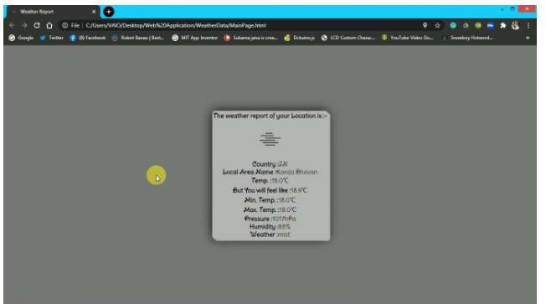
OUTPUT:

Program5: Develop a java stand alone application that connects with the database (Oracle / mySql) and perform the CRUD operation on the database tables.

CREATE DATABASE testdb;
USE testdb;

CREATE TABLE users (
Stu_id INT PRIMARY KEY AUTO_INCREMENT,
Stu_name VARCHAR(100),
Stu_email-id VARCHAR(100),
Stu_address VARCHAR(100)
Stu_contact VARCHAR(100)
);
Java code CRUD operations:

import java.sql.Connection;
import java.sql.DriverManager;
import java.sql.PreparedStatement;
import java.sql.ResultSet;
import java.sql.SQLException;

public class CRUDOperations {

// Database URL, username and password
private static final String DB_URL = "jdbc:mysql://localhost:3306/testdb";
private static final String DB_USERNAME = "root";
private static final String DB_PASSWORD = "password";

// Method to create a new user
public static void createUser(String Stu_name, String Stu_email-id, String Stu_address, String Stu-contact)
{
String query = "INSERT INTO users (Stu_name, Stu_email-id, Stu_address, Stu_contact) VALUES (?, ?, ?,?)";
try (Connection conn = DriverManager.getConnection(DB_URL, DB_USERNAME, DB_PASSWORD);
PreparedStatement stmt = conn.prepareStatement(query)) {
stmt.setString(1, Stu_name);
stmt.setString(2, Stu_email-id);
stmt.setString(3, Stu_address);
stmt.setString(4, Stu_contact);
stmt.executeUpdate();
System.out.println("User created successfully.");
} catch (SQLException e) {
e.printStackTrace();
}
}
// Method to read all users
public static void readUsers() {
String query = "SELECT * FROM users";
try (Connection conn = DriverManager.getConnection(DB_URL, DB_USERNAME, DB_PASSWORD);
PreparedStatement stmt = conn.prepareStatement(query);
ResultSet rs = stmt.executeQuery()) {
while (rs.next()) {
int id = rs.getInt("id");
String name = rs.getString("Stu_name");
String email = rs.getString("Stu_email-id");
String country = rs.getString("Stu_address");
String country = rs.getString("Stu_contact");

System.out.println("ID: " + id + ", Stu_Name: " +Stu_name + ", Stu_Email-id: " + Stu_email-id + ",Stu_Address: " + Stu_address + “Stu_Contact:” + Stu_contact);
}
} catch (SQLException e) {
e.printStackTrace();
}
}

// Method to update a user
public static void updateUser(int id, String name, String email, String country) {
String query = "UPDATE users SET Stu_name = ?, Stu_email-id = ?, Stu_address=? Stu_contact = ? WHERE Stu_id = ?";
try (Connection conn = DriverManager.getConnection(DB_URL, DB_USERNAME, DB_PASSWORD);
PreparedStatement stmt = conn.prepareStatement(query)) {
stmt.setString(1, Stu_name);
stmt.setString(2, Stu_email-id);
stmt.setString(3, Stu_address);
stmt.setString(4, Stu_contact);
stmt.setInt(5, Stu_ id);
stmt.executeUpdate();
System.out.println("User updated successfully.");
} catch (SQLException e) {
e.printStackTrace();
}
}

// Method to delete a user
public static void deleteUser(int id) {
String query = "DELETE FROM users WHERE id = ?";
try (Connection conn = DriverManager.getConnection(DB_URL, DB_USERNAME, DB_PASSWORD);
PreparedStatement stmt = conn.prepareStatement(query)) {
stmt.setInt(1, id);
stmt.executeUpdate();
System.out.println("User deleted successfully.");
} catch (SQLException e) {
e.printStackTrace();
}
}

// Main method
public static void main(String[] args) {
// Create a new user
createUser("John Doe", "john@example.com", "USA", ”+1765789023”);

// Read all users
System.out.println("Reading users:");
readUsers();

// Update a user
updateUser(1, "John Doe", "john.doe@example.com", "Canada", ”+1768964398”);

// Read all users again
System.out.println("Reading users after update:");
readUsers();

// Delete a user
deleteUser(1);

// Read all users again
System.out.println("Reading users after deletion:");
readUsers();
}
}

Explanation
- Database Connection: Establishes a connection to the MySQL database using DriverManager.getConnection.
- Create User: Inserts a new user into the users table.
- Read Users: Fetches and prints all users from the users table.
- Update User: Updates a user's details based on the provided ID.
- Delete User: Deletes a user based on the provided ID.
- Main Method: Demonstrates the usage of CRUD methods.

Running the Application
- Set Up Database: Ensure the MySQL database is running, and the testdb database and users table are created.
- Update Credentials: Update the DB_URL, DB_USERNAME, and DB_PASSWORD in the Java code with your MySQL credentials.
- Compile and Run: Compile and run the Java application from your IDE or command line.

Output :
Inserting Data into student table:
________________________________________
Enter student id: 101
Enter student name: John Doe
Enter student email-id: "john@example.com
Enter student address: USA
Enter student contant: +1765789023
Data inserted successfully into student table

Update Data in student table:
________________________________________
Enter student id: 101
Enter student name: Jane Doe
Enter student email-id: john.doe@example.com
Enter student address: Canada
Enter student contact:+1768964398
Data updated successfully

Delete Data from student table:
______________________________________
Enter student id: 101
Data deleted successfully
Display data:
SID STU_NAME ADDRESS
________________________________________
102 Alice Smith 789 Oak Avenue
________________________________________
103 Bob Johnson 567 Pine Road

Program 6: Create an xml for the bookstore. Validate the same using both DTD and XSD

bookstore.xml
<?xml version="1.0" encoding="UTF-8"?>
<!DOCTYPE bookstore[
<!ELEMENT bookstore (book+)>
<!ELEMENT book (title,author,ISBN,publisher,edition,price)>
<!ELEMENT title (#PCDATA)>
<!ELEMENT author (#PCDATA)>
<!ELEMENT ISBN (#PCDATA)>
<!ELEMENT publisher (#PCDATA)>
<!ELEMENT edition (#PCDATA)>
<!ELEMENT price (#PCDATA)>
]>
<bookstore>
<book>
<title>Webprogramming,buildinginternetapplications</title>
<author>ChrisBates</author>
<ISBN>0-07-049543-7</ISBN>
<publisher>WileyDreamtech</publisher>
<edition>2ndedition</edition>
<price>Rs.250</price>
</book>
<book>
<title>ComputerNetworks</title>
<author>AndrewSTanebaum</author>
<ISBN>81-203-1165-5</ISBN>
<publisher>Pearson</publisher>
<edition>4ndedition</edition>
<price>Rs.350</price>
</book>
<book>
<title>FrontiersofElectroniccommerce</title>
<author>Kalakata</author>
<ISBN>978-81-265-1173-0</ISBN>
<publisher>Pearson</publisher>
<edition>1stedition</edition>
<price>Rs.350</price>
</book>
<book>
<title>JavaProgrammingwithCORBA</title>
<author>G.Brose</author>
<ISBN>978-81-265-1173-0</ISBN>
<publisher>WileyDreamtech</publisher>
<edition>2ndedition</edition>
<price>Rs.250</price>
</book>
<book>
<title>TheUnifiedModellinglanguageUserGuide</title>
<author>GradyBooch,JamesRumbaugh,IvarJacabson</author>
<ISBN>81-7758-372-7</ISBN>
<publisher>PerarsonEducation</publisher>
<edition>2ndedition</edition>
<price>Rs.400</price>
</book>
<book>
<title>Datamining-Conceptsandtechniques</title>
<author>JiaweiHAnandKamber</author>
<ISBN>978-81-312-0538-8</ISBN>
<publisher>Pearson</publisher>
<edition>1stedition</edition>
<price>Rs.550</price>
</book>
</bookstore>
bookstore.xsd

<?xml version="1.0" encoding="UTF-8"?>

<xs:schema xmlns:xs="http://www.w3.org/2001/XMLSchema"

targetNamespace="http://example.com"

xmlns="http://example.com">

<xs:element name="root">

<xs:complexType>

<xs:sequence>

<xs:element name="bookstore" type="bookstoreType"/>

</xs:sequence>

</xs:complexType>

</xs:element>

<xs:complexType name="bookstoreType">

<xs:sequence>

<xs:element name="book" type="bookType" minOccurs="0" maxOccurs="unbounded"/>

</xs:sequence>

</xs:complexType>

<xs:complexType name="bookType">

<xs:sequence>

<xs:element name="title" type="xs:string"/>

<xs:element name="author" type="xs:string"/>

<xs:element name="price" type="xs:decimal"/>

<xs:element name="ISBN" type="xs:decimal"/>

<xs:element name="publisher" type="xs:decimal"/>

<xs:element name="edition" type="xs:decimal"/>

</xs:sequence>

</xs:complexType>

</xs:schema>

bookinf.xsl
<?xml version="1.0"?>
<xsl:stylesheet xmlns:xsl="http://www.w3.org/1999/XSL/Transform" version="1.0">
<xsl:outputmethod="html"/>
<xsl:templatematch="/">
<html>
<body>
<tablealign="center"cellspacing="5"cellpadding="10">
<caption>BOOKSINFORMATION</caption>
<tr bgcolor="lightbrown ">
<th>Title</th>
<th>Author</th>
<th>ISBN</th>
<th>Publisher</th>
<th>Edition</th>
<th>Price</th>
</tr>
<xsl:for-eachselect="books/book">
<tr>
<td><xsl:value-ofselect="title"/></td>
<td><xsl:value-ofselect="author"/></td>
<td><xsl:value-ofselect="ISBN"/></td>
<td><xsl:value-ofselect="publisher"/></td>
<td><xsl:value-ofselect="edition"/></td>
<td><xsl:value-ofselect="price"/></td>
</tr>
</xsl:for-each>
</table>
</body>
</html>
</xsl:template>
</xsl:stylesheet>

Output:

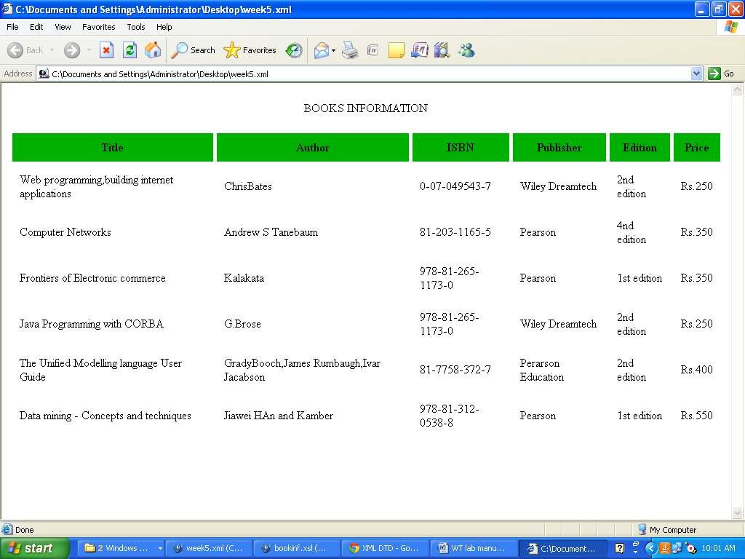

Program7: Design a controller with servlet that provides the interaction with application developed in experiment1 and the database excreated in experiment5.

Reg.html:
<html>
<head>
<title>validation</title>
</head>
<bodybgcolor="magenta">
<formaction="Register.jsp"method="post">

<h1align="center">REGISTRATIONFORM</h1>
<tableborder="0">
<tr>
<td>Name:</td>
<td><inputtype="text"name="t1"minlength="6"></td>
</tr>
<tr>
<td>Password:</td>
<td><inputtype="password"name="t2"></td>
</tr>
<tr>
<td>Phonenumber:</td>
<td><inputtype="text"name="t3"></td>
</tr>
<tr>
<td>E-mailid:</td>
<td><inputtype="text"name="t4"></td>
</tr>
<tr>
<td><inputtype="submit"value="submit"></td>
<td><inputtype="reset"value="cancel"></td>
</tr>
</table>
</form>
</body>
</html>

Register.jsp:
<%@pagelanguage="java"import="java.sql.*,javax.servlet.*"%>
<html>
<form>
<%
String v1,v2,v3,v4,str; v1=request.getParameter("t1"); v2=request.getParameter("t2"); v3=request.getParameter("t3"); v4=request.getParameter("t4");

try{
Class.forName("sun.jdbc.odbc.JdbcOdbcDriver");
Connection cn=DriverManager.getConnection("jdbc:odbc:oradsn","system","ravindra"); Statement st=cn.createStatement();
st.executeUpdate("insertintoregistervalues('"+v1+"','"+v2+"',"+v3+",'"+v4+"')"); if(cn!=null)
{
%>
</form>
RegistrationSuccessful
<%
}
else
{
out.println("Registrationfailed");
}
st.close();
cn.close();
}catch(Exceptione){out.println("Registrationfailed");
%>
<P><ahref="reg.html"target=f2><B>Back<B></a>
<%
}
%>
</body></html>
Execution:
Createatablewithnameregisterwithname(varchar2(10)),password(varchar2(10)), Phone(number (10)) ,Email-ID (varchar2(10)).
CreatetheDatasource name.
Start->settings->controlpanel->AdministrativeTools->DataSources. Under SystemDSN add Microsoft ODBC for Oracle.
SetDataSourcenameto oradsn.

Output:

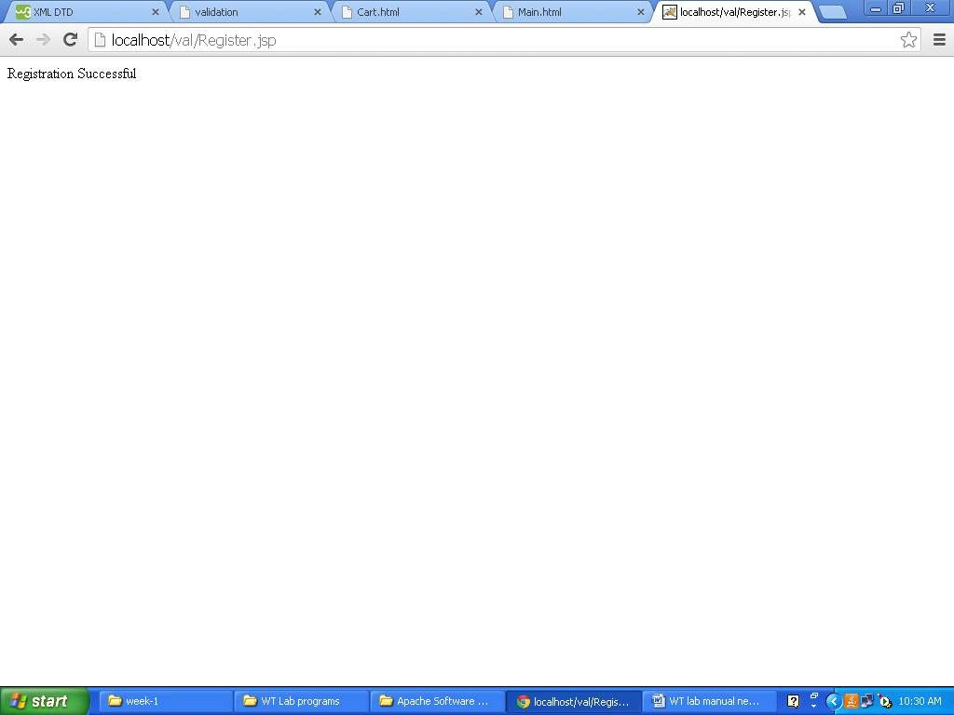
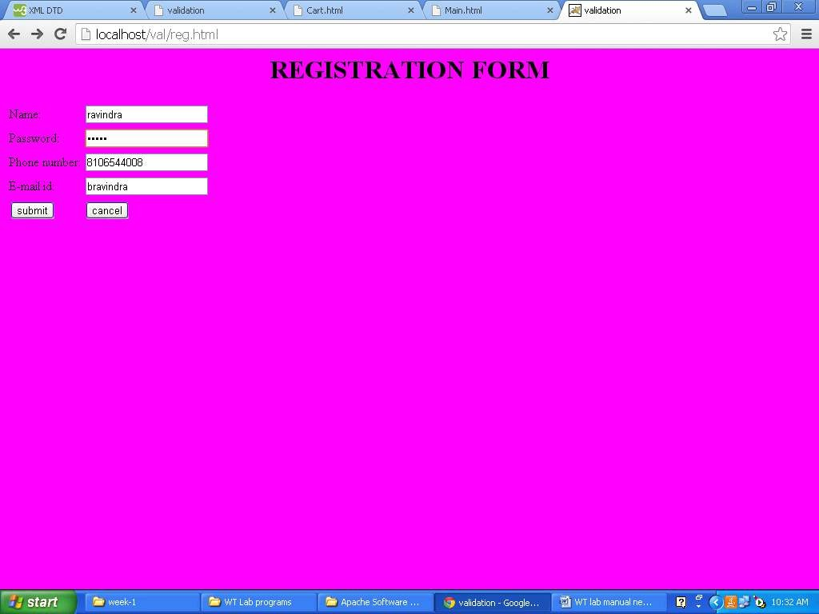
Program 8: Maintaining the transactional history of any user is very important. Explore the
various session tracking mechanism (Cookies, HTTP Session)
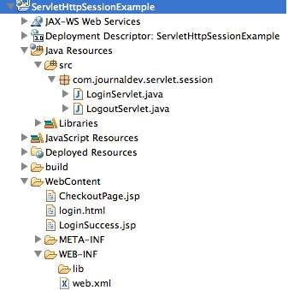
packagecom.journaldev.servlet.session;importjava.io.IOException;
importjava.io.PrintWriter;

importjavax.servlet.RequestDispatcher;importjavax.servlet.ServletException;importjavax.servlet.annotation.WebServlet;importjavax.servlet.http.Cookie;
importjavax.servlet.http.HttpServlet;
importjavax.servlet.http.HttpServletRequest;importjavax.servlet.http.HttpServletResponse;importjavax.servlet.http.HttpSession;

/**
*ServletimplementationclassLoginServlet
*/@WebServlet("/LoginServlet")
publicclassLoginServletextendsHttpServlet{privatestaticfinallongserialVersionUID=1L;privatefinalStringuserID="admin";
privatefinalStringpassword="password";

protectedvoiddoPost(HttpServletRequestrequest,

HttpServletResponseresponse)throwsServletException,IOException

//getrequestparametersforuserIDandpasswordStringuser=request.getParameter("user");Stringpwd=request.getParameter("pwd");

if(userID.equals(user)&&password.equals(pwd)){HttpSessionsession=request.getSession();session.setAttribute("user","Pankaj");
//settingsessiontoexpiryin30minssession.setMaxInactiveInterval(30*60);CookieuserName=newCookie("user",user);userName.setMaxAge(30*60);response.addCookie(userName);response.sendRedirect("LoginSuccess.jsp");
}else{
RequestDispatcherrd=
getServletContext().getRequestDispatcher("/login.html");
PrintWriterout=response.getWriter();
out.println("<fontcolor=red>Eitherusernameorpasswordis

wrong.</font>");

}

}

}

rd.include(request,response);

LoginSuccess.jspcodeisgivenbelow.

<%@pagelanguage="java"contentType="text/html;charset=US-ASCII"pageEncoding="US-ASCII"%>
<!DOCTYPEhtmlPUBLIC"-//W3C//DTDHTML4.01Transitional//EN""https://www.w3.org/TR/html4/loose.dtd">
<html>
<head>
<metahttp-equiv="Content-Type"content="text/html;charset=US-ASCII">
<title>LoginSuccessPage</title>
</head>
<body>
<%
//allowaccessonlyifsessionexistsStringuser=null;if(session.getAttribute("user")==null){

response.sendRedirect("login.html");
}elseuser=(String)session.getAttribute("user");StringuserName=null;
StringsessionID=null;
Cookie[]cookies=request.getCookies();if(cookies!=null){
for(Cookiecookie:cookies){
if(cookie.getName().equals("user"))userName=cookie.getValue();if(cookie.getName().equals("JSESSIONID"))sessionID=cookie.getValue();
}
%>
<h3>Hi<%=userName%>,Loginsuccessful.YourSessionID=<%=sessionID%></h3>
<br>User=<%=user%>
<br>
<ahref="CheckoutPage.jsp">CheckoutPage</a>
<formaction="LogoutServlet"method="post">
<inputtype="submit"value="Logout">
</form>
</body>
</html>
WhenaJSPresourceisused,containerautomaticallycreatesasessionforit,sowecan’tcheckifsessionisnulltomakesureifuserhascomethroughloginpage,soweareusingsessionattributetovalidaterequest.CheckoutPage.jspisanotherpageandit’scodeisgivenbelow.

<%@pagelanguage="java"contentType="text/html;charset=US-ASCII"pageEncoding="US-ASCII"%>
<!DOCTYPEhtmlPUBLIC"-//W3C//DTDHTML4.01Transitional//EN""https://www.w3.org/TR/html4/loose.dtd">
<html>
<head>
<metahttp-equiv="Content-Type"content="text/html;charset=US-ASCII">
<title>LoginSuccessPage</title>
</head>
<body>
<%
//allowaccessonlyifsessionexistsif(session.getAttribute("user")==null){
response.sendRedirect("login.html");
}
StringuserName=null;StringsessionID=null;
Cookie[]cookies=request.getCookies();if(cookies!=null){
for(Cookiecookie:cookies){
if(cookie.getName().equals("user"))userName=cookie.getValue();

}
}
%>
<h3>Hi<%=userName%>,dothecheckout.</h3>
<br>
<formaction="LogoutServlet"method="post">
<inputtype="submit"value="Logout">
</form>
</body>
</html>

OurLogoutServletcodeisgivenbelow.packagecom.journaldev.servlet.session;
importjava.io.IOException;

importjavax.servlet.ServletException;importjavax.servlet.annotation.WebServlet;importjavax.servlet.http.Cookie;
importjavax.servlet.http.HttpServlet;
importjavax.servlet.http.HttpServletRequest;importjavax.servlet.http.HttpServletResponse;importjavax.servlet.http.HttpSession;

/**
*ServletimplementationclassLogoutServlet
*/@WebServlet("/LogoutServlet")
publicclassLogoutServletextendsHttpServlet{privatestaticfinallongserialVersionUID=1L;

protectedvoiddoPost(HttpServletRequestrequest,HttpServletResponseresponse)throwsServletException,IOException{
response.setContentType("text/html");Cookie[]cookies=request.getCookies();if(cookies!=null){
for(Cookiecookie:cookies){if(cookie.getName().equals("JSESSIONID")){
System.out.println("JSESSIONID="+cookie.getValue());break;
}
}
}

//invalidatethesessionifexists
HttpSessionsession=request.getSession(false);System.out.println("User="+session.getAttribute("user"));if(session!=null){
session.invalidate();
}
response.sendRedirect("login.html");
}

}

Below images shows the execution of our web application.
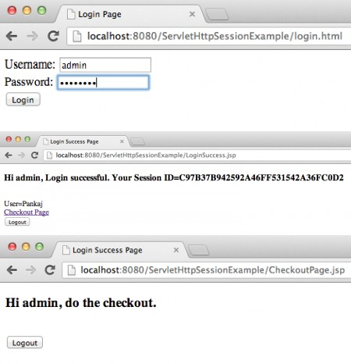

Program9. Create a custom server using http module and explore the other modules of NodeJS like OS, path ,event.

STEPS TO INSTALL NODE-JS & REACT -JS

Step 1: Install Node-js
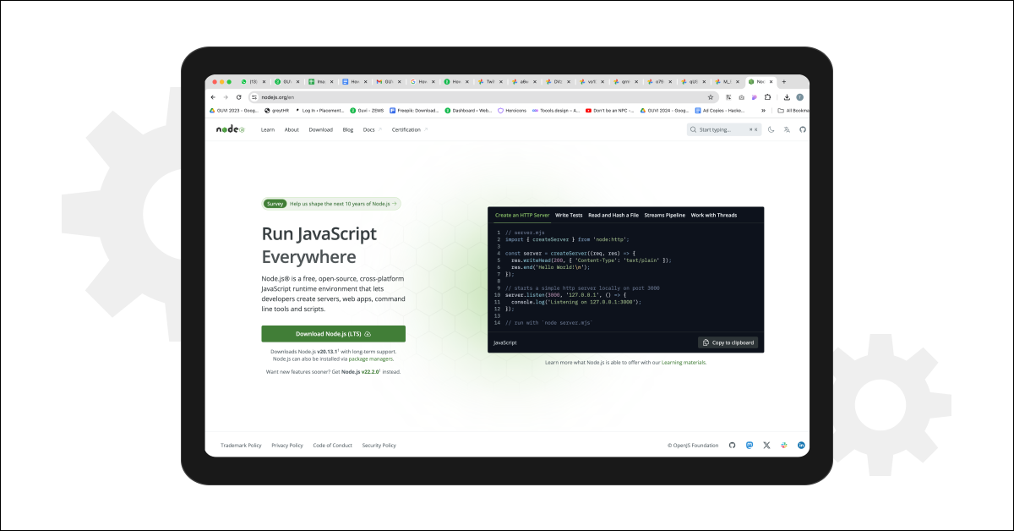

Step 2: Verify the Installation
To ensure Node.js has been installed correctly, open the command prompt and type:
node -v
If the installation is successful, the terminal will display the installed version of Node.js.
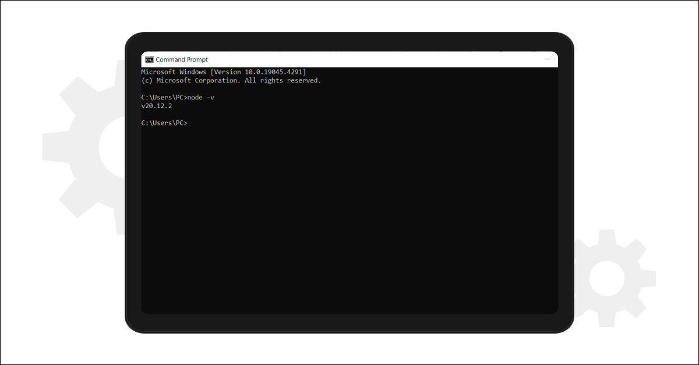

Step 3: Install Create React App
Next, in the terminal, run the following command:
npm install -g create-react-app
This command will globally install the Create React App tool. To verify the installation, type:
create-react-app –version
If installed correctly, it will display the installed version of create react app.
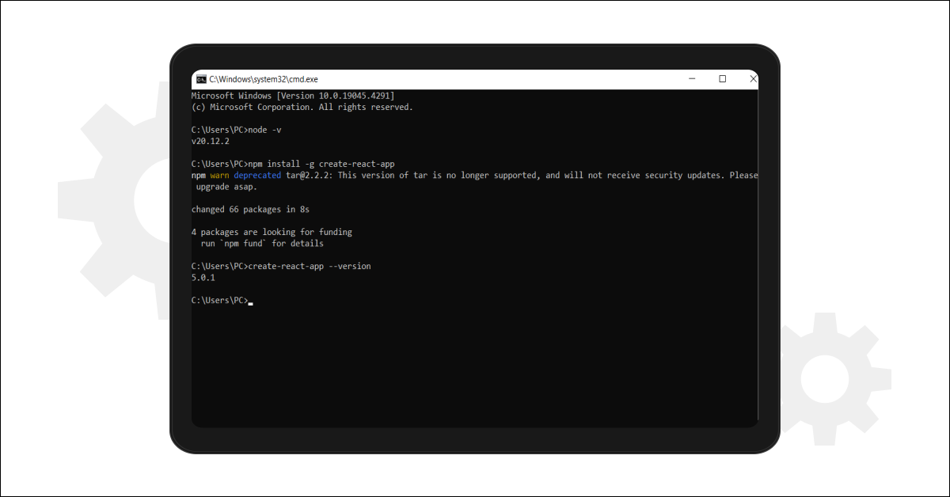

Step 4: Create a New Folder for Your React App
Create a new folder for your React app by running:
mkdir newfolder
Replace “newfolder” with your desired folder name. Move inside the folder using:
cd newfolder
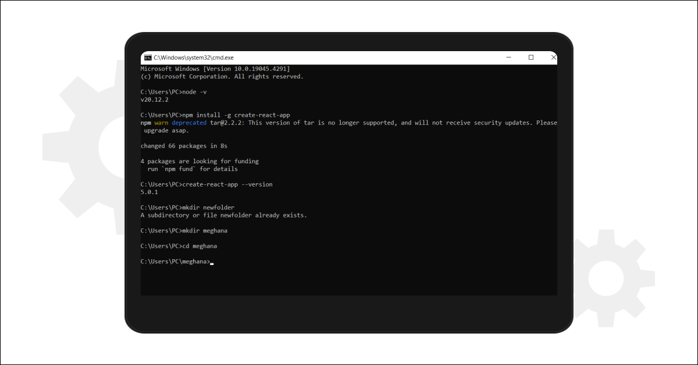

Step 5: Create a New React App
Inside the newly created folder, run the command:
create-react-app your_app_name
This will take some time as it installs the required dependencies. Note: Due to npm naming restrictions, the app name should only contain lowercase letters
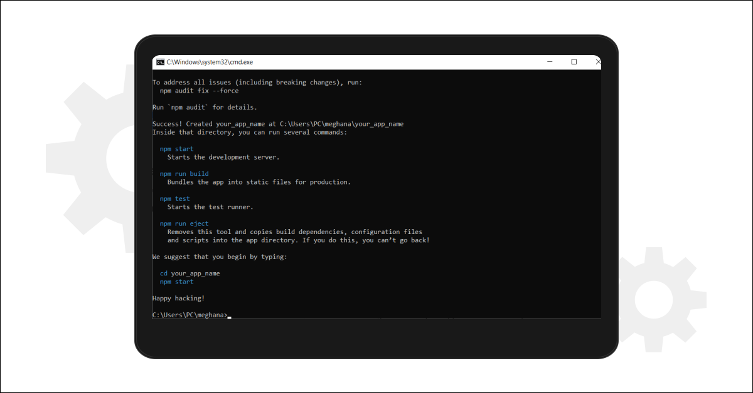

Step 6: Open Your Project in an IDE
Open your preferred IDE (e.g., Visual Studio Code) and navigate to the folder where your React app was installed. Enter the directory using:
cd your_app_name
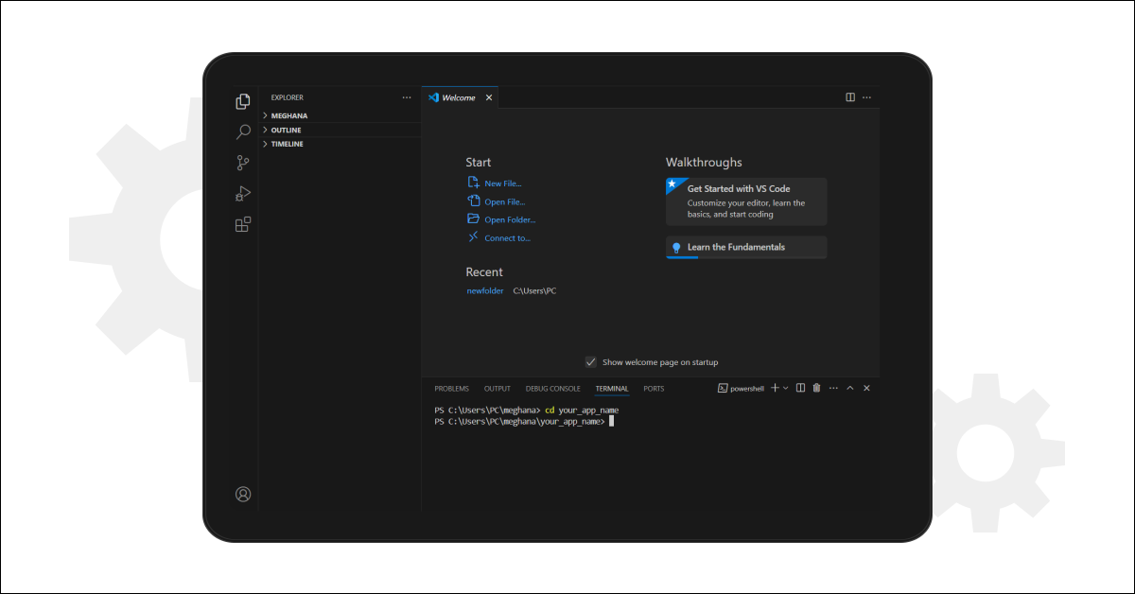
Step 7: Start Your App
To start your app, run the following command:
npm start
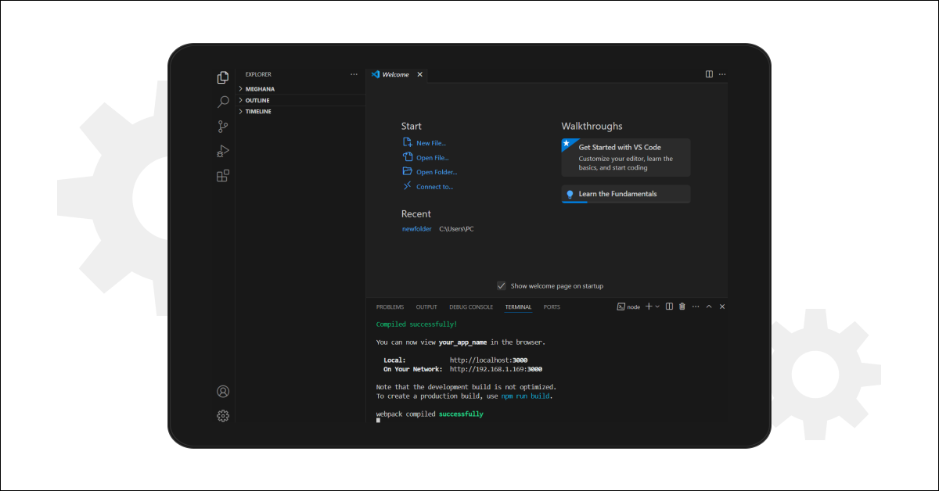
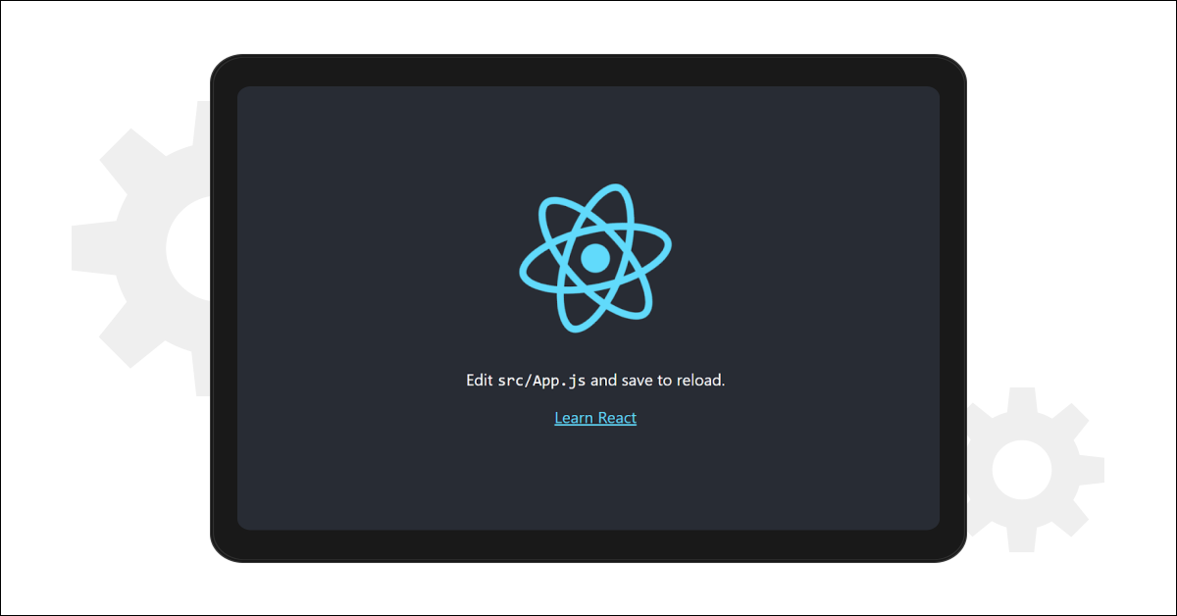

Step 1: Set Up the Project
- Initialize a new Node.js project:
mkdir custom-server
cd custom-server
npm init -y
- Create the main server file:
node server.js

Step 2: Create a Basic HTTP Server
javascript

// server.js
const http = require('http');
const os = require('os');
const path = require('path');
const EventEmitter = require('events');

// Create a custom event emitter
class MyEmitter extends EventEmitter {}
const myEmitter = new MyEmitter();

// Event listener for logging requests
myEmitter.on('log', (message) => {
console.log(`[LOG]: ${message}`);
});

// Create an HTTP server
const server = http.createServer((req, res) => {
// Log the request method and URL
myEmitter.emit('log', `Request received: ${req.method} ${req.url}`);

// Use path module to handle file paths
const filePath = path.join(__dirname, 'public', req.url === '/' ? 'index.html' : req.url);

// Handle different routes
if (req.url === '/') {

res.writeHead(200, { 'Content-Type': 'text/html' });
res.end('<h1>Welcome to the Custom Server!</h1>');
} else if (req.url === '/os-info') {
// Use os module to get OS information
const osInfo = {
platform: os.platform(),
cpus: os.cpus().length,
arch: os.arch(),
freeMemory: os.freemem(),
totalMemory: os.totalmem(),
uptime: os.uptime()
};
res.writeHead(200, { 'Content-Type': 'application/json' });
res.end(JSON.stringify(osInfo, null, 2));
} else {
res.writeHead(404, { 'Content-Type': 'text/plain' });
res.end('404 Not Found');
}
});

// Start the server
const PORT = process.env.PORT || 3000;
server.listen(PORT, () => {
console.log(`Server running on http://localhost:${PORT}`);
});

Step 4: Run the Server
node server.js

Step 5: Test the Server
- Open your browser and go to http://localhost:3000 to see the welcome message.
- Go to http://localhost:3000/os-info to see the JSON response with your system's OS information.
- Check the console for logged requests using the custom event emitter.

OUTPUT:
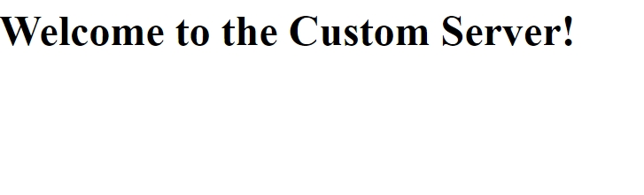

Program10. Develop an express web application that can interact with REST API to perform14 CRUD operations on student data. (Use Postman)
- Firstly we need to create a new folder and open the folder in the command prompt and enter a command as below:
Npm init -y
- Open that folder in the vscode by entering code.
- Next in the terminal we need to install all the packages we need, so we mainly use express and sqlite3.
- The Command to install express and sqlite3 is
npm install express sqlite3
Then create file named as the app.js and db.js

db.js

const sqlite3 = require('sqlite3').verbose();

// Function to initialize the database schema
function initializeDatabase() {
const db = new sqlite3.Database('./mydatabase.db', (err) => {
if (err) {
console.error(err.message);
} else {
console.log('Connected to the SQLite database.');
createStudentsTable(db);
}
});

// Close the database connection when the Node process exits
process.on('exit', () => {
db.close((err) => {
if (err) {
console.error(err.message);
} else {
console.log('Disconnected from the SQLite database.');
}
});
});

}
// Function to create the 'students' table if it doesn't exist
function createStudentsTable(db) {
const createTableQuery = `
CREATE TABLE IF NOT EXISTS students (
id INTEGER PRIMARY KEY AUTOINCREMENT,
name TEXT,
age INTEGER,
grade TEXT
);
`;

db.run(createTableQuery, (err) => {
if (err) {
console.error(err.message);
} else {
console.log('The students table has been created or already exists.');
}
});
}

module.exports = { initializeDatabase };

when we execute both the db.js then the database will be created that is mydatabase.db

app.js

const express = require('express');
const sqlite3 = require('sqlite3');
const{ initializeDatabase } = require('./db');
const app = express();
const port = 3000;

// Connect to SQLite database
const db = new sqlite3.Database('./mydatabase.db', (err) => {
if (err) {
console.log(err.message);
} else {
console.log('Connected to the SQLite database.');
}
});

// Middleware to parse request body as JSON
app.use(express.json());

app.get('/', (req, res) => {
res.send('Welcome to the Student');
});

// Get all Students
app.get('/students', (req, res) => {
db.all('SELECT * FROM students', [], (err, rows) => {
if (err) {
return console.error(err.message);
}
res.json(rows);
});
});

// Get a single student by id
app.get('/students/:id', (req, res) => {
const id = req.params.id;
db.all('SELECT * FROM students WHERE id = ?', [id], (err, row) => {
if (err) {
return console.error(err.message);
}
res.json(row);
});
});

// Create a new student
app.post('/students', (req, res) => {
const{ name, age, grade } = req.body;
db.run('INSERT INTO students (name, age, grade) VALUES (?, ?, ?)', [name, age, grade], function (err) {
if (err) {
return console.error(err.message);
}
res.status(201).json({ id:this.lastID });
});
});

// Update a student
app.put('/students/:id', (req, res) => {
const id = req.params.id;
const{ name, age, grade } = req.body;
db.run('UPDATE students SET name = ?, age = ?, grade = ? WHERE id = ?', [name, age, grade, id], function (err) {

if (err) {
return console.error(err.message);
}
res.json({ updatedID:id });
});
});

// Delete a student
app.delete('/students/:id', (req, res) => {
const id = req.params.id;
db.run('DELETE FROM students WHERE id = ?', id, function (err) {
if (err) {
return console.error(err.message);
}
res.json({ deletedID:id });
});
});

app.listen(port, () => {
console.log('Server running at http://localhost:${port}');
});

Output :

GET:
- Open Postman.
- Set the request type to GET.
- Enter the URL: http://localhost:3000/students.
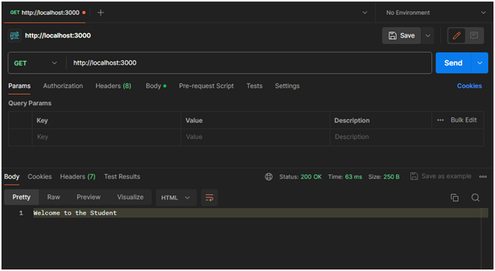

POST : Create a New Student
- Open Postman.
- Set the request type to POST.
- Enter the URL: http://localhost:3000/students.
- Go to the "Body" tab.
- Select raw and set the body to JSON format.
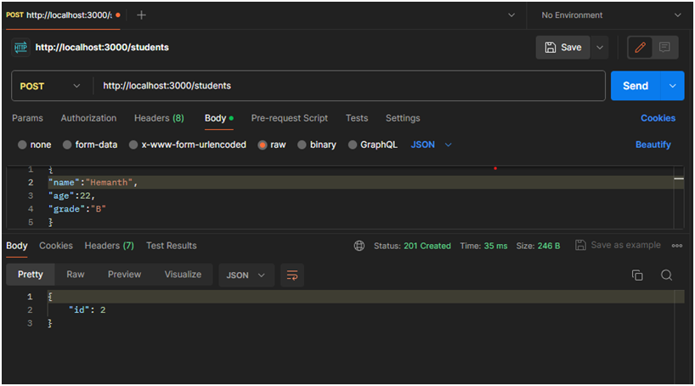

GET: #all Students
- Set the request type to GET.
- Enter the URL: http://localhost:3000/students.
- Click on the "Send" button
- You should receive a response with details of all students in your SQLite database.
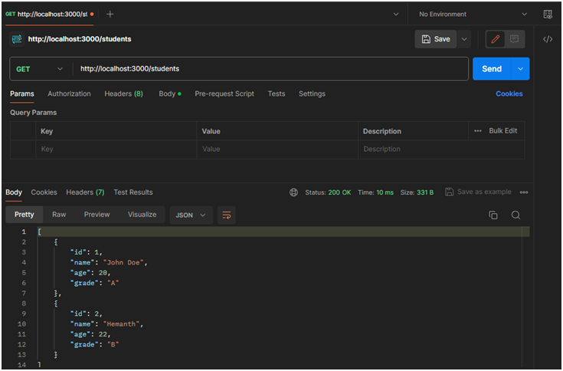

DELETE:
- Set the request type to DELETE.
- Enter the URL for the student you want to delete (replace: id with an actual student ID): http://localhost:3000/students/:id
- Place instead of ID which replace with number that is ID to be deleted.
- Then click send

OUTPUT:
- Set the request type to PUT.
- Enter the URL for the student you want to delete (replace: id with an actual student ID): http://localhost:3000/students/:id
- Go to the "Body" tab.
- Select raw and set the body to JSON format
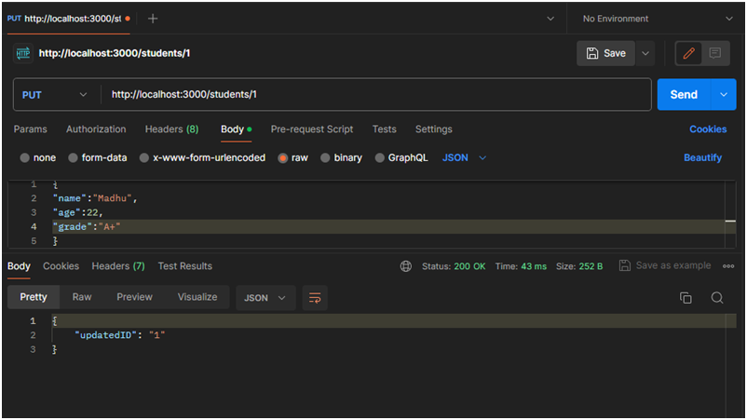

Program11: For the above application create authorized end points using JWT(JSON Web Token).

Create API endpoints
Our default endpoint returns string — we see that above. Now we’ll create another API endpoint, that is another URL which returns some useful data.

Before proceed, let’s do some more exercise:
→ Create a folder inside the project root with name "routes".
→ Then create a file inside this "routes" folder with name "items.js".

Next, Open up and update your node-ex-api/routes/items.js file with below code:
// import required essentials const express = require('express');
// create new router
const router = express.Router();
// create a JSON data array let data = [
{ id: 1, title: 'Create a project', order: 1, completed: true, createdOn: new Date() },
{ id: 2, title: 'Take a cofféé', order: 2, completed: true, createdOn: new Date() },
{ id: 3, title: 'Write new article', order: 3, completed: true, createdOn: new Date() },
{ id: 4, title: 'Walk toward home', order: 4, completed: false, createdOn: new Date() },
{ id: 5, title: 'Have some dinner', order: 5, completed: false, createdOn: new Date() },
];
// this end-point of an API returns JSON data array router.get('/', function (req, res) {
res.status(200).json(data);
});
// this end-point returns an object from a data array find by id
// we get `id` from URL end-points router.get('/:id', function
(req, res) {
// find an object from `data` array match by `id` let found = data.find(function (item) {
return item.id === parseInt(req.params.id);
});
// if object found return an object else return 404 not-found if (found) {
res.status(200).json(found);
} else {
res.sendStatus(404);
}

});
module.exports = router;

See below ↓↓

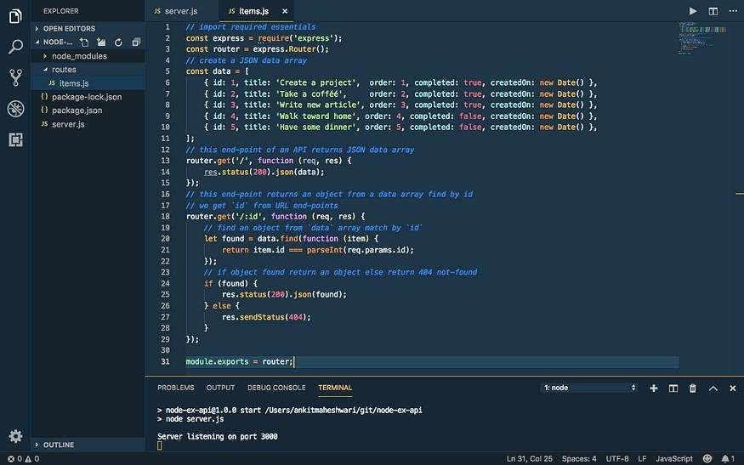

Register API endpoints

Let’s register it in the "server.js" file to make use of new endpoints.
Do not forget to install CORS.Open your terminal in the "node-ex-api" folder and run this command:npm install cors.

Now, open up your node-ex-api/server.js file and modify with below code

// import required essentials const http= require('http');
const express = require('express');
var cors = require('cors');// import `items` from `routes` folder const itemsRouter = require('./routes/items');
// create new app const app = express();
app.use(express.json());

// use it before all route definitions
// allowing below URL to access these APIs end-points
// you can replace this URL(http://localhost:8100) with your
// application URL from where you are calling these APIs app.use(cors({origin: 'http://localhost:8100'}));
/* this '/items' URL will have two end-points:
→ localhost:3000/items/ (this returns array of objects)
→ localhost:3000/items/:id (this returns single object)*/
app.use('/items', itemsRouter);
// default URL to API app.use('/', function(req, res) {
res.send('node-ex-api works :-)');
});

const server = http.createServer(app); const port = 3000; server.listen(port);
console.debug('Server listening on port ' + port);

□ See below ↓↓
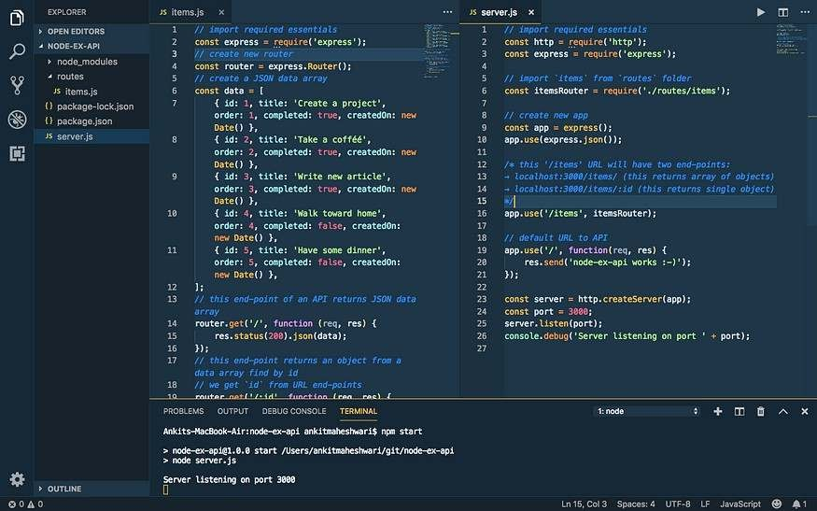
The "items.js" and "server.js" file will look like this ↑
Now, run npm start if your server is not running. This time we have three end-points:
→ localhost:3000 (Default)
→ localhost:3000/items (Returns all objects)
→ localhost:3000/items/1 (Returns single object of id=1)
□ See browser below ↓

Click image If you can’t see this.

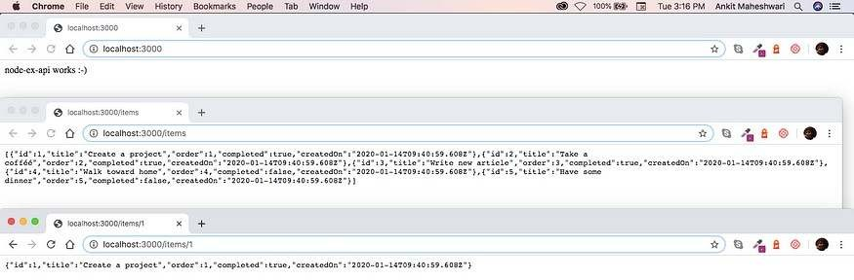

Program 12. Create a react application for the student management system having registration, login, contact, about pages and implement routing to navigate through these pages.

Create the project folder containing two sub-folders named client and server. mkdir auth-system cd auth-system mkdir client server Navigate into the server folder and create a package.json file.cd server & npm init –y Install Express.js, CORS, and Nodemon. npm install express cors nodemon Express.js is a fast, minimalist framework that provides several features for building web applications in Node.js. CORS is a Node.js package that allows communication between different domains. Nodemon is a Node.js tool that automatically restarts the server after detecting file changes.
Create an index.js file - the entry point to the web server. touch index.js
Set up a simple Node.js server as below:
const express = require("express"); const cors = require("cors");
const app = express(); const PORT = 4000;
app.use(express.urlencoded({ extended: true })); app.use(express.json());
app.use(cors());
app.get("/api", (req, res) => { res.json({ message: "Hello world" });
});
app.listen(PORT, () => {
console.log(`Server listening on ${PORT}`);
});

Building the app user interface
In this section, we'll build the user interface for the application allowing users to register and sign in to an application. Users can create an account, log in, and perform 2FA via SMS before they are authorised to view the dashboard.
Create a new React.js project within the client folder.
cd client
npx create-react-app ./

Delete the redundant files such as the logo and the test files from the React app, and update the App.js file to display Hello World as below.
function App() { return (
<div>
<p>Hello World!</p>
</div>
);
}

export default App;
Navigate into the src/index.css file and copy the code below. It contains all the CSS required for styling this project.

@importurl("https://fonts.googleapis.com/css2? family=Space+Grotesk:wght@300;400;500;600;700&display=swap");
* {

box-sizing: border-box; margin: 0;
padding: 0;
font-family: "Space Grotesk", sans-serif;
}
input {
height: 45px; padding: 10px 15px; margin-bottom: 15px;
}
button {
width: 200px; outline: none; border: none; padding: 15px; cursor: pointer; font- size: 16px;
}
.login container,
.signup container,
.verify,
.dashboard { width: 100%;
min-height: 100vh; padding: 50px 70px; display: flex;
flex-direction: column; align-items: center; justify-content: center;
}
.login form,
.verify form,
.signup form { width: 100%; display: flex;
flex-direction: column;
}
.loginBtn,
.signupBtn,
.codeBtn {
background-color: green; color: #fff;
margin-bottom: 15px;
}
.signOutBtn {
background-color: #c21010; color: #fff;
}
.link {
cursor: pointer;
color: rgb(39, 147, 39);
}
.code {
width: 50%;
text-align: center;
}

.verify form {
align-items: center;
}
@media screen and (max-width: 800px) {
.login container,

.signup container,
.verify {
padding: 30px;
}
}
Install React Router - a JavaScript library that enables us to navigate between pages in a React application.
npm install react-router-dom
Create a components folder within the React app containing the Signup.js, Login.js, PhoneVerify.js and Dashboard.js files. mkdir components cd components touch Signup.js Login.js PhoneVerify.js Dashboard.js Update the App.js file to render the newly created components on different routes via React Router.
import { BrowserRouter, Route, Routes } from "react-router-dom"; import Login from "./components/Login";
import Signup from "./components/Signup";
import Dashboard from "./components/Dashboard"; import PhoneVerify from "./components/PhoneVerify";
function App() { return (
<BrowserRouter>
<Routes>
<Route path='/' element={<Login />} />
<Route path='/register' element={<Signup />} />
<Route path='/dashboard' element={<Dashboard />} />
<Route path='phone/verify' element={<PhoneVerify />} />
</Routes>
</BrowserRouter>
);
}
export default App;
The Login page Copy the code below into the Login.js file. It accepts the email and password from the user.
import React, { useState } from "react";
import { useNavigate } from "react-router-dom";
const Login = () => {
const [email, setEmail] = useState("");
const [password, setPassword] = useState("");
const navigate = useNavigate();
const handleSubmit = (e) => { e.preventDefault();

console.log({ email, password }); setPassword("");
setEmail("");
};
const gotoSignUpPage = () => navigate("/register");
return (
<div className='login container'>
<h2>Login </h2>
<form className='login form' onSubmit={handleSubmit}>
<label htmlFor='email'>Email</label>

<input
type='text' id='email' name='email' value={email} required
onChange={(e) => setEmail(e.target.value)}
/>
<label htmlFor='password'>Password</label>
<input
type='password' name='password' id='password' minLength={8} required value={password}
onChange={(e) => setPassword(e.target.value)}
/>
<button className='loginBtn'>SIGN IN</button>
<p>
Don't have an account?{" "}
<span className='link' onClick={gotoSignUpPage}> Sign up
</span>
</p>
</form>
</div>
);
};
export default Login;

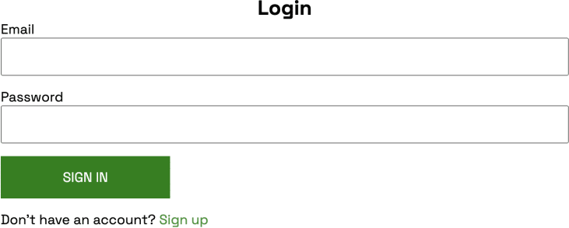

The Sign up page
Copy the code below into the Signup.js file. It accepts the email, username, telephone, and password from the user.
import React, { useState } from "react";
import { useNavigate } from "react-router-dom";
const Signup = () => {
const [email, setEmail] = useState("");
const [username, setUsername] = useState(""); const [tel, setTel] = useState("");
const [password, setPassword] = useState(""); const navigate = useNavigate();
const handleSubmit = (e) => { e.preventDefault();
console.log({ email, username, tel, password }); setEmail("");
setTel("");
setUsername("");
setPassword("");
};
const gotoLoginPage = () => navigate("/");
return (
<div className='signup container'>
<h2>Sign up </h2>

<form className='signup form' onSubmit={handleSubmit}>
<label htmlFor='email'>Email Address</label>
<input
type='email' name='email' id='email' value={email} required
onChange={(e) => setEmail(e.target.value)}
/>
<label htmlFor='username'>Username</label>
<input
type='text' id='username' name='username' value={username} required
onChange={(e) => setUsername(e.target.value)}
/>
<label htmlFor='tel'>Phone Number</label>
<input
type='tel' name='tel' id='tel' value={tel} required
onChange={(e) => setTel(e.target.value)}
/>
<label htmlFor='tel'>Password</label>
<input
type='password' name='password' id='password' minLength={8} required value={password}
onChange={(e) => setPassword(e.target.value)}
/>
<button className='signupBtn'>SIGN UP</button>
<p>
Already have an account?{" "}
<span className='link' onClick={gotoLoginPage}> Login
</span>
</p>
</form>
</div>
);
};

exportdefaultSignup;
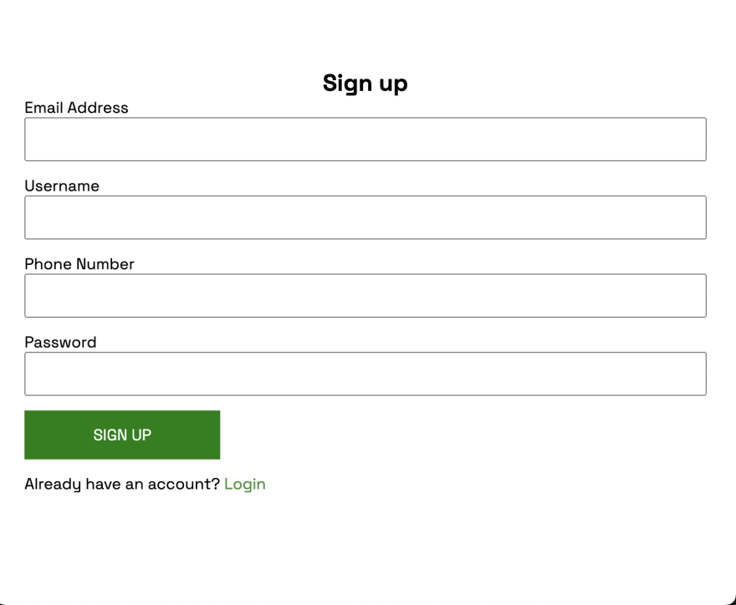
program 13. Create a service in react that fetches the weather information from openweathermap.org and the display the current and historical weather information using graphical representation usingchart.js

Step 1: Create an OpenWeatherMap Account and Generate API Key
- Visit the OpenWeatherMap website (https://openweathermap.org/) and click on "Sign Up" or "Log In" to create an account or log into your existing account.
- Once logged in, navigate to your account dashboard.
- From the dashboard, locate my API Keys section and click on "Create Key" or "API Keys" to generate a new API key.
- Provide a name for your API key (e.g., "WeatherApp") and click on the "Generate" or "Create" button.
- Your API key will be generated and displayed on the screen. Make sure to copy it as we will need it later.
Locate API key
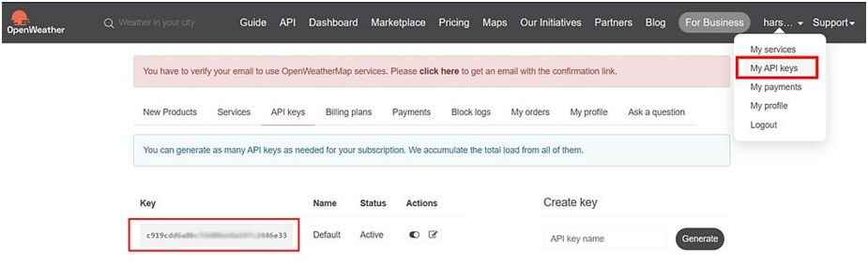

Step 2: Set up a new React project
- Open your terminal or command prompt.
- Run the following command to create a new React project:

npxcreate-react-app weather-app
s

- Once the project is created, navigate into the project directory:

cd weather-app

Step 3: Install required packages
In the project directory, install the necessary packages by executing the following command

npm install axios

We will use the Axios library to make HTTP requests to the OpenWeatherMap API.

Step 4: Create a Weather component
- Inside the "src" directory, create a new file called "Weather.js" and open it in your code editor.
- Add the following code to define a functional component named Weather:

import React, { useEffect, useState } from 'react';
import axios from 'axios';

const Weather = () => {
const [city, setCity] = useState('');
const [weatherData, setWeatherData] = useState(null);

const fetchData = async () => {
try {
const apiKey = 'c97c0c1086d42990e89d64d76f50bb61'; // Replace with your OpenWeatherMap API key
const response = await axios.get(
'https://api.openweathermap.org/data/2.5/weather?q=${city}&units=metric&appid=${apiKey}'
);
setWeatherData(response.data);
console.log(response.data); //You can see all the weather data in console log
} catch (error) {
console.error(error);
}
};

useEffect(() => {
fetchData();
}, []);

const handleInputChange = (e) => {
setCity(e.target.value);
};

const handleSubmit = (e) => {
e.preventDefault();
fetchData();
};

return (
<div>
<form onSubmit={handleSubmit}>
<input
type="text"
placeholder="Enter city name"
value={city}
onChange={handleInputChange}
/>
<button type="submit">Get Weather</button>
</form>
{weatherData ? (
<>
<h2>{weatherData.name}</h2>
<p>Temperature: {weatherData.main.temp} C</p>
<p>Description: {weatherData.weather[0].description}</p>
<p>Feels like : {weatherData.main.feels_like} C</p>
<p>Humidity : {weatherData.main.humidity}%</p>
<p>Pressure : {weatherData.main.pressure}</p>
<p>Wind Speed : {weatherData.wind.speed}m/s</p>
</>
) : (
<p>Loading weather data...</p>
)}
</div>
);
};

export default Weather;

Replace {YOUR_API_KEY} in the API URL with the API key you generated from OpenWeatherMap.

Step 5: Connect the Weather component to your app.
- Open the "App.js" file in the "src" directory.
- Replace the existing code with the following code:

import React from'react';
import Weather from'./Weather';

const App = () => {
return (
<div>
<h1>Weather Forecast App</h1>
<Weather />
</div>
);
};

exportdefault App;

Your output should look like this:
Output :

Initial Screen
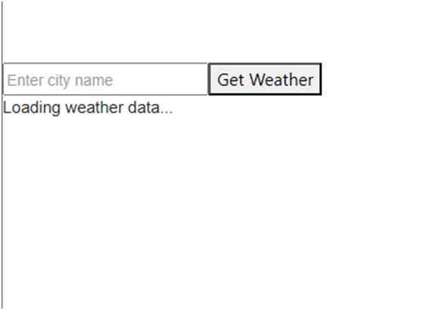

After Supply the City name
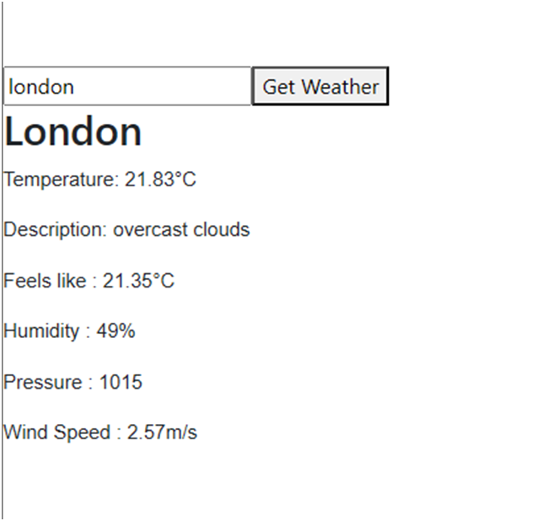

Program14: Create a TODO application in react with necessary components and deploy it into github

How To Install Git Bash On Windows

Step 1: Downloading Git Bash

In this section, you will download Git Bash executable from the official website.

Open your preferred browser and visit Git Bash downloads page by clicking the following link: Git Download Page

Once the page loads, click the Download for Windows button.

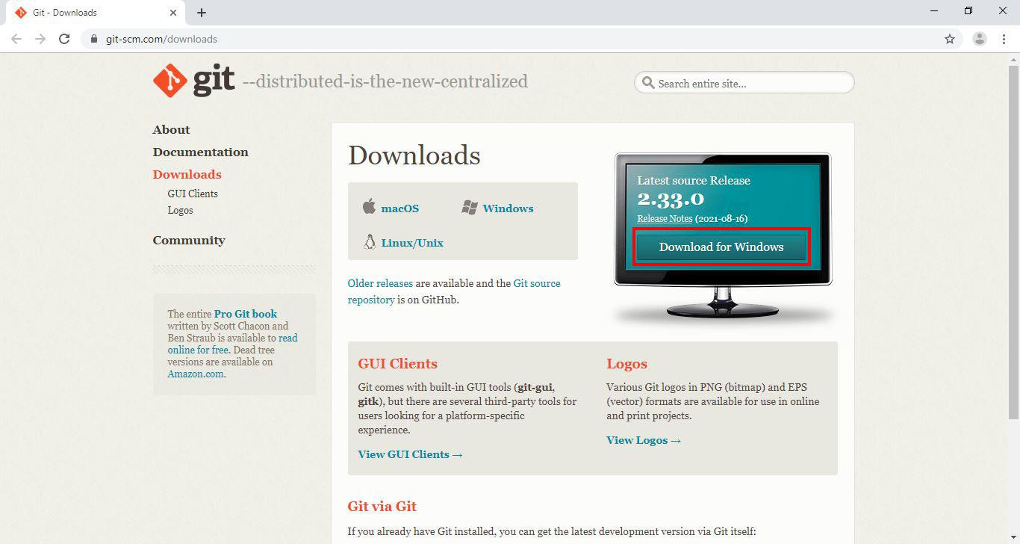

Next, you will be redirected to a different page and download will start automatically in a few seconds.
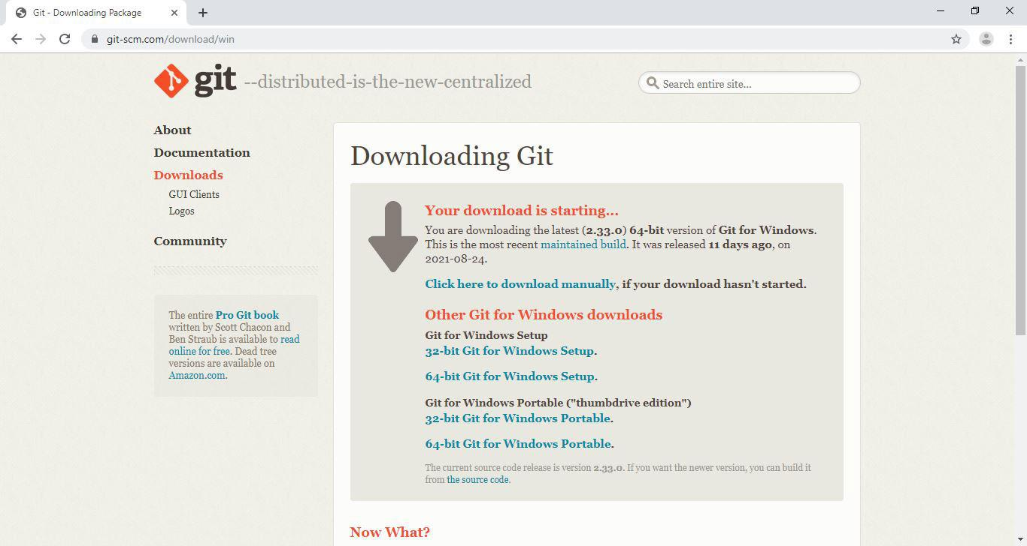

Now that you have downloaded the Git Bash executable, you will run the installer.
Step 2: Running the Installer
In this step you will start the Git Bash installation wizard. Go into your Downloads directory or the location where your browser download things in. Click the Git Bash executable(.exe file) to run the installer.
Windows will prompt you with the message "Do you want to allow this app to make changes to your device?", click Yes.
Next, read the GNU General Public License and click Next.

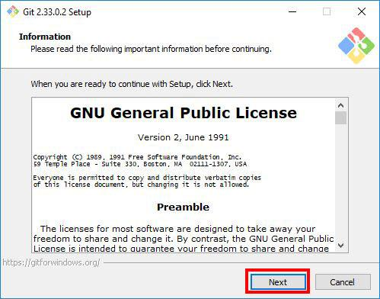

Step 3: Selecting the Destination Location
In this step, the installer will ask you select the location you want to install Git Bash. Proceed with the default option, and click Next.
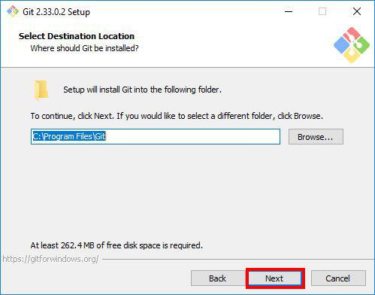

Step 4: Selecting Components
Select the components you want to install. I prefer selecting the Additional icons component which creates a Git Bash shortcut on the desktop. After you've selected the components, click Next.
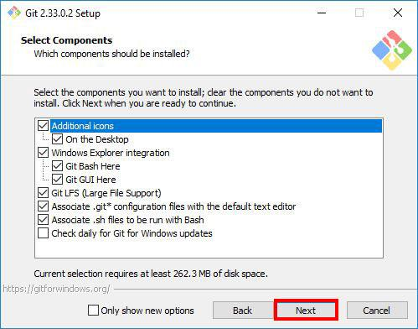

Step 5: Selecting the Start Menu Folder
The installer will ask you to choose the folder to create Start Menu folder. Proceed with the default name by clicking Next.

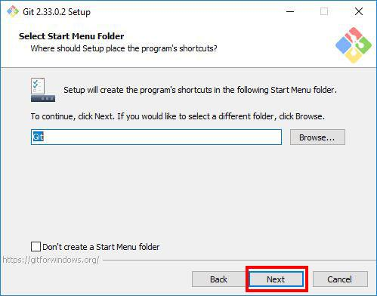
Step 6: Choosing the Default Editor for Git
In this step, the installer will ask you to choose the default editor for Git. By default it chooses Vim, please don't proceed with the Vim editor as it has a steep learning curve.
Instead, choose a text editor that you like. If you looking for recommendations, you can download Visual studio code or notepad++ which are much easier to use and restart the installation wizard.
I prefer Visual Studio code, so I will select that.
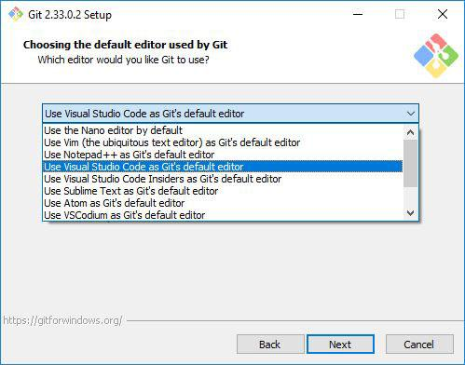

After choosing the editor, click Next.
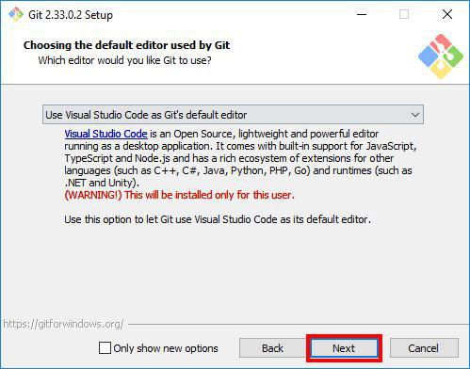

Step 7: Adjusting the Name of the Initial Branch in New Repositories.
The installer will now ask you to choose the branch name for new repositories. Naming a branch master used to be a popular naming convection, but lately there has been a shift to naming branches main. This due to negative association with the word master. Even GitHub changed the default branch name from master to a more inclusive name main.
So in this step, we will name the branch name main. select the Override the default branch name for new repositories option, and type main. After that, click Next.
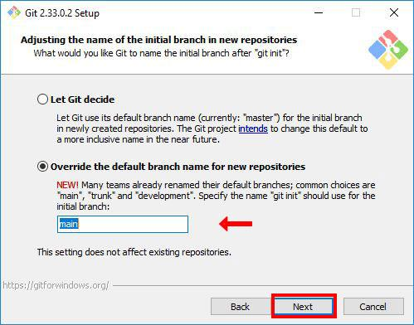

Step 8: Adjusting your PATH Environment
In this section, the installer will ask you to choose how you want to use Git. It offers you the following options:
Use Git from Git Bash only: allows you to run Git and Bash commands in the Git Bash terminal only. The commands won't work on Windows Command Line(CMD) or PowerShell.
Git from the command line and also from 3rd-party software(recommended): allows you to run Git commands only on CMD, PowerShell and when you need bash commands, you will need to open the Git Bash terminal.
Use Git and optional Unix tools from the Command Prompt: Allows you to run both Git and Bash commands on CMD or Powershell. This option overrides default CMD tools like find and sort.
We will go with the default option Git from the command line and also from 3rd-party software. We will be able to use Git on all terminals: CMD, PowerShell and Git Bash terminal. And we can always open the Git Bash Terminal when we need more bash tools. Click Next to proceed.

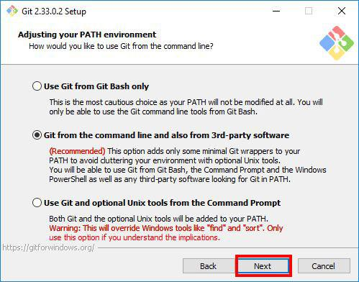

Step 9: Choosing the SSH executable
Select the Secure Shell(SSH) client, it's recommended to go with the default option. So select Use bundled OpenSSH, and click Next
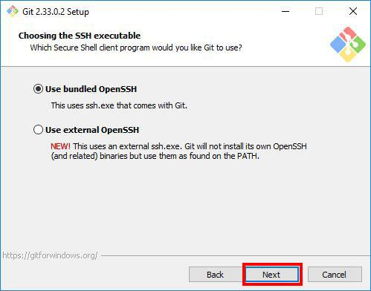

Step 10: Choosing HTTPS Transport Backend
The installer will ask you to choose the SSL/TLS library for Git HTTPS connections. Proceed with the default option Use the OpenSSL library and click Next.
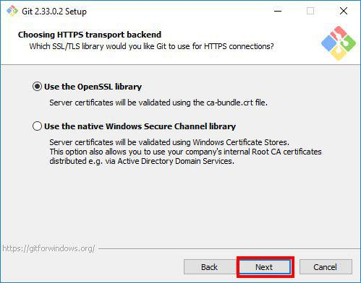

Step 11: Configuring the Line Ending Conversions
In this step, you will be prompted to choose how Git should treat line endings in text files. Since you are on Windows system, go with the default option Checkout Windows-Style, commit Unix-style line endings and click Next.
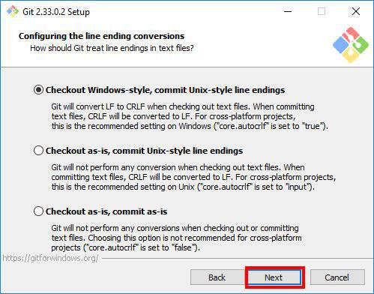

Step 12: Configuring the Terminal Emulator to use with Git Bash
Choose the terminal emulator you want Git Bash to use. MinTTY works well, so I would recommend you to proceed with the default option Use MinTTY(the default terminal of MSYS2) and click Next.
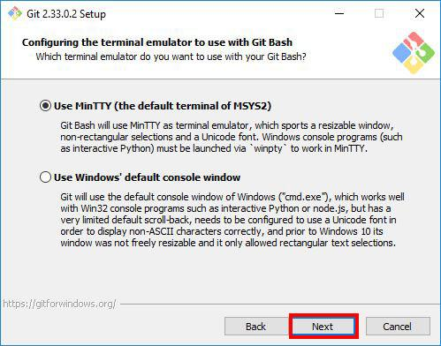

Step 13: Choosing the Default Behaviour of git pull
In this step, the installer asks you if you want to change the default behaviour of git pull(a git command). Unless you know what you doing, proceed with the default option Default (fast-forward or merge) and click Next.
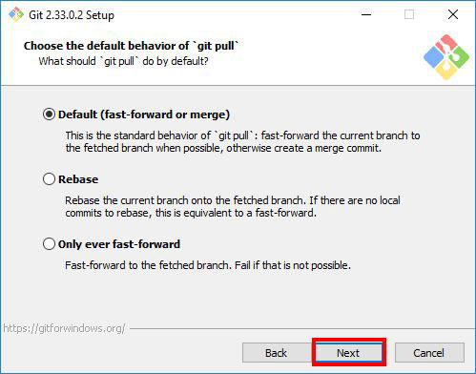

Step 14: Choosing a Credential Manager
In this step, you will be asked to choose a credential manager. Proceed with the default option Git Credential Manager Core and click Next.
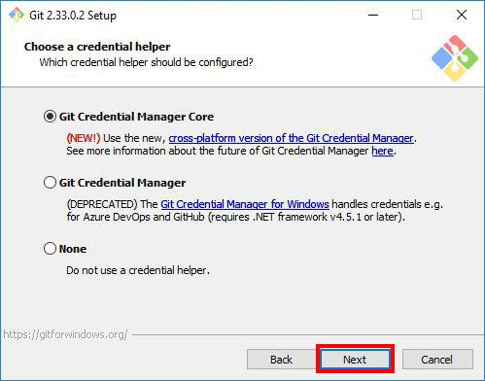
Step 15: Configuring Extra Options
Select the features you want. I find the default options sufficient for my needs. You can proceed with them and click Next.
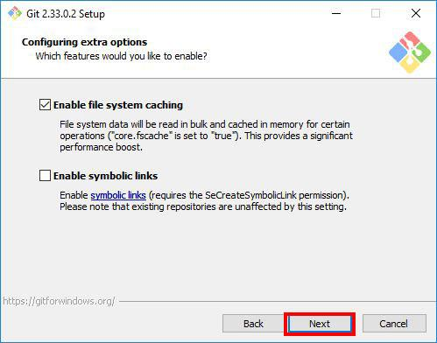

Step 16: Configuring Experimental Options
If you are feeling adventurous, you can try new experimental features. I like to play it safe and I don't enable them, so I will proceed to start the installation process by clicking Install.
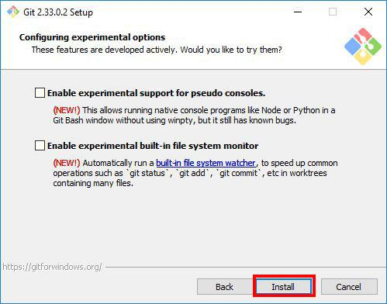

Step 17: Waiting for Git Bash to install
In this step, you take a step back and wait for a few minutes for the Setup Wizard to install Git Bash on your computer.
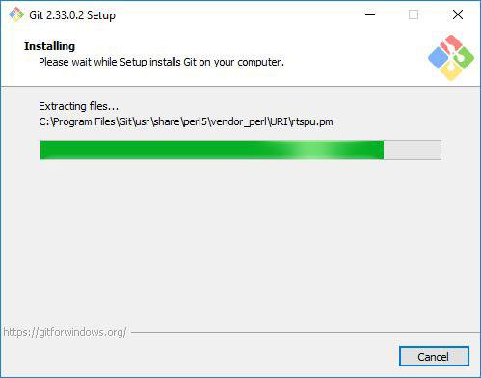

Step 18: Completing the Installation
After the installation has finished, select Launch Git Bash and click Finish to launch Git Bash.
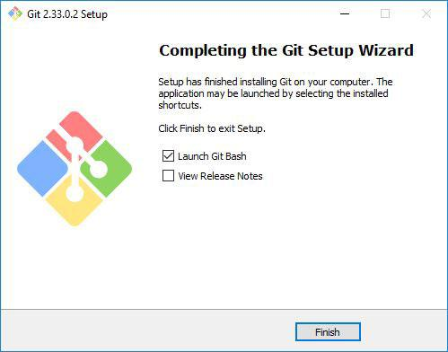

The Git Bash terminal will now open and you will be able to enter Git and Bash commands.
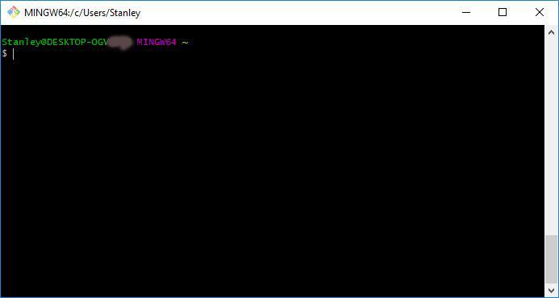
Congratulations on successfully installing Git Bash.

Step 19: Launching Git Bash
The following are just some tips on how you can easily launch Git Bash.
- Right-click on any folder, anywhere and it will have the launch Git Bash option on the context menu.
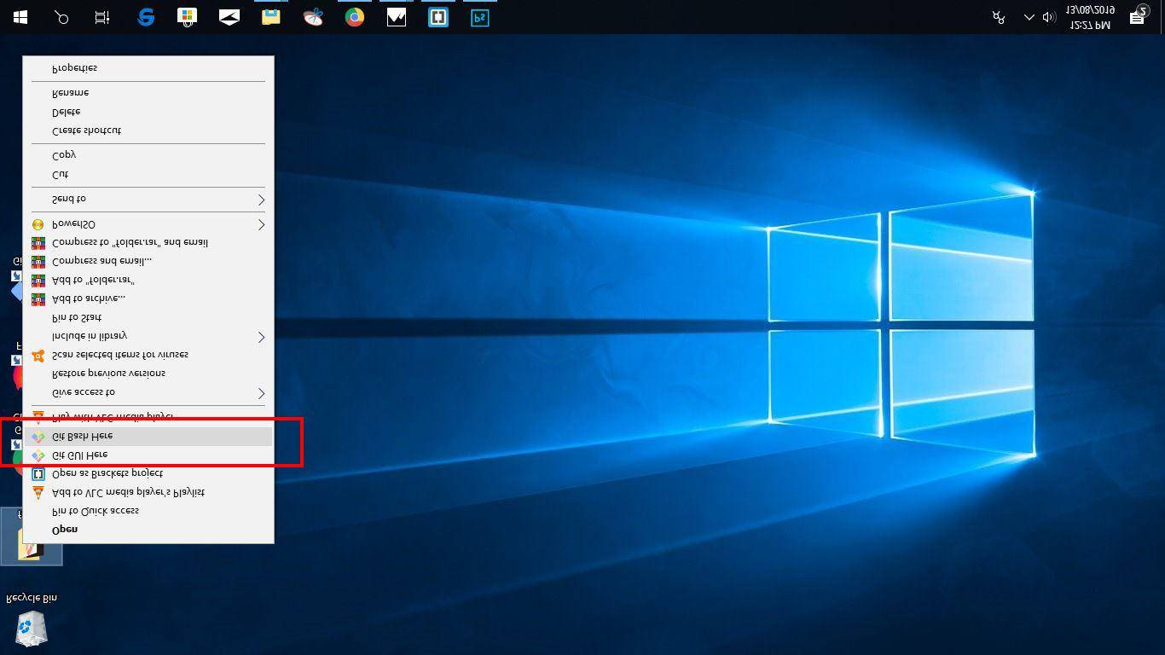

2. If you enabled the "Additional icons" option on Step 4, you can easily launch Git Bash by clicking the Git Bash desktop icon.
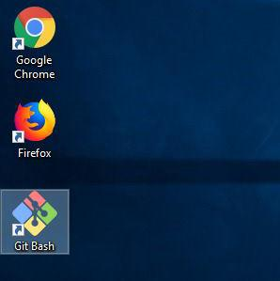
As mentioned in Step 7, you will be able to run Git commands on Git bash terminal, Windows Command Prompt, and Powershell.
Quickly, lets verify that Git works on CMD and PowerShell by typing the following commands:
git --version

git --version tells you the Git version currently installed on your system.
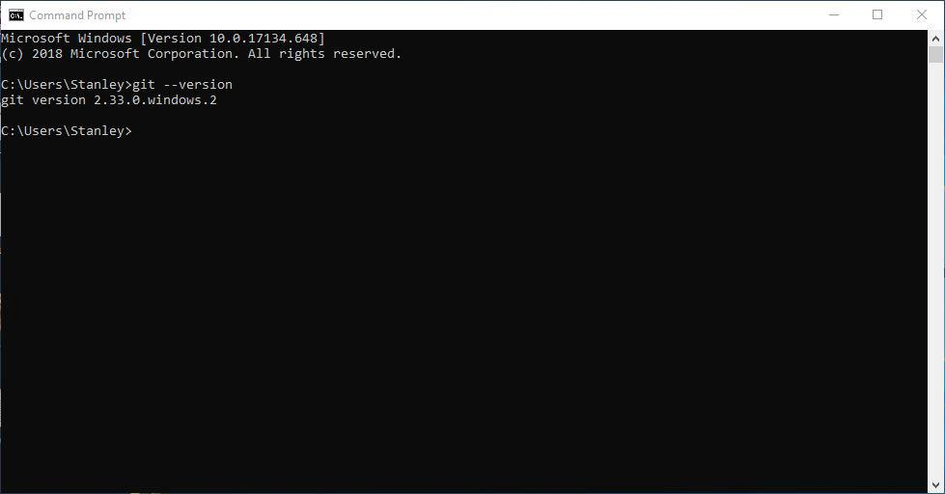
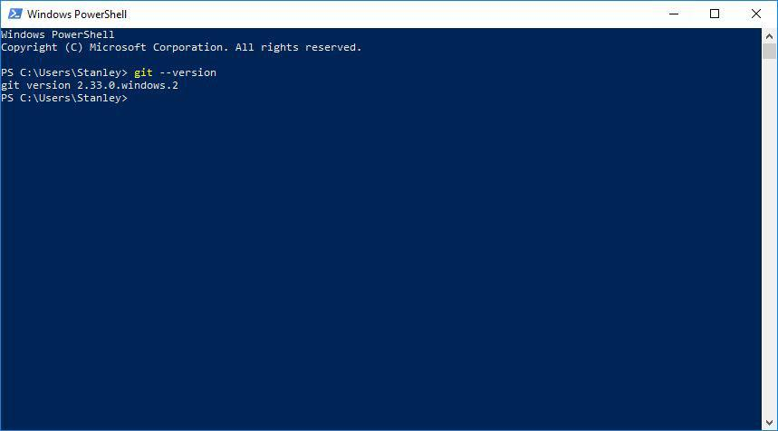

Steps to start the program in Visual Studio

Step 1: Set up the React Project
First, create a new React project using create-react-app:
npx create-react-app todo-app
cd todo-app
Step 2: Create Necessary Components
Create the following components: Todo, TodoList, and TodoForm.
- Todo Component
Create a file named Todo.js inside the src folder:
// src/Todo.js
import React from 'react';

const Todo = ({ todo, index, completeTodo, removeTodo }) => {
return (
<div
style={{ textDecoration: todo.isCompleted ? 'line-through' : '' }}
className="todo"
>
{todo.text}
<div>
<button onClick={() => completeTodo(index)}>Complete</button>
<button onClick={() => removeTodo(index)}>Remove</button>
</div>
</div>
);
};

export default Todo;
- TodoList Component
Create a file named TodoList.js inside the src folder:
// src/TodoList.js
import React, { useState } from 'react';
import Todo from './Todo';
import TodoForm from './TodoForm';

const TodoList = () => {
const [todos, setTodos] = useState([
{
text: 'Learn about React',
isCompleted: false
},
{

text: 'Meet friend for lunch',
isCompleted: false
},
{
text: 'Build really cool todo app',
isCompleted: false
}
]);

const addTodo = (text) => {
const newTodos = [...todos, { text }];
setTodos(newTodos);
};

const completeTodo = (index) => {
const newTodos = [...todos];
newTodos[index].isCompleted = true;
setTodos(newTodos);
};

const removeTodo = (index) => {
const newTodos = [...todos];
newTodos.splice(index, 1);
setTodos(newTodos);
};

return (
<div className="todo-list">
{todos.map((todo, index) => (
<Todo
key={index}
index={index}
todo={todo}
completeTodo={completeTodo}
removeTodo={removeTodo}
/>
))}
<TodoForm addTodo={addTodo} />
</div>
);
};

export default TodoList;
- TodoForm Component
Create a file named TodoForm.js inside the src folder:
// src/TodoForm.js
import React, { useState } from 'react';

const TodoForm = ({ addTodo }) => {
const [value, setValue] = useState('');

const handleSubmit = (e) => {
e.preventDefault();
if (!value) return;
addTodo(value);
setValue('');
};

return (
<form onSubmit={handleSubmit}>
<input
type="text"
className="input"
value={value}
onChange={(e) => setValue(e.target.value)}
/>
</form>
);
};

export default TodoForm;

Step 3: Modify App Component
Modify the App.js file to use the TodoList component:
// src/App.js
import React from 'react';
import './App.css';
import TodoList from './TodoList';

function App() {
return (
<div className="app">
<div className="container">
<h1>Todo List</h1>
<TodoList />
</div>
</div>
);
}

export default App;

Step 4: Add Basic Styling
Create an App.css file inside the src folder and add some basic styling
/* src/App.css */
body {
background: #f5f5f5;
font-family: Arial, sans-serif;
}

.app {
text-align: center;
margin-top: 50px;
}

.container {
background: #fff;
padding: 20px;
border-radius: 5px;
max-width: 400px;
margin: 0 auto;
box-shadow: 0 0 10px rgba(0, 0, 0, 0.1);
}

.todo {
display: flex;
justify-content: space-between;
align-items: center;
padding: 10px;
border-bottom: 1px solid #ddd;
}

.todo button {
margin-left: 5px;
}

input {
padding: 10px;
border: 1px solid #ddd;
border-radius: 5px;
width: calc(100% - 22px);
margin-top: 10px;
}
Output:
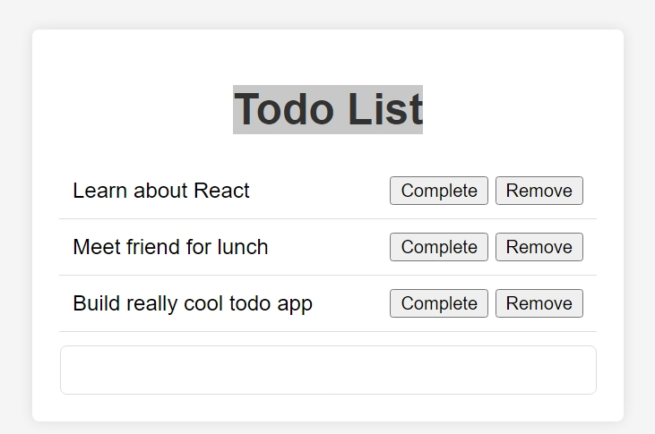
If your want to remove from list:
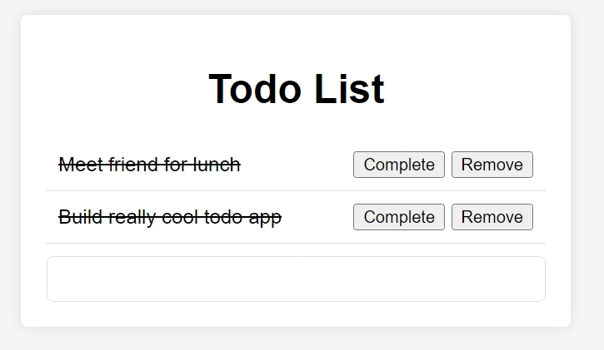

If your Todo List work has completed:




