TASK 3: AUTOMATION SYSTEM DESIGN
Automated Smart Home Lighting System
Design Explanation Report

1. Introduction
Lighting in homes is traditionally controlled manually — occupants switch lights on when entering a room and off when leaving. This is inefficient: lights are frequently left on in empty rooms or run unnecessarily during daylight hours. An automated smart home lighting system removes this dependency on human memory by using sensors and simple control logic to switch lighting on only when it is needed: when a room is occupied and ambient light is insufficient.
This report explains the design of such a system, accompanying the flowchart submitted as the design file (flowchart.svg / flowchart.png). The design is presented as a control-logic flowchart rather than a circuit schematic because the behaviour of the system is best communicated through its decision sequence; the underlying hardware is a simple sensor–microcontroller–relay circuit described in Section 3.

2. System Objective
The system is designed to automatically:
- Turn lighting ON when a room is occupied and the ambient light level is low.
- Keep lighting OFF when the room is unoccupied or when there is already enough natural light.
- Turn lighting OFF automatically after a fixed period of no detected motion, to avoid wasted energy.
- Allow a manual override so the occupant can force lights on or off at any time.

3. System Components
The system combines three sensing inputs, a decision-making controller, and one switching output, summarised below:
Component | Function | Role in the System
PIR Motion Sensor | Detects infrared radiation from moving bodies | Triggers the lighting decision when a person enters the room
LDR (Light Dependent Resistor) | Measures ambient light intensity | Prevents lights turning on during daytime, saving energy
Microcontroller (e.g., Arduino/ESP32) | Reads sensor inputs and executes control logic | The 'brain' that decides ON/OFF state and manages the timer
Relay / Triac Module | Switches the mains-voltage lighting circuit | Physically turns the connected lamp/load ON or OFF
RTC / Software Timer | Tracks elapsed time since last motion | Keeps the light on for a hold period, then times out
Manual Override Switch | User-operated physical/app switch | Lets the occupant force lights on or off regardless of sensors

4. Working Principle (Flowchart Description)
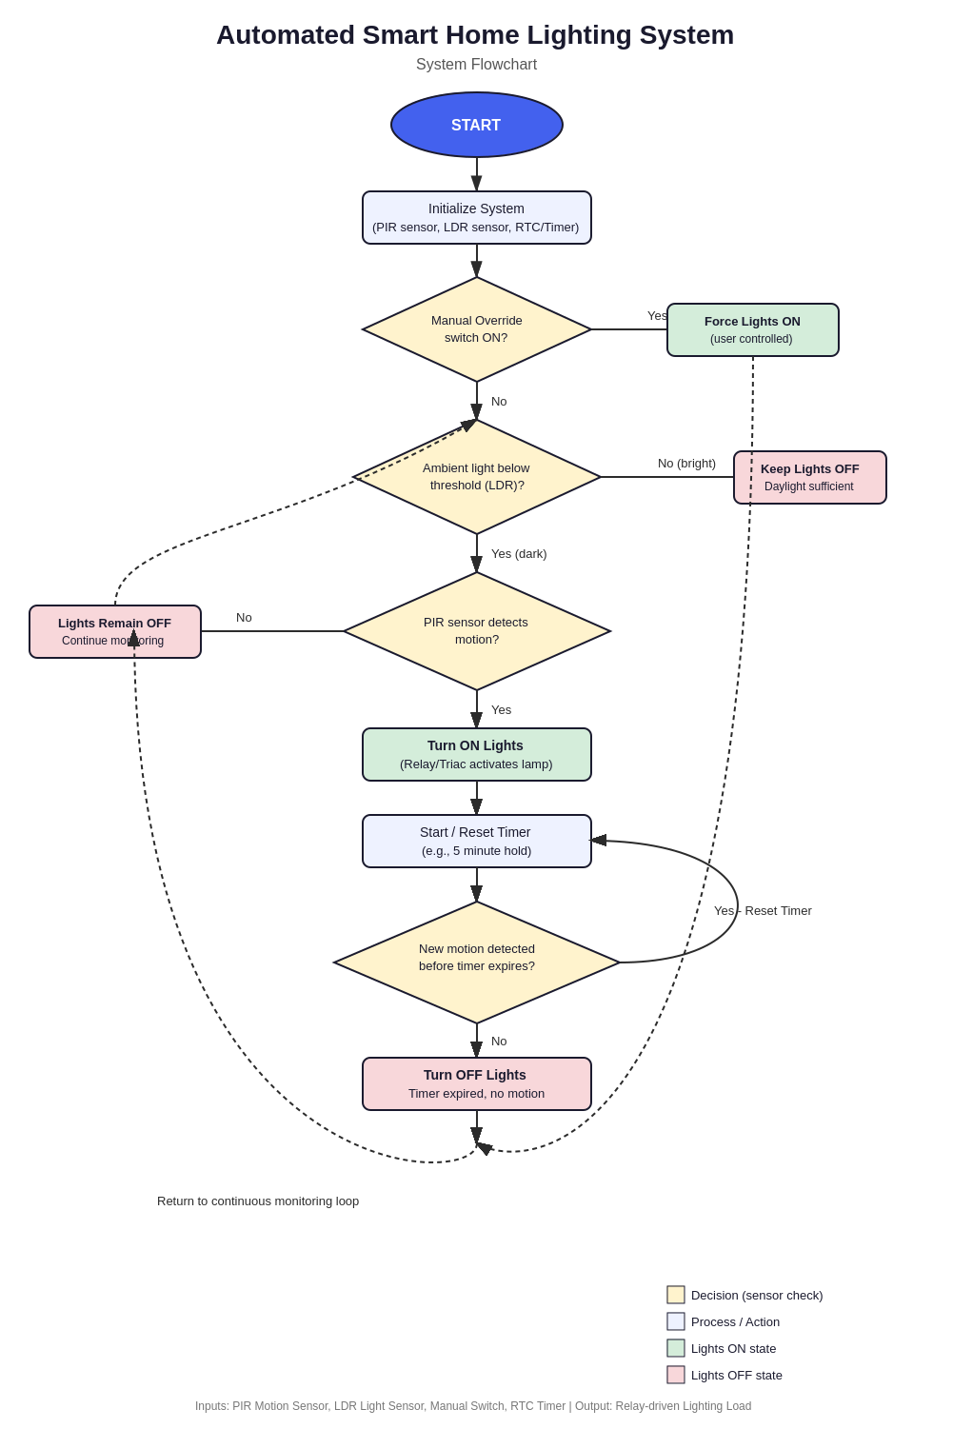
Figure 1: Control-logic flowchart (full-size version submitted separately as flowchart.svg / flowchart.png)
The submitted flowchart follows the control sequence below:
- Initialization: On power-up, the microcontroller initializes the PIR sensor, LDR sensor, and internal timer.
- Manual override check: The system first checks whether the manual switch has been engaged. If yes, the lights are forced ON (or OFF) under direct user control, bypassing automatic logic.
- Ambient light check: If no manual override is active, the LDR reading is compared against a brightness threshold. If the room is already bright enough, the system keeps the lights OFF and returns to monitoring — this is the main energy-saving step.
- Motion detection: If the room is dark, the PIR sensor is checked for motion. No motion means the lights stay OFF and the loop continues.
- Lights ON and timer start: If motion is detected in a dark room, the relay switches the lights ON and a hold-timer (e.g. five minutes) starts.
- Timer monitoring: While the timer runs, the system keeps checking for new motion. Any new motion resets the timer, keeping the lights on for as long as the room is in use.
- Timeout and shutdown: If the timer expires with no further motion, the relay switches the lights OFF, and the system returns to the continuous monitoring loop at Step 2.
This loop repeats continuously, allowing the system to respond automatically to changing occupancy and lighting conditions throughout the day.

5. Circuit-Level Overview
At the hardware level, the PIR sensor and LDR are connected as digital/analogue inputs to a microcontroller (such as an Arduino Uno or ESP32). The microcontroller runs the logic described above and drives a relay module or triac-based dimmer through a digital output pin. The relay switches the mains-voltage lighting circuit, keeping the low-voltage control side (sensors, microcontroller) electrically isolated from the high-voltage lamp circuit for safety. A manual push-button or app-based switch (for Wi-Fi enabled versions) is wired as an additional interrupt input, giving it priority over the automatic logic as shown in the flowchart.

6. Advantages
- Energy saving: lights only run when a room is both dark and occupied.
- Convenience: no need to locate switches, especially useful in hallways, staircases, and garages.
- Extended equipment life: reduced unnecessary ON/OFF cycling compared to habitual manual use.
- Scalability: the same logic block can be replicated per room and networked for whole-house control.

7. Limitations and Possible Improvements
- PIR sensors can miss very slow movement or be blocked by obstacles — dual-technology (PIR + microwave) sensors improve reliability.
- A fixed timer is a compromise; an adaptive timer based on historical occupancy patterns would reduce false shutoffs.
- Adding Wi-Fi/Bluetooth connectivity would allow remote monitoring, scheduling, and integration with voice assistants.

8. Conclusion
The automated smart home lighting system demonstrates a practical, low-cost application of sensor-based automation. By combining occupancy sensing (PIR), ambient light sensing (LDR), and a timed relay control loop, the system meaningfully reduces energy waste while improving convenience over manual switching. The accompanying flowchart (design file) captures the complete decision logic, from initialization through the continuous monitoring loop, and can be directly translated into microcontroller firmware such as Arduino C++ or MicroPython.

