CSARCH2 Virtual Exhibit Case Proposal

Group Title: “Adeos”

Group Number: 9

Group Members:
Abenojar, Fredrikzen
Dollentas, Raine Anne
Encisco, Gabriel Jeremy
Obregon, Sian Ysabelle
Singson, Keith Railey

Topic Theme: “Flash memory: How SSDs store data”
This virtual exhibit explains how Solid-State Drives, or SSDs, store data using NAND flash memory. Instead of using spinning disks or moving parts, SSDs store information inside flash memory cells through electrical charge. The exhibit will focus on how a flash memory cell can represent binary data, how groups of cells form pages and blocks, and how this allows SSDs to store files electronically.

The main goal of the exhibit is to help visitors understand that digital data is stored as 0s and 1s, and that SSDs preserve those values using flash memory cells. Through a simplified interactive NAND flash simulator, visitors will be able to write binary data into memory cells and see how charged and uncharged states can represent stored information.

Tech Stack Plan:

Exhibit Overview:
Our exhibit will focus primarily on how SSDs store data via NAND flash memory showcasing the tiny scale and sheer number of the components that make up the SSDs.

There will be 3 parts to the exhibit, the first showing the SSDs with the NAND flash chips highlighted. Clicking it will bring you to the second part of the exhibit, which will show a simplified version of the chip's components that you can interact with, which is a die with planes, blocks, and pages.

The main part of the exhibit will be covering the individual components that store data which are Single-Level Cells and Triple-Level Cells which store 1 and 3 bits each respectively. Both of these will be shown due to the fact that Single-Level Cells are easier to understand and the Triple-Level Cells are the most commonly used NAND flash memory. We will be showcasing a simplified interactable version of both the TLC and SLC (Triple-Level Cells and Single-Level Cells) with an output screen for users to play with.

Proposed Interactive Element:
The exhibit will begin showing the viewers a SATA SSD and an NVMe SSD, both with visible NAND flash memory chips, which will be highlighted to emphasize interactability. The users will be allowed to click on any of the NAND flash memory chips. Regardless of what chip the user clicked, the user will be brought into a scene which is a simplified zoomed-in scene of a die with planes, blocks, and pages.

Each of the components of the NAND flash chip will be interactable. Hovering over them will show the viewer information about the component in a tab next to the scene. Clicking on a page, does not matter which, will play a zoom in transition showing that each page is made of thousands of cells. After the transition, the viewer enters into another scene which shows you 3 cells in series with the parts of each individual cell such as the control gate, sources and drains, the oxide layer and the TLCs or SLCs.

Each of the components when hovered over displays information about the said component in the same tab as the previous scene. On the top left of this scene, there will be a toggle allowing users to switch between TLCs and SLCs.

The viewer will be acting as the SSD’s controller, whilst the control gates of each cell will have 2 clickable instructions: Write and Erase. The first instruction, write, will increase the charge, adding electrons to the gate, whilst erase brings the gate back to a zero state. The part of the gate where electrons transfer will increase in brightness whenever an instruction is pressed. Depending on the charges of the cells, an output screen, which will be next to the scene, will be displayed, showing the value stored in the cells. Besides this the current charge state of the cell the user is hovering also will also be displayed

Concept Discussion:
SSDs store their data in NAND flash memory chips which are made of multiple stacked grids of Individual NAND memory cells. NAND flash memory cells are arranged via a hierarchical structure starting with strings which are made of 32-128 cells, each of those cells are connected via bit lines (Prasad, 2026). Each cell of a string is connected to cells from other strings through word lines and each wordline contains many thousands of cells which form a page which is also the smallest addressable unit for read and write operations. Multiple pages usually about 64-512 pages form a block which is the smallest unit that can be erased at once. A block is usually 128kb-8mb (Prasad, 2026). Multiple blocks are stored in a plane which contains thousands of blocks and those planes, planes are stored in dies which contain multiple planes, each NAND flash memory chip containing 1-16 individual dies.

NAND flash cells usually store 1-3 bits of information but some versions can store more. Each NAND flash cell stores information by storing electrons in a floating gate. Electrons inside these cells are trapped stored in an insulating layer in between the floating and control gate and cannot escape. The value of a cell is determined by how many electrons are stored in the gate which affects the conductivity of the channel. The source and drain of a flash cell work as the entry and exit point of the channel passing by a cell. The way information is read is through a reference voltage that is used to measure the current through the current/bitline. (Ele, 2025).

A NAND flash cell can also Write and erase data and those instructions are sent to the control gate of the cell via the wordline through certain voltages which correspond to an action. Instructions to write add electrons to the floating gate whilst instructions to erase remove electrons from the floating gate (Ele, 2025).

Mobile-Responsive Layout

The exhibit will be designed to work on desktop, tablet, and mobile screens. On the desktop, the interactive scene and information panel will be displayed side by side. This allows users to explore SSD components while reading short explanations at the same time.

On smaller screens, the layout will shift into a vertical format. The interactive scene will appear first, followed by the controls, output screen, and explanation panel. Since mobile devices do not use hover, hover interactions will be replaced with tap-based selection. When users tap an SSD part, NAND chip, page, block, or memory cell, the selected component will stay highlighted and its information will remain visible even after the user lifts their finger. When the user taps another component, the information panel will update to show the newly selected part. If the user taps outside the interactive area or selects a close button, the information panel may disappear or reset.

The exhibit will not rely on long-press interactions because they may be less intuitive for visitors. Simple taps will be used for selecting components, switching between SLC and TLC views, and interacting with the memory cells. When users play with the cells, the output screen and information panel will show the current cell state, instruction, and stored value!

The mobile layout will use larger buttons, responsive diagrams, simplified labels, and stacked information cards. The SLC/TLC toggle, Write and Erase buttons, and output screen will also resize for easier touch interaction.

Tentative style guide snapshot:

Theme: Minimalist Cyberpunk
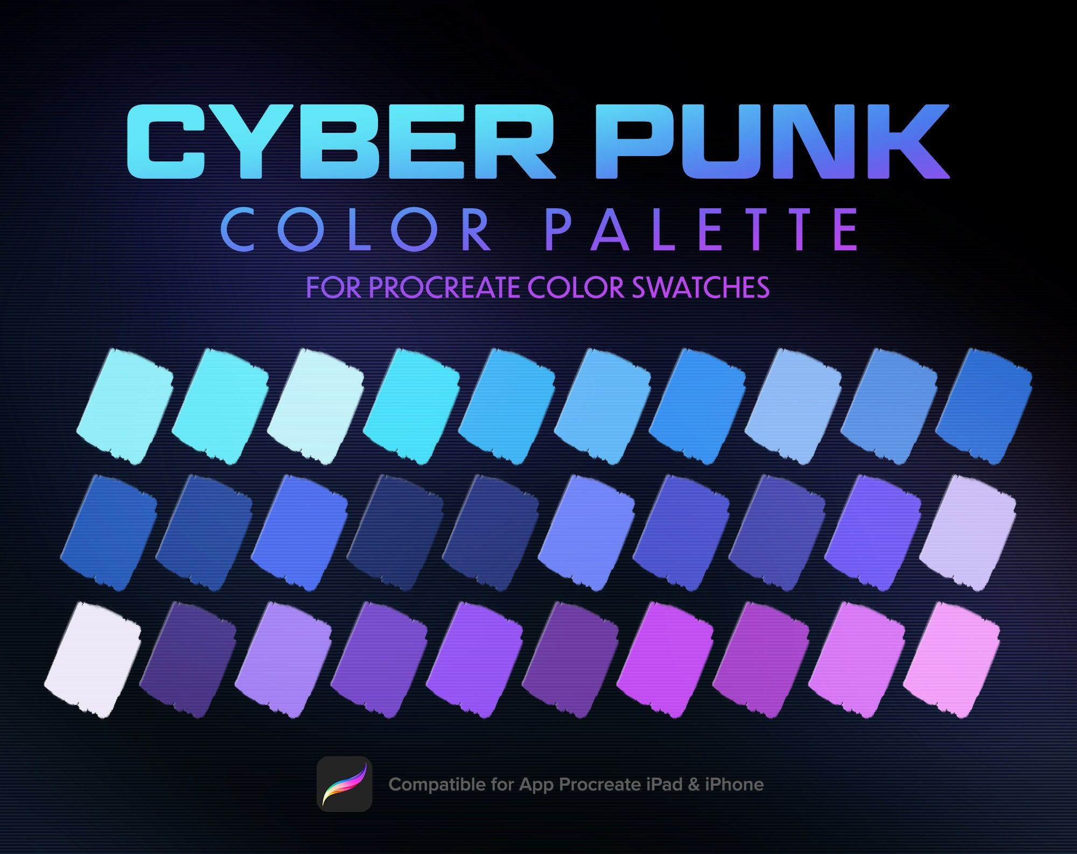
Color Palette:
The exhibit will use a dark color scheme consisting of black, dark blue, and gray
backgrounds accented with neon cyan, blue, and purple highlights. These accent colors will be used to emphasize interactive components such as SSD components, NAND flash chips, memory cells, control buttons, and output displays.

Example Usage of Color Palette:
Background: Near black / dark navy
Main text: White or light gray
Primary accent: Cyan / electric blue
Secondary accent: Purple
Active cell highlight: Neon green or cyan glow
Inactive cell: Dark gray or muted blue
Warning/note: Amber
Font:
Heading: Tomorrow
Links: Disket Mono
Body: Space Mono

Typography:
Element | Style Rule | Example
Heading (h1) | h1 {  text-align: center;  font-family: "Tomorrow";  font-size: 200%;  } | 
Link | a {  text-align: center;  font-family: "Disket Mono";  font-size: 150%;  } | 
Body Text (p/span) | p {  text-align: center;  font-family: "Space Mono";  font-size: 80%;  } | 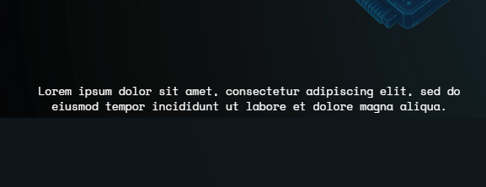

Visual Sample of Home Page:
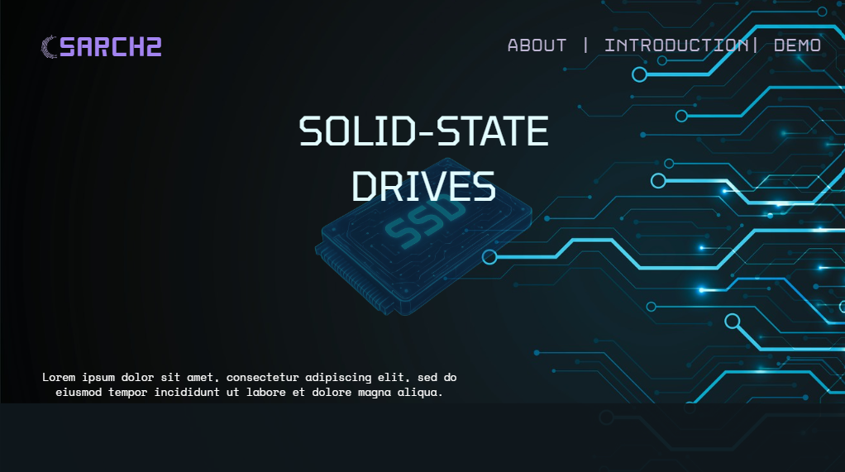

Layout Style
The exhibit will use a card-based layout with clear sections. Each major part of the exhibit will be placed inside a visually distinct section or panel.
- Rounded information cards
- Interactive diagram panels
- Component explanation boxes
- Toggle controls
- Output screen panel
- Step-by-step navigation buttons
- Short callout boxes for important concepts
The layout will avoid long walls of text. Instead, explanations will be broken into short, focused sections that appear when the user interacts with components.

Diagram and Icon Style
Adeos’ exhibit will mainly focus on geometric shapes like dies, planes, blocks, and pages instead of realistic illustrations. SSDs, NAND chips, cells will be represented using clean outlines, grid highlights, and labeled sections. Icons and labels will be visually minimal to not overwhelm the exhibit but still maintain the cyberpunk theme.

Visual Effects
On any selected, active components, or clickable components will mainly have a glow effect. Hover states and tap states may use neon outlines, brightness change, or shadows to visually show interactivity. Simple zoom transitions, highlighting effects, and change of brightness animations will be subtle to avoid excessive movement that can distract from the learning experience.

Proposed Exhibit Layout:
This layout is designed by moving from larger components to the smaller internal structures:

Hero Section (Landing Page; Shows the SSD)
↓
Introduction: What Is an SSD?
↓
Interactive Scene 1: Click a NAND Flash Chip
↓
Interactive Scene 2: Explore Die, Planes, Blocks, and Pages
↓
Transition: Zoom Into a Page containing Cells
↓
Interactive Scene 3: Explore Single and Triple-Level Cells

References:

Prasad, A. (2026, February 7). Flash Memory Explained: NAND vs NOR, Architecture, and Memory Organization. DEV Community. https://dev.to/amanprasad/flash-memory-explained-nand-vs-nor-architecture-and-memory-organization-3abf#memory-organization-sector-block-and-page

Ele. (2025, March 18). How does NAND reading work? Electrical Engineering Stack Exchange. https://electronics.stackexchange.com/questions/336586/how-does-nand-reading-work

NAND configuration possibilities: The challenges of NAND die stacking and the role of ATP AcuCurrent technology in ensuring SIGn. (2025, May 5). Retrieved June 12, 2026, from https://www.atpinc.com/blog/what-is-nand-die-stacking

