Skip to content

- Features
- Business
- Explore
- Marketplace
- Pricing
This repository
Sign in or Sign up

- 21
- 208
- 33

anbox/anbox
Code Issues 281 Pull requests 7 Wiki Insights
anbox/docs/build-android.md
a54b2f4
 rmescandon correct build-android supported build targets names
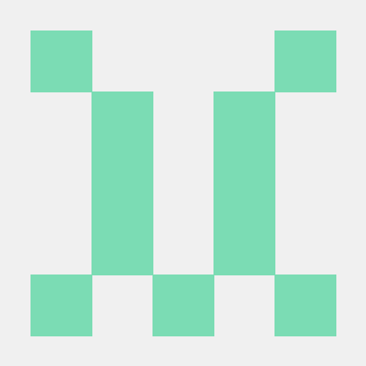
118 lines (84 sloc) 3.35 KB

Build Android Image
For Anbox we're using a minimal customized version of Android but otherwise base all our work of a recent release of the Android Open Source Project.
To rebuild the Android image you need first fetch all relevant sources. This will take quite a huge amount of your disk space (~40GB). AOSP recommends at least 100GB of free disk space. Have a look at their pages too.
In general for building the Anbox Andorid image the instructions found on the pages from the AOSP project apply. We will not describe again here of how to build the Android system in general but only focus on the steps required for Anbox.

Fetch all relevant sources
First setup a new workspace where you will download all sources too.
$ mkdir $HOME/anbox-work
Now initialize the repository by download the manifest and start fetching the sources:
$ cd $HOME/anbox-work
$ repo init -u https://github.com/anbox/platform_manifests.git -b anbox
$ repo sync -j4
This will take quite some time depending on the speed of your internet connection.

Build Android
When all sources are successfully downloaded you can start building Android itself.
Firstly initialize the environment with the envsetup.sh script.
$ . build/envsetup.sh
Then initialize the build using lunch.
$ lunch anbox_x86_64-userdebug
The complete list of supported build targets:
- anbox_x86_64-userdebug
- anbox_armv7a_neon-userdebug
- anbox_arm64-userdebug
Now build everything with
$ make -j8
Once the build is done we need to take the results and create an image file suitable for Anbox.
$ cd $HOME/anbox-work/anbox
$ scripts/create-package.sh \
$PWD/../out/target/product/x86_64/ramdisk.img \
$PWD/../out/target/product/x86_64/system.img
This will create an android.img file in the current directory.
With this, you are now able to use your custom image within the Anbox runtime.

Run Anbox with self build android.img
If you have Anbox installed on your system you need to stop it first. If you used the installer script and the snap you can do this via
$ initctl stop anbox
$ sudo systemctl stop snap.anbox.container-manager
It is important that you stop both, the container manager and the session manager.
Once both services are stopped you can start the container manager with your custom android.img file by running
$ datadir=$HOME/anbox-data
$ mkdir -p $datadir/rootfs
$ sudo anbox container-manager \
--android-image=/path/to/android.img \
--data-path=$datadir
This will start the container manager and setup the container rootfs inside the specified data path.
$ ls -alh $HOME/anbox-data
total 20K
drwxrwxr-x 5 ubuntu ubuntu 4,0K Feb 22 08:04 .
drwxrwxr-x 16 ubuntu ubuntu 4,0K Feb 22 08:04 ..
drwxr-xr-x 2 100000 100000 4,0K Feb 22 08:04 cache
drwxr-xr-x 2 100000 100000 4,0K Feb 22 08:04 data
drwxr-xr-x 2 root root 4,0K Feb 22 08:04 rootfs
NOTE: If you look into the $HOME/anbox-data/rootfs directory you won't see anything as the container manager spawns up a private mount namespace which prevents anything from the outside to see its mount points.
The cache and data directories are bind-mounted into the rootfs at rootfs/data and rootfs/cache.
- © 2017 GitHub, Inc.
- Terms
- Privacy
- Security
- Status
- Help
- Contact GitHub
- API
- Training
- Shop
- Blog
- About

