Informatica PowerCenter
XML Internals, Python Parsing & The Ultimate Solution
A Complete Guide — Written So a Kid Can Understand
LineageIQ Project | March 2026 | Version 1.0

Chapter 1 — What is Informatica PowerCenter?

The Simple Explanation
Imagine you have data sitting in 10 different databases — customer information in one, account balances in another, transaction history in a third. Your boss wants one clean report that combines all of it. That is the problem Informatica PowerCenter solves.
Informatica is an ETL tool — Extract, Transform, Load. It pulls data from sources, transforms it (cleans it, calculates new columns, combines tables), and loads it into a destination database. It is the plumbing of a data warehouse.

Simple Analogy: Think of Informatica like a factory assembly line. Raw materials (source data) come in on a conveyor belt. Workers at each station (transformations) do something to it — sort it, filter it, calculate something, look up extra information. The finished product (target data) gets packaged at the end.

Key Components
Component | What it does | Real-world analogy
Mapping | Defines the data flow — which source connects to which target through which transformations | The blueprint/recipe
Session | Runtime configuration — what connections to use, when to run, how many partitions | The work order for a specific production run
Workflow | Orchestrates multiple sessions in a specific order with conditions | The factory schedule for the whole day
Transformation | A single processing step — Expression, Lookup, Filter, Aggregator etc. | One worker on the assembly line
Maplet | A reusable group of transformations packaged together (like a function) | A pre-built machine that can be plugged in anywhere
Source Qualifier | Reads from the source database — can have a custom SQL override | The loading dock where raw materials arrive

Chapter 2 — Informatica Internal Architecture

The Big Picture
Informatica stores everything in a repository — a regular Oracle or SQL Server database with about 400 tables. Every mapping you build in the Designer is actually rows in this database. When you click Save, your work goes into these tables, not into a file.

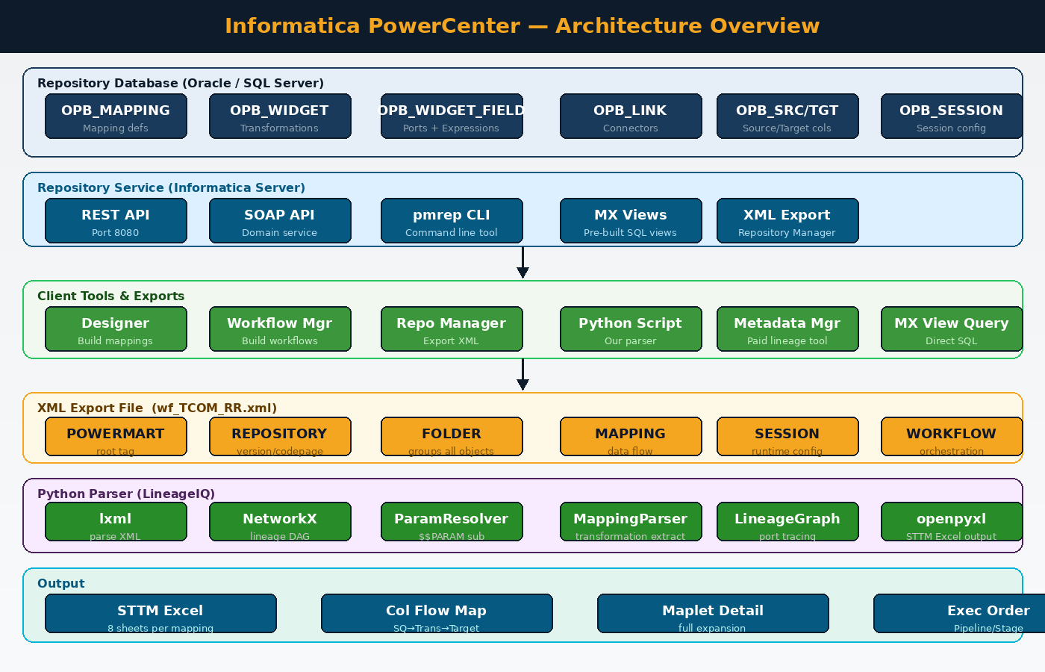
Figure 1 — Informatica PowerCenter architecture from repository database to Python output

The Repository Database Tables
The most important tables you need to understand for parsing:
Table Name | Contains | Why it matters for lineage
OPB_MAPPING | Mapping definitions | Master list — name, description, folder
OPB_WIDGET | Every transformation instance | Name, type (Expression/Lookup/Filter etc.)
OPB_WIDGET_FIELD | Every port + expression | THIS is where all the logic lives — formulas are here
OPB_LINK | Every connector | One row per edge in the lineage graph — the entire data flow
OPB_SRC / OPB_SRC_FLD | Source tables and columns | Schema, table name, column datatypes
OPB_TGT / OPB_TGT_FLD | Target tables and columns | Schema, table name, key types
OPB_SESSION | Session configuration | Which mapping runs, in what order, with what connections
OPB_CNX | Connection objects | Real database connection strings — resolves all schema names
OPB_VAR | Parameter variables | Resolves $$PARAM values at runtime

Key Insight: When Informatica's own tools (Designer, Metadata Manager) need lineage information, they query OPB_LINK joined to OPB_WIDGET_FIELD. This gives 100% accurate, fully resolved lineage. When we parse the XML export, we are doing the same thing — but from a file dump of those same tables rather than a live database query.

Chapter 3 — How the XML File is Created

The Export Process Step by Step
When you export from the Repository Manager, Informatica performs a database-to-XML serialisation. It reads the OPB_* tables and writes each object as an XML tag. Here is exactly what happens:

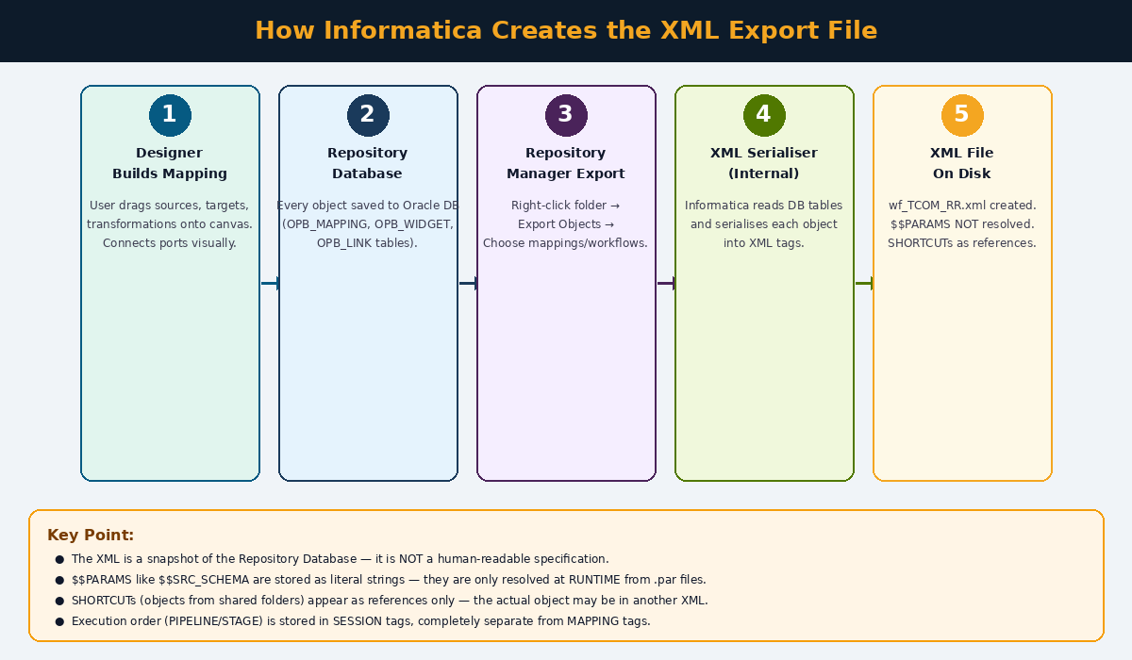
Figure 2 — The 5-step process from Designer canvas to XML file on disk

- You build a mapping in the PowerCenter Designer by dragging and dropping objects onto a canvas.
- Every time you save, the Designer writes each object to the Repository Database (OPB_MAPPING, OPB_WIDGET, OPB_LINK etc.).
- You right-click the folder in Repository Manager and choose Export Objects.
- The Repository Manager calls an internal XML serialiser that reads the DB tables and converts each object to XML tags.
- The resulting file (e.g. wf_TCOM_RR.xml) is saved to disk — a snapshot of the repository database at that moment.

Critical Properties of the Exported XML
There are four things about the XML that make it difficult to parse. Understanding these is the key to everything:

Property 1: $$PARAMS Are NOT Resolved
When Informatica exports the XML, it writes $$PARAM variable names as literal strings. It does NOT look up their values.
In the XML file you see:
<SOURCE NAME="TPR_CUSTOMER" OWNERNAME="$$SRC_SCHEMA" DBDNAME="$$SRC_DB">

What it actually means at runtime (from the .par file):
$$SRC_SCHEMA = TPR_PROD
$$SRC_DB = TPR_PROD_DB

So the real source is: TPR_PROD.TPR_CUSTOMER on database TPR_PROD_DB
Analogy: It is like a recipe that says 'add $$AMOUNT of sugar' without telling you $$AMOUNT = 2 cups. You need the separate parameter file (.par) to know the real value.

Property 2: SHORTCUTs Are References, Not Copies
If your mapping uses a source table that is defined in a shared folder, the XML only contains a reference (SHORTCUT tag) — not the actual source definition. You need to export the shared folder too to get the column definitions.

Property 3: Execution Order is in SESSION, Not MAPPING
The MAPPING tag tells you what transformations exist and how they are connected. But it does NOT tell you in what order they execute, or which ones run in parallel. That information is stored separately in the SESSION tag under SESSTRANSFORMATIONINST with PIPELINE and STAGE numbers.
<!-- MAPPING has no order information -->
<TRANSFORMATION NAME="EXP_DERIVE" TYPE="Expression">
<TRANSFORMATION NAME="LKP_EXCH_RATE" TYPE="Lookup Procedure">

<!-- SESSION tells you the real execution order -->
<SESSTRANSFORMATIONINST PIPELINE="0" STAGE="2" SINSTANCENAME="EXP_DERIVE"/>
<SESSTRANSFORMATIONINST PIPELINE="0" STAGE="3" SINSTANCENAME="LKP_EXCH_RATE"/>
<SESSTRANSFORMATIONINST PIPELINE="1" STAGE="4" SINSTANCENAME="ep_CRC_GEN"/>

Reading: PIPELINE=0 and PIPELINE=1 = two parallel pipelines running simultaneously
STAGE numbers = sequential order within each pipeline

Property 4: The XML is a Database Dump, Not a Specification
Informatica never designed the XML as a public exchange format. There is no official documentation for the XML schema. The powrmart.dtd file referenced in the DOCTYPE declaration does not exist publicly. Every third-party tool that parses Informatica XML — including our LineageIQ — is doing reverse engineering based on observed patterns.

Chapter 4 — XML Internal Tag Structure

The Tag Hierarchy
Every Informatica XML export follows a strict hierarchy. Understanding this hierarchy is essential for writing a parser.

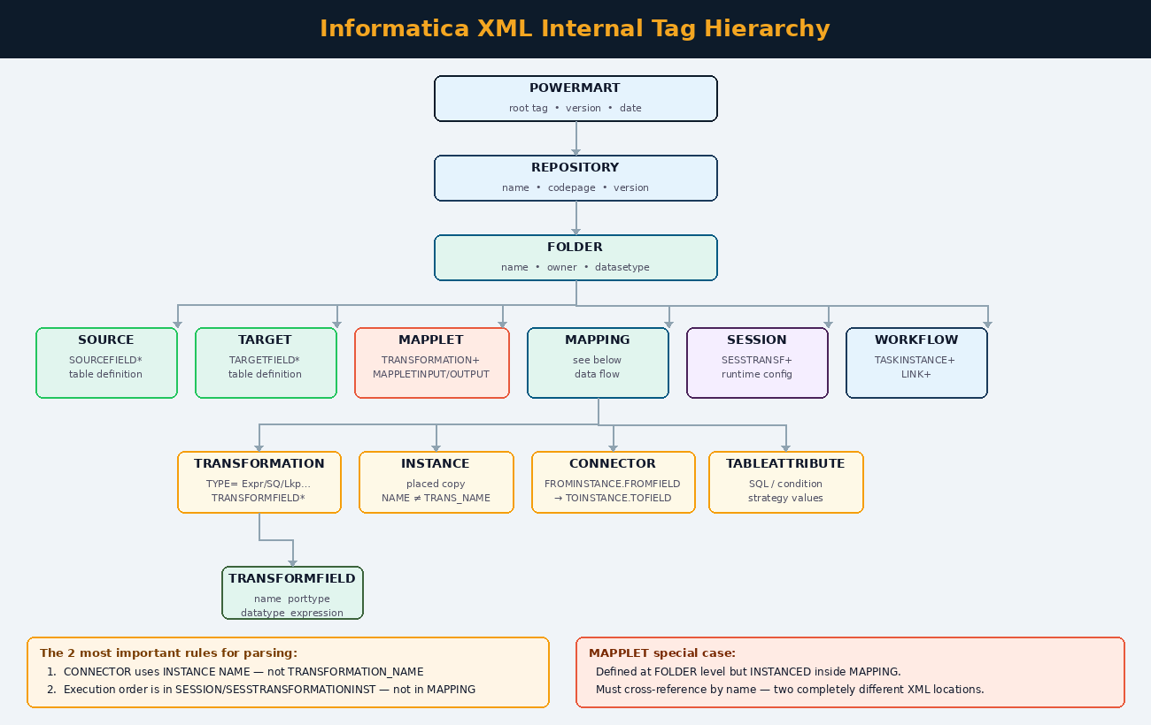
Figure 3 — Complete XML tag hierarchy from POWERMART root to TRANSFORMFIELD leaves

Every Important Tag Explained
Tag | Lives Inside | What it contains and why it matters
POWERMART | Root | Top-level container. Holds REPOSITORY_VERSION (e.g. 189.98 for PC 10.5.8). Version matters because tag names changed between PC versions.
REPOSITORY | POWERMART | Holds FOLDER children. Has CODEPAGE attribute — critical for ISO-8859-1 vs UTF-8 handling.
FOLDER | REPOSITORY | Groups all objects for one project. Contains SOURCE, TARGET, MAPPLET, MAPPING, SESSION, WORKFLOW tags as direct children.
SOURCE | FOLDER | Defines a source table. Has OWNERNAME (the schema — often $$PARAM), DBDNAME (the database). Children are SOURCEFIELD tags with column definitions.
TARGET | FOLDER | Same as SOURCE but for target tables. TARGETFIELD children include KEYTYPE (PRIMARY KEY / NOT A KEY).
MAPPLET | FOLDER | Reusable transformation group. Contains TRANSFORMATION children (the internal logic) and MAPPLETINPUT/MAPPLETOUTPUT tags (the boundary ports).
MAPPING | FOLDER | The data flow. Contains TRANSFORMATION, INSTANCE, and CONNECTOR tags. Does NOT contain execution order — that is in SESSION.
TRANSFORMATION | MAPPING | A single transformation step. TYPE attribute specifies what kind: 'Expression', 'Lookup Procedure', 'Source Qualifier', 'Filter', 'Router', 'Aggregator', 'Update Strategy', 'Maplet', 'Sequence', 'Joiner' etc.
TRANSFORMFIELD | TRANSFORMATION | One port (column) of a transformation. Has NAME, PORTTYPE (INPUT/OUTPUT/INPUT/OUTPUT/VARIABLE), DATATYPE, EXPRESSION (the formula for output ports).
TABLEATTRIBUTE | TRANSFORMATION | Key-value pairs for transformation configuration: 'Sql Query', 'Lookup table name', 'Lookup condition', 'Filter Condition', 'Update Strategy Expression' etc.
INSTANCE | MAPPING | A placed copy of a TRANSFORMATION. TRANSFORMATION_NAME references the definition. NAME is the instance name (can be different — this is the rename trap). TRANSFORMATION_TYPE tells you what kind.
CONNECTOR | MAPPING | One directed edge in the lineage graph. FROMINSTANCE.FROMFIELD → TOINSTANCE.TOFIELD. Uses INSTANCE NAME (not TRANSFORMATION_NAME).
SESSION | FOLDER | Runtime configuration. Most importantly contains SESSTRANSFORMATIONINST children with PIPELINE and STAGE for execution order. MAPPINGNAME attribute links to its MAPPING.
SESSTRANSFORMATIONINST | SESSION | One row per transformation in the session. PIPELINE=parallel stream index. STAGE=order within stream. ISREPARTITIONPOINT and PARTITIONTYPE for parallel data distribution.
WORKFLOW | FOLDER | Orchestration. Contains TASKINSTANCE (sessions/worklets) and LINK tags. LINK tags define execution order via FROMTASK/TOTASK/CONDITION.
WORKLET | FOLDER | A reusable group of sessions. Like a Maplet but for sessions rather than transformations.

Chapter 5 — Maplets: The Most Misunderstood Part

What is a Maplet?
A Maplet is a reusable transformation that packages multiple transformations together into one unit. Think of it exactly like a function in programming — you define it once, give it input parameters, it does some work, and returns output values.
The most common maplet you will see in real projects is a CRC generator like ep_CRC_GEN — it takes several columns as input, concatenates them, hashes them with CRC32, and returns a single checksum value used to detect changed records.

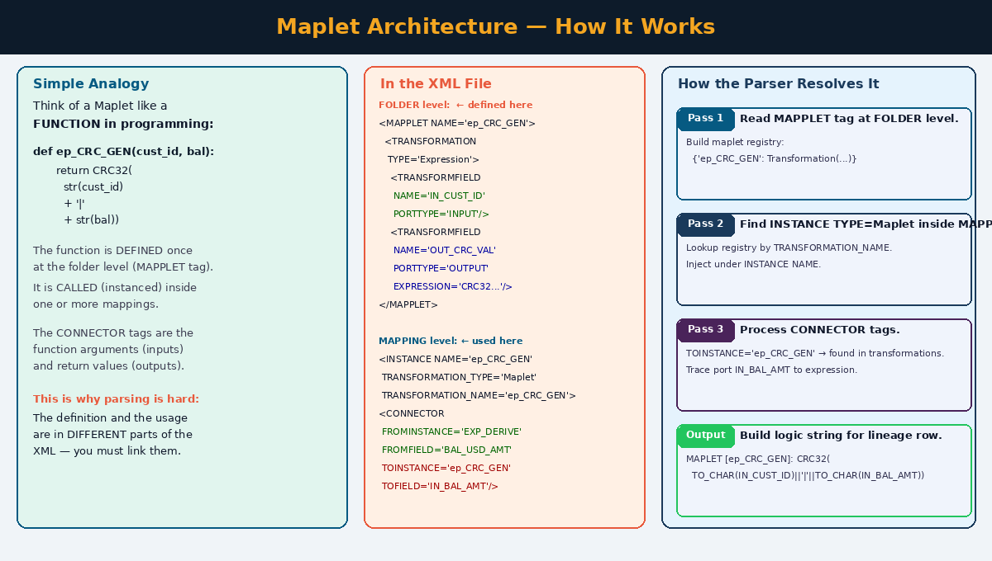
Figure 5 — Maplet architecture: definition at folder level, usage inside mapping, resolution by parser

Why Maplets Are Hard to Parse
A maplet exists in TWO different locations in the XML at the same time:

Location | What is there | What the parser must do
FOLDER level  (MAPPLET tag) | The logic definition — internal TRANSFORMATION tags with TRANSFORMFIELD expressions, MAPPLETINPUT/OUTPUT boundary ports | Pass 1: Parse ALL MAPPLET tags first. Build a registry: {'ep_CRC_GEN': Transformation(...)}
MAPPING level  (INSTANCE tag) | A reference to the maplet — INSTANCE NAME='ep_CRC_GEN' with TRANSFORMATION_TYPE='Maplet' and TRANSFORMATION_NAME='ep_CRC_GEN' | Pass 2: When INSTANCE TYPE=Maplet found, look up TRANSFORMATION_NAME in registry. Inject under INSTANCE NAME.
MAPPING level  (CONNECTOR tags) | Connectors feed INTO the maplet's input ports and OUT OF its output ports — using the INSTANCE NAME | Pass 3: Build lineage graph using INSTANCE NAME. Look inside maplet_internals to find the expression for each output port.

Two Forms of Maplet in the XML
There are two ways a maplet can appear inside a MAPPING — this is one of the most common sources of parsing errors:

Form 1: Reference via INSTANCE tag (most common)
The maplet is defined at FOLDER level as a MAPPLET tag. Inside the MAPPING, it appears only as an INSTANCE tag referencing it by name.
<!-- At FOLDER level: -->
<MAPPLET NAME="ep_CRC_GEN">
<TRANSFORMATION TYPE="Expression" NAME="EXP_CRC_CALC">
<TRANSFORMFIELD NAME="IN_CUST_ID" PORTTYPE="INPUT" .../>
<TRANSFORMFIELD NAME="OUT_CRC_VAL" PORTTYPE="OUTPUT"
EXPRESSION="CRC32(TO_CHAR(IN_CUST_ID)||'|'||TO_CHAR(IN_BAL_AMT))"/>
</TRANSFORMATION>
</MAPPLET>

<!-- Inside MAPPING: -->
<INSTANCE NAME="ep_CRC_GEN" TRANSFORMATION_NAME="ep_CRC_GEN"
TRANSFORMATION_TYPE="Maplet" REUSABLE="YES"/>

Form 2: Inline TRANSFORMATION TYPE=Maplet (less common)
The maplet is declared directly inside the MAPPING as a TRANSFORMATION tag with TYPE=Maplet. Ports are TRANSFORMFIELD children directly on the element — no inner TRANSFORMATION tags.
<!-- Inside MAPPING — inline definition: -->
<TRANSFORMATION TYPE="Maplet" NAME="ep_CRC_GEN" REUSABLE="NO">
<TRANSFORMFIELD NAME="IN_CUST_ID" PORTTYPE="INPUT" .../>
<TRANSFORMFIELD NAME="IN_BAL_AMT" PORTTYPE="INPUT" .../>
<TRANSFORMFIELD NAME="OUT_CRC_VAL" PORTTYPE="OUTPUT"
EXPRESSION="CRC32(TO_CHAR(IN_CUST_ID)||'|'||TO_CHAR(IN_BAL_AMT))"/>
</TRANSFORMATION>
Key Rule: Our parser handles BOTH forms. Form 1 uses _build_maplet_from_element(). Form 2 uses _build_maplet_from_inline_trans(). The difference is that Form 2 has no inner TRANSFORMATION children — ports are directly on the element.

Chapter 6 — Python Parsing: How It Works

The Tools Required
Library | Install | Why we use it
lxml | pip install lxml | Parses XML with recovery mode (recover=True). Handles the DOCTYPE declaration, ISO-8859-1 encoding, and malformed characters that crash standard parsers.
networkx | pip install networkx | Builds a Directed Acyclic Graph (DAG) from CONNECTOR tags. Topological sort gives execution order. BFS traversal traces column lineage.
openpyxl | pip install openpyxl | Generates the STTM Excel workbook with multiple sheets, cell formatting, colours, and frozen panes.

The 4-Step Parsing Pipeline
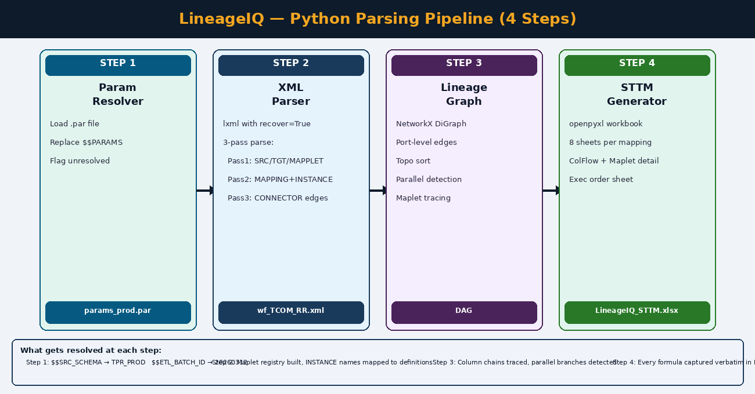
Figure 4 — The LineageIQ parsing pipeline: from input files to STTM Excel output

Step 1 — Parameter Resolution
Before any XML is touched, the .par file is loaded and a substitution dictionary is built. Every time the XML parser encounters a string containing $$PARAM, it substitutes the real value.
# params_prod.par content:
$$SRC_SCHEMA=TPR_PROD
$$TGT_SCHEMA=TT_PROD
$$ETL_BATCH_ID=20260316001

# After resolution:
OWNERNAME='$$SRC_SCHEMA' → OWNERNAME='TPR_PROD'
EXPRESSION='$$ETL_BATCH_ID' → EXPRESSION='20260316001'

# If no .par file provided: $$PARAMS kept as literal strings
# Unresolved params flagged as: [UNRESOLVED:$$SRC_SCHEMA]

Step 2 — Three-Pass XML Parse
The parser reads the XML in three distinct passes to resolve all cross-references correctly:
Pass | What is parsed | Why this order matters
Pass 1 | SOURCE, TARGET, MAPPLET tags | Global definitions must be registered before anything references them. A MAPPING can only be parsed correctly after we know all MAPPLET definitions.
Pass 2 | MAPPING with TRANSFORMATION, INSTANCE tags | INSTANCE tags reference TRANSFORMATION_NAME — looked up in registry. Maplet instances resolved from registry and injected under their INSTANCE NAME.
Pass 3 | CONNECTOR tags | CONNECTORs use INSTANCE NAME — which only exists after Pass 2. The lineage graph is built on instance names not definition names.

Step 3 — Lineage Graph
NetworkX builds a directed graph where every node is 'INSTANCE_NAME.FIELD_NAME' and every edge is a CONNECTOR row. Two graphs are built simultaneously:
- Port-level graph (G) — one node per port, one edge per connector. Used for tracing individual column lineage.
- Instance-level graph (IG) — one node per transformation instance. Used for topological sort and parallel detection.

Step 4 — STTM Excel Generation
openpyxl writes 8 sheets per mapping: MappingParse (5 sections), Sources, Targets, Transforms, ColFlowMap, Lookups, MapletDetail, ExecOrder.

Chapter 7 — What Works, What is Partial, What Breaks

The Complete Honest Assessment
Here is the complete truth about what our Python parser can and cannot do. This is not a limitation of Python — it is a limitation of what information is available in the XML file.

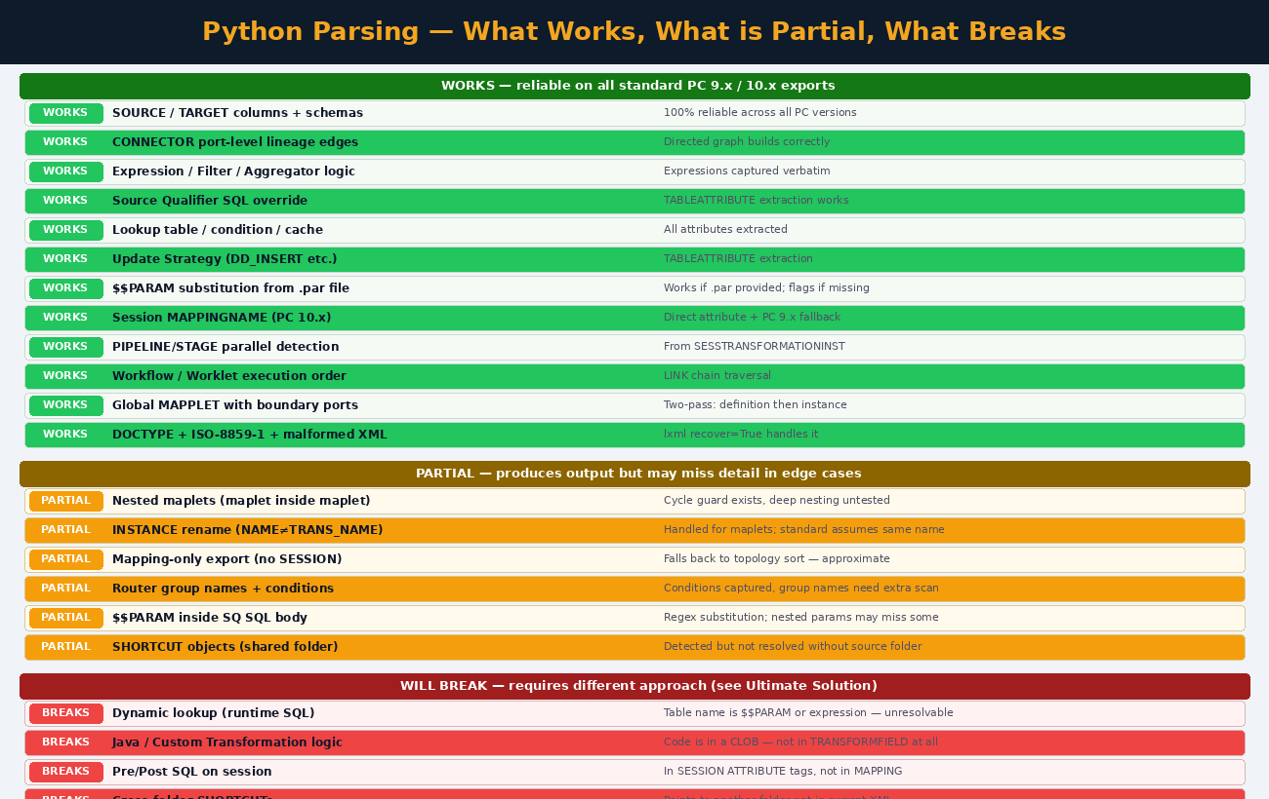
Figure 5 — Complete parsing readiness matrix: green=works, amber=partial, red=breaks

Why the Green Items Work Reliably
The green items work because the information they need is completely self-contained in the XML. SOURCE tags have all their column definitions. TRANSFORMFIELD has the full expression text. CONNECTOR tags have all four attributes needed (from/to instance/field). None of these depend on external information.

Why the Amber Items are Partial

INSTANCE Rename
When a transformation is placed multiple times with different names (e.g. LKP_CUST_1 and LKP_CUST_2 both pointing to LKP_CUSTOMER), the current code handles this for maplets but assumes standard transformations have matching names. If your mappings rename standard transformations you will get blank lineage rows.
<!-- This works: -->
<INSTANCE NAME="LKP_EXCH_RATE" TRANSFORMATION_NAME="LKP_EXCH_RATE"/>

<!-- This breaks: -->
<INSTANCE NAME="LKP_EXCH_RATE_USD" TRANSFORMATION_NAME="LKP_EXCH_RATE"/>
CONNECTOR uses TOINSTANCE='LKP_EXCH_RATE_USD' but parser looks for 'LKP_EXCH_RATE'

SHORTCUT Objects
A SHORTCUT is a reference to an object in a shared folder. The XML only contains the reference, not the object itself. Without exporting the shared folder alongside your working folder, those columns appear as UNCONNECTED in the output.

Why the Red Items Break

Java / Custom Transformations
The logic for a Java Transformation is Java source code stored as a CLOB (large text field) in the repository database. When exported to XML, this code is embedded as a CDATA section. Our parser reads transformation ports but there is no structured TRANSFORMFIELD to extract logic from. The parser will note the transformation exists but cannot describe what it does.

Dynamic Lookups
If a Lookup transformation uses a $$PARAM for the table name (e.g. '$$LOOKUP_TABLE') and that parameter is not in your .par file, the lookup table name will be [UNRESOLVED:$$LOOKUP_TABLE]. The lineage will show the lookup exists but not which table it queries.

Cross-Folder SHORTCUTs
If your mapping uses a source from folder A while you exported from folder B, the SHORTCUT tag in folder B's XML points to folder A. Without folder A's XML also present, those source columns are invisible.
Run This First: Before running the parser on your real files, run the diagnostic script (provided in Chapter 9) to see exactly which of these issues exist in your specific XML. This tells you upfront what percentage of your mappings will have complete vs partial lineage.

Chapter 8 — The Ultimate Solution

Why XML Parsing Has Limits
Every challenge we described — $$PARAMS, SHORTCUTs, dynamic lookups, Java transforms — exists because the XML is a partial snapshot of the repository database with some information deliberately left as references rather than values. The XML was designed for portability (to move objects between environments), not for lineage analysis.
The ultimate solution is to bypass the XML entirely and go directly to the source of truth: the repository database or the live repository service.

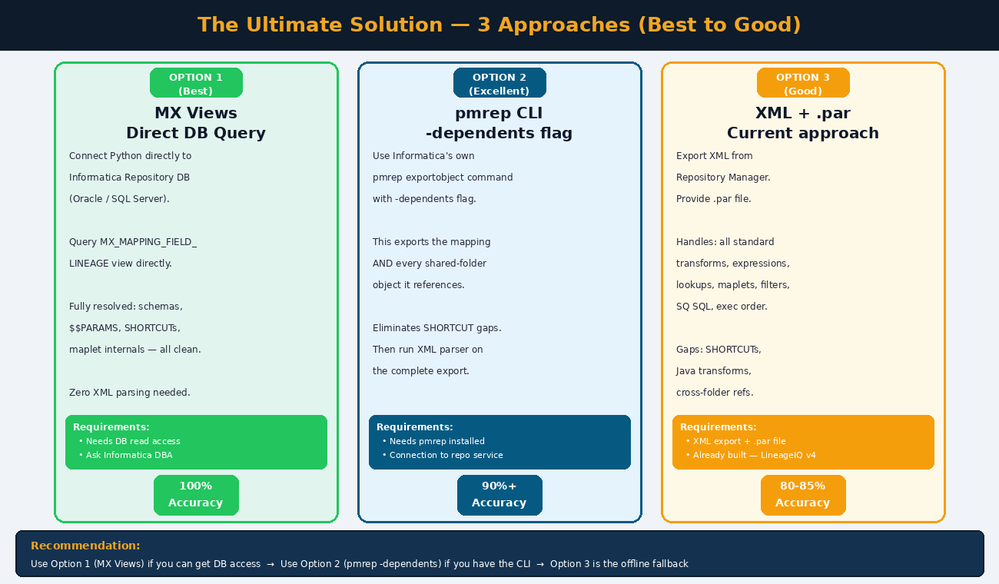
Figure 6 — Three solution options ranked by accuracy: MX Views, pmrep CLI, XML parsing

Option 1 — MX Views (Best: 100% Accuracy)
Informatica ships a set of pre-built database views called MX Views specifically for metadata reporting. They join the complex OPB_* tables for you and give clean, fully-resolved results.
import cx_Oracle
import pandas as pd

conn = cx_Oracle.connect('infa_user/password@repo_db:1521/REPODB')

# Get full column lineage — fully resolved, no $$PARAMS, no ambiguity
df = pd.read_sql("""
SELECT
src_name, -- real source table name
src_field_name, -- source column
tgt_name, -- real target table name
tgt_field_name, -- target column
expression, -- transformation formula
transformation_name,
transformation_type
FROM MX_SUBJECT_AREA_FIELD_LINEAGE
WHERE mapping_name = 'M_TPR_CUST_BAL'
ORDER BY tgt_field_name
""", conn)

print(df)
What you need: Read-only access to the Informatica Repository Database. Ask your Informatica DBA for a read-only account on the repository schema.

Option 2 — pmrep CLI with -dependents (Excellent: 90%+ Accuracy)
Every PowerCenter installation includes a command-line tool called pmrep. The -dependents flag exports an object AND everything it depends on — including objects from other folders (SHORTCUTs).
# Connect to repository
pmrep connect -r DEV_REPO -d INFA_DOMAIN -n admin -x password

# Export mapping with ALL dependencies resolved
pmrep exportobject \
-f ETL_PROJECT \
-o mapping \
-n M_TPR_CUST_BAL \
-u M_TPR_CUST_BAL_complete.xml \
-dependents # <-- This is the magic flag

# Now run the Python XML parser on the complete export
python lineageiq_mapping.py --xml M_TPR_CUST_BAL_complete.xml --par params_prod.par
The -dependents flag resolves the SHORTCUT problem completely. Combined with the .par file for $$PARAM resolution, this gives you accurate lineage for all standard transformation types.

Option 3 — XML + .par File (Good: 80-85% Accuracy)
This is the LineageIQ v4 code already built. It handles all standard transformation types, full maplet architecture (both forms), parallel execution detection, and $$PARAM substitution. The gaps are SHORTCUTs, Java transforms, and dynamic lookups.
This is the right choice when you have no database access and no pmrep CLI — for example, if you have only been given the XML export files and the .par file.

Option | Resolves $$PARAMS | Resolves SHORTCUTs | Accuracy | Requires
MX Views | Yes — from OPB_CNX | Yes — live DB | 100% | DB read access
pmrep -dependents | With .par file | Yes — included in export | 90%+ | pmrep CLI
XML + .par | With .par file | No — reference only | 80-85% | XML + .par file

Chapter 9 — Practical Steps: What to Do Right Now

Step 1 — Run the Diagnostic on Your Real XML
Before running the full parser, run this diagnostic script to understand exactly what is in your XML file:
import lxml.etree as ET
from collections import Counter

xp = ET.XMLParser(load_dtd=False, no_network=True,
resolve_entities=False, recover=True)
tree = ET.parse('wf_TCOM_RR.xml', xp)
root = tree.getroot()

# 1. Count all tag types
tags = Counter(el.tag for el in root.iter())
print('=== Tag Counts ===')
for tag, count in tags.most_common(20):
print(f' {count:>6} {tag}')

# 2. Find SHORTCUTs
shortcuts = root.findall('.//SHORTCUT')
print(f'\nSHORTCUTs: {len(shortcuts)}')
for s in shortcuts[:5]:
print(f' {s.attrib}')

# 3. Find Java/Custom transforms
java = [t for t in root.findall('.//TRANSFORMATION')
if t.get('TYPE') in ('Custom Transformation','Java')]
print(f'\nJava/Custom transforms: {len(java)}')

# 4. Find renamed instances
print('\nRenamed instances:')
for mp in root.findall('.//MAPPING'):
for inst in mp.findall('INSTANCE'):
n = inst.get('NAME','')
t = inst.get('TRANSFORMATION_NAME', n)
if n != t:
print(f' {n} -> {t} in {mp.get("NAME")}')

# 5. Check PC version
repo = root.find('.//REPOSITORY')
print(f'\nPC Version: {repo.get("VERSION")} ({repo.get("REPOSITORY_VERSION")})')

Step 2 — Run the Parser
Scenario | Command
Mapping XML + par file | python lineageiq_mapping.py --xml m_TPR_CUST_BAL.xml --par params_prod.par
Mapping XML, no par file | python lineageiq_mapping.py --xml m_TPR_CUST_BAL.xml
Workflow XML + par file | python lineageiq_workflow.py --xml wf_TCOM_RR.xml --par params_prod.par
Workflow XML, no par file | python lineageiq_workflow.py --xml wf_TCOM_RR.xml
Custom output name | python lineageiq_mapping.py --xml m_TPR_CUST_BAL.xml --par params_prod.par --out MySTTM.xlsx
pmrep + dependencies | pmrep exportobject -f ETL_PROJECT -o mapping -n m_TPR_CUST_BAL -u complete.xml -dependents

Step 3 — Read the Output
The STTM Excel has 8 sheets per mapping. Open them in this order:
- _A_MappingParse — Start here. Section D (Column Flow Map) shows the complete source-to-target journey for every column.
- _G_MapletDetail — If the mapping uses maplets, this sheet shows the full expansion with internal expressions.
- _H_ExecOrder — Check which transformations are parallel vs sequential.
- _B_Sources and _C_Targets — Verify schema names are resolved (not showing [UNRESOLVED:$$PARAM]).
- _E_ColFlow — The dedicated column flow map for detailed cross-referencing.

Step 4 — Handle Gaps
For any row showing UNCONNECTED or [UNRESOLVED:$$PARAM]:
- UNCONNECTED target columns — The column exists in the target table definition but no CONNECTOR feeds it. This may be intentional (nullable columns not populated) or a SHORTCUT gap. Check the mapping in the Designer.
- [UNRESOLVED:$$PARAM_NAME] — The parameter exists in the XML but was not in the .par file provided. Get the correct .par file for your environment or ask the Informatica team for the value.
- Columns from shared folder sources — These require either the shared folder XML or MX View access to resolve.

Chapter 10 — Quick Reference

The 7 Parsing Traps and Their Fixes
# | Trap | What happens without the fix | The fix in LineageIQ v4
1 | DTD declaration (<!DOCTYPE>) | lxml tries to fetch powrmart.dtd — file not found — parse fails | XMLParser(load_dtd=False, no_network=True, recover=True)
2 | ISO-8859-1 encoding | Non-UTF-8 characters cause UnicodeDecodeError | recover=True handles encoding issues gracefully
3 | INSTANCE NAME ≠ TRANSFORMATION_NAME | CONNECTOR lookups return nothing for renamed instances | Maplet instances resolved under INSTANCE NAME via registry lookup
4 | MAPPLET at folder vs INSTANCE in mapping | Two-location cross-reference never resolved — maplet appears as empty | 3-pass parse: registry built in Pass 1, resolved in Pass 2
5 | $$PARAMS not substituted | Column sources show $$SRC_SCHEMA.TABLE — meaningless | ParamResolver substitutes before any parsing uses the value
6 | Exec order in SESSION not MAPPING | Cannot tell if transformations are parallel or sequential | SESSTRANSFORMATIONINST PIPELINE+STAGE read from SESSION
7 | Inline Maplet (TRANSFORMFIELD directly on TRANSFORMATION) | Ports not detected — maplet has no ports in output | _build_maplet_from_inline_trans() handles this form separately

File Naming Reference
File type | Example name | Notes
Mapping XML (single mapping) | m_TPR_CUST_BAL.xml | Export one mapping from Repository Manager
Workflow XML (full workflow) | wf_TCOM_RR.xml | Export entire workflow — includes sessions, worklets
Parameter file | params_prod.par | Copy from Unix server: $PM_ROOT_DIR/BWParam/
Mapping parser output | LineageIQ_Mapping_m_TPR_CUST_BAL.xlsx | Auto-named from XML stem
Workflow parser output | LineageIQ_Workflow_wf_TCOM_RR.xlsx | Auto-named from XML stem

Final Summary: Python CAN parse Informatica XML correctly for all standard ETL patterns (expressions, lookups, filters, maplets, SQ SQL, parallel pipelines). The gaps — SHORTCUTs and Java transforms — require either the pmrep -dependents export or direct MX View access. For a production-grade lineage system, use MX Views queried directly from Python via cx_Oracle. That is the only approach with zero ambiguity.

— End of Document —
LineageIQ Project | Data Engineering Team | March 2026

