Map and Directions for Computer Science Faculty, Staff, and Graduate Students Picnic

September 4, 2015, 1:00PM

Westinghouse Shelter, Schenley Park

Hosted by CS Graduate Student Organization [www.gso.cs.pitt.edu](http://www.gso.cs.pitt.edu)

# Trail Overview

Destination Coordinate: 40.437951, -79.944486 or 40d26m16.6sN, 79d56m40.1sW

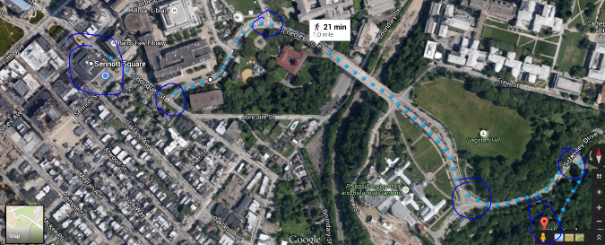

# Step-by-step Walking Directions

## Let’s start from Sennott Square

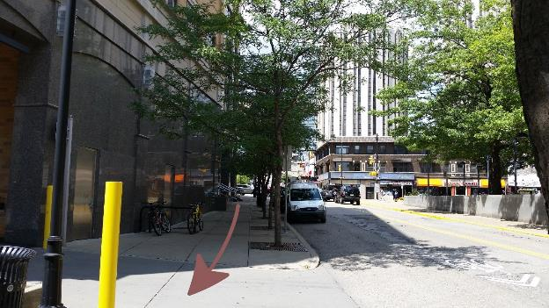

Exit the building from the main entrance, go towards the road leads you to the building’s parking area, continue on this road.

## Look for Elevation

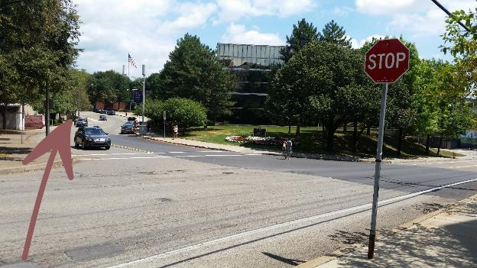

At the stop sign, switch to this twisted road to go up towards the bridge. Continue on this road.

## Cross the Bridge

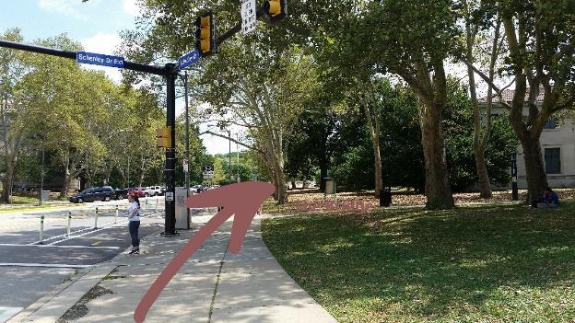

The road is called Schenley Dr. Continue on this road to cross the bridge.

## Intersection with Botanical Garden

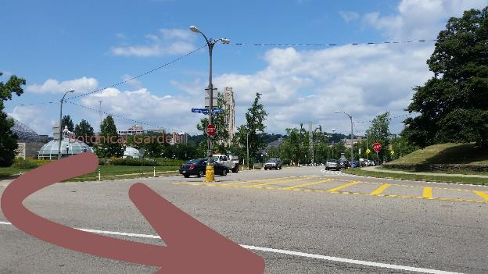

Continue on Schenley Drive until you see the Westinghouse Memorial…

## The Westinghouse Memorial (Construction Site)

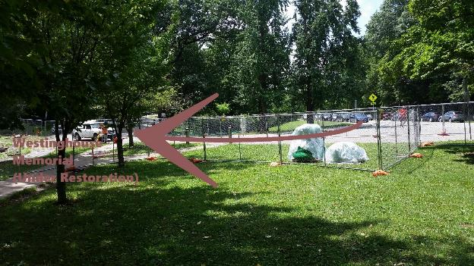

Turn towards the sidewalk closest to the memorial. Continue on this road until you see the shelter on your right.

## Destination

