“Eat me” “Drink me”

Have a happy Purim from the Millers!

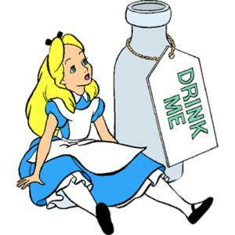

“Eat me” “Drink me”

Have a happy Purim from the Millers!



“Eat me” “Drink me”

Have a happy Purim from the Millers!



“Eat me” “Drink me”

Have a happy Purim from the Millers!



“Eat me” “Drink me”

Have a happy Purim from the Millers!



“Eat me” “Drink me”

Have a happy Purim from the Millers!



“Eat me” “Drink me”

Have a happy Purim from the Millers!



“Eat me” “Drink me”

Have a happy Purim from the Millers!



“Eat me” “Drink me”

Have a happy Purim from the Millers!



“Eat me” “Drink me”

Have a happy Purim from the Millers!



“Eat me” “Drink me”

Have a happy Purim from the Millers!



“Eat me” “Drink me”

Have a happy Purim from the Millers!



“Eat me” “Drink me”

Have a happy Purim from the Millers!



“Eat me” “Drink me”

Have a happy Purim from the Millers!



“Eat me” “Drink me”

Have a happy Purim from the Millers!



“Eat me” “Drink me”

Have a happy Purim from the Millers!



“Eat me” “Drink me”

Have a happy Purim from the Millers!



“Eat me” “Drink me”

Have a happy Purim from the Millers!



“Eat me” “Drink me”

Have a happy Purim from the Millers!



“Eat me” “Drink me”

Have a happy Purim from the Millers!

