|  |  |  |  |  |  |  |  |  |
| --- | --- | --- | --- | --- | --- | --- | --- | --- |
| **Name:** Dominique Sarmiento | | | | | | | | |
| **Age:** 20 | | | | | | | | |
|  | | | | | | | | |
| What was your first impression of the game? | | | | | | | | |
| Comments: So far, the game is pretty cool: nice art, concept, and choice of sound effects. In terms of gameplay, it’s great – I can move and shoot pretty well and it doesn’t lead me to break the game – but I can’t run and shoot the burritos/beans at the same time (not sure if it’s not in the program or my 10-year-old laptop is just done with me today). | | | | | | | | |
| Rate the Game Overall: | | | | | | | | |
| **Bad** |  | | **OK** | | |  | | **Great** |
| 1 | 2 | | 3 | | | 4 | | ***5*** |
| Comments: It’s a pretty solid game, you can shoot and move smoothly (my character is practically gliding on the screen), and my old laptop doesn’t lag after playing for a while. If it means anything, I had a lot fun playing the game and it reminds me of the old flash games from the early 2000s. | | | | | | | | |
| Rate the Game’s UI: | | | | | | | | |
| **Bad** | |  | | **OK** |  | | **Great** | |
| 1 | | 2 | | 3 | 4 | | ***5*** | |
| Comments: Would be nice if I could shoot using spacebar since I’m not on desktop, but overall, it’s great. | | | | | | | | |
| Rate the Game’s Controls: | | | | | | | | |
| **Bad** |  | | **OK** | | |  | | **Great** |
| 1 | 2 | | 3 | | | 4 | | **5** |
| Comments: It doesn’t glitch and it works really well | | | | | | | | |
| Rate the Game’s Art Direction: | | | | | | | | |
| **Bad** | |  | | **OK** |  | | **Great** | |
| 1 | | 2 | | 3 | 4 | | ***5*** | |
| Comments: The cowboy was pretty cool. I like the wiggling burritos, but I don’t know what the other thing was…Beans? A gang of beans? Chickens? Point is: art direction is great so far and the huge cactus was cute. | | | | | | | | |
| Please Rate the Game’s Gameplay: | | | | | | | | |
| **Bad** | |  | | **OK** |  | | **Great** | |
| 1 | | 2 | | 3 | ***4*** | | 5 | |
| Comments: It’s great but after running away from the burrito/bean mob, it takes me a few seconds before I can shoot again but I’m dead at that point so it’s fine. | | | | | | | | |
| Please Rate the Game’s Story: | | | | | | | | |
| **Bad** | |  | | **OK** |  | | **Great** | |
| 1 | | 2 | | 3 | 4 | | ***5*** | |
| Comments: I’m just a guy shooting burritos and beans looking for chili peppers, that’s all the plot I need. Dialogue surprised me when I stepped foot in the main building and that there’s a little more to the story and the cowboy’s personality – thought it was just a run and gun game. Hope he gets to watch the sunset. | | | | | | | | |
| Please Rate the Game’s Sounds/Music: | | | | | | | | |
| **Bad OK Great** | | | | | | | | |
| 1 2 3 4 ***5*** | | | | | | | | |
| Comments: Music is catchy and the sound effects are good whoever chose them did a good job. Both the music and sound effects weren’t distracting and it fits the tone of the game. Nitpick: I just find it a little weird that the menu doesn’t have a little tune in the background but it doesn’t affect the overall game so don’t worry about it. | | | | | | | | |
| If you could change/add anything in the game, how would you make it better? | | | | | | | | |
| Comments: Explosions need more jpeg. On a serious note, the game needs some tweaking in the run and gun part – my best scores are when I’m staying in place but when I try to run away and shoot, I have lower scores because the burritos and beans gang up on me before I can start shooting again. | | | | | | | | |

P.S. AI in the game is too good, I just wanted to explore. The picture is blurry but please not like this

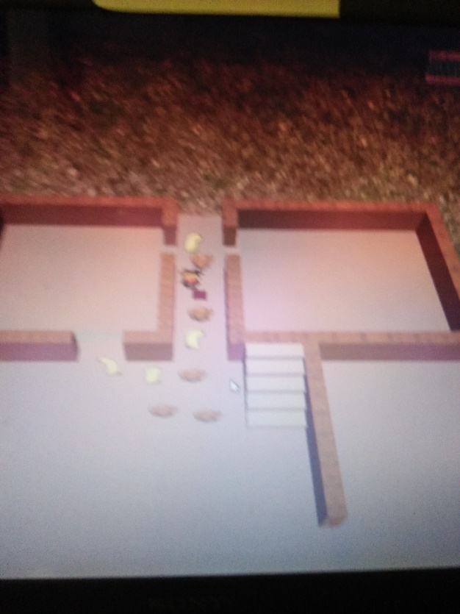 (I forgot Prt Sc existed so this was from my phone before I died)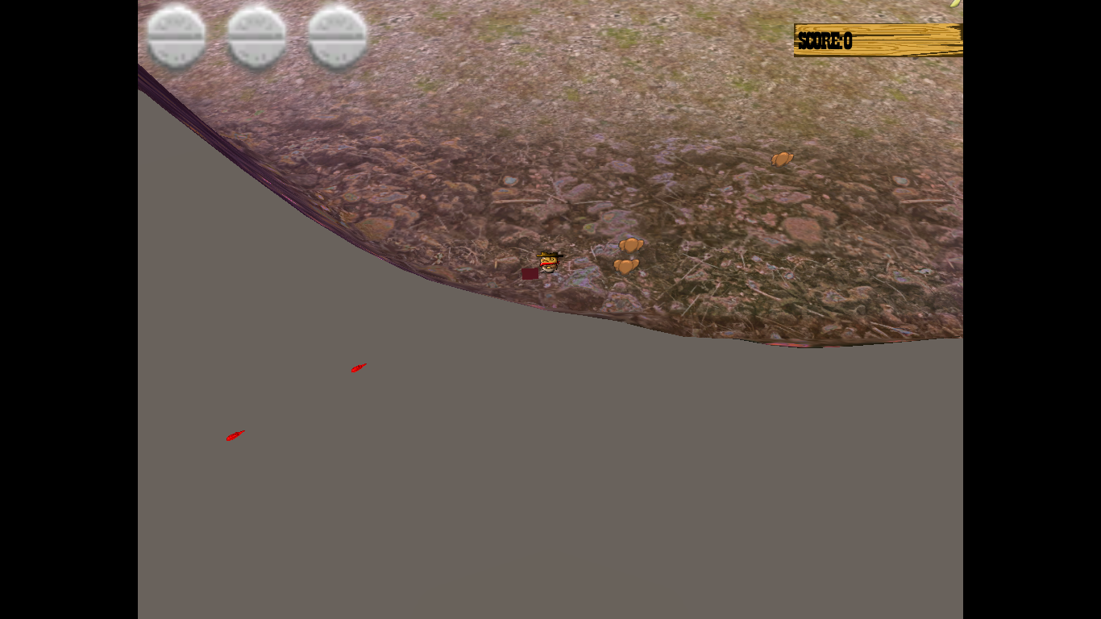

On the bright side, I did find the chili pepper! ＼(￣▽￣)／