Positioning in a Tunnel Environment by Detecting Emergency Telephone Indicators Using Infrared Cameras
自車位置を同定のための赤外線カメラを用いたトンネル内の非常電話ボックス検知

Zhipeng Wang¹, Matasaka Kagesawa¹, Shintaro Ono¹, Atsuhiko Banno², Takeshi Oishi¹, and Katsushi Ikeuchi¹
¹Institute of Industrial Science, The University of Tokyo, Japan
Email: {wangzp, kagesawa, onoshin, oishi, ki}@cvl.iis.u-tokyo.ac.jp
²Advanced Industrial Science and Technology, Ibaraki, Japan
Email: atsuhiko.banno@aist.go.jp

ABSTRACT
Vehicle positioning is of great importance to driving assistance and vehicles’ navigation. In tunnel environment, positioning is challenging, since neither GPS sensors nor ordinary cameras function properly. In this paper, we propose a real-time solution for positioning of vehicles. In tunnels, we can gain the absolute coordinates of some specific objects, here the emergency telephone indicators, which are some special lights. Then during the travelling in tunnels, we sense the environment using infrared cameras and detect the emergency telephone indicators to infer the experimental vehicle’s position. In our detection method, we make use of both the emergency telephone indicators’ appearance information and motion information. Through well balancing the pipeline, by making time-consuming steps deal with fewer instances, we gain a real-time detection method with promising detection results.

本論文では、トンネル内で赤外カメラのみを用いて自車位置を同定する手法を提案する。高速道路のように非常電話ボックスの位置が既知であることを前提とし、トンネル内での自車位置同定を、非常電話ボックスを検出することに帰着する。非常電話ボックス検出手法は、次の通りである。まず、赤外画像から非常電話ボックスに対応する特徴点を抽出し、その点を含む小さな領域が非常電話ボックスであるかどうか検証する。非常電話ボックス候補と判定された小領域を時空間追跡することで非常電話ボックスであるかどうかを最終的に判定する。通常、時空間追跡は時間がかかるが、実時間での検出を可能にした。最後に、屋外実験を行って本手法の有効性を確認した。
Keywords: Positioning, Detection, Real-time

1. INTRODUCTION
For intelligent vehicles, especially for automated vehicles, it is very important to estimate its location. When GPS sensors function effectively, positioning of vehicles is relatively easy. In tunnel environment, GPS data are missing for most of the time. And most methods such as [1] using ordinary cameras also fail due to darkness. Thus it is necessary to develop vehicle positioning system in tunnels. In this paper, we have focused on vehicle positioning in tunnels of express way for intelligent vehicles. In most tunnels of express way in Japan, there are lots of signs which are placed at equal intervals. For instance, every 200 meters there exist some emergency telephone location indicator lights. We can obtain the absolute coordinates of those emergency telephone indicators by the method of Ono [3] or so. Then if we can sense emergency telephone indicators during the traveling in tunnels, we can estimate the distance from the vehicle to the light, which means that we can estimate absolute position. On the other hand, recent intelligent vehicles are equipped with infrared cameras. And infrared cameras are expected to be suitable for detecting lights. We have developed the system of detecting the emergency telephone indicators on infrared cameras [2]. To support positioning, the detection method needs to be real-time. Besides, the clutter property of the collected data also makes the detection challenging. As shown in Figure 1, ordinary lights, other vehicle(s) and their shadow(s) act as noisy objects, and by appearance, instances of the latter two can hardly be distinguished from the target object(s). To meet the challenges, we propose an efficient object detection method by combining appearance and motion information. We show the effectiveness of our system by demonstrating outdoor experiment in Awagatake tunnel.

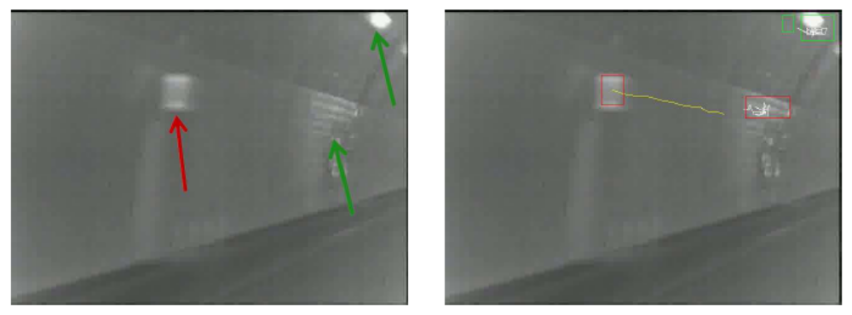

Figure 1. Left: original data (target object(s) pointed by red arrows, noisy object(s) pointed by green arrows), Right: detection results (red rectangles and yellow trajectories mark the correctly detected objects).

2. ROPOSED METHOD
The method can be considered as a two-step method. The first step deals with keypoints. It takes original data as input, and outputs keypoint clusters as detection hypotheses. The second step takes these keypoint clusters as input, verifies them by their appearance and motion information, and outputs the ones which pass verifications as detection results.

2.1 DETECTION, VERIFICATION, AND GROUPING OF KEYPOINTS
Detection: Our method employs a simple yet useful method to detect keypoints. Firstly, all points are uniformly sampled with width step 3, and height step 4. Then the points of which the intensities satisfy the set thresholds are considered as keypoints. Verification: To further verify the keypoints, the appearance of the sub-image around each keypoint is used. Intensity histograms are used to describe the appearance. The verification is done using a simple general model powered by k-means. Grouping: The keypoints which pass the verification step are then grouped. To group the keypoints, a minimum spanning tree (mst) is built using the pairwise Euclidean distance between two keypoints. And the mst is split by cutting edges larger a threshold, and this results in several keypoint clusters.

2.2 VERIFICATION OF KEYPOINT CLUSTERS BY APPEARANCE AND MOTION
For each keypoint cluster, the smallest bounding rectangle is considered as a detection hypothesis. There are two main sources of noise. Ordinary lights are the first, and other vehicles with their shadows are the second. Appearance: An Adaboost machine is trained using intensity histograms of the emergency telephone indicators and ordinary lights. The appearance of other vehicles and their shadows is close to the emergency telephone indicators’, and they are not used for training the machine. The trained machines decides whether each keypoint cluster is a emergency telephone indicator by appearance. Motion: The keypoint clusters are tracked, and the significance of fitting the generated trajectory as a straight line is used as criterion to decide whether each keypoint cluster is a emergency telephone indicator by motion.

3. EXPERIMENTAL RESULTS
As shown in Figure 2, our method utilizes both appearance and motion. We go several tours in Awagatake Tunnel on Shin-Tomei Expressway. The parameters of our method are adjusted on one tour, and then detection is evaluated on another tour. On an ordinary desktop computer with Intel Core2 Quad 2.6GHz processors, the method deals with real data at a frame rate of 41 frames per second, and this fulfills real-time requirements. The detection rate and false alarm rate are evaluated on one tours, and for a detection rate of 99.2%, the false alarm rate is 4.4%. Detailed results are shown in Table 1. We further evaluate the method at the time when each object disappear from the scene by combining the information encoded in one object's trajectory. And the method can detect all the 22 emergency telephone indicators with 0 false alarms. Using rough estimation, the solution can provide positioning results of 20-meter attitude. And we plan to provide better positioning results with careful calibrations.

Total number | 472
Correctly labeled | 468
Miss detections | 4
False alarms | 22
Detection rate | 99.2%
False alarm rate | 4.4%

Table 1. Detection rate and false alarm rate.

4. CONCLUSION
We propose an object detection method to detect emergency telephone indicators in tunnel environment. The method makes use of appearance and motion information of the target objects in a hierarchical manner. With careful optimization of detection pipeline, the method gives promising results in real time. Based on the detection results, a positioning system in tunnel environment can be expected.

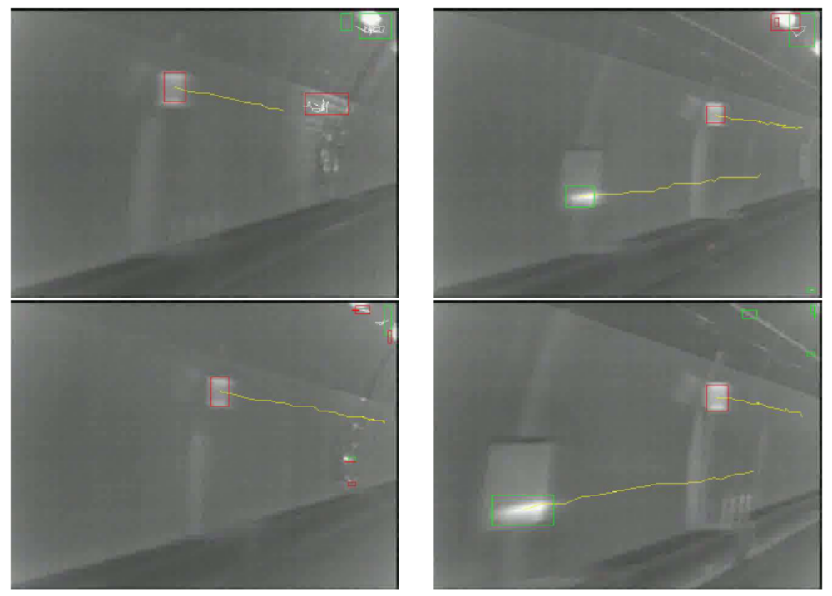

Figure 2. Detection Results.

references
[1] C. Wojek, S. Roth, K. Schindler, and B. Schiele, “Monocular 3d scene modeling and inference: Understanding multi-object traffic scenes,” 12th European Conference on Computer Vision, pages IV: 467–481, 2010.
[2] Z. Wang, M. Kagesawa, S. Ono, A. Banno, and K. Ikeuchi, “Emergency Light Detection in Tunnel Environment: an Efficient Method,” 1st Asian Conference on Pattern Recognition, pages:628-632, Nov. 2011.
[3] S. Ono, L. Xue, A. Banno, T. Oishi, Y. Sato, K. Ikeuchi, "Global 3D Modeling and its
Evaluation for Large-Scale Highway Tunnel using Laser Range Sensor," 19th World Congress
on Intelligent Transport Systems and Services, Oct. 2012.

