Sri Lanka Institute of Information Technology

**Modern Topics in IT (IT4020)**

Assignment 01- Modular development

Telecommunication System

|  |  |
| --- | --- |
| IT19209944 | Aluvihare W.B.W.M.R.U.P.U. |
| IT19207964 | Weerasooriya K.T.N. |
| IT19152110 | Rajapaksha K.D. |
| IT19047034 | Wijayasinha P.R. |

# **Table content**

[1.Introduction…………………………………………………………………………………...3](bookmark://intro)

[2.Methanology………………………………………………………………………………….4](bookmark://methno)

   2.1. System diagram……………………………………………………………………4

3.Internet Service……………………………………………………………………………….5

3.1 manifest implementation……………………………………………………………5

3.2 producer installation and consumer installation & running services……………… 6

3.3. Sample screenshots of its behavior & outputs…………………………………… 8

4.Call Service…………………………………………………………………………………...9

4.1 manifest implementation……………………………………………………………9

4.2 producer installation and consumer installation & running services……………...10

4.3. Sample screenshots of its behavior & outputs……………………………………12

5.SMS Service…………………………………………………………………………………14

5.1 manifest implementation…………………………………………………………..14

5.2 producer installation and consumer installation & running services……………...15

5.3. Sample screenshots of its behavior & outputs……………………………………17

6.Loan Service………………………………………………………………………………...19

6.1 manifest implementation………………………………………………………….19

6.2 producer installation and consumer installation & running services……………...20

6.3. Sample screenshots of its behavior & outputs……………………………………22

# **1.Introduction**

The OSGi, formerly known as the **Open Service Gateway Initiative**, is an open standards organization founded in March 1999. It is a Java framework for developing (remotely)and deploying modular software programs and libraries.  OSGi makes it possible to define the dependencies of each individual module with the others. It enables users to control the lifecycle and dynamically change each component of the system. Most essentials concepts are publisher and subscriber.

For modern topics in information technology module assignment 01, we have done the Telecommunication system according to OSGI framework. Internet Service, Call Service and SMS service and loan service are the producers of this system. The consumers are internet service subscriber, call service subscriber, SMS service subscriber and loan service subscriber. We used Equinox OSGI framework to our system.

# **2.Methanology**

# **2.1 system diagram**

# **3.Internet Service**

(IT19209944 - Aluvihare W.B.W.M.R.U.P.U)

## **3.1. Manifest implementation**

Internet service publisher

Internet service subscriber

## **3.2. Producer installation and consumer installation & running services**.

**Commands**

Run configuration

* Select MANIFEST.MF => run as =>run configurations.
* Select only internet service publisher bundle and internet service subscriber bundle.
* Rename it as “OSGI internet service”.
* Click on “**Apply changes**”
* Click on **Run**.

Activate bundles

Start services

Stop services

**3.3 Sample screenshots of its behavior & outputs**

# **4.Call Service**

(IT19207964 – Weerasooriya K.T.N)

# **4.1Manifest implementation**

call service publisher

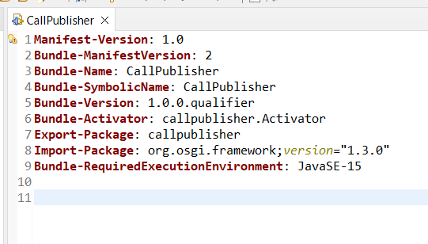

call service subscriber

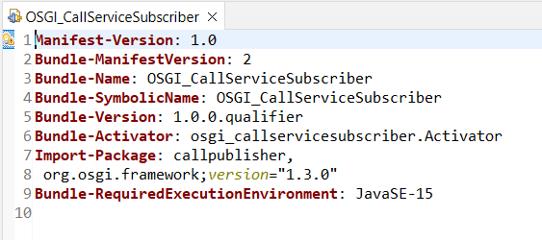

## **4.2. Producer installation and consumer installation & running services.**

**Commands**

Run configuration

* Select MANIFEST.MF => run as =>run configurations.
* Select call service publisher bundle and call service subscriber bundle.
* Rename it as “OSGI call service”.
* Click on “**Apply changes**”
* Click on **Run**.

Activate bundles

Start services

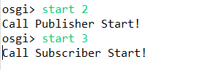

Stop services

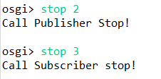

## **4.3. Sample screenshots of its behavior & outputs**

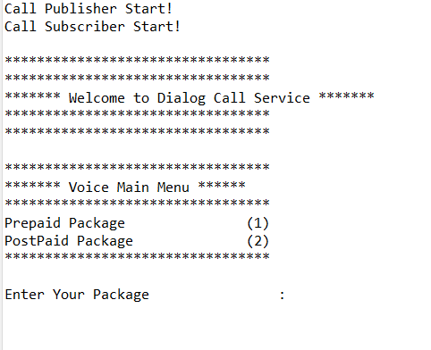

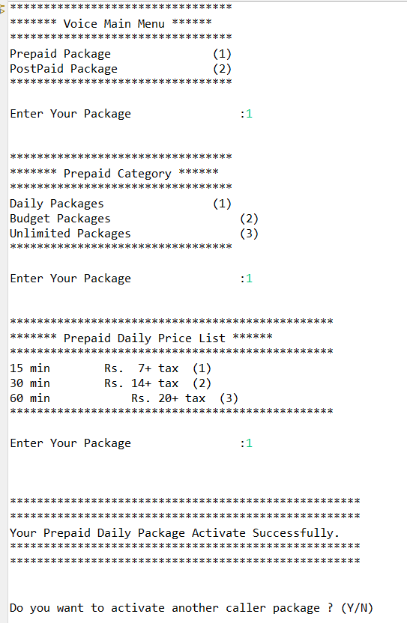

# **5.SMS Service**

(IT19152110 – Rajapaksha K.D)

# **5.1 Manifest implementation**

Sms service publisher

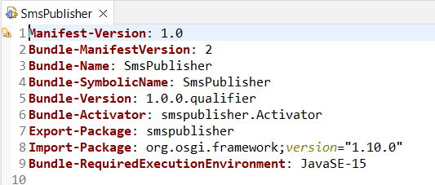

sms service subscriber

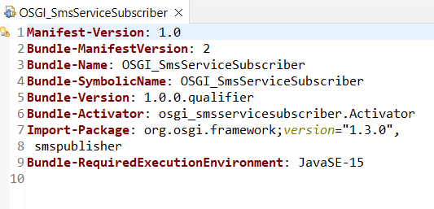

# **5.2 Producer installation and consumer installation & running services**.

**Commands**

Run configuration

* Select MANIFEST.MF => run as =>run configurations.
* Select sms service publisher bundle and sms service subscriber bundle.
* Rename it as “OSGI sms service”.
* Click on “**Apply changes**”
* Click on **Run**.

Activate bundles

Start services

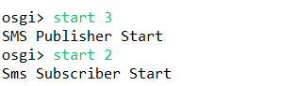

Stop services

## **5.3. Sample screenshots of its behavior & outputs**

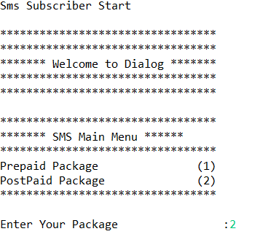

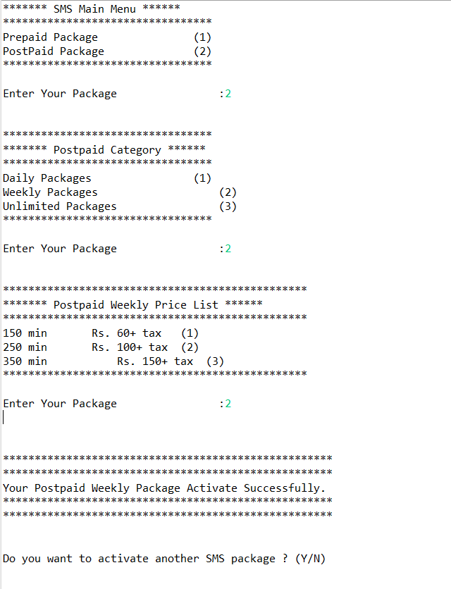

# **6. Loan Service**

(IT19047034 – Wijayasinha P.R.)

# **6.1 Manifest implementation**

Loan service publisher

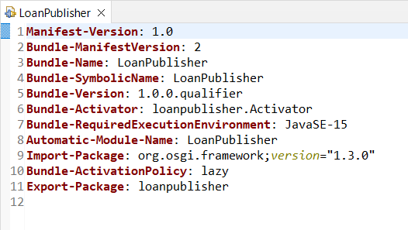

Loan service subscriber

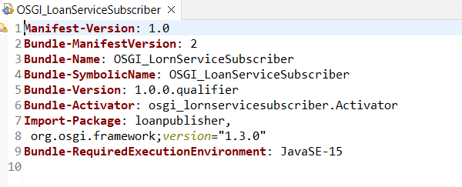

# **6.2. Producer installation and consumer installation & running services**.

**Commands**

Run configuration

* Select MANIFEST.MF => run as =>run configurations.
* Select loan service publisher bundle and loan service subscriber bundle.
* Rename it as “OSGI loan service”.
* Click on “**Apply changes**”
* Click on **Run**.

Activate bundles

Start services

Stop services

## **6.3. Sample screenshots of its behavior & outputs**

