Results
Home Page:
- Landing Page: A welcoming landing page that introduces the system’s functionality – to predict diamond prices accurately using machine learning.
- Navigation Bar: A top navigation menu with links to “Home,” “Predict,” “About,” and “Contact.”
- Responsive Design: Designed to be compatible with desktops, tablets, and mobile phones using responsive web technologies.

Prediction Form:
- Input Fields: A form where users can input the diamond’s attributes like:
  - Carat
  - Cut (Ideal, Premium, etc.)
  - Color (D to J)
  - Clarity (IF, VS1, etc.)
  - Depth, Table, X, Y, Z dimensions
- Validation: Input validation is applied to ensure numeric fields are correctly formatted and dropdowns are restricted to valid options.
- Submit Button: Upon submission, the form sends the input data to the backend via Flask, which processes it using a pre-trained .pkl model and returns the predicted price.

Output Section:
- Predicted Price Display: Once the backend returns the result, the frontend displays the diamond's predicted price in a clean format.
- Error Handling: Displays user-friendly messages for invalid input, server errors, or model prediction issues.

Tools Used:
- HTML: Structures the layout of the web pages.
- CSS: Styles the UI to ensure clarity, modern aesthetics, and a good user experience.
- Bootstrap: A responsive framework used to optimize the web pages for various screen sizes, enhancing usability across all devices.
- Flask (in Backend Module): Handles communication between the frontend form and the .pkl file containing the trained machine learning model.

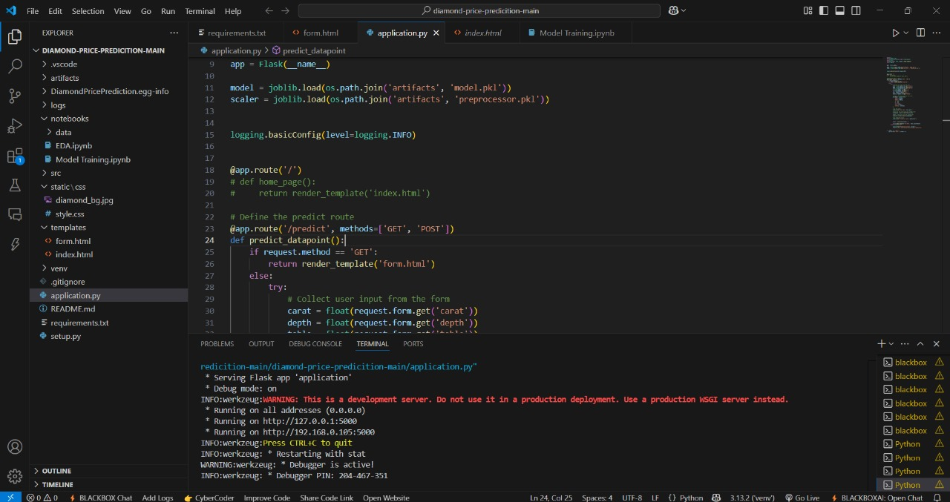
Output:

