
Production Deployment Runbook — AWS af-south-1
A step-by-step guide to stand up the Tier B production environment yourself: high-availability, multi-AZ, encrypted, in the AWS af-south-1 (Cape Town) region for African data residency. Pairs with the target-architecture and data-residency diagrams.
Shape of the system: Cloudflare edge → ALB → ECS Fargate API (≥2 tasks, 2 AZs) → RDS PostgreSQL (Multi-AZ) + ElastiCache Redis + object storage; CloudFront for the static client. Each phase has a goal, steps, and a ✓ checkpoint before you move on.
⏱ Realistic effort: ~6–10 working days for a first build (more if also doing SOC 2). 💡 Strongly recommended: express all of this as Terraform (IaC) so it’s reproducible, reviewable, and rebuildable for DR. The console steps below map 1:1 to Terraform resources.

Phase 0 — Account, guardrails & decisions
Goal: a safe, well-governed AWS account before anything is created.
- Use a dedicated AWS account (or Organisation sub-account) for production — separate from UAT.
- Lock down the root user (MFA, no access keys); create an IAM admin user/role for daily work.
- Set the region to af-south-1 (note: it’s an opt-in region — enable it in Account → Regions).
- Create an AWS Budget + billing alarm (e.g. alert at $1k, $3k, $5k/mo).
- Turn on CloudTrail (audit), GuardDuty (threat detection), and AWS Config (compliance) — also useful evidence for SOC 2.
- Decisions to lock now:
  - Object storage: the app currently uses Supabase Storage (SUPABASE_* env vars). For true residency, plan to migrate file storage to S3 (small code change in the storage helper). If you keep Supabase Storage short-term, note that uploaded files then live outside the af-south-1 boundary.
  - Live integration keys ready and kept out of the repo: Stripe/Paystack live, WhatsApp production number, Anthropic prod key, Resend verified domain.
  - Never set OTP_DEV_MODE or DEMO_SEED_PASSWORD in production.
✓ Checkpoint: billing alarms active, CloudTrail logging, admin role works, af-south-1 enabled.

Phase 1 — Network & platform foundation
Goal: an isolated VPC and the shared building blocks.
- VPC across 2 availability zones with three subnet tiers per AZ:
  - public (ALB, NAT gateway), private-app (ECS tasks), private-data (RDS, Redis).
- NAT gateway (one per AZ for HA) so private subnets can reach the internet for outbound calls.
- Security groups (least privilege):
  - ALB SG: inbound 443 from internet → ECS SG.
  - ECS SG: inbound from ALB SG only; outbound to DB/Redis SGs + internet (via NAT).
  - DB SG / Redis SG: inbound only from ECS SG.
- KMS customer-managed keys for RDS, S3, Secrets Manager (encryption at rest).
- AWS Secrets Manager — where all production secrets will live.
- ECR repository (mobicova-api) for the container image.
✓ Checkpoint: VPC + subnets + route tables + SGs created; ECR repo exists; KMS keys created.

Phase 2 — Data tier
Goal: durable, HA, encrypted stores in the private-data subnets.
- RDS PostgreSQL (or Aurora PostgreSQL):
  - Multi-AZ (primary + standby, automatic failover).
  - Encrypted at rest (KMS), automated backups + PITR (retain ≥ 7 days), deletion protection on.
  - In the private-data subnet group; SG allows only the ECS SG.
  - (Optional) add a read replica for reporting/analytics queries.
  - Grab the RDS CA certificate PEM → this becomes DATABASE_CA_CERT.
- ElastiCache for Redis — Multi-AZ replication group, in private-data subnets, SG from ECS only. (Used for sessions, cache, rate-limit, and the job queue.)
- S3 bucket for object storage — private, block public access, versioning on, encrypted (KMS). (Target for the Supabase-Storage → S3 migration.)
- Run migrations against the prod DB (see Phase 4 for the one-off ECS task), using a build that exposes a prod-safe command — add to server/package.json:
- "migrate:prod": "node dist/db/migrate.js"
- (Migrations compile to dist/ via tsc, so prod doesn’t need tsx/devDeps.)
✓ Checkpoint: can connect to RDS from a temporary task in the VPC; Redis reachable; S3 bucket private + encrypted.

Phase 3 — Containerise & publish the API
Goal: a production image in ECR.
- Add a server/Dockerfile:
- # --- build stage ---
FROM node:22-slim AS build
WORKDIR /app
COPY package*.json ./
RUN npm ci
COPY . .
RUN npm run build # tsc -> dist (compiles app + migrations)
# --- runtime stage ---
FROM node:22-slim AS runtime
WORKDIR /app
ENV NODE_ENV=production
COPY package*.json ./
RUN npm ci --omit=dev
COPY --from=build /app/dist ./dist
EXPOSE 8080
USER node
CMD ["node", "dist/server.js"]
- Build, tag, and push to ECR:
- aws ecr get-login-password --region af-south-1 | docker login --username AWS --password-stdin <acct>.dkr.ecr.af-south-1.amazonaws.com
docker build -t mobicova-api ./server
docker tag mobicova-api:latest <acct>.dkr.ecr.af-south-1.amazonaws.com/mobicova-api:<git-sha>
docker push <acct>.dkr.ecr.af-south-1.amazonaws.com/mobicova-api:<git-sha>
- (Confirm the app honours PORT — set it to 8080 in the task definition.)
✓ Checkpoint: image visible in ECR; docker run locally serves /health 200.

Phase 4 — Compute (ECS Fargate + ALB)
Goal: redundant API behind a load balancer.
- ACM certificate for api.yourdomain (DNS-validated) in af-south-1.
- Application Load Balancer in the public subnets; HTTPS:443 listener using the ACM cert; HTTP:80 → redirect to 443.
- Target group (IP type), health check path /health.
- ECS cluster (Fargate) + task definition:
  - container = the ECR image, port 8080, PORT=8080.
  - env/secrets injected from Secrets Manager (see Phase 7).
  - CPU/memory sized (start 0.5 vCPU / 1 GB), logs → CloudWatch.
- ECS service: desired count ≥ 2, spread across both AZs, attached to the ALB target group.
- Auto-scaling: target-tracking on CPU/memory (e.g. scale out at 60% CPU).
- Migrations: run a one-off ECS task using the same image with command override node dist/db/migrate.js before sending traffic.
✓ Checkpoint: ALB DNS serves /health 200; killing one task auto-replaces it with zero failed requests.

Phase 5 — Frontend (static client)
Goal: the React app on a global CDN.
- Build with the prod API URL: VITE_API_URL=https://api.yourdomain → npm run build (output client/dist).
- S3 bucket (private) + CloudFront distribution with Origin Access Control, ACM cert for app.yourdomain, and an SPA fallback (403/404 → /index.html, 200).
- Upload dist/ to S3; invalidate CloudFront on each release.
Alternative: host the client on Cloudflare Pages for simpler edge hosting — your call.
✓ Checkpoint: https://app.yourdomain loads, talks to the API, deep links resolve.

Phase 6 — Edge, DNS & TLS (Cloudflare)
Goal: protected, fast entry points.
- DNS: api.yourdomain → ALB; app.yourdomain → CloudFront.
- WAF rules (managed OWASP ruleset + bot mitigation), rate limiting, DDoS protection.
- TLS/HSTS end-to-end; security headers (CSP, X-Frame-Options, etc.).
- Keep a Lagos PoP in play for low-latency African delivery.
✓ Checkpoint: WAF blocks an injection probe; SSL Labs / security-header scan grades A.

Phase 7 — Secrets & production config
Goal: every secret managed, nothing in the repo.
Store these in Secrets Manager and inject into the ECS task. Production / LIVE values only.
Variable | Notes
NODE_ENV | production
APP_ENV | production
PORT | 8080 (match the task/ALB)
DATABASE_URL | RDS primary endpoint (SSL)
DATABASE_CA_CERT | RDS CA PEM (verifies DB TLS)
JWT_SECRET | strong, unique
JWT_EXPIRES_IN | e.g. 7d
CLIENT_URL / SERVER_URL | https://app.… / https://api.…
ANTHROPIC_API_KEY / ANTHROPIC_MODEL | prod key
STRIPE_SECRET_KEY / STRIPE_WEBHOOK_SECRET | live
PAYSTACK_SECRET_KEY | live
RESEND_API_KEY / EMAIL_FROM | verified domain
WHATSAPP_VERIFY_TOKEN / WHATSAPP_TOKEN / WHATSAPP_PHONE_ID | production number
PLATFORM_ADMIN_EMAILS | your platform admins
Object storage | SUPABASE_URL / SUPABASE_SERVICE_ROLE_KEY / SUPABASE_STORAGE_BUCKET or S3 vars after migration
⛔ Do NOT set in prod: OTP_DEV_MODE (must be off — real OTPs), DEMO_SEED_PASSWORD (no demo seed). 🔁 Enable rotation for JWT_SECRET, DB creds, and API keys.
✓ Checkpoint: ECS task starts cleanly with all secrets; no secret appears in logs or the repo.

Phase 8 — Observability & alerting
Goal: you can see and be paged about problems.
- CloudWatch: container logs, metrics, and alarms (5xx rate, p95 latency, CPU, DB connections, Redis evictions, queue depth).
- Error tracking: Sentry on API + client (release tagging, source maps).
- Uptime / synthetic checks: external monitor hitting /health and a login flow from multiple regions.
- On-call: route alarm → pager (e.g. Better Stack / PagerDuty) on SLO breach.
✓ Checkpoint: an injected 5xx spike fires an alarm and pages within minutes; dashboards show live latency.

Phase 9 — CI/CD: promote to production
Goal: safe, repeatable releases (UAT → Prod).
Recommended GitHub Actions flow on a release tag (vX.Y): 1. Build + type-check (reuse the UAT gate). 2. Build the Docker image → push to ECR (:<git-sha>). 3. Run the migration task (node dist/db/migrate.js) against prod DB. 4. Update the ECS service to the new image (rolling deploy; ECS waits for healthy targets). 5. Invalidate CloudFront for the client. 6. Smoke test the live /health + a key path; manual approval gate before the ECS update.
Rollback = re-point the ECS service to the previous image tag (keep the last N images in ECR).
✓ Checkpoint: a tagged release deploys end-to-end; a deliberate bad build is blocked at the gate; rollback works in < 5 min.

Phase 10 — Go-live cutover
Goal: flip to live safely.
- Final migration applied; verify schema.
- Seed only real admin accounts (no demo data); create the platform admin(s).
- Point live webhooks to prod API: WhatsApp (Meta), Africa’s Talking (USSD/SMS), Stripe/Paystack.
- Configure payment live keys + webhook secrets; do a 1-unit test transaction, then refund.
- DNS cutover to prod (low TTL beforehand).
- Smoke test all channels (web, WhatsApp, USSD), enrolment → membership ID, OTP login, a claim.
- Watch dashboards for the first hours; keep the rollback ready.
✓ Checkpoint: real enrolment via each channel works; payments + OTP live; error rate flat.

Phase 11 — Post-launch hardening
- Verify backups and run a restore drill (RDS snapshot → temp instance) — prove RPO ≤ 5 min, RTO ≤ 30 min.
- Write the DR runbook (failover + restore steps, contact tree).
- Cost review after week 1 (right-size ECS/RDS, check NAT/data-transfer).
- Start the SOC 2 / ISO 27001 observation window and book the penetration test (see production plan).

Quick sequence (dependency order)
0 Account/guardrails → 1 VPC/SG/KMS/ECR → 2 RDS+Redis+S3 → 3 Docker→ECR
→ 4 ALB+ECS (+migrate task) → 5 S3+CloudFront client → 6 Cloudflare/WAF/DNS
→ 7 Secrets → 8 Observability → 9 CI/CD → 10 Cutover → 11 Hardening

If full AWS-native feels too heavy
You can run a hardened managed prod (Render/Supabase scaled + Cloudflare) far faster, trading African data residency (it would sit in the EU) and some control. Given residency + SOC 2 are firm requirements, AWS af-south-1 is the right destination — but a managed interim is a valid bridge while you build this out. See the production plan’s Tier A vs Tier B comparison.

Reference diagrams
Target production architecture
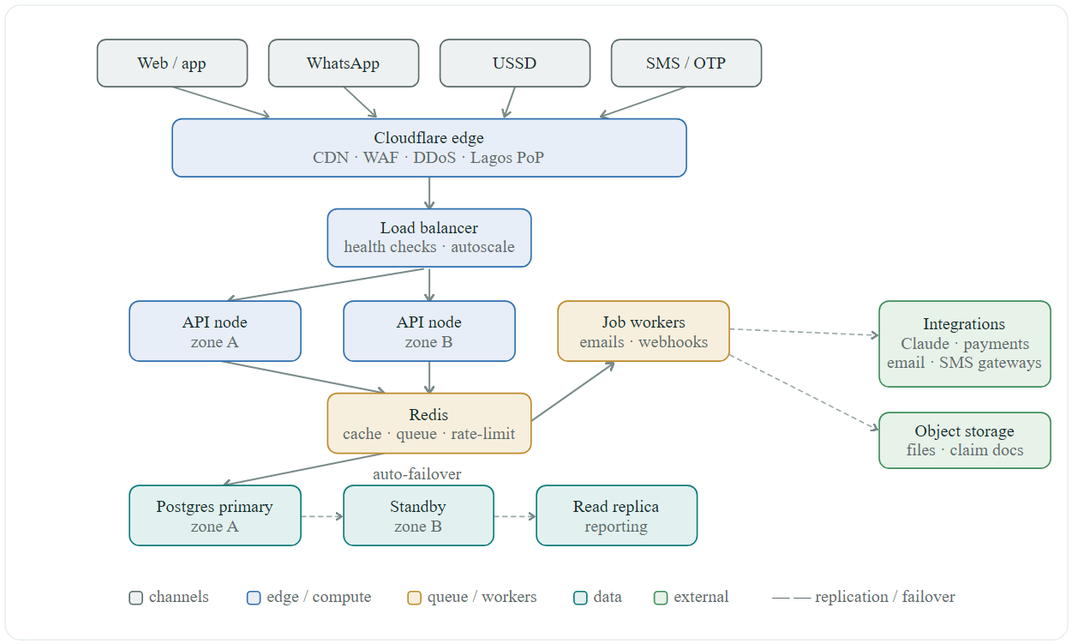

Data residency & network boundary
