

Walchand College of Engineering, Sangli

(Government aided Autonomous Institute)

Department of Computer Science and Engineering
TY CSE Mini Project 1(7CS345)
Report on

PromptOpt: Token-Efficient Prompt Optimization for LLMs

Submitted by

Piush U. Gogi | 255200005
Nirzara A. Manade | 255200006
Siddhi S. Bolaikar | 255200008

Under the guidance of

Prof. A. S. Pawar

Department of Computer Science and Engineering,
Walchand College of Engineering, Sangli

2026 - 2027

Walchand College of Engineering, Sangli
(Government aided Autonomous Institute)

Department of Computer Science and Engineering

CERTIFICATE

This is to certify that the Project Report entitled, “PROMPTOPT: TOKEN-EFFICIENT PROMPT OPTIMIZATION FOR LLMS” submitted by Piush U. Gogi, Nirzara A. Manade and Siddhi S. Bolaikar, to Walchand College of Engineering Sangli, India, is a record of bonafide project work of course Mini Project-I (7CS345) carried out by them under my/our supervision and guidance and is worthy of consideration for the award of the degree of Bachelor of Technology in Computer Science & Engineering of the Institute.

Prof. A. S. Pawar | Mr. H.R. Chandoba |  | Dr. A.R. SURVE
Guide | Mini Project Coordinator | External Examiner | Head Of Department
Department of Computer Science and Engineering, | Department of Computer Science and Engineering, |  | Department of Computer Science and Engineering,
Walchand College of Engineering, Sangli | Walchand College of Engineering, Sangli |  | Walchand College of Engineering, Sangli

Acknowledgement

We express our sincere gratitude to our guide, Prof. A. S. Pawar, for constant guidance, timely reviews and for pushing us to measure every claim instead of assuming it. The suggestions on evaluation, on the validation of our dataset and on presenting the system through one worked example shaped the way this project was carried out and reported.
We thank Mr. H. R. Chandoba, Mini Project Coordinator, for organising the mini-project reviews, and Dr. A. R. Surve, Head of the Department of Computer Science and Engineering, for providing the facilities and the environment to work on this project. We also thank the faculty member who reviewed a sample of our dataset, and the students who answered our survey.
Finally, we thank Walchand College of Engineering, Sangli, and our families and friends for their support throughout the project.

Declaration

We hereby declare that the work presented in this project report titled “PROMPTOPT: TOKEN-EFFICIENT PROMPT OPTIMIZATION FOR LLMS” submitted by us in the partial fulfillment of the requirement of the award of the degree of Bachelor of Technology (B. Tech) in the Department of Computer Science & Engineering, Walchand College of Engineering, Sangli is an authentic record of our project work carried out under the guidance of Prof. A. S. Pawar.

Date:
Place: Sangli
(Signature)

Piush U. Gogi (255200005)
Nirzara A. Manade (255200006)
Siddhi S. Bolaikar (255200008)

Table of Contents
Abstract 12
1 Introduction and Related work 13
1.1 Background 13
1.2 Motivation and customer connect 13
1.3 Related work 14
1.4 Research gap 15
1.5 Organisation of the report 16
2 Problem statement 17
2.1 Description 17
2.2 Formal statement 17
2.3 Scope of the work done 17
2.4 Alignment with the Sustainable Development Goals 18
3 Objectives 19
4 Methodology 20
4.1 Development approach (SDLC) 20
4.2 Phase 1: Requirement analysis 21
4.3 Phase 2: Dataset preparation 23
4.4 Phase 3: System design 29
4.5 Phase 4: Implementation of Stage A (feature detection) 31
4.6 Phase 4: Implementation of Stage B (rule-based optimization) 36
4.7 Phase 4: Implementation of Stage C (LoRA fallback) and its training 38
4.8 Phase 4: Rendering, token counting and the web application 43
4.9 Phase 5: Validation 44
4.10 Phase 6: Testing and evaluation method 44
4.11 Phase 7: Deployment 46
4.12 Technology stack 46
5 Project diagrams 47
5.1 The example first 47
5.2 System architecture 47
5.3 Pipeline flow of one request 49
5.4 Database design 50
5.5 Evaluation flow 52
6 Test plan 53
6.1 Unit testing 53
6.2 Integration testing 56
6.3 System testing 60
7 Results 61
7.1 Results with screenshots and description 61
7.2 Comparative analysis: input, output and input + output tokens 69
7.3 Performance measures in tabular form and graphs 72
7.4 Result analysis 74
7.5 GUI images and screenshots 76
7.6 Screenshots of the GitHub project upload 78
7.7 Use of Git and GitHub 79
7.8 Challenges faced and how we solved them 80
8 Conclusion 81
Limitations of the proposed solution 81
Future scope and possible extensions 82
9 References 83
10 Scholarly contribution 85

List of Figures
Figure 4.1: SDLC phases followed in the project, with the two feedback loops 20
Figure 4.2: Project schedule (Gantt chart): all ten tasks done 21
Figure 4.3: Dataset pipeline: from Dolly-15k and CodeAlpaca-20k to PromptOpt Dataset v1.2 final 23
Figure 4.4: The review example through every stage of PromptOpt 30
Figure 4.5: System architecture, with the review example under each component 30
Figure 4.6: Stage A: every arrow is labelled with what flows along it 32
Figure 4.7: Stage A scores for the review example: k-NN vote, head and final score against the 0.6 gate 35
Figure 4.8: Stage B: rule order, the 0.6 confidence gate and the group fallback 36
Figure 4.9: Stage C in block form: routing, request, model, checker, fallback and the user's confirmation 39
Figure 4.10: Stage C training pipeline 40
Figure 5.1: The review example through the system 47
Figure 5.2: System architecture with the review example under each component 48
Figure 5.3: Module diagram: core modules, supporting modules and the data layer 48
Figure 5.4: Pipeline flow of one request, with the commit decision at step 7 50
Figure 5.5: Entity-relationship diagram (10 tables) 51
Figure 5.6: Evaluation flow: splits, variants and metrics 52
Figure 6.1: Correctness suite: correct answers per category, vague vs optimized 59
Figure 7.1: Improve prompt (simple app): the vague prompt, the pasted review and the target AI 61
Figure 7.2: The improved prompt, written in ChatGPT's layout (50 tokens), with the task-type question 62
Figure 7.3: Token usage analysis: both prompts on the same AI, 270 → 162 tokens (40% fewer) 63
Figure 7.4: History (simple app): the prompt, the improved prompt and its token saving, kept for 30 days 64
Figure 7.5: Developer view, Optimize: the vague prompt and the pasted review, target GPT, category auto-detect 64
Figure 7.6: Stage A on the review example: summarization 0.52, below the 0.6 gate, so marked unsure 65
Figure 7.7: Stage B on the review example: two rules fired, each shown with the text before and after 65
Figure 7.8: Stage C on the review example: the model filled format, constraints and category; the user is asked to confirm 66
Figure 7.9: The optimized prompt rendered for GPT, with 50 input tokens 67
Figure 7.10: Compare: the vague and the optimized prompt answered by the same model 68
Figure 7.11: Review example: input, output and total tokens on the same model 69
Figure 7.12: Input, output and input + output tokens per category, vague vs optimized 70
Figure 7.13: Mean input + output tokens per prompt by category, vague vs optimized 71
Figure 7.14: Benchmark split: quality, task success and input + output tokens 72
Figure 7.15: Stage A F1 per category (test split) 72
Figure 7.16: Test suite: correctness summary and the case grid 74
Figure 7.17: One case (cqa-01): gold answer 80300; the vague answer was wrong, the optimized right 74
Figure 7.18: Results page: headline numbers, read from the final results file 75
Figure 7.19: A rejected Stage C answer: the checker failed, so Stage B's result is kept 75
Figure 7.20: Optimize with a coding example: B07, B05 and B03 fire; Stage C is skipped 76
Figure 7.21: Compare on the coding example: 768 → 248 tokens (−67.7%), both answers pass 6 of 6 tests 77
Figure 7.22: How it works: the pipeline explained inside the application 78
Figure 7.23: History: search, view and delete; prompts expire after 30 days 78
Figure 7.24: Image mode: the user's words are kept, missing attributes are suggestions 78
Figure 7.25: Status: providers with 24-hour usage, Stage C device, sandbox 78
Figure 7.26: GitHub repository piush365/PromptOpt: branches, tags and top-level folders 79
Figure 7.27: Release v1.0 with the Stage C adapter and the Stage A index 79
Figure 7.28: Branches: main (default), ui-v2, correctness-suite 79
Figure 7.29: Commits per week (all branches) 80

List of Tables
Table 1.1: Survey: how often users must ask an AI tool more than once to get the answer they want 13
Table 1.2: Survey: what users notice about token consumption 13
Table 1.3: Gap analysis: existing prompt tools vs PromptOpt 15
Table 2.1: What the project covers 17
Table 2.2: Sustainable Development Goals addressed by PromptOpt 18
Table 4.1: SDLC phases: activities and outputs 20
Table 4.2: Functional requirements 22
Table 4.3: Non-functional requirements 22
Table 4.4: Constraints and their consequences 22
Table 4.5: Source datasets 23
Table 4.6: Answer-length cut-offs per category 24
Table 4.7: Automatic quality checks on every generated pair 25
Table 4.8: Expansion plan per category 26
Table 4.9: Purpose of each split 27
Table 4.10: Rating design 28
Table 4.11: Agreement of the three team raters on the 90 overlap rows 28
Table 4.12: PromptOpt Dataset v1.2 final: rows per category and split 29
Table 4.13: Fields of the intermediate representation 31
Table 4.14: Main design decisions and their basis 31
Table 4.15: Output of Stage A for the review example 32
Table 4.16: How a neighbour's weight falls with its distance (τ = 0.05) 33
Table 4.17: Keyword cues per category (weights in brackets) 33
Table 4.18: Confidence calculation for the review example 34
Table 4.19: Rule-based detectors of Stage A 35
Table 4.20: Stage B rule catalogue 36
Table 4.21: Default output format added by B03 per category 37
Table 4.22: Items Stage B may leave unresolved 38
Table 4.23: Stage B steps for the review example 38
Table 4.24: Fields Stage C is asked to fill 39
Table 4.25: Base model Qwen2.5-0.5B-Instruct [10] 39
Table 4.26: Trainable LoRA parameters per transformer layer (r = 16) 40
Table 4.27: Stage C examples per split 41
Table 4.28: Training settings 42
Table 4.29: Validation loss during training 42
Table 4.30: Layouts per target LLM 43
Table 4.31: Decisions taken on the validation split 44
Table 4.32: Technology stack 46
Table 5.1: Main modules 48
Table 5.2: Tables of the database 51
Table 6.1: Types of testing and tools 53
Table 6.2: Unit test cases per module and their pass rate 54
Table 6.3: Unit and module test cases: four sample cases per module 54
Table 6.4: Correctness suite: closed_qa (vague → optimized correct: 8/10 → 10/10) 57
Table 6.5: Correctness suite: information_extraction (vague → optimized correct: 7/10 → 10/10) 57
Table 6.6: Correctness suite: classification (vague → optimized correct: 7/10 → 8/10) 58
Table 6.7: Correctness suite: summarization (vague → optimized correct: 7/10 → 5/10) 58
Table 6.8: Correctness suite: coding (vague → optimized correct: 8/10 → 9/10) 58
Table 6.9: Correctness suite: accuracy and tokens per category (OpenAI's GPT model gpt-oss-120b) 59
Table 6.10: Browser end-to-end tests (Playwright, real application) 60
Table 7.1: Headline results on held-out data (output tokens measured on OpenAI's GPT model gpt-oss-120b) 69
Table 7.2: Mean tokens per prompt: input, output and input + output (482 test prompts, OpenAI's GPT model gpt-oss-120b) 70
Table 7.3: Change per prompt by token type (482 test prompts, OpenAI's GPT model gpt-oss-120b) 70
Table 7.4: Stage C ablation on the test split 71
Table 7.5: Stage A per-category results (482 test prompts) 72
Table 7.6: Stage B per category (482 test prompts) 72
Table 7.7: Per-rule agreement with the dataset's optimized prompts (test) 73
Table 7.8: Stage C: zero-shot base model vs LoRA (964 test examples) 73
Table 7.9: Other components 73
Table 7.10: Git and GitHub usage 79
Table 7.11: Challenges and solutions 80

Acronyms
API Application Programming Interface
CI Confidence Interval
CLIP Contrastive Language-Image Pre-training
CPU Central Processing Unit
ER Entity-Relationship
GPU Graphics Processing Unit
IR Intermediate Representation
JSON JavaScript Object Notation
k-NN k-Nearest Neighbours
LLM Large Language Model
LoRA Low-Rank Adaptation
ORM Object-Relational Mapping
PEFT Parameter-Efficient Fine-Tuning
PII Personally Identifiable Information
QA Question Answering
SD Stable Diffusion
SDLC Software Development Life Cycle
SRS Software Requirements Specification
UI User Interface
bwrap bubblewrap (Linux sandboxing tool)

Abstract
People write prompts for large language models (LLMs) the way they type a search query: short, vague and without saying what the answer should look like. The model then guesses, often producing long, unrequested answers that cost output tokens, time and money and are harder to use. PromptOpt is a lightweight, self-hosted system that rewrites such a prompt into a clear, structured and token-efficient one for the model the user works with (GPT, Gemini or Claude), explains every change, and measures whether the rewrite helps.
PromptOpt works in three stages. Stage A detects what a prompt is missing, Stage B fixes it with fifteen small, individually tested rules, and Stage C, a 0.5-billion-parameter model fine-tuned with LoRA, fills in only what the rules cannot resolve (6.4% of test prompts). The result is written in the layout each target LLM prefers and is served through a web application with a side-by-side Compare and a 30-day history.
On 482 held-out test prompts, measured on OpenAI's GPT model gpt-oss-120b, optimized prompts reduce total tokens (input + output) by 39.2% (95% CI 35.9-42.5%): input grows slightly (226 to 241 tokens) while output falls from 682 to 165 tokens. An output format is stated in 95.0% of prompts instead of 3.1%; on the benchmark split, quality rises from 8.2 to 9.0 and task success from 67% to 85%. On 50 new hand-written cases with verifiable answers, optimized prompts were correct in 42 cases versus 37 for the vague prompts. The system is covered by 720 unit test cases (60 for each of 12 modules) and 16 browser tests, all passing.
Keywords: prompt optimization, large language models, token efficiency, rule-based NLP, LoRA, FastAPI.

Introduction and Related work

1.1 Background
Large language models such as GPT, Gemini and Claude are now used daily by students, developers and small teams for answering questions, summarising notices, sorting messages and writing code. Their cost and speed depend on tokens. A token is a piece of a word; every token of the prompt (the input) and every token of the answer (the output, including hidden reasoning tokens of reasoning models) is counted, billed on paid plans and charged against the daily budget on free plans. When the budget is used up, the free tier stops working for the rest of the day.
A large part of this cost is caused by the prompt itself. A prompt such as “hey can you just tell me if this review is good or bad”, typed together with a short product review, does not say what the answer should look like. The model therefore writes a heading, a list of positive and negative points and a closing paragraph. In our measurement, OpenAI's GPT model gpt-oss-120b answered this vague prompt with 166 output tokens. The optimized prompt produced by PromptOpt adds one line, “Provide only the label.”, and the same model answered with 41 output tokens; the total for the request fell from 270 to 162 tokens (−40%) and the answer came back in 97 ms instead of 353 ms. This review example is followed through every stage of the system in this report (Chapter 4 and Chapter 5).

1.2 Motivation and customer connect
Before designing the system we surveyed students, developers and members of small teams, the people who need more value from every token. The survey asked how often they had to ask an AI tool more than once to get the answer they wanted and what they noticed about token limits.
Table 1.1: Survey: how often users must ask an AI tool more than once to get the answer they want
Very often | Often | Sometimes | Rarely | Never
20% | 30% | 25% | 15% | 10%

Table 1.2: Survey: what users notice about token consumption
Observation | Share of respondents
Run out of tokens very quickly | 72%
Need multiple prompts to get one output | 58%
Notice a big drop in quality as tokens run low | 46%
Have to stop their work due to token limits | 31%

Half of the respondents need to repeat a request often or very often, and almost three quarters run out of tokens quickly. A tool that makes the first prompt clear enough to get a usable, short answer addresses both problems at once: fewer repeated requests and fewer output tokens per request.

1.3 Related work
We studied four lines of work that are close to this problem: automatic prompt optimization, cost-aware prompt optimization, prompt compression and the sensitivity of LLMs to prompt format. We also used two technical building blocks: parameter-efficient fine-tuning and sentence embeddings.
Automatic prompt optimization
Ramnath et al. [1] survey automatic prompt optimization and define it as a search over the space of prompts for a fixed task, scored on a labelled development set. Representative methods are APE (Zhou et al. [4]), which asks an LLM to propose candidate instructions and keeps the best scoring one, and OPRO (Yang et al. [5]), which uses an LLM as an optimizer that sees previous candidates and their scores. These methods improve a task prompt that will be reused many times, but each optimization costs many LLM calls, needs labelled examples of the task and returns a prompt without explaining why it is better. They do not fit a single user who types a single, one-off prompt and wants the improved version immediately.
Cost-aware prompt optimization
CAPO (Zehle et al. [3]) adds the length of the prompt to the objective of an evolutionary search, so that shorter prompts with the same accuracy are preferred. It is the closest work to our goal of token efficiency, but it still optimizes one task prompt with many LLM evaluations, and it counts input length only. It is too expensive for a lightweight, self-hosted tool that must answer in well under a second.
Prompt compression
LLMLingua (Jiang et al. [6]) removes tokens from long prompts with a small language model to reduce input cost. Our measurements show that for short, everyday prompts the opposite lever matters: the optimized prompt is slightly longer (input 226 to 241 tokens on average), and the saving comes from much shorter answers (output 682 to 165 tokens). An evaluation that counts only input tokens would miss this effect entirely, which is why we measure input and output tokens separately everywhere.
Sensitivity to prompt format
Ngweta et al. [2] show that LLM output quality changes with the formatting of the prompt alone, even when the content is the same. This motivates our renderers: the same content is laid out in the style each model family's own prompting guide recommends (XML tags for Claude, Markdown sections for GPT, plain labels with the instruction first for Gemini).
Building blocks
• Sentence-BERT (Reimers and Gurevych [11]) produces sentence embeddings whose cosine similarity reflects meaning; Stage A uses the small all-MiniLM-L6-v2 model of this family to find training prompts similar to a new prompt.
• LoRA (Hu et al. [7]) freezes a pretrained model and trains small low-rank matrices next to its weight matrices. With LoRA, fine-tuning the 0.5-billion-parameter Qwen2.5 model [10] fits on a 4 GB laptop GPU.
• The source datasets are Databricks Dolly-15k [8] (question answering, information extraction, classification and summarization) and CodeAlpaca-20k [9] (coding).

1.4 Research gap
Table 1.4 compares PromptOpt with four existing prompt tools that we examined in the requirement phase. All of them rewrite prompts, but none evaluates the rewritten prompt on a real model, none reports the token effect of input and output together, and none combines deterministic rules with a fine-tuned fallback.
Table 1.3: Gap analysis: existing prompt tools vs PromptOpt
Feature | PO.tools | Aiven | SiteGPT | BenchLM | PromptOpt
Rewrite prompts | Yes | Yes | Yes | Yes | Yes
Goal / framework customization | Limited | Yes | Yes | Limited | Yes
Preserve constraints | No | - | - | Yes | Yes
LLM output evaluation | No | No | No | No | Yes
Token efficiency report | - | Yes | - | - | Yes
Multi-stage pipeline | No | No | No | No | Yes
Comprehensive reporting | No | No | No | Partial | Yes
Access | Free | Free | Free | Limited | Self-hosted

From the literature and the tool comparison we identified four gaps, each of which PromptOpt addresses:
1. No automated evaluation of optimized prompts against the original prompts on a real model. PromptOpt's Compare feature and its evaluation harness run both prompts on the same model and report tokens, latency, quality and correctness.
2. Limited or unclear handling of constraints and requirements. PromptOpt keeps every word of the user's data, adds only missing constraints and logs every change with the text before and after it.
3. No systematic measurement of token efficiency with its quality trade-off. PromptOpt measures input and output tokens separately on a held-out test split and reports quality and correctness next to them.
4. No multi-stage pipeline that combines rule-based and learned methods. PromptOpt uses deterministic rules first and a small LoRA model only where the rules stop.

1.5 Organisation of the report
Chapter 2 states the problem and Chapter 3 the objectives. Chapter 4 describes the methodology phase by phase of the software development life cycle (SDLC) we followed: requirement analysis, dataset preparation, design, implementation of the three stages including the training of Stage C, validation, testing and deployment. Chapter 5 collects the project diagrams, starting from the review example. Chapter 6 is the test plan (unit, integration and system testing), Chapter 7 the results with screenshots, and Chapter 8 concludes with limitations and future scope.

Problem statement
Problem definition: to build a lightweight, self-hosted system that rewrites a vague user prompt into a clear, structured prompt for the user's chosen LLM, shows every change it makes, and measures whether the rewritten prompt reduces total tokens (input + output) without lowering the quality of the answer.

2.1 Description
Users often write prompts that are vague, verbose or missing key details: the output format, a length, the programming language, the labels to choose from, or which text is meant by “this”. The model then guesses, which wastes output tokens, increases latency and gives answers that are inconsistent and harder to use. The problem addressed in this project is to detect these gaps in a single user prompt, fix them without changing what the user asked for, write the result in the layout the target model prefers, and prove with measurements on held-out data that the fix helps.

2.2 Formal statement
Given a user prompt ‘p’, a target LLM ‘t’ ∈ {GPT, Gemini, Claude}, a category ‘c’ (one of five, or auto-detect) and an optional attachment type ‘a’, produce an optimized prompt ‘p′’ rendered for ‘t’ such that:
1. the user's intent and every piece of data in ‘p’ are preserved;
2. the missing output format and relevant constraints are stated;
3. every change from ‘p’ to ‘p′’ is logged with the text before and after it;
4. the total tokens (input + output) needed to answer ‘p′’ are lower than for ‘p’, without lowering answer quality or correctness, as measured on a held-out test split.

2.3 Scope of the work done
Table 2.1: What the project covers
Aspect | Covered in this project
Task categories | closed_qa, information_extraction, classification, summarization, coding, plus “other”
Target LLMs (rendering) | GPT, Gemini and Claude layouts; exact token counts for GPT, approximate for the others
Attachments | image, PDF, PPTX, DOCX, spreadsheet, code file, other: as a modifier, not a category
Optimizer | Stage A detection, Stage B rules, Stage C LoRA fallback, offline (no API needed)
Evaluation | input, output and total tokens, quality, task success, correctness, ablation; answers from OpenAI's GPT model gpt-oss-120b on free tiers
Application | FastAPI + React web app: Optimize, Compare, History (30 days), Test suite, Results, Image mode

2.4 Alignment with the Sustainable Development Goals
Table 2.2: Sustainable Development Goals addressed by PromptOpt
Goal | How PromptOpt contributes
SDG 9: Industry, innovation and infrastructure | an open, self-hosted tool that makes everyday use of LLMs clearer and cheaper, built only on free and open components
SDG 12: Responsible consumption and production | fewer tokens per answer (39.2% fewer on the test split) means less computing, and so less energy, for every request

Objectives
The objectives below describe what was built and measured in this project.
1. To detect what a user prompt is missing (task category with a confidence, output format, length, tone, audience, programming language, filler words and ambiguous references) using spaCy, regular expressions and a sentence-embedding classifier (Stage A).
2. To fix the detected gaps with fifteen deterministic, individually unit-tested rules that log every change with the text before and after it (Stage B).
3. To fine-tune a small language model (Qwen2.5-0.5B-Instruct with LoRA) on a 4 GB laptop GPU and use it only for what the rules cannot resolve, under a validated contract with a fallback to Stage B (Stage C).
4. To build PromptOpt Dataset v1.2 final, 5,184 vague-to-optimized prompt pairs in five categories, validated by automatic checks and human raters, with train, validation, test and benchmark splits that share no instruction.
5. To represent the optimized prompt in one model-agnostic intermediate representation and render it for GPT, Gemini and Claude, with token counts per target.
6. To support an optional attachment type (image, PDF, PPTX, DOCX, spreadsheet, code file) as a modifier.
7. To measure input, output and total tokens, quality, task success and correctness on held-out data with a real model, together with an ablation study of the three stages.
8. To provide a working web application with Optimize, Compare (original vs optimized on the same model), a history with 30-day retention, removal of e-mail addresses and phone numbers before storage, and one database transaction per request.

Methodology
This chapter describes how PromptOpt was built, phase by phase. Each phase of the software development life cycle (SDLC) is described with its activities, the decisions taken and their basis, and the output it handed to the next phase. Throughout the chapter one running example is followed through the system: the prompt “hey can you just tell me if this review is good or bad” typed together with the review “The battery lasts two days and the camera is great, but the phone heats up while gaming.”

4.1 Development approach (SDLC)
The project followed an iterative waterfall model: the phases run in order, each with a clear output, but two feedback loops are allowed. Results on the validation split feed back into implementation (rule wording, thresholds, the Stage C policy), and problems found during implementation feed back into dataset preparation (the v1.1 repair and the v1.2 expansion). A strict rule separated tuning from testing: every decision was taken on the validation split, the code was then frozen, and the test split was run only once.
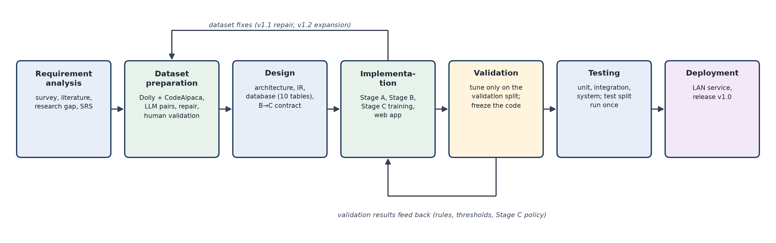
Figure 4.1: SDLC phases followed in the project, with the two feedback loops
Table 4.1: SDLC phases: activities and outputs
Phase | Main activities | Output
1. Requirement analysis | customer survey, literature review, research gap, functional and non-functional requirements (SRS) | requirements, scope, five fixed categories
2. Dataset preparation | source selection, cleaning, sampling, LLM generation of prompt pairs, automatic checks, repair, splits, human validation | PromptOpt Dataset v1.2 final (5,184 pairs)
3. Design | architecture, intermediate representation (IR), B-to-C contract, database schema (10 tables), API | design documents, diagrams
4. Implementation | Stage A, Stage B rules, Stage C data and LoRA training, renderers, FastAPI back end, React UI | working system
5. Validation | tuning on the validation split only; freeze of the code; freeze check | frozen pipeline
6. Testing | unit, integration and system tests; evaluation on the test split (once) and the benchmark | test reports, final numbers
7. Deployment | service on the laptop reachable on the local network; release v1.0 with the trained artefacts | running application

The work was planned as ten tasks over four months, from problem identification and customer connect in July to the final demo and documentation in October. Requirement and design tasks overlap in July and August; prototype development, model development (rules and LoRA) and evaluation follow from September. All ten tasks are done.
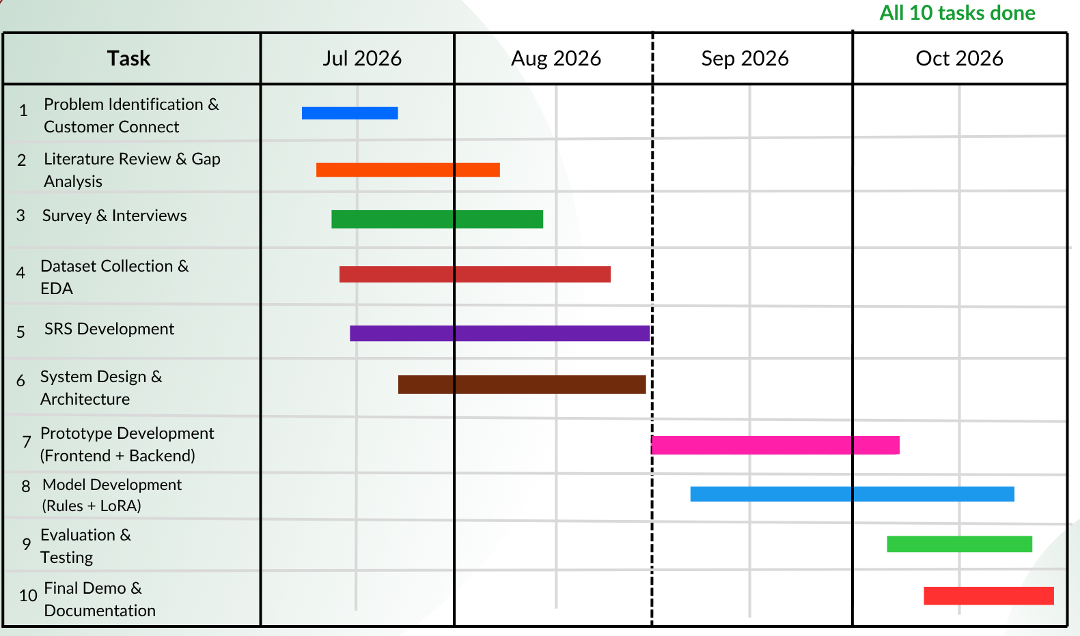
Figure 4.2: Project schedule (Gantt chart): all ten tasks done

4.2 Phase 1: Requirement analysis
The requirement phase combined three inputs: the customer survey (Section 1.2), the literature review and research gap (Sections 1.3 and 1.4), and the constraints of the environment the system had to run in. The requirements were written down in a Software Requirements Specification (SRS) before any code was written.
Functional requirements
Table 4.2: Functional requirements
ID | Requirement
FR1 | The user enters any prompt and optionally pastes the text the prompt is about.
FR2 | The user selects a target LLM (GPT, Gemini or Claude), a category (one of five, or auto-detect) and optionally an attachment type.
FR3 | The system detects missing parts of the prompt and shows them to the user.
FR4 | The system adds only what is missing, keeps the user's data verbatim and shows every change with the text before and after it.
FR5 | A user-selected category overrides the automatic one; when the system is unsure, it asks the user.
FR6 | The optimized prompt is shown in the layout of the chosen target LLM, with the number of input tokens.
FR7 | Compare sends the original and the optimized prompt to the same real model and shows both answers, tokens and time.
FR8 | A history lists, searches, shows and deletes past prompts; prompts expire after 30 days.

Non-functional requirements
Table 4.3: Non-functional requirements
ID | Requirement | How it was met
NFR1 | Self-hosted and offline optimizer | Stages A, B and C run locally; no API is needed to optimize
NFR2 | Explainable | every rule is a small pure function; every change is logged and shown
NFR3 | Fast | Stage A on CPU in milliseconds; Stage C under 3 s per prompt on the laptop GPU
NFR4 | Privacy | e-mail addresses and phone numbers are removed before storage; prompts expire after 30 days
NFR5 | Reliable storage | one database commit per request; a failure stores nothing
NFR6 | Honest measurement | tuning on the validation split only; the test split run once; the answering model always named
NFR7 | Testable | every rule and detector has unit tests; the whole suite runs without network

Constraints that shaped the design
Table 4.4: Constraints and their consequences
Constraint | Consequence in the design
One laptop GPU with 4 GB of memory (NVIDIA RTX 3050) and a CPU-only default install | Stage C uses a 0.5-billion-parameter model with LoRA; the application also runs fully without it
Only free API tiers (Groq: 200,000 tokens per day per model; Cerebras: 1,000,000) | every LLM call is recorded in a rolling 24-hour ledger; tools stop at 70% of a limit and resume the next day
Examiners must be able to follow every change | rules are small functions; every change is logged with before/after text
Results must not be tuned on the test data | split discipline, a frozen code version and a byte-level freeze check
Privacy of users' prompts | personal data removed before anything is stored; 30-day retention

4.3 Phase 2: Dataset preparation
No public dataset pairs a vague prompt with a clear version of the same request, so we built one: PromptOpt Dataset. Each row is a pair of a degraded prompt (how a rushed, non-expert user types a request) and an optimized prompt (the same task stated clearly, with an explicit output format and only helpful constraints), together with the original instruction, the context passage and the reference answer of the source row. The dataset is used to train Stage A's classifier, to build Stage C's training data, and to evaluate every stage. It is stored outside the database and outside git.
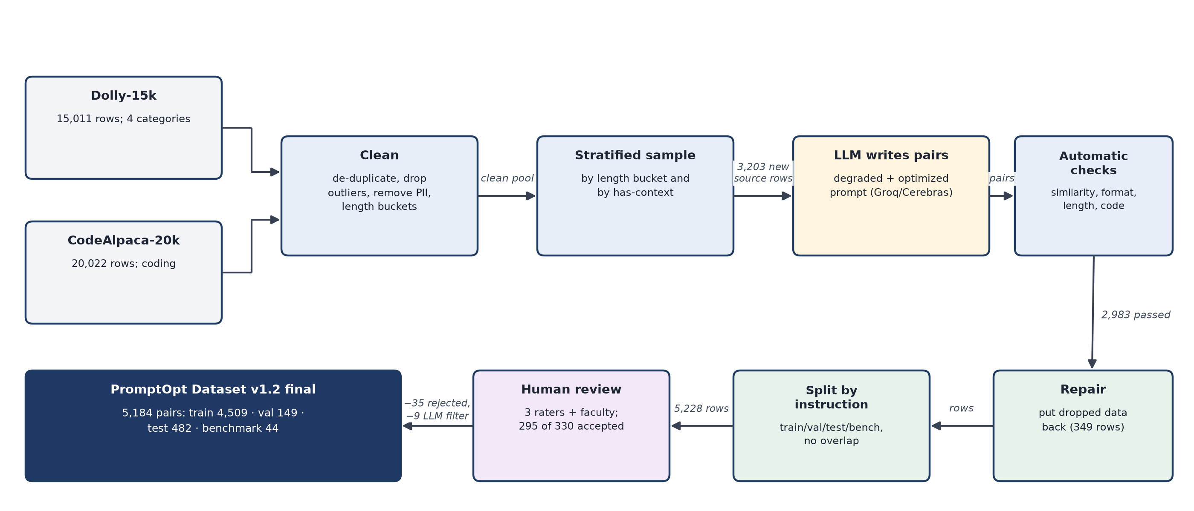
Figure 4.3: Dataset pipeline: from Dolly-15k and CodeAlpaca-20k to PromptOpt Dataset v1.2 final
4.3.1 Sources
Table 4.5: Source datasets
Source | Rows | Used for
Databricks Dolly-15k [8] | 15,011 | closed_qa (1,773), information_extraction (1,506), classification (2,136), summarization (1,188); brainstorming and creative writing as “other” examples for Stage A only
CodeAlpaca-20k [9] | 20,022 | coding

Every source row keeps a permanent identifier (its row number in the original file, e.g. dolly-4205), assigned before any filtering, so a row can always be traced back to its source even after the dataset is rebuilt.
4.3.2 Cleaning
1. Category filter: Dolly rows of the four categories with a non-empty instruction and response.
2. De-duplication on the normalised instruction and context (lower case, whitespace collapsed); the first copy is kept.
3. Removal of reference answers that are extremely long for their category (rule below).
4. Removal of e-mail addresses and phone numbers with the same patterns the application uses.
5. CodeAlpaca: de-duplication, and outputs of fewer than three words dropped (they are not code).
6. Attributes added to every row: whether it has a context, whether it states a format, word counts, and a length bucket (short, medium or long: the tertile of instruction + context length within the category).
A Dolly row ‘i’ in category ‘c’ is dropped when its reference answer is longer than the category's cut-off:
cutoff(c) = median(w) + 3 · σ(w), drop row i if w(i) > cutoff(c)
where ‘w’ is the number of words in the reference answer and σ the sample standard deviation. The median is a robust centre for right-skewed word counts, and three standard deviations is the classical outlier tail; the rule removes a few very long answers that would otherwise dominate the evaluation.
Table 4.6: Answer-length cut-offs per category
Category | Rows after de-dup | Median words | σ | Cut-off | Dropped
closed_qa | 1,759 | 17 | 48.3 | 162.0 | 36
information_extraction | 1,501 | 19 | 105.1 | 334.4 | 45
classification | 2,133 | 14 | 36.4 | 123.3 | 37
summarization | 1,186 | 54 | 154.5 | 517.5 | 10

4.3.3 Generation of prompt pairs
For each sampled source row, an LLM (gpt-oss-120b or gpt-oss-20b on Groq and Cerebras, qwen3.8-27b as a fallback) wrote both prompts in one JSON answer. The instructions to the generator describe the degraded prompt (short, casual, no format, may refer to “this”) and the optimized prompt, with requirements per category: closed_qa answers only from the text and states a length; extraction states what to extract and the output structure; classification lists the labels and ends with the items; summarization states a length and a focus; coding names the language, behaviour, inputs and outputs. A data rule requires that any data written inside the instruction (items to classify, code, numbers, the named subject) appears verbatim in both prompts. Settings: temperature 0.7 for variety, JSON output, context truncated to 1,000 characters, up to three attempts per row.
To use the free daily quotas efficiently, five rows were sent per call (one shared system prompt). On the same ten rows this reduced the cost from about 1,070 to 400 tokens per row with checks as good or better; every reply echoes the row's identifier and results are matched only by identifier, never by position.
4.3.4 Automatic quality checks
Similarity between two texts is the cosine of their all-MiniLM-L6-v2 embeddings; since the embeddings are normalised to length 1, it is their dot product:
sim(a, b) = e(a) · e(b) = cos θ, between −1 and 1
A generated pair is rejected if any of the following flags is set:
Table 4.7: Automatic quality checks on every generated pair
Flag | Condition | Why
degraded drifted | sim(original, degraded) < 0.45 | the degraded prompt must ask the same thing
not degraded | degraded equals the original (or sim > 0.98) and the original stated a format | nothing was degraded
degraded keeps a format | the format patterns match the degraded prompt | degraded prompts have no format
degraded longer | words(degraded) − words(data) > 1.25 × words(original) + 3 | degraded prompts are short
optimized drifted | sim(original, optimized) < 0.35, or no shared key word and sim < 0.50 | the optimized prompt keeps the task
coding target not code | coding row whose optimized prompt names no code word | –
optimized too long | words(optimized) − words(data) > 120 | over-specification

4.3.5 Repair of dropped data (v1 to v1.1)
The first generation often dropped the literal data of the instruction. For example, the original “Identify which instrument is string or percussion: Sheker, Taishogoto” became an optimized prompt that asked to classify “each listed instrument” without listing them, so it could not be answered. A deterministic repair finds the data in the original instruction (an item list, code on later lines, an arithmetic expression), decides whether a prompt lost it, and appends it verbatim. For non-classification prompts, data is considered lost when less than half of its content words are still present:
coverage = |content words of data also in prompt| / |content words(data)|, lost if coverage < 0.5
Optimized prompts that stopped naming the instruction's subject (“the temple” instead of “Doleshwor Mahadeva temple”) were sent back to the generator for a minimal edit, accepted only if the edit names every lost subject and adds at most 12 words. Result: 349 optimized and 20 degraded prompts repaired, 75 subjects restored, 9 rows removed because their data existed nowhere; every change is written to a log file.
4.3.6 Expansion to about 1,000 rows per category (v1.2)
To reach about 1,000 rows per category, new rows were generated only from source rows never used before. The number to sample in category ‘c’ accounts for the share of rows that survive the checks:
needed(c) = max(0, 1000 − rows(c)), to_sample(c) = min(unused(c), ceil(needed(c) / rate(c) × 1.05))
where rate(c) is the survival rate of the first generation and 1.05 adds a 5% margin. Rows were drawn by stratified sampling over length bucket and has-context, with the largest-remainder method so that every stratum keeps its share.
Table 4.8: Expansion plan per category
Category | v1.1 rows | Survival rate | Needed | Unused source rows | Sampled
closed_qa | 425 | 0.850 | 575 | 1,223 | 711
information_extraction | 449 | 0.898 | 551 | 956 | 645
classification | 474 | 0.948 | 526 | 1,596 | 583
summarization | 436 | 0.872 | 564 | 676 | 676 (all)
coding | 472 | 0.944 | 528 | 18,524 | 588
all |  |  |  |  | 3,203

Of the 3,203 generated pairs, 2,983 passed the checks and 2,972 were added after repair, giving v1.2 with 5,228 rows.
4.3.7 Splits
Rows are split by original instruction, so the same instruction (or a paraphrase of it) never appears in two splits. Each category has 100 test rows, 30 validation rows and 10 benchmark rows; the rest is training data. The extra test rows of v1.2 came only from new rows that no tuning had seen.
Table 4.9: Purpose of each split
Split | Used for | Who may look at it
train | Stage A's index and classifier head; Stage C's training data | every phase
validation | every tuning decision (thresholds, rule wording, Stage C policy, judge wording) | development
test | the final offline numbers of Stage A, B and C and the full token evaluation | run once, after the code was frozen
benchmark | the final run with a real model and a blind judge | run once

4.3.8 Human validation
The three team members and the faculty guide rated rows with five yes/no questions. A row is accepted only if all five answers are yes.
1. Q1: the degraded prompt asks for the same task as the original instruction.
2. Q2: the degraded prompt is a realistic, vaguer version a real user might type.
3. Q3: the optimized prompt keeps the task and intent, without adding facts, answers or unwanted requirements, and without dropping data.
4. Q4: the optimized prompt is clearer and better specified than the degraded one.
5. Q5: the category label is correct.
Table 4.10: Rating design
Who | Rows | Purpose
all three team members | 90 overlap rows (18 per category) | agreement between raters
each team member alone | 60 extra rows (test and benchmark splits and borderline rows first) | filtering bad pairs
each team member alone | 20 rows of the new v1.2 generation | human check of the new rows
faculty guide | 20 of the overlap rows | independent check (never decides a row)

Overlap rows are decided by majority vote per question (2 of 3); other rows by their single rater. In total 330 distinct rows were rated: 295 accepted and 35 rejected. The faculty guide accepted 19 of 20 rows.
Agreement on the overlap rows is reported with Fleiss' kappa [14], Gwet's AC1 [12] and the raw agreement. With ‘n’ = 3 raters and n(i,j) the number of raters giving answer j to item i, the agreement on item i and the mean over the I items are
P(i) = [Σ n(i,j)² − n] / [n(n − 1)], P̄ = (1/I) Σ P(i)
Kappa compares P̄ with the agreement expected by chance from the answer frequencies p(j), while AC1 uses a chance term that stays small when one answer dominates:
κ = (P̄ − Pₑ) / (1 − Pₑ), Pₑ = Σ p(j)²; AC1 = (P̄ − Pₑʹ) / (1 − Pₑʹ), Pₑʹ = 2π(1 − π)
Worked example for Q1: 81 items were answered yes by all three raters, 8 split 2-1 and 1 split 1-2, with 260 yes answers out of 270. Then P̄ = (81 + 9/3)/90 = 0.933, p(yes) = 0.963, Pₑ = 0.963² + 0.037² = 0.929, so κ = (0.933 − 0.929)/(1 − 0.929) = 0.065, while AC1 = (0.933 − 0.071)/(1 − 0.071) = 0.928. Because almost every answer is yes, the chance term of kappa approaches 1 and a handful of disagreements decides its value; this is the known kappa paradox [13]. We therefore report kappa and AC1 together.
Table 4.11: Agreement of the three team raters on the 90 overlap rows
Question | % yes | All three agree | Fleiss' κ | Gwet's AC1
Q1 degraded asks the same task | 96.3% | 90.0% | 0.065 | 0.928
Q2 degraded is realistic | 96.3% | 88.9% | −0.038 | 0.920
Q3 optimized keeps the intent | 96.3% | 90.0% | 0.065 | 0.928
Q4 optimized is better | 98.1% | 94.4% | −0.019 | 0.962
Q5 category is correct | 98.1% | 94.4% | −0.019 | 0.962
accept (all five yes) | 86.3% | 67.8% | 0.092 | 0.719

After the human review, an LLM-assisted filter re-read the 90 overlap rows as a strict reviewer, without seeing the human answers. Only rows where the optimized prompt adds facts, leaks the answer, sets an impossible constraint or changes the task were removed: 9 rows. The filter never overrides a human answer and is not part of any agreement statistic.
4.3.9 Final dataset
PromptOpt Dataset v1.2 final = 5,228 rows − 35 rows rejected by the raters − 9 rows removed by the filter = 5,184 rows.
Table 4.12: PromptOpt Dataset v1.2 final: rows per category and split
Category | Train | Validation | Test | Benchmark | Total
closed_qa | 951 | 29 | 99 | 10 | 1,089
information_extraction | 867 | 30 | 93 | 10 | 1,000
classification | 906 | 30 | 98 | 8 | 1,042
summarization | 920 | 30 | 94 | 6 | 1,050
coding | 865 | 30 | 98 | 10 | 1,003
all | 4,509 | 149 | 482 | 44 | 5,184

Known limitations of the dataset: the optimized prompts are written by an LLM and only 330 rows were rated by people; Dolly's category labels are noisy in the question / extraction / summary group; and some CodeAlpaca reference answers are wrong (these are listed and excluded from the evaluation summaries).

4.4 Phase 3: System design
The design starts from the user's request and follows it through three stages that each do one job. Figure 4.4 shows the running example as it passes through the whole system; the rest of this chapter explains each block.
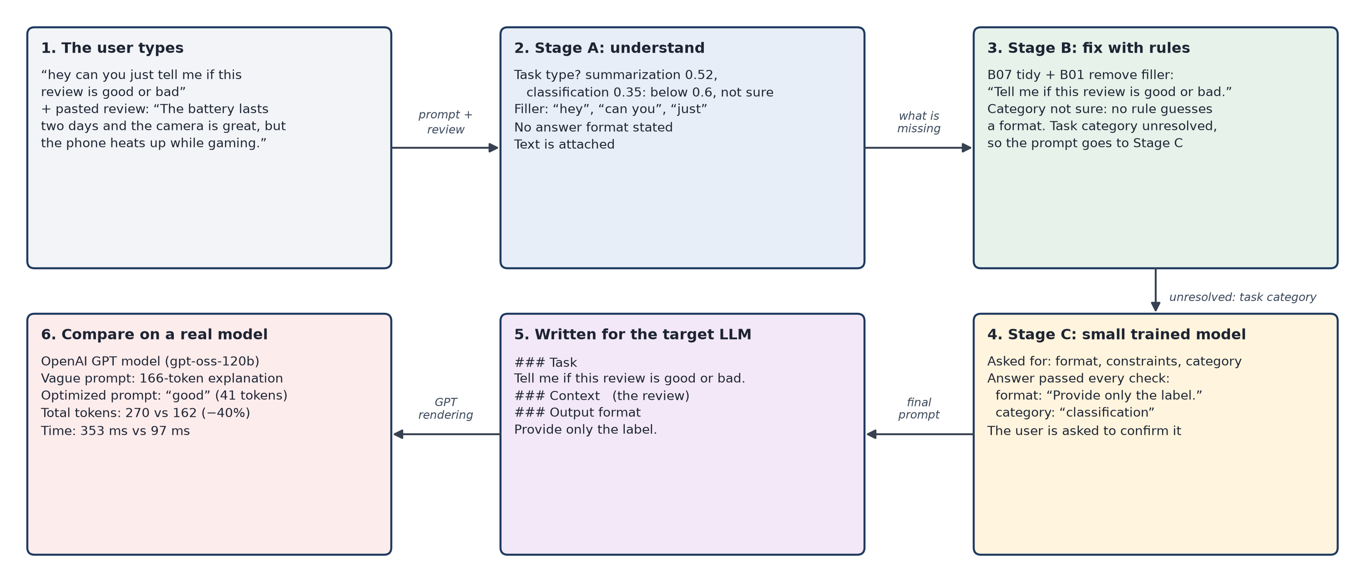
Figure 4.4: The review example through every stage of PromptOpt
Stage A reads the prompt and writes down what is missing; it never changes the prompt. Stage B turns the prompt into a structured intermediate representation (IR) and applies deterministic rules to it. Stage C, a small fine-tuned model, is called only when Stage B leaves the task category or an ambiguous reference unresolved. The final IR is written out by a renderer for the chosen LLM, and Compare can run the original and the optimized prompt on the same real model.
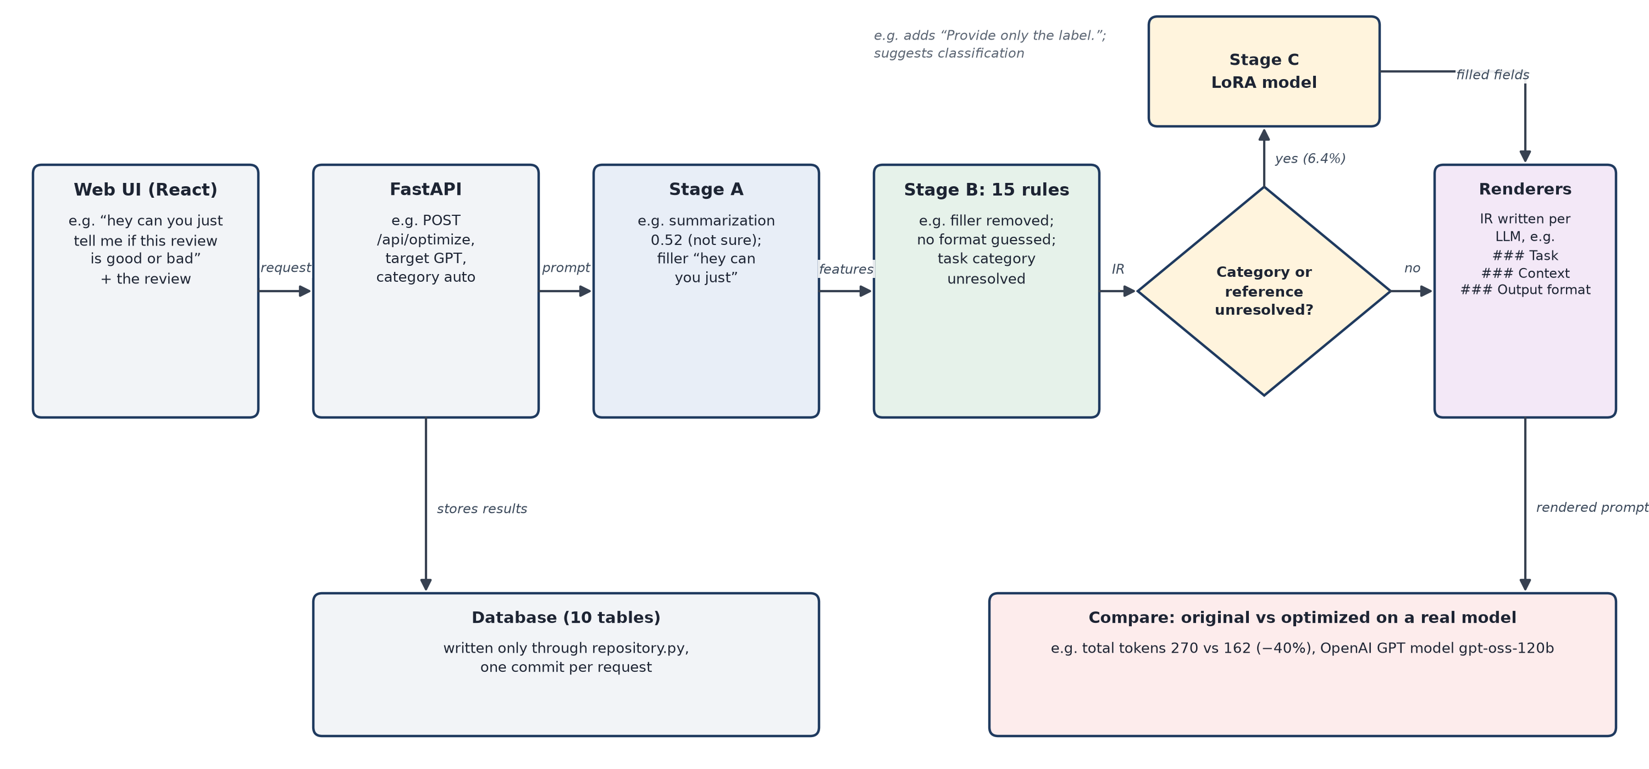
Figure 4.5: System architecture, with the review example under each component
4.4.1 The intermediate representation (IR)
All stages work on one model-agnostic data structure instead of editing a string. Rules return a new IR instead of changing the old one, so every change is small, testable and can be logged.
Table 4.13: Fields of the intermediate representation
Field | Meaning | Review example after Stage C
task | what to do, in the user's words, cleaned | Tell me if this review is good or bad.
context / context_ref | data moved out of the prompt; where the material is | the pasted review (separate)
constraints | length, programming language, grounding | (none)
requirements | task-specific rules: allowed labels, how to use an attachment | (none)
output_format | how to lay out the answer | Provide only the label.
attachment | attachment type and optional file name | none
category / category_source | category used and where it came from | unresolved: user asked to confirm “classification”
target_llm | the user's target | GPT
unresolved | what Stage B could not fix | task category (waiting for the user)

4.4.2 Design decisions
Table 4.14: Main design decisions and their basis
Decision | Basis
Rules first, model last | rules are cheap, explainable and testable; a model is used only where rules cannot decide (6.4% of test prompts)
Category rules only above a confidence of 0.6 | a wrong format is worse than none; on the validation split Stage A was right 77-96% of the time above 0.6 and only 47-59% between 0.4 and 0.6
Stage C fills only requested fields | everything else is locked, so the model cannot damage what the rules already fixed
Stage C's category is only a suggestion | on validation prompts routed for the category, Stage A was right 40% and Stage C 30% of the time: neither is reliable, so the user decides
One IR, several renderers | the content is decided once; only the layout differs per model, and tests prove no field is lost
One repository module and one commit per request | a failure half-way stores nothing; privacy rules are applied in one place

4.5 Phase 4: Implementation of Stage A (feature detection)
Stage A turns the raw prompt into a PromptFeatures object. It combines a learned classifier for the task category with rule-based detectors for everything else.
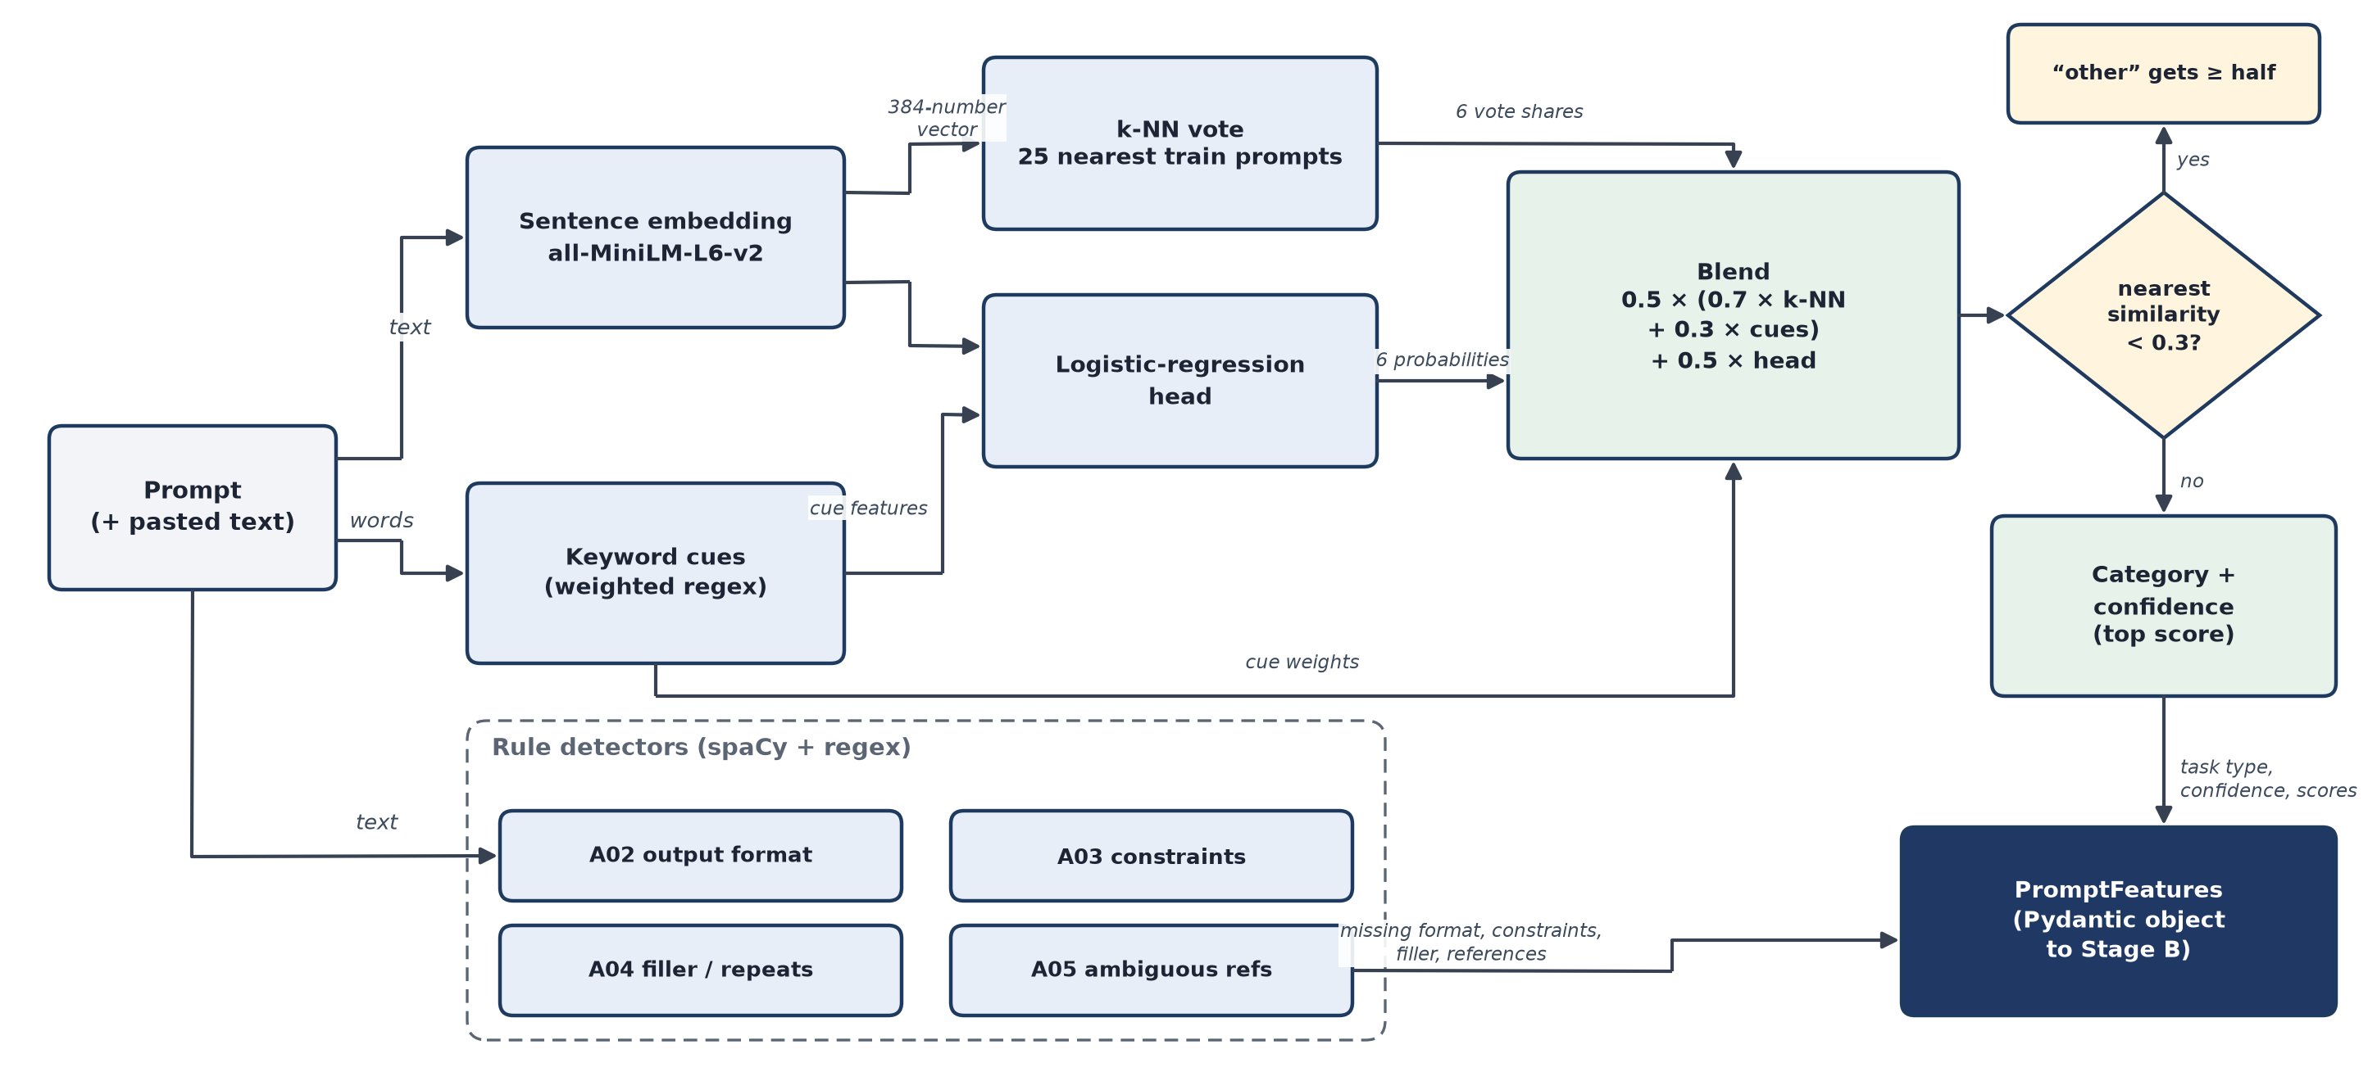
Figure 4.6: Stage A: every arrow is labelled with what flows along it
Table 4.15: Output of Stage A for the review example
Field | Meaning | Review example
task_type, confidence | the category with the highest score, and that score | summarization, 0.52
category_scores | the score of every category (they sum to 1) | summarization 0.52, classification 0.35, other 0.09, extraction 0.03, coding 0.01, closed_qa 0.00
has_format_spec (A02) | an output format is stated | no
missing_constraints (A03) | constraints relevant to the category that are not stated | length, audience, tone
redundant_phrases (A04) | filler and repeated text | “hey”, “can you”, “just”
ambiguous_refs (A05) | references to material that is not there | none (the review is pasted)
has_context | material to work on was pasted or embedded | yes

4.5.1 Sentence embedding and the labelled index
The prompt is encoded by all-MiniLM-L6-v2, a six-layer transformer that maps a sentence to a vector of 384 numbers, normalised to length 1. The model is small (about 90 MB) and fast on a CPU: 7.9 ms per prompt on average. The labelled index is built once from the training split only: for each of the 4,509 training rows, its degraded prompt and its original instruction, labelled with the row's category (9,018 texts), plus 500 out-of-scope instructions (Dolly brainstorming and creative writing) labelled “other”. Validation and test prompts never enter the index.
4.5.2 k-nearest-neighbour vote
For the query vector q, the similarity to every index vector e(i) is s(i) = e(i) · q. The k = 25 most similar examples vote for their category, each with a weight that falls quickly with its distance from the nearest one (a softmax with temperature τ = 0.05):
w(i) = exp((s(i) − sₘₐₓ) / τ), knn(c) = Σ w(i) over neighbours of category c / Σ w(i) over all 25
Table 4.16: How a neighbour's weight falls with its distance (τ = 0.05)
sₘₐₓ − s(i) | 0.01 | 0.02 | 0.05 | 0.10 | 0.20
weight w(i) | 0.819 | 0.670 | 0.368 | 0.135 | 0.018

4.5.3 Keyword cues
Hand-written regular expressions with weights add explicit evidence. A cue counts once if it matches anywhere in the prompt; the raw score of a category is the sum of its matching weights, normalised over the categories.
Table 4.17: Keyword cues per category (weights in brackets)
Category | Cues
coding | programming terms such as function, script, array, regex (1.0); a language name such as Python, Java (1.5); “write/create/build … function/program/script/query” (2.0)
summarization | summary, summarize, TL;DR, sum up, recap, gist, condense (3.0); “main/key points” (1.5)
classification | classify, categorize, label, sort into, sentiment (3.0); “which of these is” (1.5); “tell me which” (2.0); “X or Y:” (1.0)
information_extraction | extract (3.0); “list/pull out/find … names/dates/places” (2.0); “mentioned in” (1.5); “list all” (1.5)
closed_qa | starts with a question word (1.5); ends with “?” (1.0); “according to the text” (1.5)

4.5.4 Logistic-regression head
A multinomial logistic regression is trained on the same index: its input is the 384-number embedding plus six keyword features (five normalised cue scores and whether the prompt ends with a question mark), and it outputs a probability for each of the six categories:
p(c | x) = exp(w(c) · x + b(c)) / Σ exp(w(cʹ) · x + b(cʹ)), x has 390 numbers
It is trained with L2 regularisation (C = 4.0, chosen by 5-fold cross-validation on the training split) and balanced class weights, so that the 500 “other” examples count as much in total as about 1,800 examples of each task category.
4.5.5 Confidence calculation
The confidence of Stage A is the final score of the winning category. The final score of every category combines the three signals:
blend(c) = 0.7 · knn(c) + 0.3 · kw(c) (if any keyword cue fired; otherwise blend(c) = knn(c))
score(c) = 0.5 · blend(c) + 0.5 · p(c | x), confidence = max over c of score(c)
If even the nearest example is not similar (sₘₐₓ < 0.3), nothing in the data looks like the prompt: every score is multiplied by keep = sₘₐₓ / 0.6 and “other” receives the rest, so “other” always wins. The weights (0.7 / 0.3 and 0.5 / 0.5), k = 25, τ = 0.05 and the 0.3 threshold were tuned on the validation split. In 5-fold cross-validation on the training split the blend reached 72.9% accuracy, against 69.3% for the k-NN vote alone and 70.4% for the head alone.
Worked example. For the review prompt no keyword cue fires (“good or bad” is not followed by a colon or question mark), so blend(c) = knn(c). The table shows the calculation; Figure 4.7 shows it as a chart.
Table 4.18: Confidence calculation for the review example
Category | k-NN vote | Head | 0.5 · k-NN + 0.5 · head
closed_qa | 0.000 | 0.001 | 0.001
information_extraction | 0.050 | 0.003 | 0.026
classification | 0.690 | 0.008 | 0.349
summarization | 0.181 | 0.858 | 0.520
coding | 0.019 | 0.010 | 0.014
other | 0.060 | 0.120 | 0.090

The similar training prompts mostly vote for classification (0.69), while the head, which learned that “tell me … this review” often asks for a summary, prefers summarization (0.86). The blend picks summarization with a confidence of 0.52. Because 0.52 is below the 0.6 gate, Stage B will not trust this category, which is the right decision here: the prompt is actually a classification request. The nearest example has a similarity of 0.53, above 0.3, so the “other” backstop does not apply.
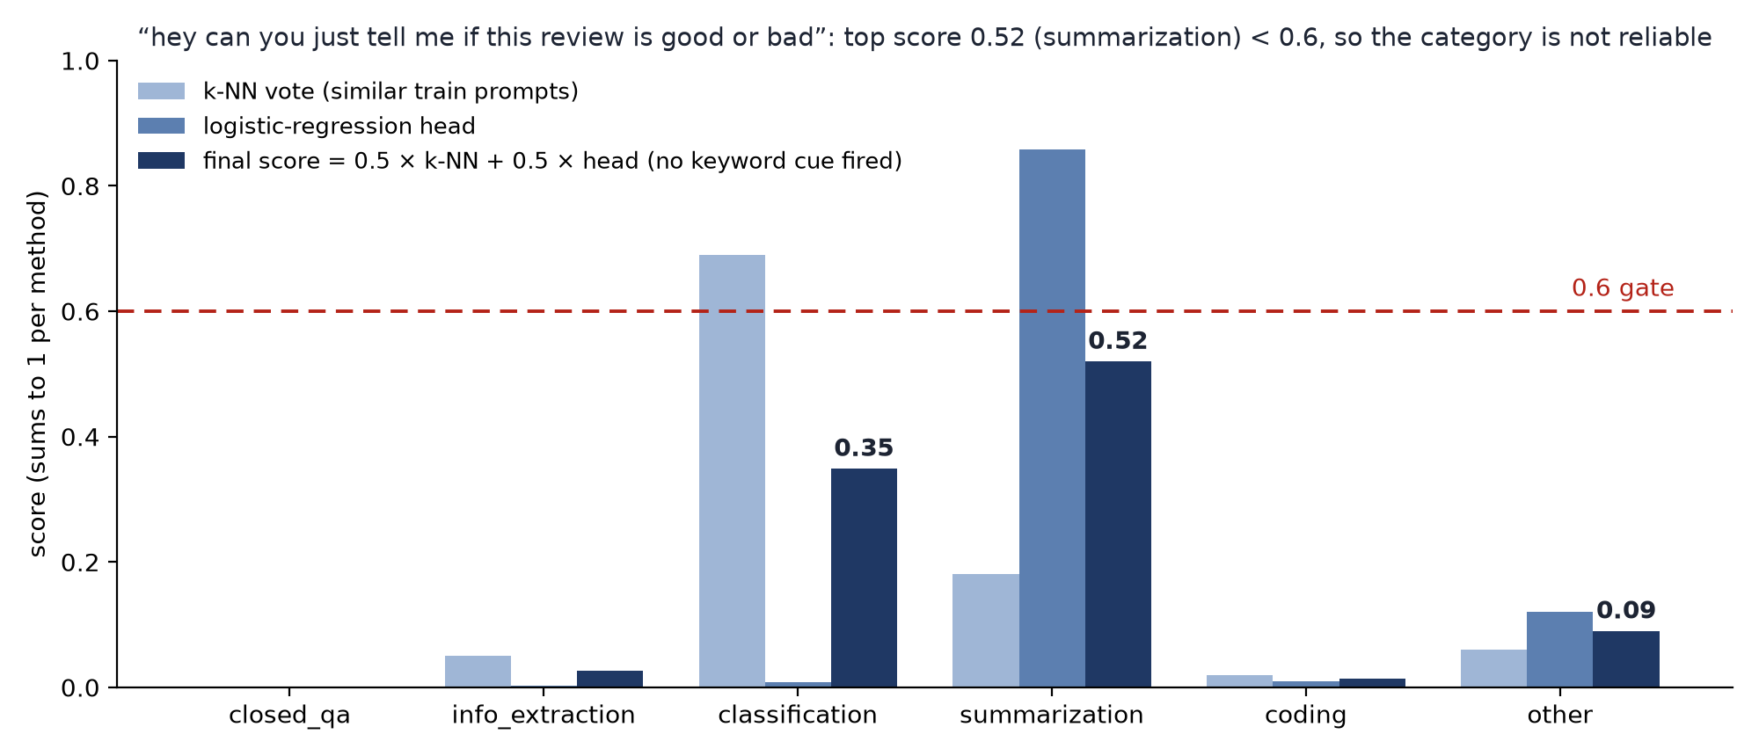
Figure 4.7: Stage A scores for the review example: k-NN vote, head and final score against the 0.6 gate
The confidence is a blended score, not a calibrated probability, which is why the 0.6 gate was chosen empirically on the validation split rather than derived from it.
4.5.6 Rule-based detectors (A02-A05)
Table 4.19: Rule-based detectors of Stage A
Detector | What it finds | Examples of patterns
A02 output format (26 patterns) | an explicitly stated output format | JSON, a table, a bulleted list, “in 3 sentences”, “only the label”, “yes or no”
A03 constraints | length, tone, audience, programming language | “brief”, “formal tone”, “explain to a beginner”, “in Python”
A04 redundancy (17 patterns) | filler and repeated sentences or words | “hey”, “can you”, “just”, “the the”
A05 ambiguous references | references to material that is not there (only when no text is given) | “summarize this”, “the above”, “fix it”

Which constraints are worth asking for depends on the category: a length for closed_qa; length, audience and tone for summarization; the programming language for coding; none for extraction and classification, whose output size is fixed by the data. For the review example (detected as summarization) A03 therefore reports length, audience and tone as missing; Stage B fills none of them because the category is below the gate. Each detector returns the exact words it matched, so the user interface can highlight them.

4.6 Phase 4: Implementation of Stage B (rule-based optimization)
Stage B fixes what fixed rules can fix. It creates the IR from the prompt, runs fifteen rules over it in a fixed order, logs every change with the text before and after it, and records what it could not fix.
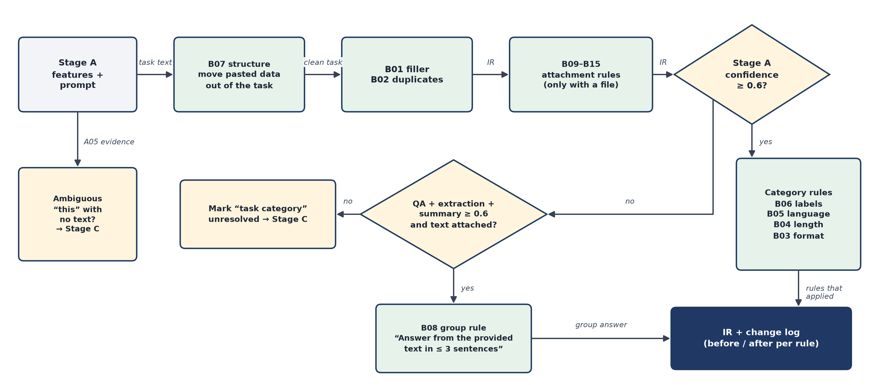
Figure 4.8: Stage B: rule order, the 0.6 confidence gate and the group fallback
4.6.1 Rule order
The rules always run in this order: B07 (structure) first, then B01 (filler) and B02 (duplicates), the attachment rules B09-B15, the group rule B08, and finally the category rules B06 (labels), B05 (language), B04 (length) and B03 (format). B07 runs first so that the user's data is moved out of the task before any other rule edits text; B03 runs last because it must know whether B08 already handled the prompt.
Table 4.20: Stage B rule catalogue
Code | Rule | Condition | Action | Example
B07 | Structure | always; data moves only if clearly data | moves pasted data or code into its own block; capital letter, full stop | “classify these as fruit or vegetable: apple, carrot” → items in a separate block
B01 | Remove filler | a filler phrase from A04 | deletes it unless quoted or part of the content | “hey can you just tell me …” → “Tell me …”
B02 | Remove duplicates | repeated sentence or doubled word | keeps one copy | “sort the the list” → “Sort the list”
B09-B15 | Attachment | an attachment of that type is given | adds how to use it and “say so instead of guessing” | PDF: “Cite the page or section numbers …”
B08 | Group fallback | confidence < 0.6, text attached, QA + extraction + summary ≥ 0.6 | adds what is missing of “Answer from the provided text in at most three sentences.” | “what are the big inventions from berkeley in that text?”
B06 | Labels | classification, reliable, no labels stated | states the allowed labels | “Use only these labels: “string”, “percussion”.”
B05 | Language | coding, reliable, no language | “Use Python.” or “Keep the language of the given code.” | “write code to get all permutations of a string”
B04 | Length | closed_qa or summarization, reliable, no length | “Answer in at most two sentences.” / “Keep it under 100 words.” | “summarize this article” + text
B03 | Output format | no format stated; reliable; no group | adds the category's default format | coding: “Return only the code, in a single code block.”

Table 4.21: Default output format added by B03 per category
Category | Format added
closed_qa | Start with the direct answer.
information_extraction | List each extracted item on its own line; if the text does not contain it, reply “Not found”.
classification | For each item, output “item: label” on its own line (or “Output only the label.” for a single item).
summarization | Use bullet points.
coding | Return only the code, in a single code block.

4.6.2 The 0.6 gate and the group fallback B08
Rules B03-B06 add category-specific content (a format, a length, a language, labels). A classification layout on a summarization request would mislead the model, so these rules act only when the category is reliable: Stage A's confidence is at least 0.6, or the user chose the category. Below the gate, Stage A often cannot tell closed_qa, information_extraction and summarization apart, but it is much surer that the prompt is one of the three. B08 therefore acts at group level when
max score < 0.6 and text attached and score(closed_qa) + score(extraction) + score(summarization) ≥ 0.6
and adds only what is missing of “Answer from the provided text in at most three sentences.” When it was introduced, it reduced the share of validation prompts sent to Stage C from 52.0% to 11.3% without any new wrong-category additions. On the test split it fires on 149 of 482 prompts (30.9%).
4.6.3 Routing to Stage C
Table 4.22: Items Stage B may leave unresolved
Unresolved item | Set by | Sent to Stage C?
task category | category “other” or confidence < 0.6, not cleared by B08 | yes
ambiguous reference | A05 found a reference and no attachment explains it | yes
output format | B03, when the category is not reliable | no (shown to the user)
label set | B06, when no labels could be found | no (shown to the user)

Stage B also stores a confidence for the user interface: the Stage A confidence minus 0.2 for every unresolved item (0.3 as the base for “other”), clipped to [0, 1]. It is not used for routing.
4.6.4 The review example in Stage B
Table 4.23: Stage B steps for the review example
Step | Text before | Text after
B07 structure | hey can you just tell me if this review is good or bad | Hey can you just tell me if this review is good or bad.
B01 filler | Hey can you just tell me if this review is good or bad. | Tell me if this review is good or bad.
B08 | not applied: the group score (0.00 + 0.03 + 0.52 = 0.55) is below 0.6 | –
B03-B06 | not applied: confidence 0.52 < 0.6 | –

Stage B leaves two items unresolved, the task category and the output format. The task category routes the prompt to Stage C.

4.7 Phase 4: Implementation of Stage C (LoRA fallback) and its training
Stage C is Qwen2.5-0.5B-Instruct with a LoRA adapter that we trained. It fills only the IR fields that Stage B left unresolved; every other field is locked. Its answer is checked by the same detectors as the rest of the pipeline, and if the check fails, the prompt keeps Stage B's result.
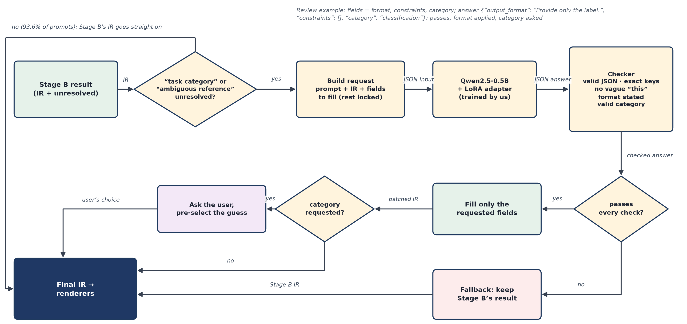
Figure 4.9: Stage C in block form: routing, request, model, checker, fallback and the user's confirmation
4.7.1 When Stage C runs and what it may fill
Table 4.24: Fields Stage C is asked to fill
Unresolved item | Fields requested | Reason
task category | output_format, constraints, category | Stage B added nothing category-specific, so format and constraints are missing too
ambiguous reference | task | the task must be rewritten to be self-contained

The model receives a short system prompt and the request as JSON: the user's prompt, Stage A's category and confidence, whether text is attached, the attachment type, Stage B's IR with the unresolved fields set to null, and the list of fields to fill. The pasted text itself is not sent: Stage C writes the instruction, not the answer, and this keeps the input short. For the review example the request asks for output_format, constraints and category, and the model answered:
{"output_format": "Provide only the label.", "constraints": [], "category": "classification"}

4.7.2 Base model and LoRA
Table 4.25: Base model Qwen2.5-0.5B-Instruct [10]
Property | Value
parameters | about 494 million
transformer layers | 24
hidden size | 896
attention | 14 query heads of 64 dimensions; 2 key/value heads (grouped-query attention)
feed-forward | SwiGLU, 896 → 4,864 → 896
vocabulary | 151,936 tokens
weights | bfloat16

LoRA [7] freezes every base weight W₀ and learns a low-rank update next to it:
h = W₀x + (α / r) · B A x, A: r × d_in matrix, B: d_out × r matrix
A is initialised randomly and B with zeros, so at the start the model equals the base model. We used rank r = 16, α = 32 (scale 2) and dropout 0.05 on all attention and feed-forward projections. A LoRA pair on a d_in → d_out projection has r(d_in + d_out) parameters:
Table 4.26: Trainable LoRA parameters per transformer layer (r = 16)
Projection | Shape | r (d_in + d_out)
q_proj | 896 → 896 | 28,672
k_proj | 896 → 128 | 16,384
v_proj | 896 → 128 | 16,384
o_proj | 896 → 896 | 28,672
gate_proj | 896 → 4,864 | 92,160
up_proj | 896 → 4,864 | 92,160
down_proj | 4,864 → 896 | 92,160
per layer |  | 366,592

Over 24 layers this gives 8,798,208 trainable parameters, 1.78% of the model, stored in a 34 MB file. At inference the update is merged into the weights (W = W₀ + (α/r)BA), so Stage C costs the same as the base model.
4.7.3 Training data
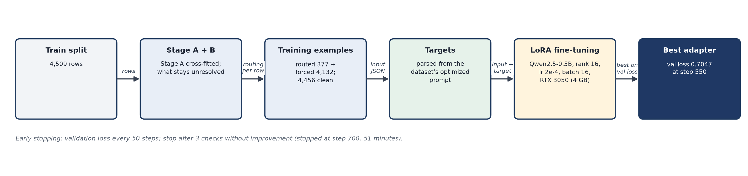
Figure 4.10: Stage C training pipeline
One training example is built per dataset row. Stage A is run on the training rows with cross-fitting: the rows are split into five folds by instruction, and each fold is classified by an index built without it. Otherwise every training prompt would find itself as its own nearest neighbour and Stage A would look unrealistically accurate (cross-fitted accuracy on train: 73.9%, close to 74.7% on test). Stage B is then run for real, and the target is parsed out of the dataset's optimized prompt.
Table 4.27: Stage C examples per split
Kind | Rule | Train | Validation | Test
routed | Stage B really sends the row to Stage C: its natural fields | 377 | 10 | 31
forced | every other row: a random non-empty subset of {task, output_format, constraints} | 4,132 | 139 | 451
forced_all | validation and test only: every row once more with all three fields | – | 149 | 482
examples |  | 4,509 | 298 | 964

Only 8.4% of training rows are routed naturally, too few to learn from, so forced examples teach the model to fill any requested field while respecting the locked ones. Each field is kept independently with probability 0.5 (an empty draw is replaced by one field), so an example asks for one field with probability 1/2, two with 3/8 and three with 1/8. 53 examples whose target was not cleanly separable were left out, giving 4,456 training examples.
The targets come from a parser that splits the dataset's optimized prompt into IR fields, reusing Stage A's detectors so that every sentence goes to exactly one field: the first sentence is the task; later sentences go to output_format if they state a structure, to constraints if they state a length, tone, audience, language or grounding, and otherwise stay in the task. The task was separated in 100% of rows, the output format in 94.0% and constraints in 75.0%; a hand check of 20 random parses found 17 fully correct.
4.7.4 Training procedure
The model sees the system prompt and the request, and learns to produce the JSON answer. The loss is the mean cross-entropy over the answer tokens only (the prompt tokens are masked), because the model must learn to write the JSON, not to repeat its input:
L(θ) = − (1 / |T|) Σ log pθ(x(t) | x(<t)), t over the answer tokens T
Table 4.28: Training settings
Setting | Value | Reason
effective batch | 16 examples per step (micro-batch 1 × 16 accumulation) | fits the 4 GB GPU with the same effective batch
optimizer | AdamW [18], learning rate 2 × 10⁻⁴, weight decay 0 | usual LoRA learning rate
schedule | linear warm-up for 25 steps, then linear decay to 0 | avoids large early updates
epochs | at most 3, with early stopping | stop when validation loss stops improving
gradient clipping | L2 norm ≤ 1.0 | stability
precision and memory | bf16 autocast, LoRA weights in fp32, gradient checkpointing | fits 4 GB
sequence length | ≤ 512 tokens (longest example 446) | no example dropped
seed | 13 | reproducibility

Every 50 steps the validation loss (token-weighted mean over all validation examples) is computed; the adapter is saved when it improves, and training stops after three evaluations without improvement.
Table 4.29: Validation loss during training
Step | 50 | 100 | 200 | 300 | 400 | 500 | 550 | 600 | 700
val loss | 0.852 | 0.789 | 0.745 | 0.726 | 0.716 | 0.706 | 0.705 | 0.744 | 0.761

The best validation loss, 0.7047, was reached at step 550 (a perplexity of e^0.7047 = 2.02 per answer token). After the third epoch began, the validation loss rose for three evaluations while training continued, the usual sign of over-fitting, and training stopped at step 700 after 51 minutes on the RTX 3050 laptop GPU.
4.7.5 Checker, fallback and category policy
Stage C answers with greedy decoding (at most 192 new tokens). The answer is accepted only if all checks pass:
1. it parses as one JSON object;
2. its keys are exactly the requested keys;
3. a rewritten task has at least two words and A05 finds no ambiguous reference in it;
4. an output format, if present, states a format according to A02;
5. constraints are a list of non-empty strings;
6. a category is one of the five categories.
Any failure keeps Stage B's result. For example, for “hey can you just summarize this article for me” without the article, Stage C answered “Summarize the provided text …”, which still refers to a text that is not there, so it was rejected. When the category was requested, Stage C's category is never applied on its own: the user interface asks the user and pre-selects Stage C's suggestion, while the format and constraints are applied. For the review example all checks passed, “Provide only the label.” was applied, and the user was asked to confirm “classification”.
Without fine-tuning, the base model passed these checks in only 5.0% of test examples (only 51.2% of its answers had exactly the requested keys); with the LoRA adapter, 98.2% passed.

4.8 Phase 4: Rendering, token counting and the web application
The final IR is written out for the chosen model family with the same four sections everywhere (task, context, constraints, output format), laid out the way each provider's prompting guide recommends.
Table 4.30: Layouts per target LLM
Target | Layout | Review example (output format section)
Claude | XML tags; the context first, then task, constraints, output format | <output_format> Provide only the label. </output_format>
GPT | Markdown sections ### Task / ### Context / ### Constraints / ### Output format | ### Output format Provide only the label.
Gemini | plain labels, the instruction first and the context last | Output format: Provide only the label.

Data blocks are wrapped in a code fence one backtick longer than any backtick run inside the data, so pasted code cannot close the block early. Tests parse every rendering back and check that no field is lost. Input tokens are counted exactly for GPT with the tiktoken o200k_base tokenizer; for Claude and Gemini, whose tokenizers are not available offline, they are estimated as characters divided by 4 and labelled as approximate (on the test renderings this estimate is within about 5-8% of the GPT count on average). For the review example the GPT rendering has 50 input tokens against 33 for the user's prompt alone.
The web application is a FastAPI back end serving a React and TypeScript front end with two views. The simple app at / is for everyday users and uses no pipeline terms: Improve prompt (type the prompt, optionally paste the text it is about, pick ChatGPT, Gemini or Claude, copy the improved prompt), Token usage analysis (both prompts sent to the same real model) and History (30 days); Section 7.1.1 shows it. The developer view at /dev is for monitoring: Optimize shows each stage in turn (Section 7.1.2); Compare, History, Test suite, Results, How it works, Image mode and Status complete it. All database access goes through one repository module (Chapter 5).

4.9 Phase 5: Validation
Every tuning decision was taken on the validation split (149 rows), never on the test split. The table below lists the main decisions and the validation evidence behind them.
Table 4.31: Decisions taken on the validation split
Decision | Validation evidence
category gate at 0.6 | Stage A right 77-96% of the time at confidence ≥ 0.6, 47-59% between 0.4 and 0.6
group fallback B08 | prompts routed to Stage C 52.0% → 11.3%, no new wrong-category additions
Stage A settings (k, τ, weights, threshold) | tuned on validation accuracy (75.8% on validation)
Stage C only for routed prompts | forcing every prompt through Stage C lowered task intent (0.855 → 0.773 on validation)
Stage C category only as a suggestion | on routed validation prompts Stage A was right 40% and Stage C 30% of the time
single-label classification format | an earlier rule wrongly picked it for 8 validation prompts with several items; made stricter

After the last decision, the code was frozen with a git tag. From then on no Stage A or Stage B rule, threshold or judge setting was changed; bugs found later were reported, not fixed. Features added afterwards had to prove that they change nothing on the frozen pipeline: a freeze check runs Stage A and Stage B of the frozen and the current code on all 482 test prompts, writes every feature, IR, text, change and routing decision as JSON, and compares the SHA-256 hashes of the two dumps. A single changed character anywhere changes the hash; the two hashes are identical.

4.10 Phase 6: Testing and evaluation method
Testing has two parts: functional tests of the software (unit, integration and system tests, Chapter 6) and the evaluation of the optimizer's effect on real answers (Chapter 7). All answers in the evaluation come from OpenAI's GPT model gpt-oss-120b on the Groq or Cerebras free tier, at temperature 0, with at most 2,048 output tokens and reasoning effort “low”. Input and output token counts are the provider's own counts; output tokens include the model's hidden reasoning tokens, as billed. Claude and Gemini were not run, so all output-token numbers in this report are for the GPT model only.
Token reduction
For a prompt ‘i’ with b(i) tokens before (vague prompt) and a(i) tokens after (optimized prompt), for input, output or total tokens:
r(i) = 100 · (b(i) − a(i)) / b(i), mean reduction = (1/n) Σ r(i)
aggregate reduction R = 100 · (Σ b(i) − Σ a(i)) / Σ b(i)
The mean of the per-prompt reductions (39.2% for total tokens) counts every prompt equally and is the headline; the aggregate reduction (55.4%) weights prompts by their size and is larger, because prompts with long unrequested answers shrink most.
Confidence interval and significance
The 95% confidence interval of the mean reduction is a percentile bootstrap [19] with 10,000 resamples of the per-prompt reductions. Significance of the paired token counts is tested with the Wilcoxon signed-rank test [20], which uses only the signs and ranks of the paired differences and so suits heavy-tailed token counts. For small paired yes/no outcomes (correct or not) the exact McNemar test is used on the discordant pairs:
p = min(1, 2 · Σ from i = 0 to k of C(n, i) · 2^(−n)), n = wins + losses, k = min(wins, losses)
Quality, task success and correctness
• Quality: a blind judge from a different model family (qwen3.8-27b) scores each answer from 0 to 10 against the reference answer, without knowing which prompt produced it.
• Task success: checked automatically where possible (classification: every item gets the reference label; coding: a code block that parses; closed_qa: the judge's yes/no).
• Correctness suite: 50 new hand-written cases, 10 per category, each with one verifiable gold answer, checked deterministically or with hidden unit tests run in a sandbox.
Cost
The project ran on free tiers, so the money spent was zero. For a paid model with input price p(in) and output price p(out) per million tokens, cost = (T(in) · p(in) + T(out) · p(out)) / 10⁶. Because the saving comes from output tokens, which usually cost several times more than input tokens, the cost saving is larger than the token saving: with output priced 4 times input, the test-split means give a saving of 69.5%.

4.11 Phase 7: Deployment
The application runs on the development laptop as a user service (uvicorn app.api:app on port 8080), reachable on the local network with an optional password; Stage C runs on the laptop GPU and the application falls back to Stages A and B when the GPU or the adapter is not available. The trained Stage C adapter, the Stage A category index and the data manifest are published as a GitHub release (v1.0), so a fresh clone can be run by following the README. SQLite is used in development and PostgreSQL is supported for deployment by changing one setting.

4.12 Technology stack
Table 4.32: Technology stack
Layer | Technologies
Front end | React 19 + TypeScript, Vite, Tailwind CSS, Radix UI, Recharts; Playwright for end-to-end tests
Back end | Python 3.14, FastAPI, Uvicorn, Pydantic
Database | SQLAlchemy 2.0 ORM; SQLite (development), PostgreSQL (deployment)
NLP / features | spaCy, regular expressions, Sentence-Transformers (all-MiniLM-L6-v2), pyspellchecker
Model / fine-tuning | Hugging Face Transformers, PEFT (LoRA), PyTorch (CUDA), Qwen2.5-0.5B-Instruct
Tokenization | tiktoken (o200k_base)
LLM providers (live models) | Groq and Cerebras free tiers: OpenAI's gpt-oss-120b as the stand-in for GPT; qwen3.8-27b as judge; Gemini wired in (needs a key, not yet run)
Data | Dolly-15k and CodeAlpaca-20k, rewritten into prompt pairs with the Groq API
Testing / tooling | pytest, Playwright, bubblewrap sandbox, Git and GitHub

Project diagrams
This chapter collects the project diagrams. Following the guidance of the review, it starts with the running example and then shows the architecture, the modules, the flow of one request through the pipeline and the database.

5.1 The example first
A student pastes a short product review and types “hey can you just tell me if this review is good or bad”. The figure below follows this request: Stage A is not sure of the task type (summarization 0.52 against classification 0.35, below the 0.6 gate) and finds filler words and no answer format; Stage B removes the filler but does not guess a format; Stage C adds “Provide only the label.” and suggests classification, which the user confirms; the GPT rendering is sent to the model; and Compare shows that the request now costs 162 tokens instead of 270.
Figure 5.1: The review example through the system

5.2 System architecture
The architecture diagram shows the same example under each component. The React user interface sends the request to the FastAPI back end; Stage A, Stage B and (when needed) Stage C produce the IR; the renderers write it out for the target model; Compare (the token usage analysis in the simple app) sends both prompts to a live model, today Groq and Cerebras as stand-ins for GPT, with Gemini wired in but not yet run; and the database (SQLite or PostgreSQL) stores the results through one repository module.
Figure 5.2: System architecture with the review example under each component
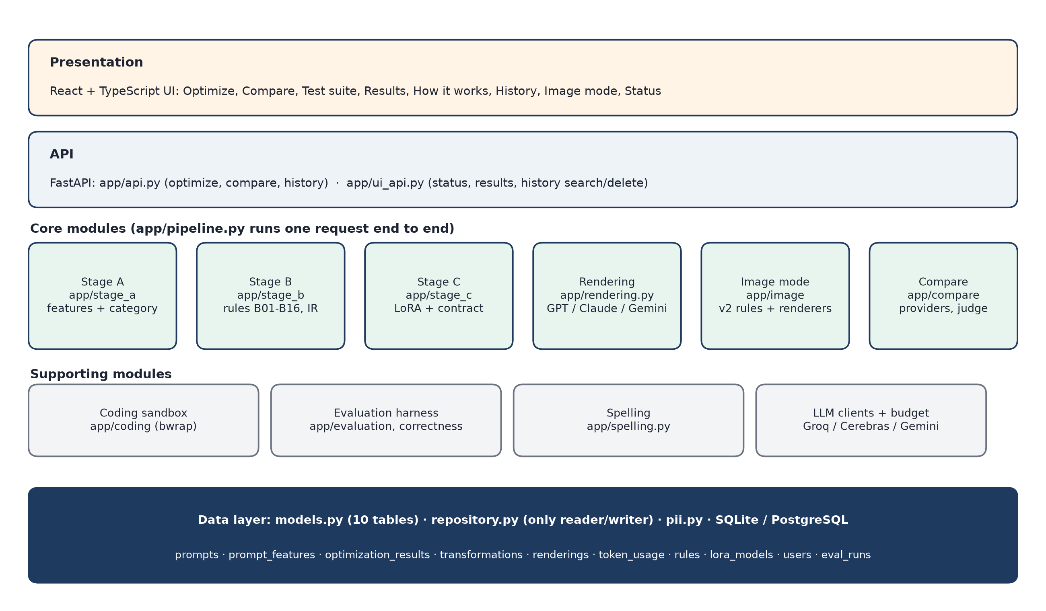
Figure 5.3: Module diagram: core modules, supporting modules and the data layer
Table 5.1: Main modules
Module | Responsibility
app/stage_a/ | feature detection: classifier, detectors A02-A05, PromptFeatures
app/stage_b/ | IR, rules B01-B15 (+ B16 in the app), optimizer, routing
app/stage_c/ | training data, parser, training script, runtime, contract and checker
app/rendering.py | renderers for GPT, Gemini and Claude; token counts
app/pipeline.py | runs one request end to end and stores it through the repository
app/api.py, app/ui_api.py | FastAPI endpoints for the user interface
app/compare/ | Compare on real models, providers, budgets
app/db/ | models (10 tables), repository, PII scrubbing, retention
app/evaluation/, app/correctness/ | evaluation harness, judge, token evaluation, correctness suite
app/coding/ | sandboxed test runner for coding answers
frontend/ | React + TypeScript user interface

5.3 Pipeline flow of one request
One optimization request is handled as one database transaction. The steps below are numbered as in the figure; every arrow in the figure is labelled with what passes along it.
1. The user submits the prompt, the target LLM, the category (auto or one of five) and an optional attachment type (POST /api/optimize).
2. Old data is cleaned: prompts older than 30 days, and everything derived from them, are deleted.
3. The prompt is saved after e-mail addresses and phone numbers are replaced by [EMAIL] and [PHONE] (table prompts).
4. Stage A detects the features (table prompt_features).
5. Stage B, and Stage C if the prompt is routed, produce the IR and the change log (tables optimization_results and transformations, one row per change).
6. The IR is rendered for GPT, Claude and Gemini and the input tokens are counted (tables renderings and token_usage).
7. Decision: did every step succeed? If yes, the request is committed once; if any step failed, the whole request is rolled back and nothing is stored.
8. The response returns the features, the rules that fired, the renderings and the token counts to the user interface.
9. Optionally, the user runs Compare: both prompts go to the same model and the run is stored.
10. Later, History lists, searches, shows and deletes past prompts; deleting a prompt deletes everything derived from it.
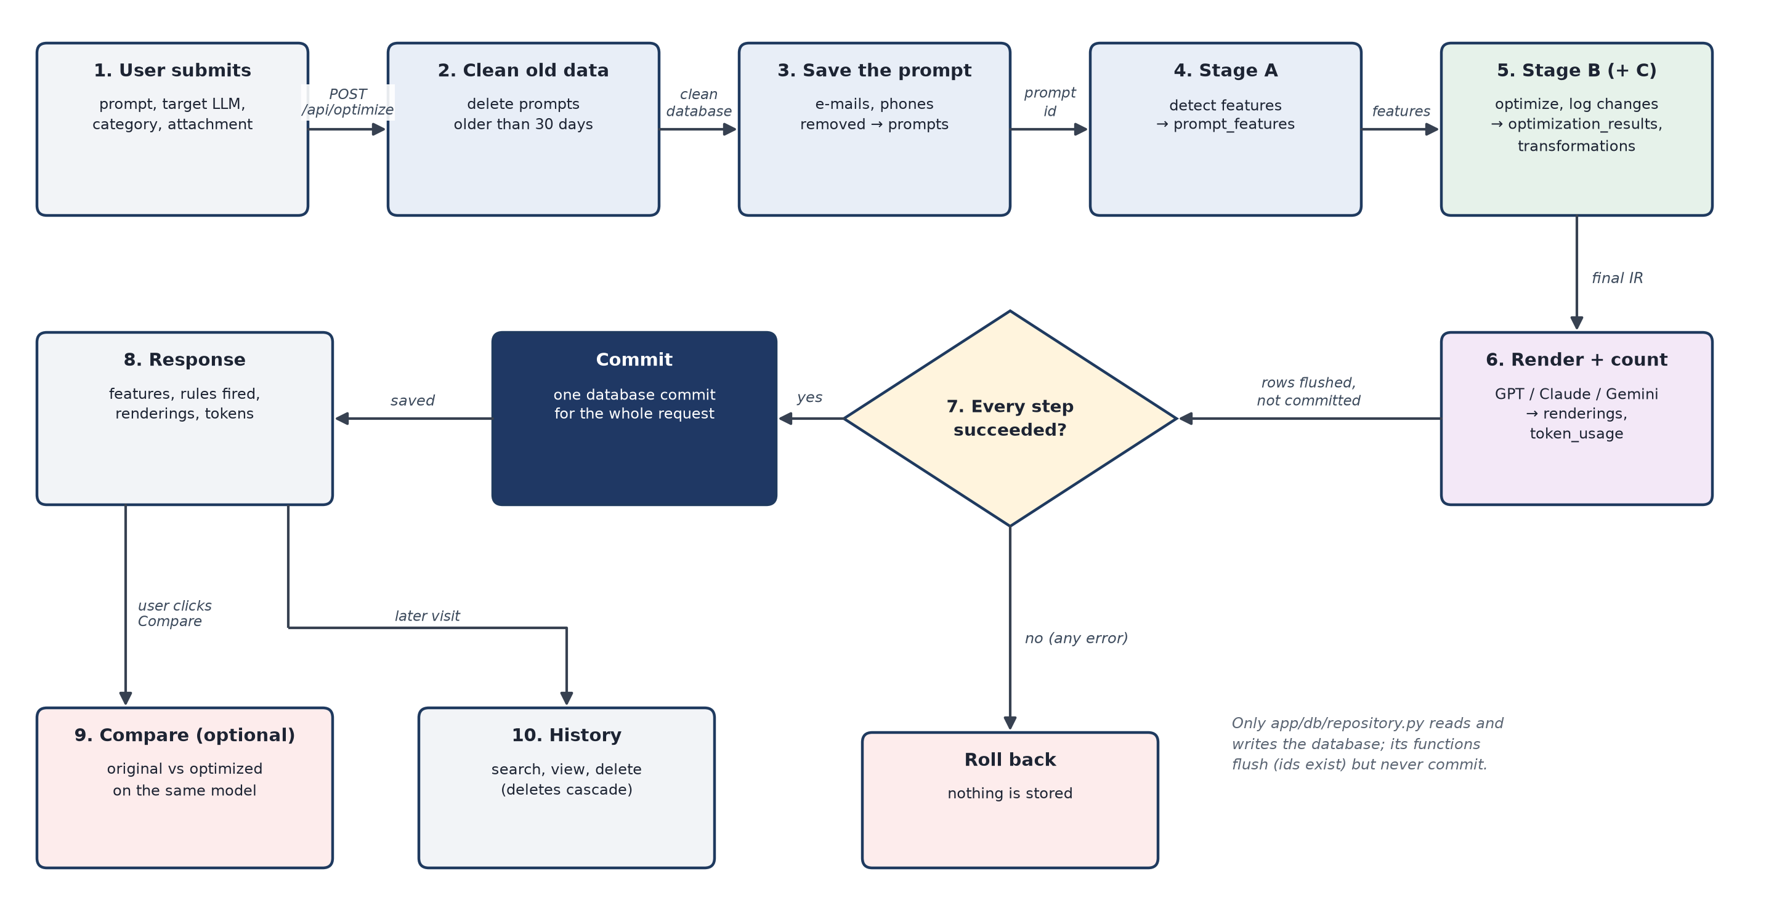
Figure 5.4: Pipeline flow of one request, with the commit decision at step 7
Only the repository module (app/db/repository.py) reads or writes the database. Its functions flush, so that the identifiers of new rows exist, but never commit; the endpoint commits once at the end. A failure half-way therefore leaves nothing behind, and the privacy rules are applied in one place.

5.4 Database design
The database has ten tables, defined with the SQLAlchemy 2.0 ORM. The prompt-side tables are deleted in cascade with their prompt, so the retention purge removes everything derived from an expired prompt. The evaluation_runs table is deliberately not linked to prompts, so benchmark results are never purged. Constraints are enforced in the schema: a confidence between 0 and 1, a Stage B transformation must reference a rule, one rendering per result and target.
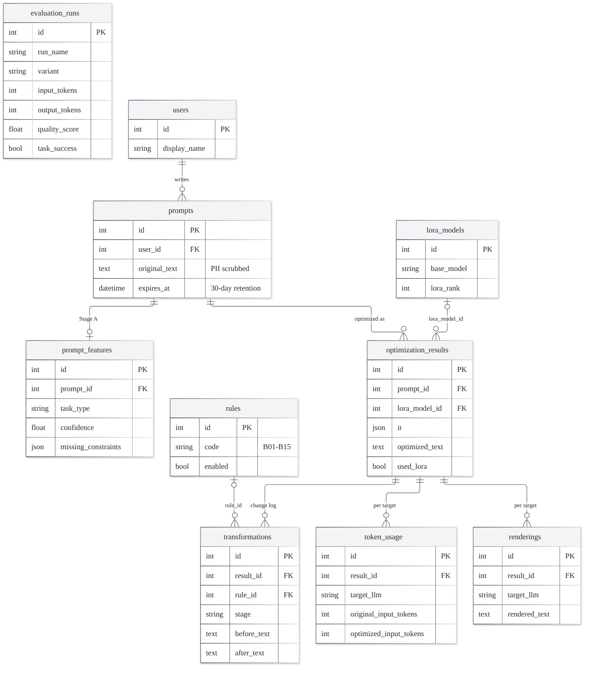
Figure 5.5: Entity-relationship diagram (10 tables)
Table 5.2: Tables of the database
Table | Content | Written by
prompts | prompt text after PII scrubbing, number of redactions, created and expiry time | create_prompt
prompt_features | task type, confidence, missing constraints, filler, ambiguous references | save_features
optimization_results | IR (JSON), optimized text, confidence, whether Stage C was used, latency | save_optimization
transformations | one row per change: step number, stage (B or C), rule, text before and after | save_optimization
renderings | the rendered prompt per target LLM | save_renderings
token_usage | original and optimized input (and output) tokens per target, tokenizer | save_token_usage
rules | the rule catalogue A01-A05, B01-B16 with an enabled flag | seed
lora_models | metadata of Stage C adapters | register_lora_model
users | optional display name (no e-mail or real name stored) | –
evaluation_runs | one row per evaluated item, variant and target: tokens, latency, quality, task success | record_evaluation

5.5 Evaluation flow
The evaluation runs each split through the variants being compared (the vague prompt, Stage A + B, Stage A + B + C, and the dataset's own optimized prompt) and measures each variant with the metrics of Section 4.10.
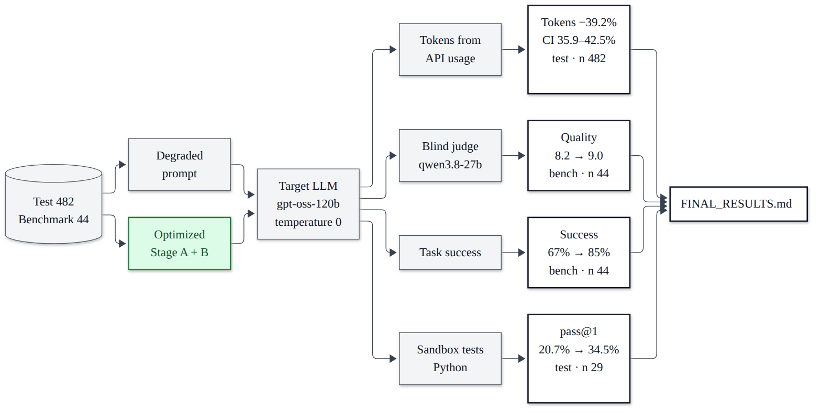
Figure 5.6: Evaluation flow: splits, variants and metrics

Test plan
Testing is automated and has three levels. Unit tests check every detector, rule and module on its own; integration tests check the modules working together, through the API and through the correctness suite of real cases; system tests run the complete application in a browser and the complete pipeline on the dataset splits. Unit and integration tests run with pytest and need no network: LLM providers are faked or replayed from recorded answers, and database tests run on an in-memory SQLite database (and on PostgreSQL when a test database is configured). Browser tests run with Playwright against the real FastAPI application on a throw-away database. Manual testing covered the demonstration flow and the human review of the dataset and of the correctness-suite gold answers.
Table 6.1: Types of testing and tools
Level | Tool | What is tested | Result
Unit | pytest | every Stage A detector, every Stage B rule, Stage C contract, renderers, database, sandbox, clients | 720 test cases, 60 per module, all pass
Integration (API) | pytest + FastAPI TestClient | endpoints end to end, pipeline storage, Compare with recorded answers, retention | included in the 720
Integration (correctness) | correctness suite | 50 hand-written cases, 10 per category, with verifiable answers | vague 37/50, optimized 42/50
System (UI) | Playwright + Chrome | simple app and developer view: optimize, token usage analysis, compare, test suite, history, image mode, tour, console errors | 16 / 16 passed
System (pipeline) | evaluation harness | 482-prompt test split, 44-prompt benchmark, ablation | Chapter 7
Regression | freeze check | Stage A + B on 482 test prompts against the frozen code | byte-identical
Security | sandbox tests | no network, read-only system, memory, time and process limits | passed

6.1 Unit testing
Every Stage B rule is a separate pure function with its own tests, and every Stage A detector has positive and negative tests. Each of the 12 modules has exactly 60 test cases, 720 in all; a check that runs over a whole example set (for instance every example prompt of image mode) counts as one test case. All 720 pass. The 68 database-backed cases run a second time on PostgreSQL, and all 68 pass there too; this is why pytest reports 788 tests (720 + 68). The commands are: cd backend && source .venv/bin/activate && python -m pytest -q (788 passed) and python -m app.test_report, which writes the per-module table below.
Table 6.2: Unit test cases per module and their pass rate
Module | Test cases | Passed | Pass rate
Stage A: feature detection | 60 | 60 | 100%
Stage B: rule-based optimizer | 60 | 60 | 100%
Stage C: small-model fallback | 60 | 60 | 100%
Rendering and pipeline | 60 | 60 | 100%
Image mode | 60 | 60 | 100%
Database and privacy | 60 | 60 | 100%
API, web UI, spelling and demo | 60 | 60 | 100%
Coding tests and sandbox | 60 | 60 | 100%
Token usage analysis and live models | 60 | 60 | 100%
Evaluation harness | 60 | 60 | 100%
Dataset building | 60 | 60 | 100%
Dataset repair and checks | 60 | 60 | 100%
Total | 720 | 720 | 100%

The test-case table below shows four of these cases for each of ten modules, each taken from the real test suite, with the input, the expected and the actual result.
Table 6.3: Unit and module test cases: four sample cases per module
ID | Module | Test | Input | Expected | Actual | Status
TC01 | Stage A | Format detected | “Answer in 3 bullet points” | format found (A02) | found | PASS
TC02 | Stage A | Filler detected | “hey can you please summarize…” | “hey”, “can you please” | as expected | PASS
TC03 | Stage A | Ambiguous reference only without text | “summarize this” with / without text | flagged / not flagged | as expected | PASS
TC04 | Stage A | Unlike anything known → other | prompt with no similar train prompt | category = other | other | PASS
TC05 | Stage B | B01 removes filler | “hey can you please summarize the text for me?” | “Summarize the text.” | as expected | PASS
TC06 | Stage B | B05 defaults to Python | “Write a function that reverses a list.” | “Use Python.” | as expected | PASS
TC07 | Stage B | B08 group fallback | “when was it finished” + passage, closed_qa 0.45 | “Answer from the provided text in at most three sentences.” | as expected | PASS
TC08 | Stage B | Running twice adds nothing | an optimized prompt optimized again | no new change | none | PASS
TC09 | Stage C | Category request | unresolved task category | asks for format, constraints, category | as expected | PASS
TC10 | Stage C | Invalid answer falls back | malformed JSON / wrong keys | Stage B's IR kept | kept | PASS
TC11 | Stage C | Dangling reference rejected | task “Summarize the provided text”, no text | rejected | rejected | PASS
TC12 | Stage C | Not routed means not called | nothing unresolved | Stage C not called | not called | PASS
TC13 | Rendering | No field lost | 13 IRs × 3 targets, parsed back | equal to the IR | equal | PASS
TC14 | Rendering | Claude: XML, context first | IR with context | <context> before <task> | as expected | PASS
TC15 | Rendering | Fence longer than data | data with ``` inside | fence of 4+ backticks | as expected | PASS
TC16 | Rendering | Token counts labelled | rendered prompt | GPT exact, Claude/Gemini approx. | as expected | PASS
TC17 | Database | PII scrubbed before storage | e-mail + two phone numbers | 1 [EMAIL], 2 [PHONE], 3 redactions | as expected | PASS
TC18 | Database | Retention purge cascades | a 31-day-old and a fresh prompt | old prompt and its rows deleted | deleted | PASS
TC19 | Database | Schema constraints hold | confidence 1.5; Stage B step without rule | rejected by the database | rejected | PASS
TC20 | Database | Full flow and history | optimize, then history | every stored part returned | returned | PASS
TC21 | API | Blank prompt | POST /api/optimize, prompt “ ” | HTTP 422 (not 500) | 422 | PASS
TC22 | API | Expired prompts hidden | prompt older than 30 days | deleted before history is listed | deleted | PASS
TC23 | API | Unsure category reported | low-confidence prompt | UI asked to confirm | as expected | PASS
TC24 | API | Models load once | parallel requests | one Stage A / Stage C instance | one | PASS
TC25 | Compare | End to end with recorded answers | prompt + model | both answers, tokens, change % | as expected | PASS
TC26 | Compare | Both prompts PII-scrubbed | prompt with an e-mail | provider sees [EMAIL] only | as expected | PASS
TC27 | Compare | Budget respected | daily budget used up | refused before calling the model | refused | PASS
TC28 | Compare | Rate limits | per-minute / per-day 429 | retry / stop for the day | as expected | PASS
TC29 | Sandbox | No network | code opening a socket to 1.1.1.1 | connection blocked | blocked | PASS
TC30 | Sandbox | Time limit | infinite loop | killed at the timeout | killed | PASS
TC31 | Sandbox | Host files hidden | code reading the home folder | not visible | not visible | PASS
TC32 | Sandbox | Refuses without bwrap | bubblewrap missing | refusal, code not run | refused | PASS
TC33 | Image mode | No user word lost | image prompts (parametrized) | every word kept, no default added | as expected | PASS
TC34 | Image mode | Suggestions only for gaps | prompt that names a style | no style suggestion | as expected | PASS
TC35 | Image mode | Aspect ratio only when implied | prompts with and without an implied shape | ratio only when implied | as expected | PASS
TC36 | Image mode | Accepted suggestions marked | click two suggestions | added after the user's words | as expected | PASS
TC37 | UI (Playwright) | Every stage shown | click an example | Stage A, B, C and rendering shown | shown | PASS
TC38 | UI (Playwright) | Unsure category asks the user | low-confidence prompt | confirmation box shown | shown | PASS
TC39 | UI (Playwright) | History works | list, search, view, delete | all four work | work | PASS
TC40 | UI (Playwright) | No console errors | every page | 0 console errors | 0 | PASS

Examples of real unit tests (backend/tests):
def test_b05_defaults_to_python():
text = "Write a function that reverses a list."
assert b.b05_add_language(ir_of(text, "coding"),
feats(text, "coding")).constraints == ("Use Python.",)

def test_pii_is_scrubbed_before_storage(db):
p = repo.create_prompt(db, "mail rahul.k@example.com or call 98765 43210 / 555-123-4567 about the report")
db.commit()
stored = db.scalar(select(Prompt.original_text).where(Prompt.id == p.id))
assert stored.count("[EMAIL]") == 1 and stored.count("[PHONE]") == 2
assert p.pii_redactions == 3

def test_blank_prompt_is_rejected_with_422_not_500(client):
r = client.post("/api/optimize", json={"prompt": " \n ", "target": "gpt"})
assert r.status_code == 422 and "empty" in r.json()["detail"]

6.2 Integration testing
6.2.1 API integration
API tests send real HTTP requests through the FastAPI test client and check the whole chain: the pipeline with and without Stage C, the storage of every part through the repository, History, Compare with recorded model answers, image mode, input errors (HTTP 422 instead of 500), retention before History is listed, and removal of personal data from what Compare sends to the provider.
6.2.2 Correctness suite, by category
The correctness suite tests the optimizer together with a real model on 50 new, hand-written cases that are close to students' daily use: hostel notices, timetables, placement circulars, bank statements, recipes and small coding tasks. There are exactly ten cases per category. Each case has one verifiable gold answer, confirmed by the team (50 of 50), and a vague prompt written the way a student would type it. The vague prompt and the optimized prompt are both sent to OpenAI's GPT model gpt-oss-120b; the answer is checked deterministically where possible (numbers, item sets, labels, hidden unit tests run in the sandbox) and with a blind checklist judge for summaries. A case passes when the optimized prompt's answer is correct. Cases marked (Stage C) were routed to Stage C.
Table 6.4: Correctness suite: closed_qa (vague → optimized correct: 8/10 → 10/10)
Case | Scenario | Vague prompt | Optimized prompt | Status
cqa-01 | hostel fee notice: total for a late second-year payer | wrong | correct | PASS
cqa-02 | timetable with a corrigendum that moves one paper | correct | correct | PASS
cqa-03 | T20 scorecard without the total: target for the chasing side | correct | correct | PASS
cqa-04 | recipe for 4 scaled to 10 people (Stage C) | correct | correct | PASS
cqa-05 | placement notice: one company's CGPA cut-off | correct | correct | PASS
cqa-06 | recharge plans: cheapest per day with 2 GB/day | correct | correct | PASS
cqa-07 | library overdue fine with two slabs | correct | correct | PASS
cqa-08 | bus timetable on a Sunday: earliest arrival | correct | correct | PASS
cqa-09 | online deal with coupon and capped bank discount | correct | correct | PASS
cqa-10 | attendance: lectures one can still miss and keep 75% | wrong | correct | PASS

Table 6.5: Correctness suite: information_extraction (vague → optimized correct: 7/10 → 10/10)
Case | Scenario | Vague prompt | Optimized prompt | Status
ie-01 | drive notice: branches eligible for one company | correct | correct | PASS
ie-02 | coordinator's e-mail: the revised deadlines | correct | correct | PASS
ie-03 | bug thread: OS versions that crash | correct | correct | PASS
ie-04 | result sheet: students with a backlog | correct | correct | PASS
ie-05 | recipe: dairy ingredients (Stage C) | correct | correct | PASS
ie-06 | PNR status: passengers with confirmed berths | correct | correct | PASS
ie-07 | lab timetable: labs of one batch | wrong | correct | PASS
ie-08 | bank statement: debits above Rs 5,000 | wrong | correct | PASS
ie-09 | Django traceback: files in the failing traces (Stage C) | correct | correct | PASS
ie-10 | scholarship notice: documents for a renewal | wrong | correct | PASS

Table 6.6: Correctness suite: classification (vague → optimized correct: 7/10 → 8/10)
Case | Scenario | Vague prompt | Optimized prompt | Status
cls-01 | pressure-cooker reviews: positive / negative / mixed | correct | correct | PASS
cls-02 | monthly expenses into four categories (Stage C) | correct | correct | PASS
cls-03 | college-app issue triage with a label guide | correct | correct | PASS
cls-04 | mess menu: veg / non-veg under the egg rule (Stage C) | correct | correct | PASS
cls-05 | placement offers: Normal / Dream / Super Dream | wrong | correct | PASS
cls-06 | SMS inbox: legit / promo / scam | correct | correct | PASS
cls-07 | student queries routed to the right office (Stage C) | wrong | wrong | FAIL
cls-08 | Big-O of short Python snippets | correct | correct | PASS
cls-09 | attendance status per student | correct | wrong | FAIL
cls-10 | language of each class-group message (Stage C) | wrong | correct | PASS

Table 6.7: Correctness suite: summarization (vague → optimized correct: 7/10 → 5/10)
Case | Scenario | Vague prompt | Optimized prompt | Status
sum-01 | accounts circular with an extended date | correct | correct | PASS
sum-02 | bug report for a team lead | correct | correct | PASS
sum-03 | six laptop reviews into pros and cons | correct | correct | PASS
sum-04 | placement-drive notice for WhatsApp | correct | correct | PASS
sum-05 | recipe method for a beginner (Stage C) | wrong | wrong | FAIL
sum-06 | industrial-visit message with a postponed date | correct | wrong | FAIL
sum-07 | fest committee minutes | wrong | wrong | FAIL
sum-08 | municipal water-cut notice | wrong | wrong | FAIL
sum-09 | mini-project abstract for a slide | correct | correct | PASS
sum-10 | PG agreement summarised for parents | correct | wrong | FAIL

Table 6.8: Correctness suite: coding (vague → optimized correct: 8/10 → 9/10)
Case | Scenario | Vague prompt | Optimized prompt | Status
cod-01 | SGPA from (grade, credits) pairs | correct | correct | PASS
cod-02 | fix an attendance-percentage function | correct | correct | PASS
cod-03 | library fine with slabs, cap and reference books | correct | correct | PASS
cod-04 | timetable clash detection | correct | correct | PASS
cod-05 | Indian digit grouping (lakh/crore commas) | wrong | correct | PASS
cod-06 | PRN format validation | correct | correct | PASS
cod-07 | fix a class average that crashes on “AB” | correct | correct | PASS
cod-08 | trip expense splitter | correct | correct | PASS
cod-09 | fix a second-highest-marks function | wrong | correct | PASS
cod-10 | recipe quantity scaler with fractions (Stage C) | correct | wrong | FAIL

Table 6.9: Correctness suite: accuracy and tokens per category (OpenAI's GPT model gpt-oss-120b)
Category | Vague correct | Optimized correct | Input tokens | Output tokens | Input + output
closed_qa | 8/10 | 10/10 | 217 → 244 | 308 → 166 | 525 → 410
information_extraction | 7/10 | 10/10 | 244 → 274 | 289 → 110 | 532 → 384
classification | 7/10 | 8/10 | 251 → 282 | 320 → 254 | 571 → 535
summarization | 7/10 | 5/10 | 257 → 274 | 155 → 170 | 412 → 444
coding | 8/10 | 9/10 | 176 → 210 | 1104 → 354 | 1279 → 563
all (50) | 37/50 (74%) | 42/50 (84%) | 229 → 257 | 435 → 211 | 664 → 467

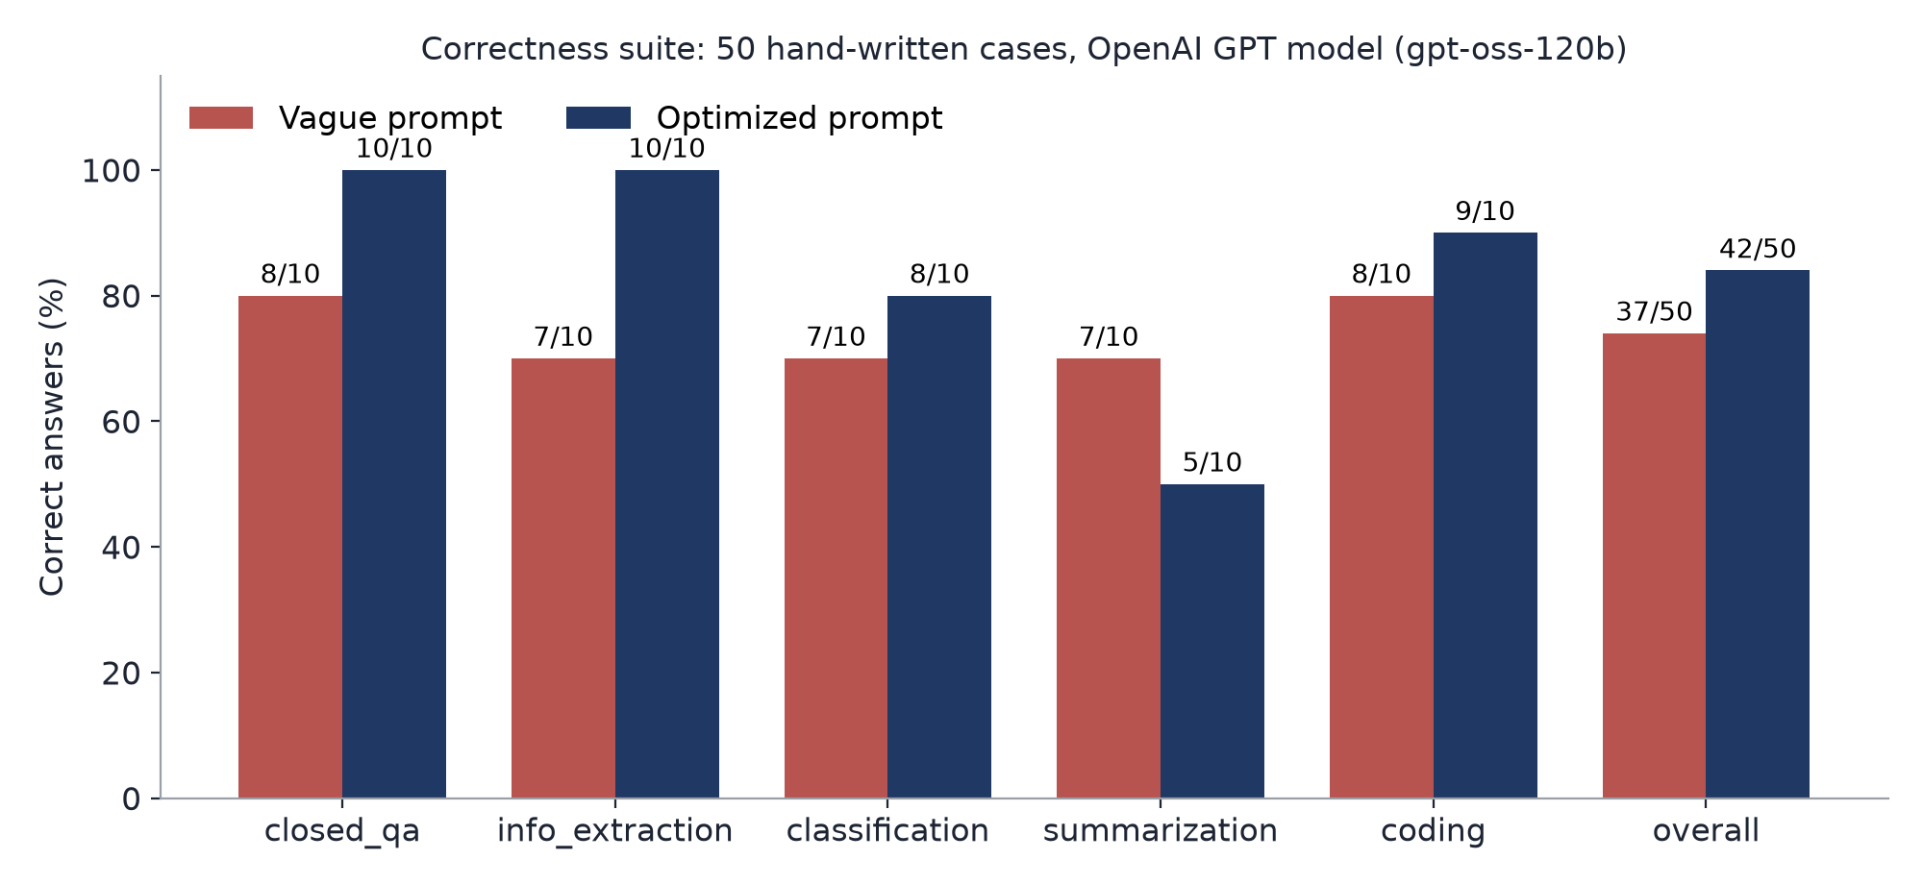
Figure 6.1: Correctness suite: correct answers per category, vague vs optimized
Optimization made 9 wrong answers right and 4 right answers wrong; the exact McNemar test gives p = 0.267, so the gain is not statistically significant with 50 cases. On a second provider (Cerebras) the same model gave 43/50 for the vague and 41/50 for the optimized prompts, while total tokens fell by 28.2%: the token saving is robust across providers, the correctness gain is not. The four cases where optimization hurt are analysed in Section 7.4.

6.3 System testing
Table 6.10: Browser end-to-end tests (Playwright, real application)
# | Test | Result
1 | example gallery → optimize shows every stage | PASS
2 | hovering an issue highlights the words in the prompt | PASS
3 | Ctrl+Enter optimizes, undo restores the previous input, live counter updates | PASS
4 | possible typos are suggested, and Fix all corrects the prompt and runs again | PASS
5 | an unsure category asks the user to confirm | PASS
6 | Compare runs both prompts on a real model | PASS
7 | test suite: summary, filter and case view | PASS
8 | history: listed, searchable, viewable, deletable | PASS
9 | theme toggle switches and persists | PASS
10 | image mode: suggestions are clickable and per-model renderings | PASS
11 | gallery image example opens Image mode and runs it there | PASS
12 | tour shows once and can be skipped; ? opens shortcuts | PASS
13 | simple app: improve a prompt, then analyse its token usage | PASS
14 | simple app: picture prompts, then history shows them and can reuse them | PASS
15 | old developer links redirect to /dev | PASS
16 | every page loads without console errors | PASS

• Full pipeline on the 482-prompt test split and the 44-prompt benchmark, with a real model and a blind judge (Chapter 7).
• Freeze check: Stage A + B of the current code and the frozen code on all 482 test prompts give byte-identical output (equal SHA-256 hashes).
• Coding sandbox: answers to coding prompts are run against 3-6 assert tests per item, kept only if they pass on the reference solution, in a bubblewrap sandbox with no network and a read-only system.
• Attachment rules: 30 hand-made prompts (5 per attachment type); in all 30 the right rule fires and no other.

Results

7.1 Results with screenshots and description
This section first follows the review example through the working application, screen by screen: first the simple app that everyday users see, then every stage in the developer view. It then summarises the results on the full test data.
7.1.1 What the user sees: the simple app
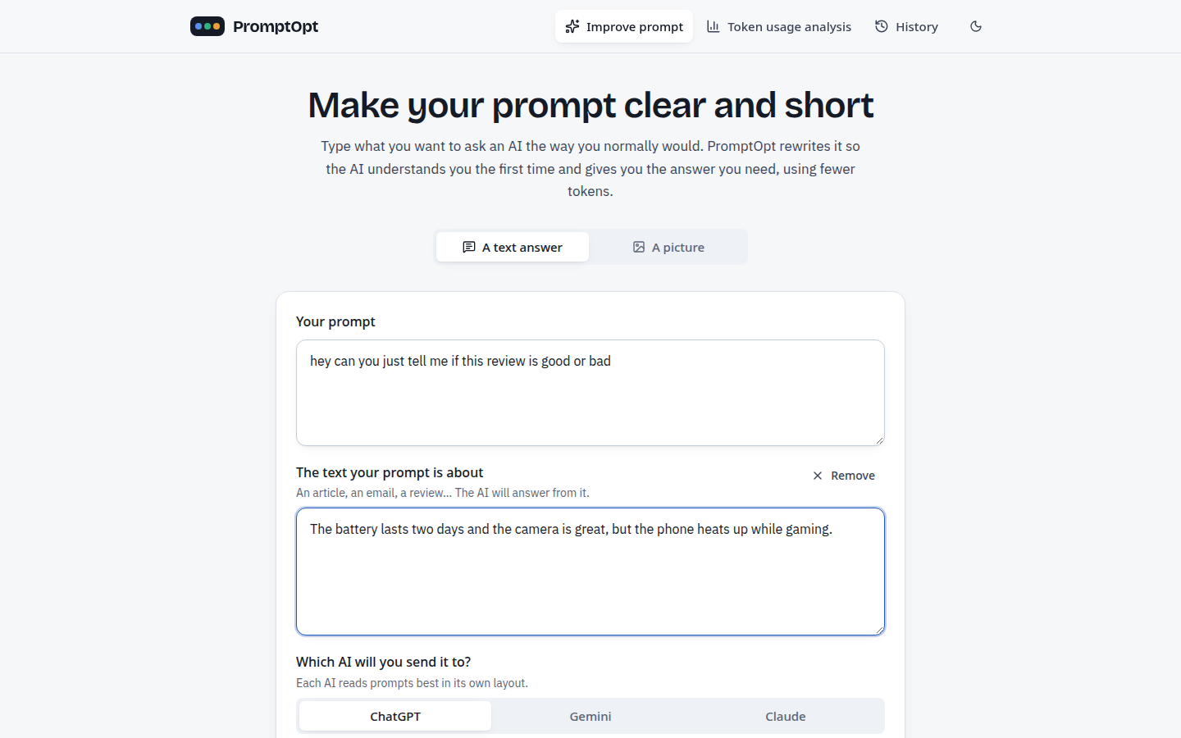
Figure 7.1: Improve prompt (simple app): the vague prompt, the pasted review and the target AI
The user types the prompt the way they normally would, adds the review under “The text your prompt is about” and picks the AI they will send it to, here ChatGPT. More options (the kind of task and an attached file) stay folded away; by default the task type is detected automatically.
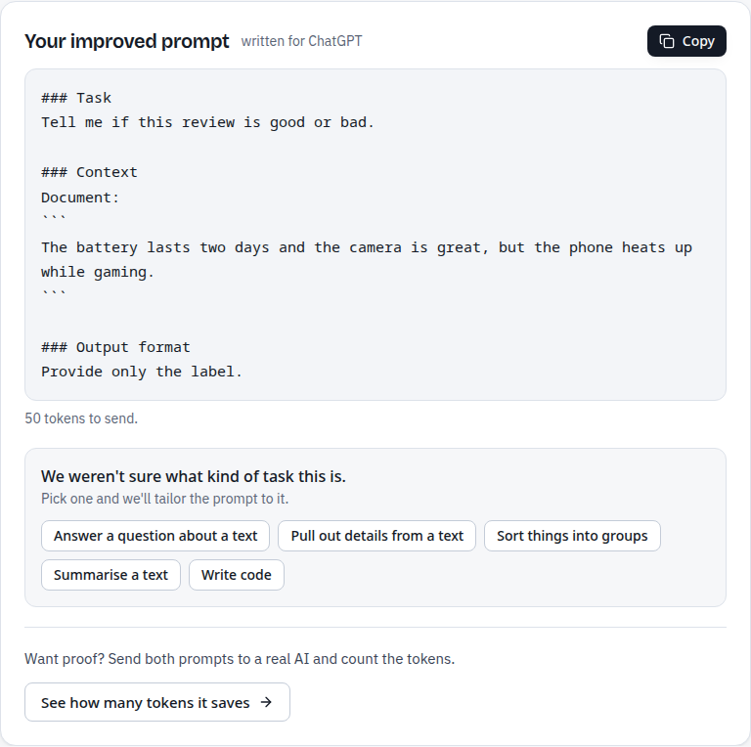
Figure 7.2: The improved prompt, written in ChatGPT's layout (50 tokens), with the task-type question
The improved prompt comes back in ChatGPT's layout, with a task, the review as the document and the output format “Provide only the label.”, ready to copy. Because the system was not sure which kind of task this is, it asks the user to pick one instead of guessing; the button below leads to the token usage analysis.
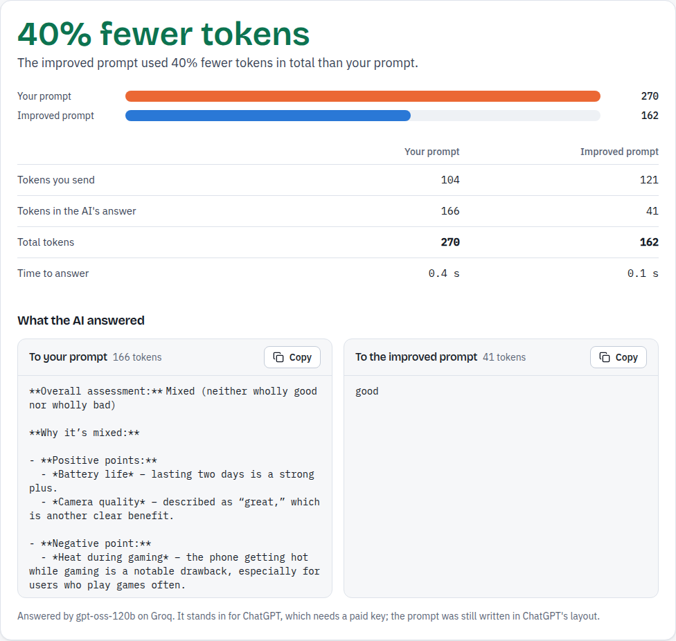
Figure 7.3: Token usage analysis: both prompts on the same AI, 270 → 162 tokens (40% fewer)
Token usage analysis sends both prompts to the same model, OpenAI's GPT model gpt-oss-120b on Groq, labelled as a stand-in for ChatGPT. The improved prompt is a little longer to send (121 instead of 104 tokens) but the answer shrinks from 166 tokens to 41, the single word “good”, so the total falls from 270 to 162 tokens, 40% fewer, and the answer arrives in 0.1 s instead of 0.4 s. The 50 tokens shown on the previous screen are the prompt alone; the model adds about 70 tokens of its own message framing, which is why 121 tokens are sent.
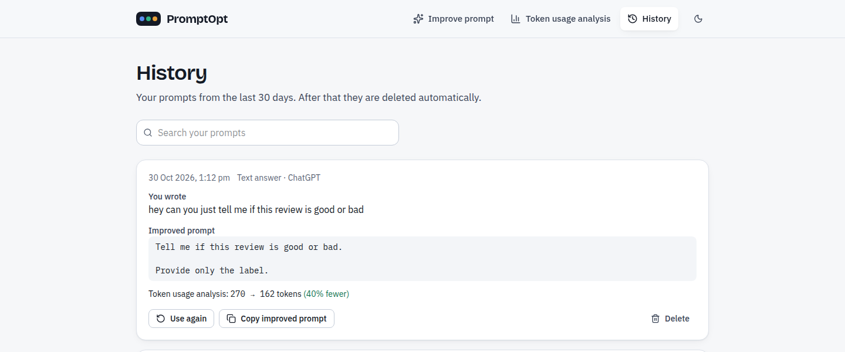
Figure 7.4: History (simple app): the prompt, the improved prompt and its token saving, kept for 30 days
History keeps every prompt for 30 days with its improved version and, when it was analysed, the token saving; a prompt can be used again, copied or deleted. E-mail addresses and phone numbers are removed before anything is stored.
7.1.2 Every stage in the developer view
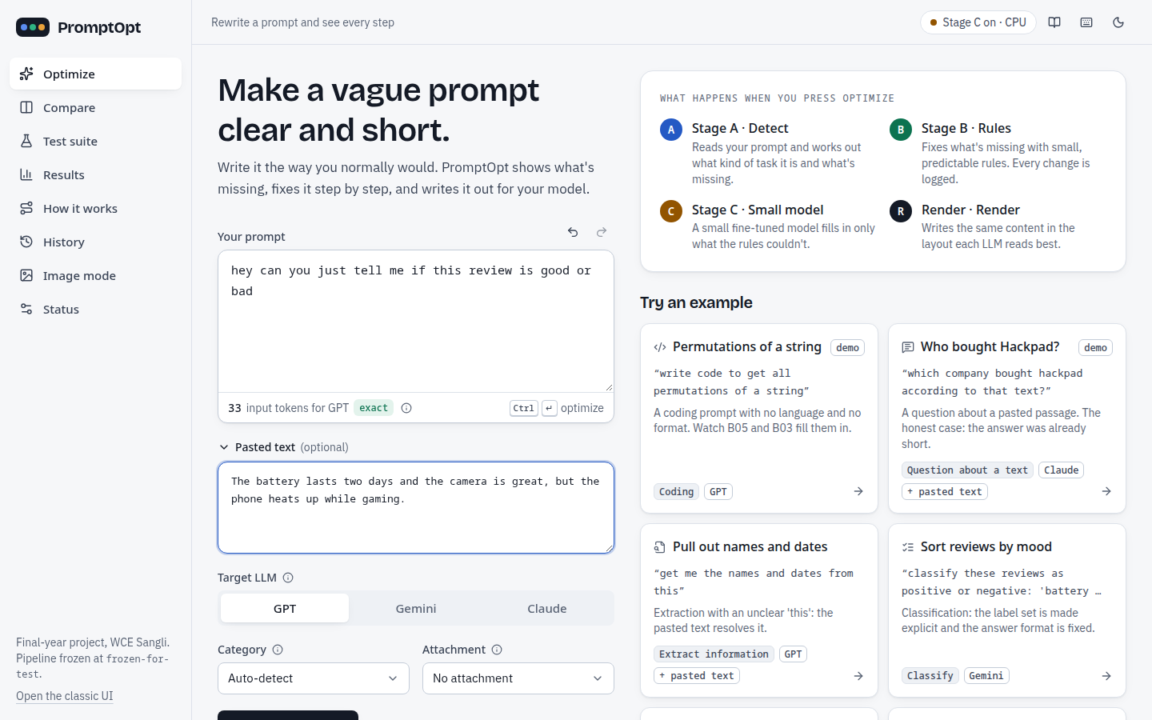
Figure 7.5: Developer view, Optimize: the vague prompt and the pasted review, target GPT, category auto-detect
The user types the prompt as they normally would and pastes the review under “Pasted text”. The live counter shows 33 input tokens for GPT (counted exactly with OpenAI's tokenizer).
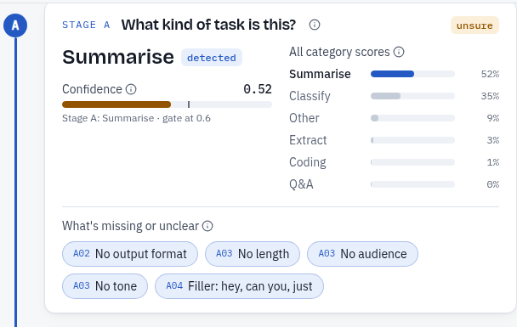
Figure 7.6: Stage A on the review example: summarization 0.52, below the 0.6 gate, so marked unsure
Stage A shows its best guess, Summarise, with a confidence of 0.52, and the score of every category (classification 0.35 is second). The confidence bar stops before the 0.6 gate mark, so the category is marked unsure. Below, the detected gaps are listed with their detector codes: no output format (A02), no length, audience or tone (A03), and the filler words “hey, can you, just” (A04).
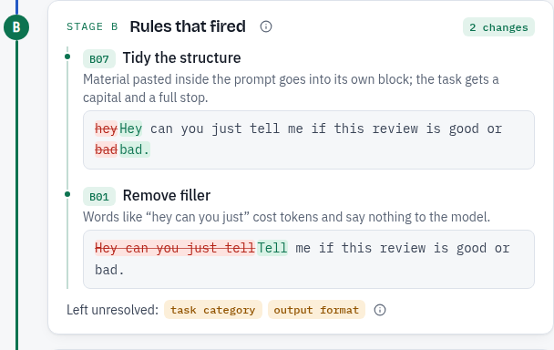
Figure 7.7: Stage B on the review example: two rules fired, each shown with the text before and after
Stage B lists the two rules that fired, each with the deleted text in red and the added text in green: B07 tidied the sentence (capital letter and full stop) and B01 removed “Hey can you just”. No format was added because the category is unsure; the task category and the output format are left unresolved.
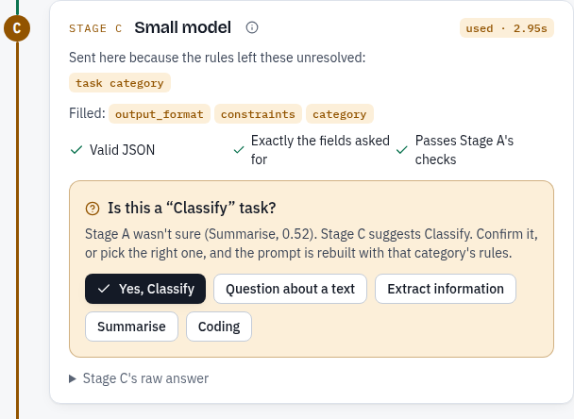
Figure 7.8: Stage C on the review example: the model filled format, constraints and category; the user is asked to confirm
Stage C was called because the task category was unresolved. It filled exactly the requested fields, and its answer passed all three checks shown (valid JSON, exactly the requested fields, Stage A's checks). Its category suggestion is not applied automatically: the application asks “Is this a Classify task?” and pre-selects Classify, while the format “Provide only the label.” is applied.
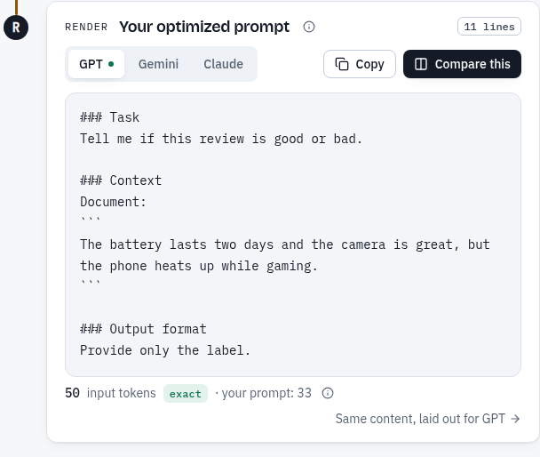
Figure 7.9: The optimized prompt rendered for GPT, with 50 input tokens
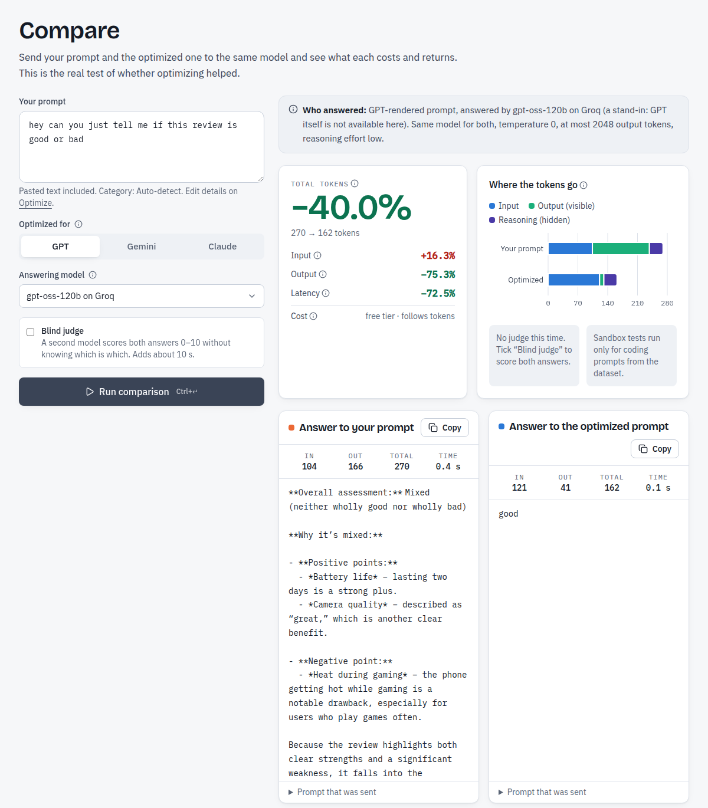
Figure 7.10: Compare: the vague and the optimized prompt answered by the same model
Compare sends both prompts to the same model, OpenAI's GPT model gpt-oss-120b on Groq, which stands in for GPT and is labelled as such on the screen. The vague prompt produced a 166-token explanation (“Overall assessment: Mixed …”); the optimized prompt produced the single word “good” in 41 output tokens. Total tokens fell from 270 to 162 (−40.0%) and the response time by 72.5%, even though the optimized prompt is longer (input 104 to 121 tokens, +16.3%). The vague answer's “mixed” is a fair reading of the review, but it is not one of the two labels the user asked for; the optimized prompt makes the model answer the question as asked.
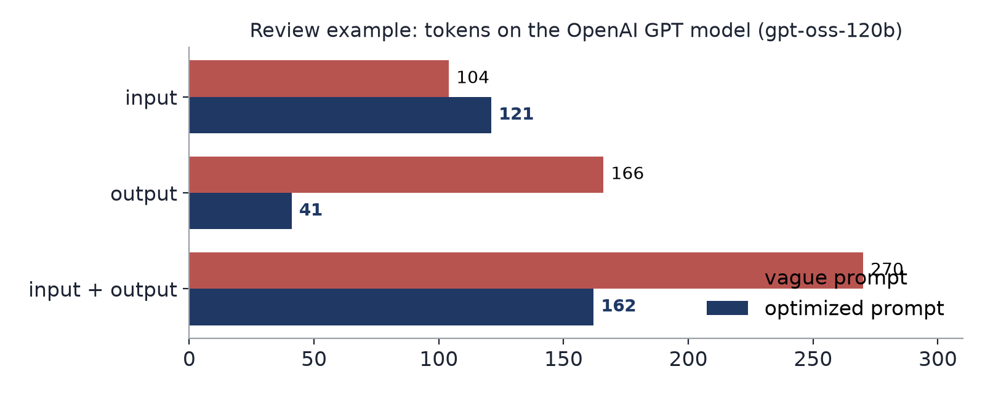
Figure 7.11: Review example: input, output and total tokens on the same model
Table 7.1: Headline results on held-out data (output tokens measured on OpenAI's GPT model gpt-oss-120b)
What | Result
Total tokens, optimized vs vague (482 test prompts) | −39.2% per prompt (95% CI 35.9-42.5%)
Output tokens per prompt | 682 → 165
Input tokens per prompt | 226 → 241
Output format stated: vague → after Stage B | 3.1% → 95.0%
Stage A category accuracy (vague prompts) | 74.7% (macro-F1 0.746)
Prompts routed to Stage C | 6.4% (31 of 482)
Benchmark (44 prompts, blind judge): quality / task success | 8.2 → 9.0 / 67% → 85%
Stage C answers passing the checker: base model vs LoRA | 5.0% vs 98.2%
Stage C on routed prompts: output format stated | 22.6% → 90.3%
Coding tests pass@1, strict (29 Python items) | 20.7% → 34.5%
Correctness suite (50 cases): vague vs optimized correct | 37/50 vs 42/50, total tokens −29.6%
Attachment rules, hand-made set | 30/30 correct

7.2 Comparative analysis: input, output and input + output tokens
The table below compares the vague prompt with the optimized prompt (Stage A + B) on all 482 test prompts, separately for input tokens, output tokens and their sum. All counts are the provider's own counts for OpenAI's GPT model gpt-oss-120b; output includes the model's hidden reasoning tokens. Claude and Gemini were not run.
Table 7.2: Mean tokens per prompt: input, output and input + output (482 test prompts, OpenAI's GPT model gpt-oss-120b)
Category | n | Input | Output | Input + output | Change of input + output per prompt [95% CI]
closed_qa | 99 | 279 → 290 | 835 → 127 | 1115 → 417 | −44.5% [−51.3, −37.6]
information_extraction | 93 | 338 → 351 | 538 → 115 | 875 → 466 | −24.2% [−32.4, −16.2]
classification | 98 | 98 → 122 | 390 → 156 | 488 → 278 | −28.5% [−35.8, −21.1]
summarization | 94 | 338 → 348 | 831 → 204 | 1169 → 552 | −43.3% [−49.4, −37.0]
coding | 98 | 89 → 102 | 813 → 222 | 903 → 324 | −54.7% [−60.8, −48.0]
all | 482 | 226 → 241 | 682 → 165 | 909 → 406 | −39.2% [−42.5, −35.9]

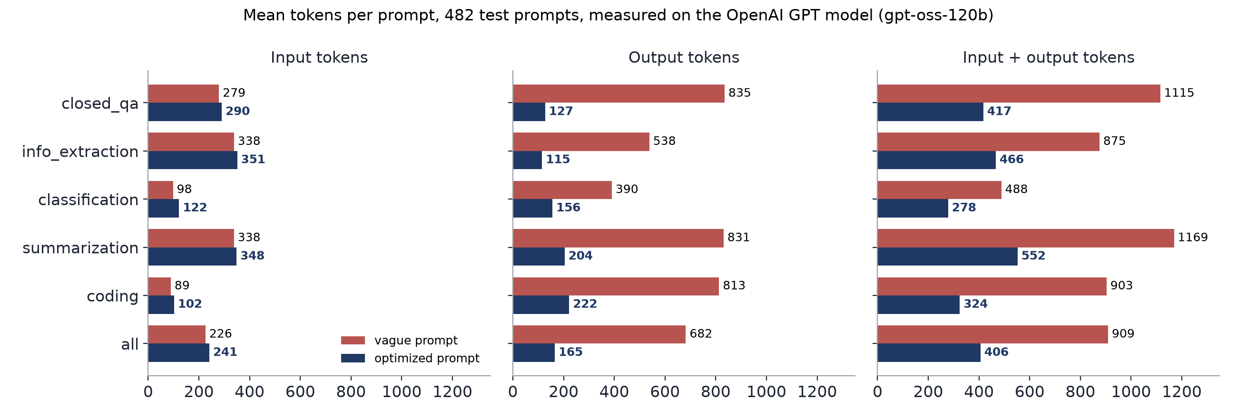
Figure 7.12: Input, output and input + output tokens per category, vague vs optimized
Table 7.3: Change per prompt by token type (482 test prompts, OpenAI's GPT model gpt-oss-120b)
Token type | Vague (mean) | Optimized (mean) | Mean change per prompt [95% CI] | Wilcoxon p
input | 226 | 241 | +11.1% [10.2, 12.1] | < 0.001
output | 682 | 165 | −52.7% [−57.1, −48.2] | < 0.001
input + output | 909 | 406 | −39.2% [−42.5, −35.9] | < 0.001

Input tokens grow in every category, by about 4-26% per prompt, because the optimized prompt states a format, a length or labels. Output tokens fall by much more, because the model no longer writes alternatives, explanations and examples nobody asked for. The sum therefore falls in every category, most for coding (−54.7%), where vague prompts produced several versions of the code with explanations. 87 of the 482 prompts (18.0%) individually cost more, mostly short-answer information_extraction prompts (35 of 93) whose answer was already short.
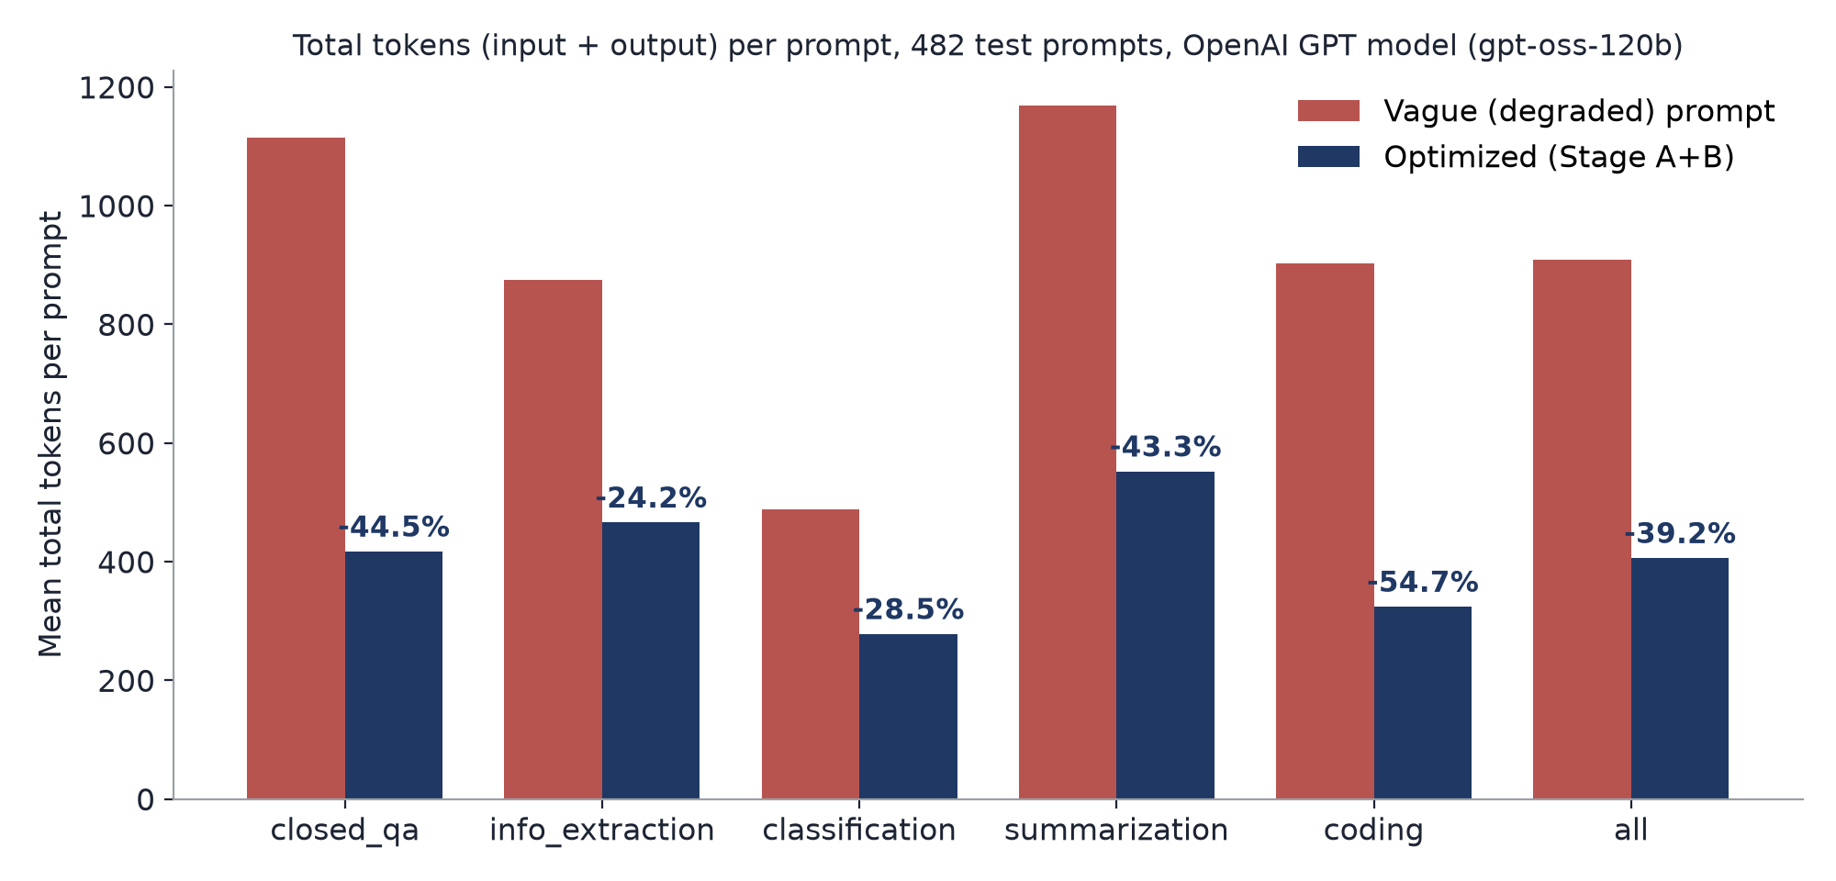
Figure 7.13: Mean input + output tokens per prompt by category, vague vs optimized
Table 7.4: Stage C ablation on the test split
Prompt set | System | n | Task intent | Format stated | Fallback
routed | A + B | 31 | 0.869 | 22.6% | –
routed | A + B + C | 31 | 0.843 | 90.3% | 3.2%
routed | C only | 31 | 0.712 | 90.3% | 6.5%
forced (all) | A + B | 482 | 0.886 | 95.0% | –
forced (all) | A + B + C | 482 | 0.769 | 90.2% | 2.1%
forced (all) | C only | 482 | 0.765 | 88.6% | 1.9%

Where Stage B routes a prompt, Stage C states a format in 90% of cases instead of 23%, at a small loss in task intent (the similarity of the final task to the original instruction). Sending every prompt through Stage C hurts (0.886 → 0.769), and Stage C alone without the rules is the weakest, so the rules are worth keeping in front of the model and Stage C stays a fallback for routed prompts only. On the 31 routed prompts, adding Stage C to A + B reduced input + output tokens by a further 26.7% per prompt.
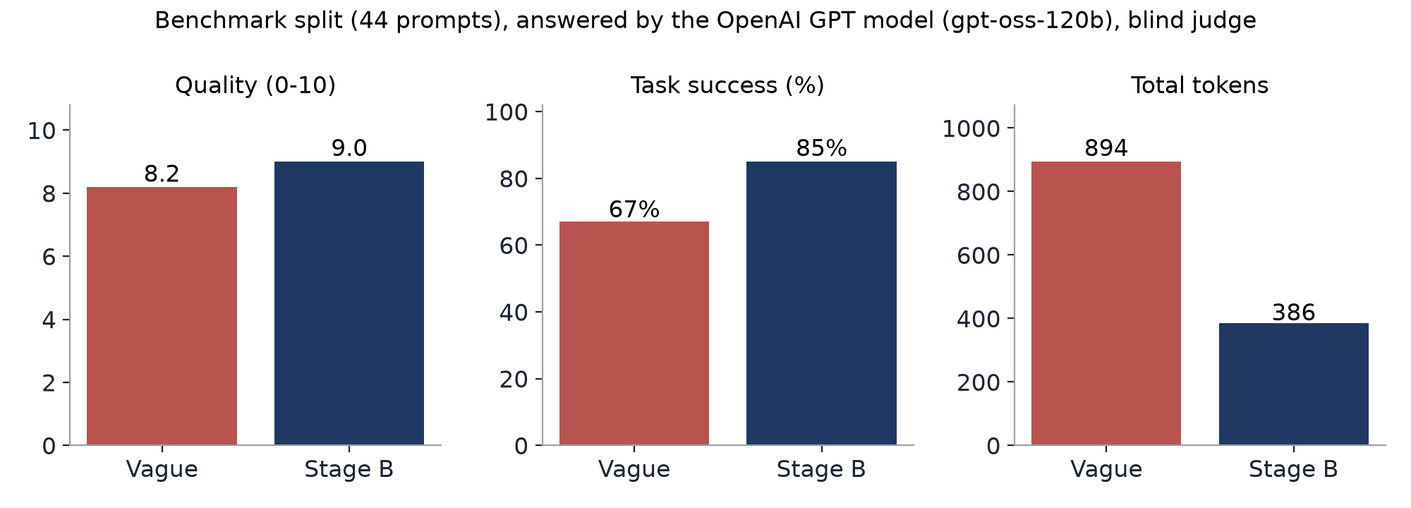
Figure 7.14: Benchmark split: quality, task success and input + output tokens

7.3 Performance measures in tabular form and graphs
Table 7.5: Stage A per-category results (482 test prompts)
Category | n | Precision | Recall | F1
closed_qa | 99 | 56.7% | 76.8% | 0.65
information_extraction | 93 | 73.2% | 55.9% | 0.63
classification | 98 | 93.1% | 95.9% | 0.94
summarization | 94 | 60.0% | 44.7% | 0.51
coding | 98 | 99.0% | 98.0% | 0.98
accuracy (all) | 482 |  |  | 74.7%

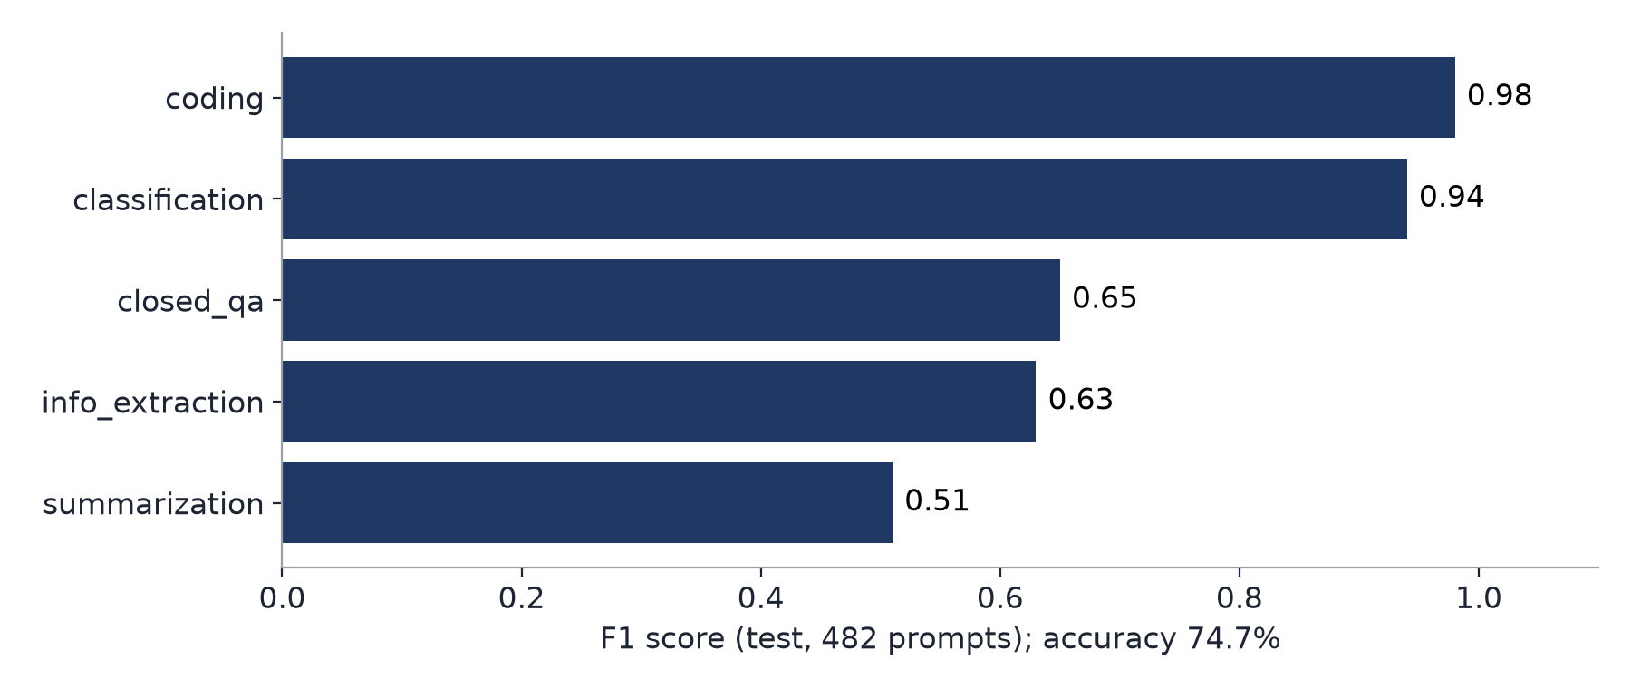
Figure 7.15: Stage A F1 per category (test split)
Table 7.6: Stage B per category (482 test prompts)
Category | n | Format stated: vague → Stage B | Words: vague → Stage B | Sent to Stage C
closed_qa | 99 | 0.0% → 96.0% | 9.1 → 18.8 | 4.0%
information_extraction | 93 | 4.3% → 94.6% | 9.1 → 20.9 | 5.4%
classification | 98 | 0.0% → 90.8% | 18.7 → 32.5 | 15.3%
summarization | 94 | 2.1% → 94.7% | 8.0 → 16.6 | 5.3%
coding | 98 | 9.2% → 99.0% | 10.6 → 20.8 | 2.0%
all | 482 | 3.1% → 95.0% | 11.2 → 22.0 | 6.4%

Table 7.7: Per-rule agreement with the dataset's optimized prompts (test)
Rule | Precision | Recall | F1
B01 remove filler | 1.000 | 1.000 | 1.000
B03 output format | 0.824 | 0.662 | 0.734
B04 length | 0.827 | 0.315 | 0.456
B05 language | 0.925 | 0.949 | 0.937
B06 labels | 0.578 | 0.649 | 0.612
B07 data moved | 0.298 | 0.824 | 0.438
B08 group fallback | 0.732 | 0.524 | 0.611

The per-rule table measures agreement with the LLM-written targets of the dataset, not with a human gold standard: a reasonable addition that the LLM left out counts against the rule. Low recall for B04 and B08 is largely by design, because lengths are added only above the confidence gate and only where they matter.
Table 7.8: Stage C: zero-shot base model vs LoRA (964 test examples)
Model | Valid JSON | Exact keys | Passes the checker | Task similarity
Qwen2.5-0.5B, zero-shot | 93.5% | 51.2% | 5.0% | 0.668
Qwen2.5-0.5B + LoRA | 100% | 100% | 98.2% | 0.801

Table 7.9: Other components
Component | Measure | Result
Coding (29 Python test items) | pass@1 strict / lenient | 20.7% → 34.5% / 37.9% → 41.4%
Attachment rules (30 hand-made prompts) | right rule only, in every rendering | 30/30
Image mode (30 held-out prompts, Stable Diffusion 1.5) | CLIP similarity to the request | original 33.08, v1 30.78 (worse, p = 0.043), v2 32.77

7.4 Result analysis
Where the saving comes from. The optimized prompt is slightly longer, but the answer is much shorter. The review example shows the mechanism on one prompt (output 166 → 41 tokens), and the test split shows it on 482 prompts (output 682 → 165). A stated format and length stop the model from writing long, unrequested answers. For a model that prices output higher than input, the money saving is larger than the token saving.
When it costs more. Prompts whose answer is already short can cost more: the added format line costs input tokens without shortening the answer. In Compare, a one-line closed_qa answer cost 17.2% more. Of the 482 test prompts, 87 cost more, mostly short extractions.
Correctness. Optimization helped most where the vague prompt left the expected answer shape open: all ten extraction cases and all ten closed_qa cases were correct with the optimized prompt. The suite viewer of the application shows each case with its gold answer and both answers side by side.
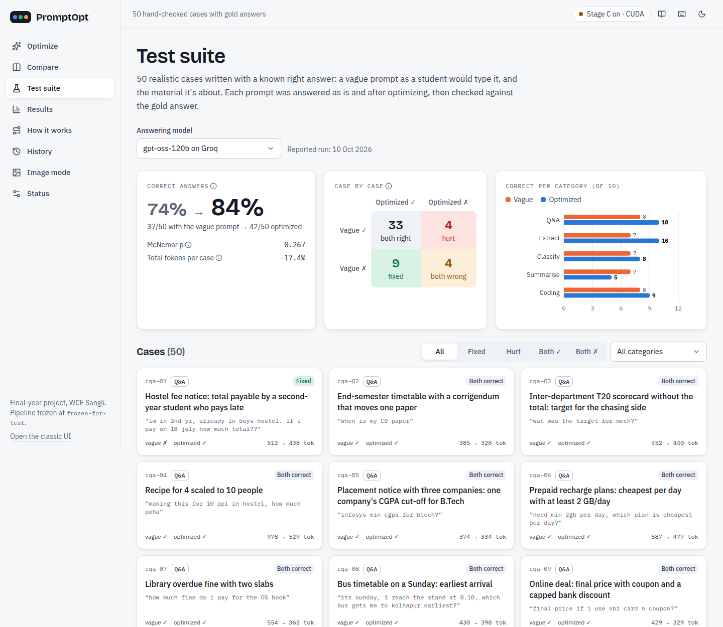  Figure 7.16: Test suite: correctness summary and the case grid | 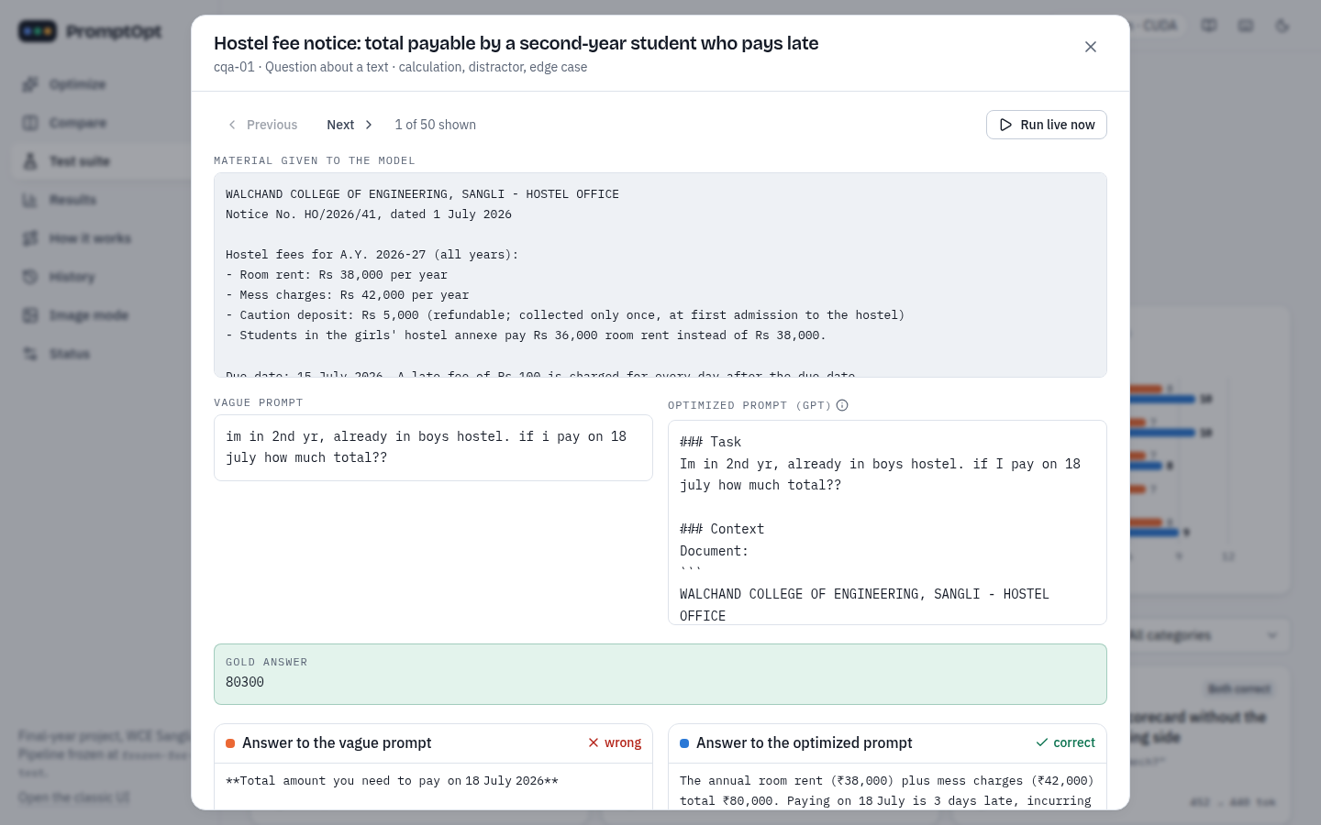  Figure 7.17: One case (cqa-01): gold answer 80300; the vague answer was wrong, the optimized right

Honest failures. The four cases where optimization made a correct answer wrong each have a clear cause:
• cls-09: Stage A read an attendance table as code (coding, 0.84, above the gate), so B05 and B03 asked for code; the model returned a Python script instead of a label per student. Choosing the category in the application avoids it.
• sum-06: B03 turned “4-5 lines” into “Use bullet points”; the bulleted answer had every key fact but 92 words against a 90-word limit.
• sum-10: only B07 fired, so the request was the same as the vague one; the answer added a title line and reached 83 words against 80. A near miss, not a rule effect.
• cod-10: routed to Stage C, which added only a code-block format; the model's fraction handling was wrong in 4 of 8 hidden tests although the specification was identical in both prompts.
Stage A is the main weak spot. Closed_qa, information_extraction and summarization are hard to tell apart on vague prompts (F1 0.51-0.65), partly because Dolly's labels in this group are noisy. The 0.6 gate, the group rule B08 and the user's confirmation keep these errors from turning into wrong formats. The Results page of the application collects these numbers from the final results file.
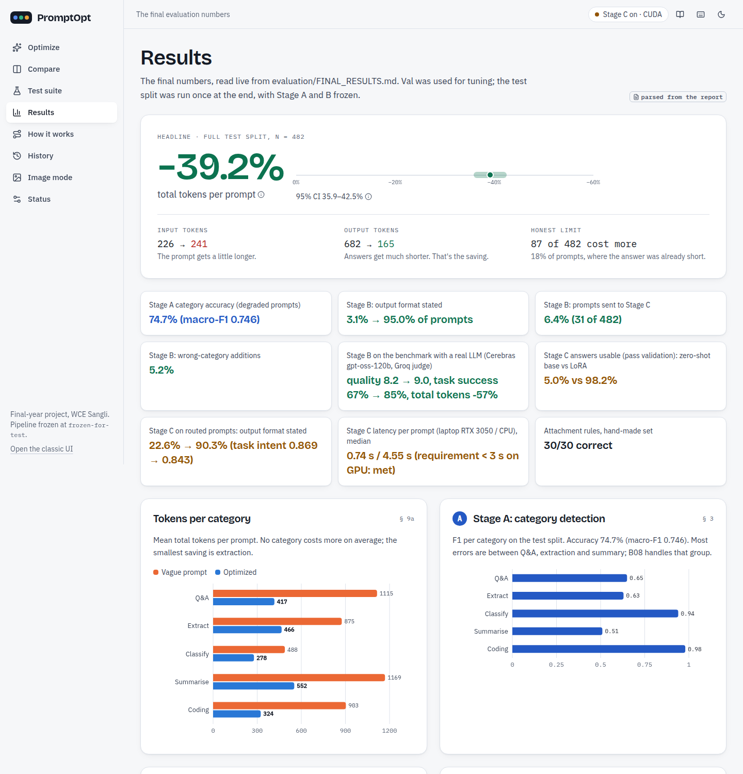  Figure 7.18: Results page: headline numbers, read from the final results file | 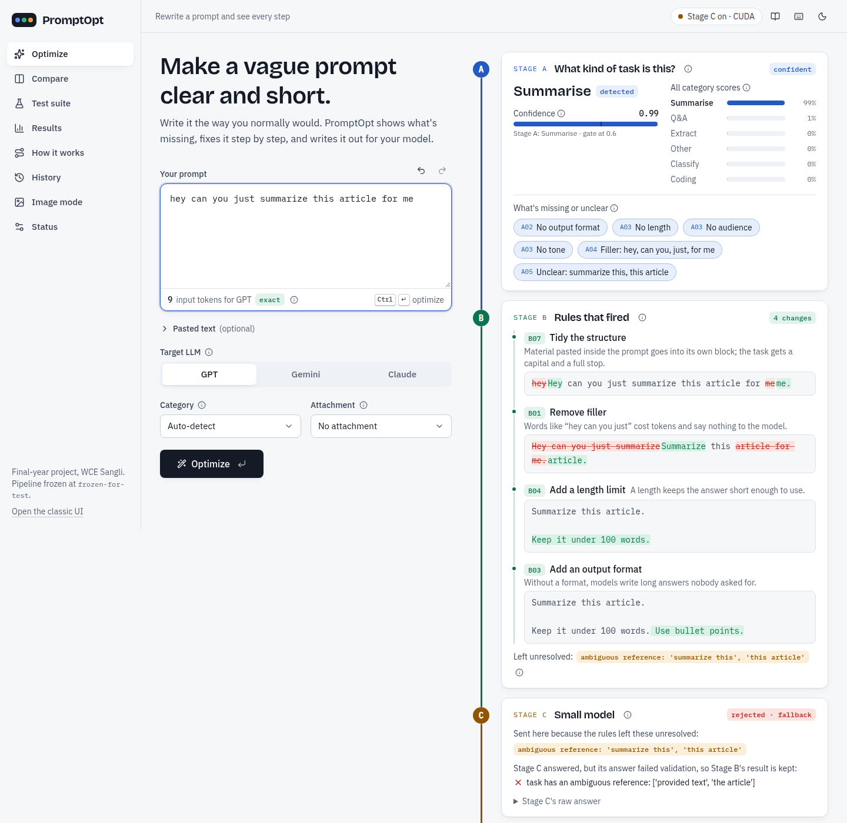  Figure 7.19: A rejected Stage C answer: the checker failed, so Stage B's result is kept

Image mode. Version 1 inserted default keywords for every missing attribute (for example “natural lighting”), which pulled Stable Diffusion images away from the request: CLIP similarity fell from 33.08 to 30.78 on 30 held-out prompts (p = 0.043). Version 2 keeps the user's words first and offers missing attributes only as clickable suggestions; it shows no measurable harm (32.77) and keeps the requested style in 12 of 12 styled prompts.

7.5 GUI images and screenshots
The application runs as a FastAPI server that also serves the React user interface. The screens below are the ones not already shown in Section 7.1.
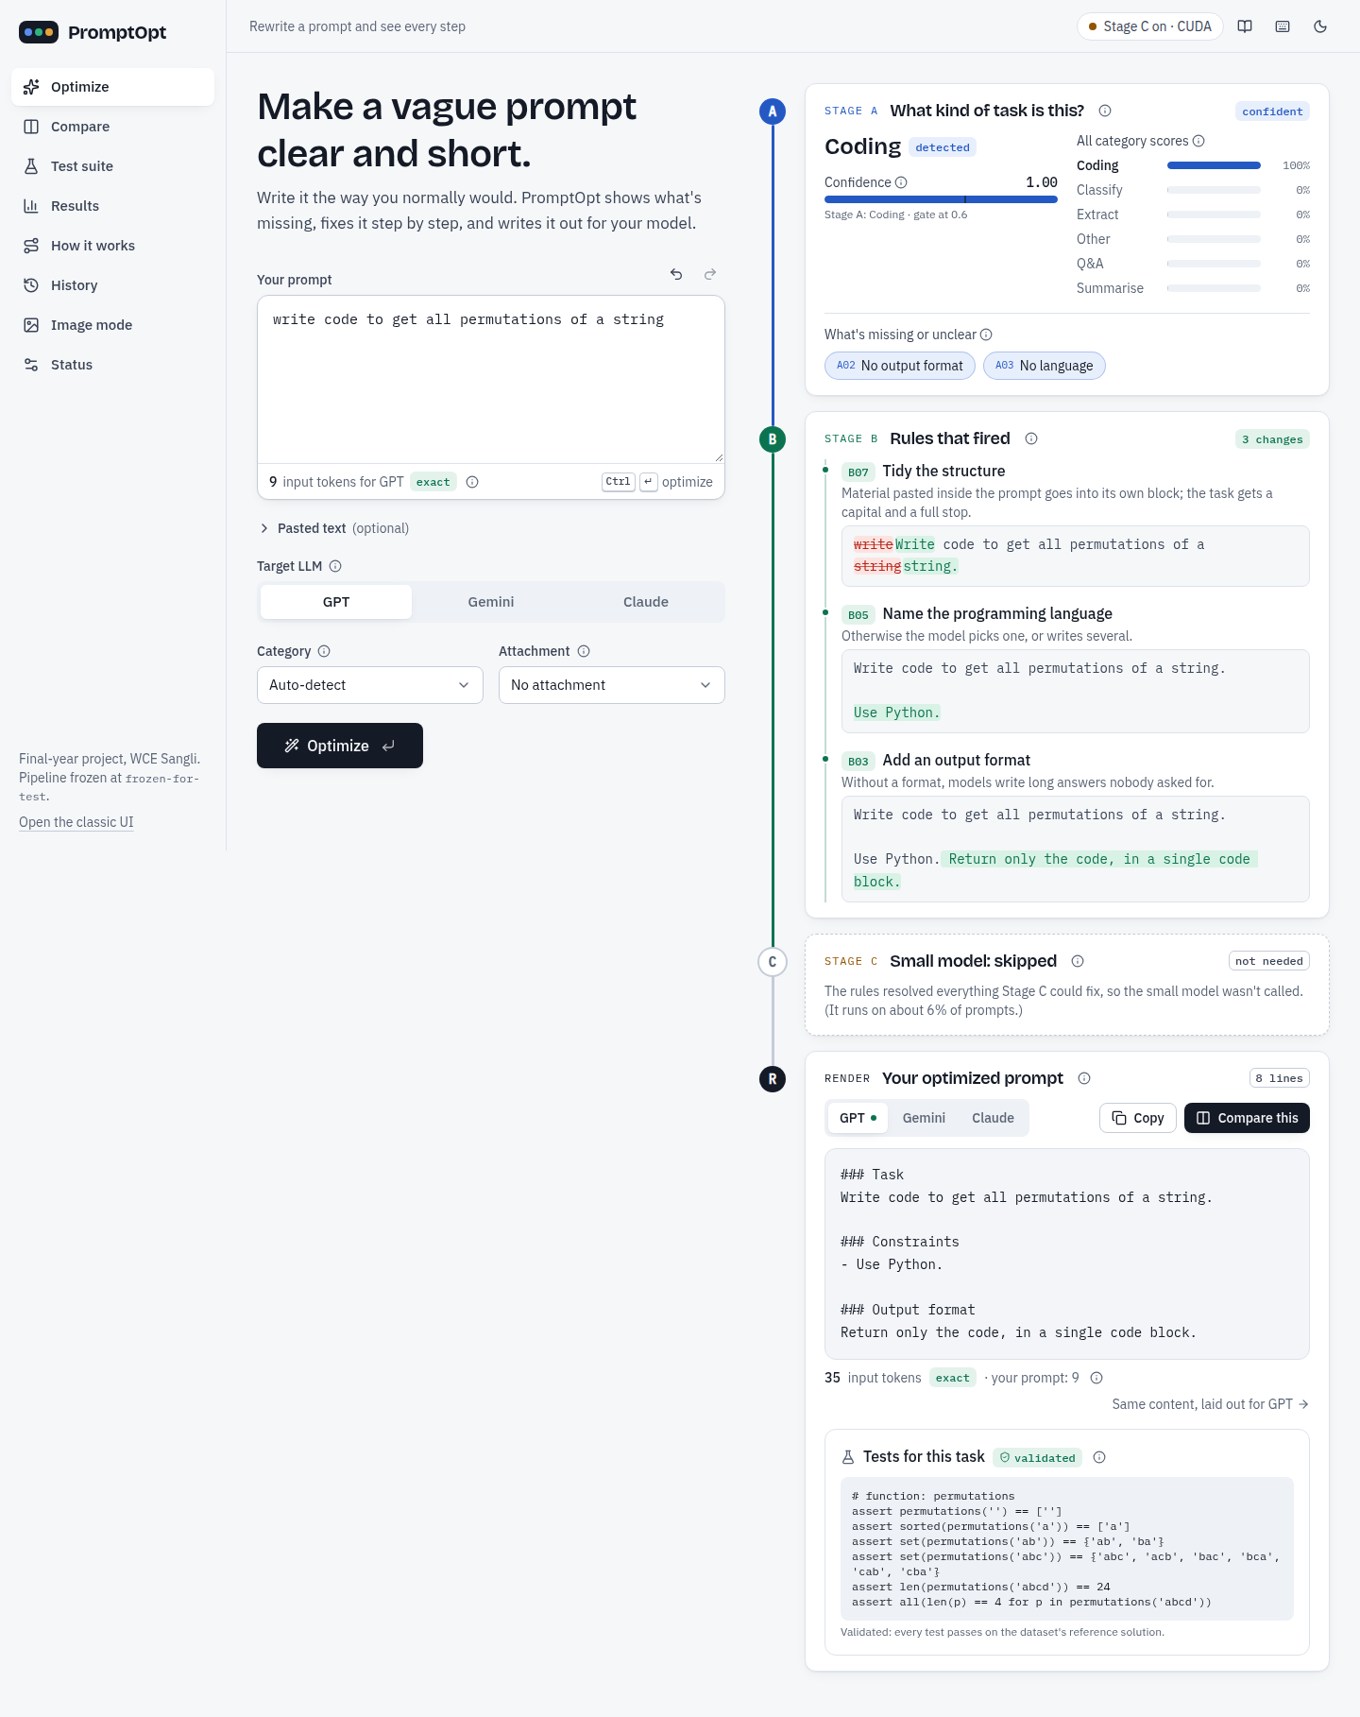
Figure 7.20: Optimize with a coding example: B07, B05 and B03 fire; Stage C is skipped
Optimize with the coding example “write code to get all permutations of a string”: Stage A is sure (coding, 1.00), Stage B adds “Use Python.” and “Return only the code, in a single code block.”, and Stage C is skipped because nothing is unresolved.
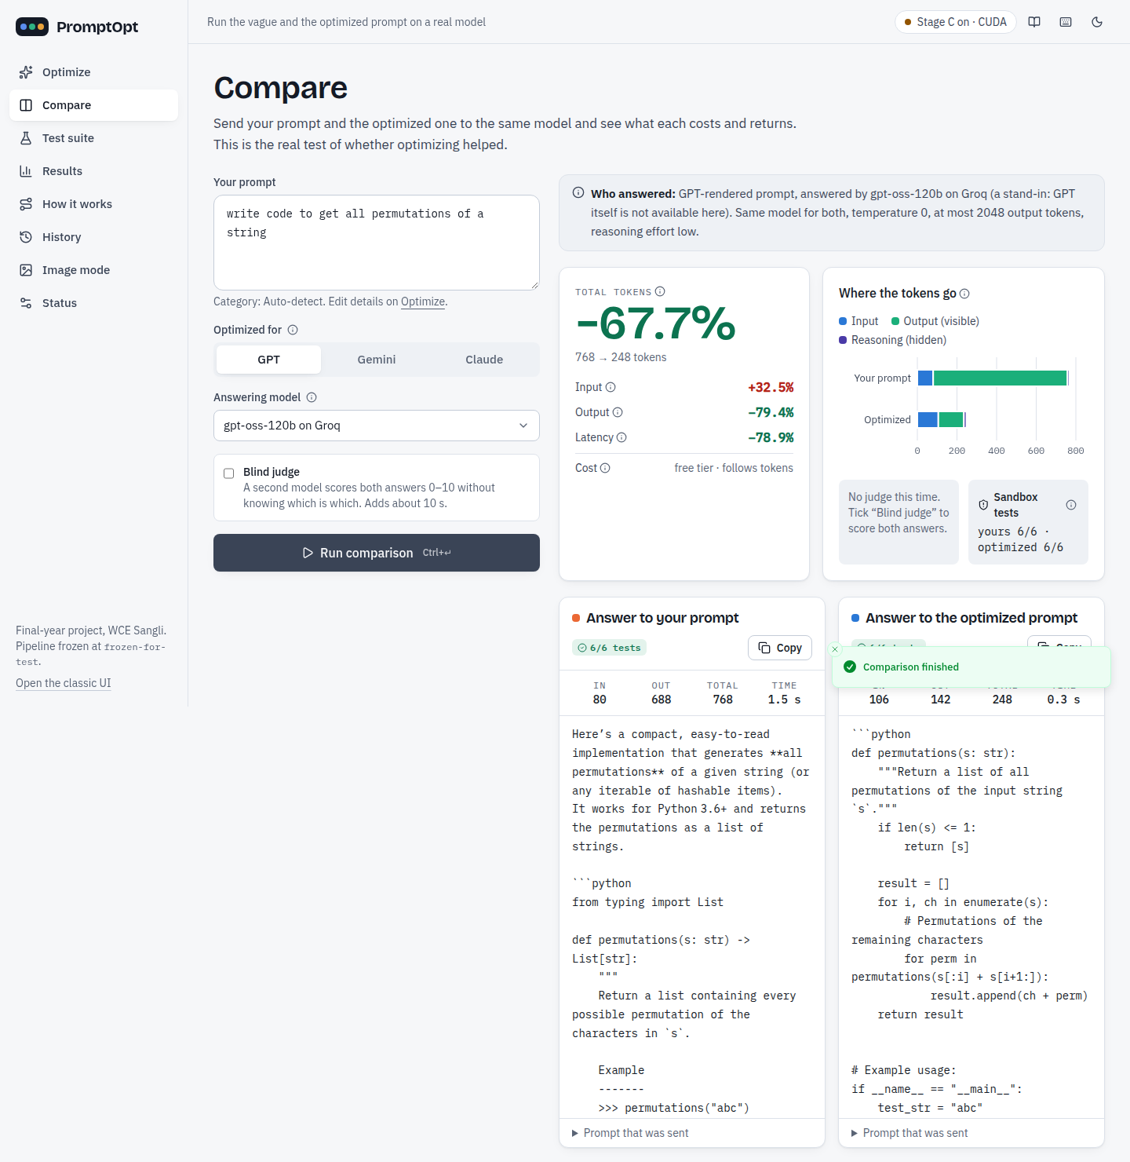
Figure 7.21: Compare on the coding example: 768 → 248 tokens (−67.7%), both answers pass 6 of 6 tests
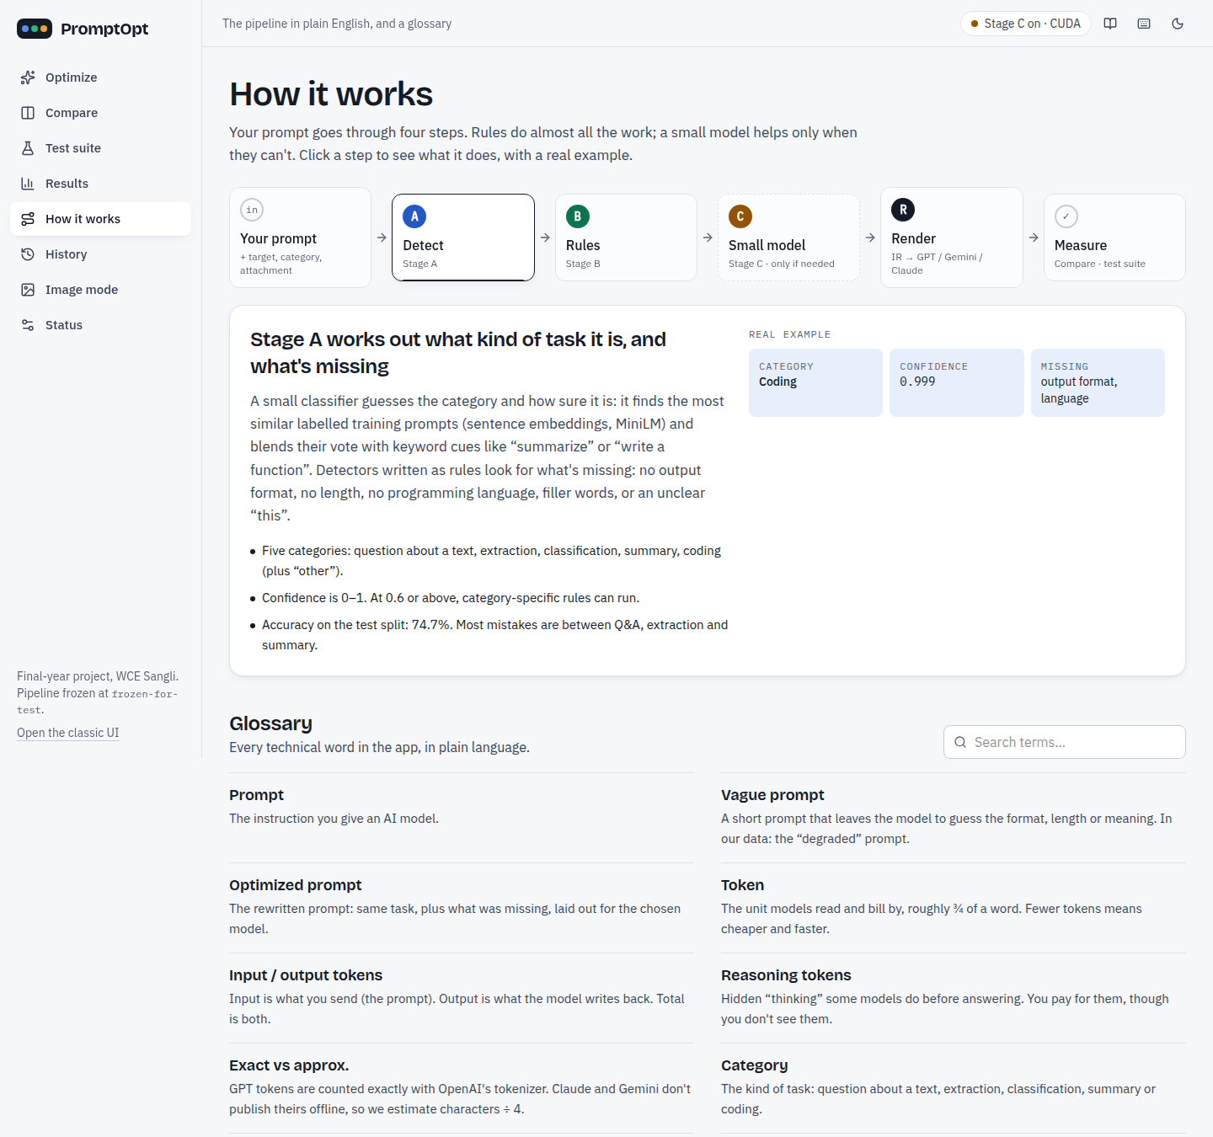  Figure 7.22: How it works: the pipeline explained inside the application | 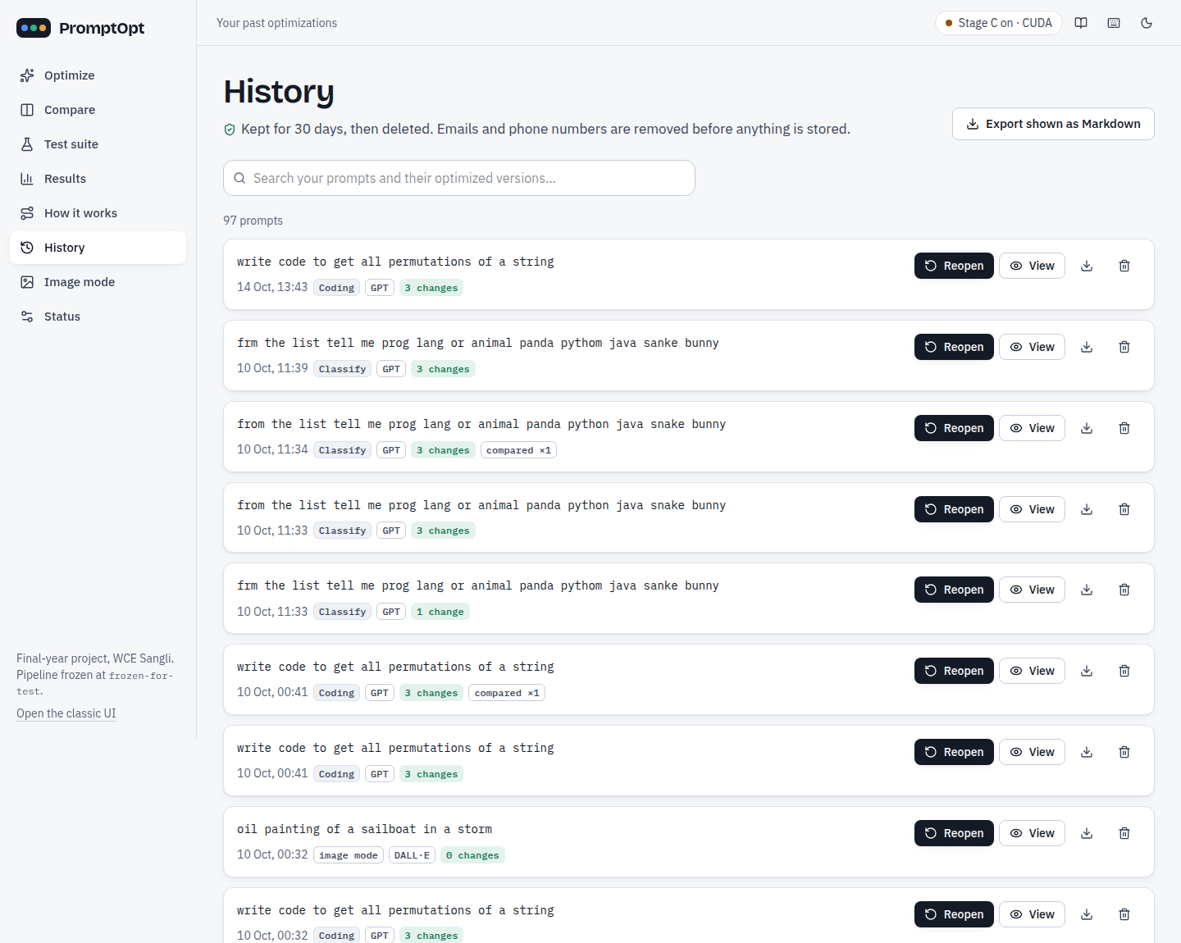  Figure 7.23: History: search, view and delete; prompts expire after 30 days

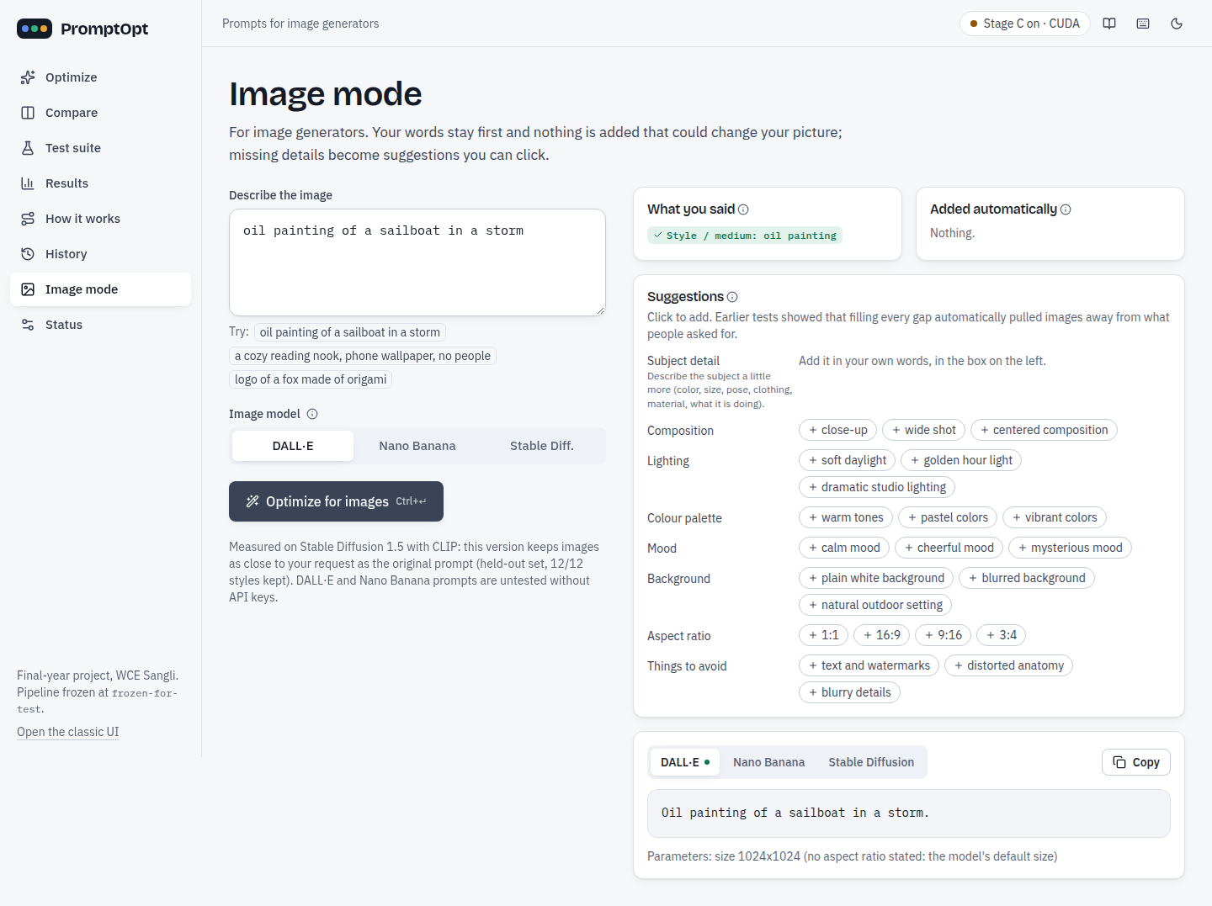  Figure 7.24: Image mode: the user's words are kept, missing attributes are suggestions | 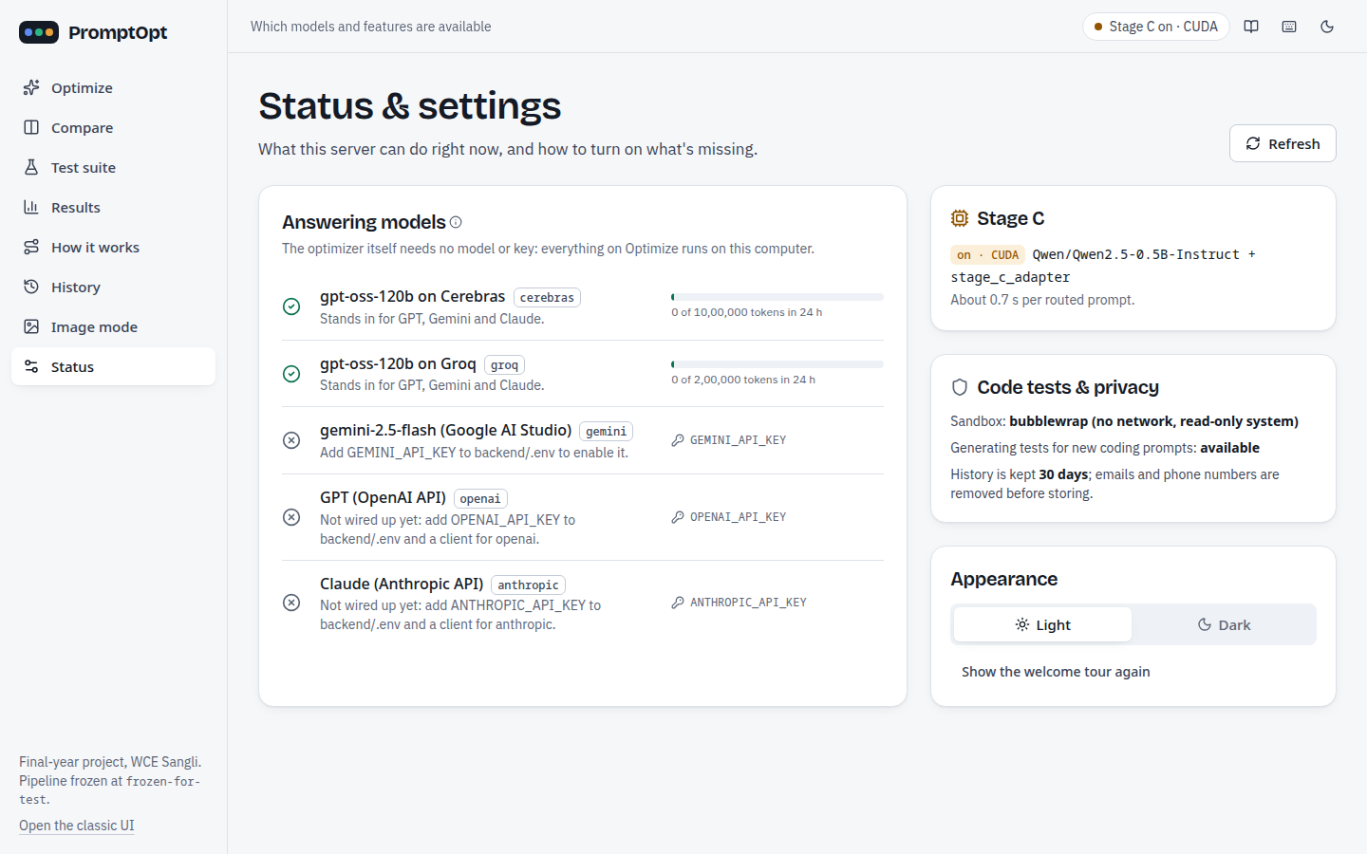  Figure 7.25: Status: providers with 24-hour usage, Stage C device, sandbox

7.6 Screenshots of the GitHub project upload
The code is public at https://github.com/piush365/PromptOpt.
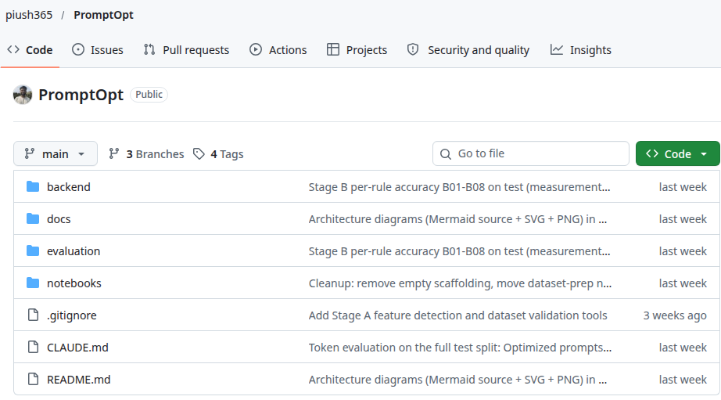
Figure 7.26: GitHub repository piush365/PromptOpt: branches, tags and top-level folders
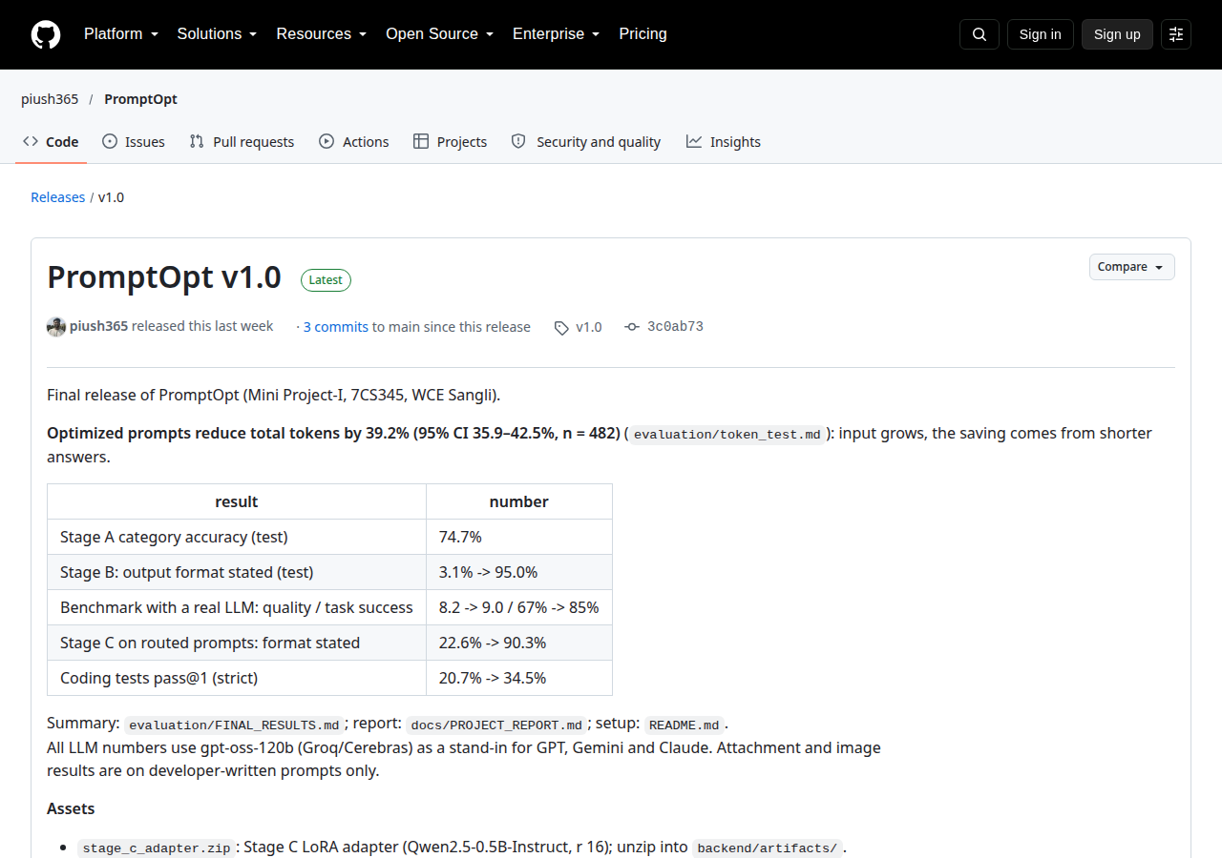  Figure 7.27: Release v1.0 with the Stage C adapter and the Stage A index | 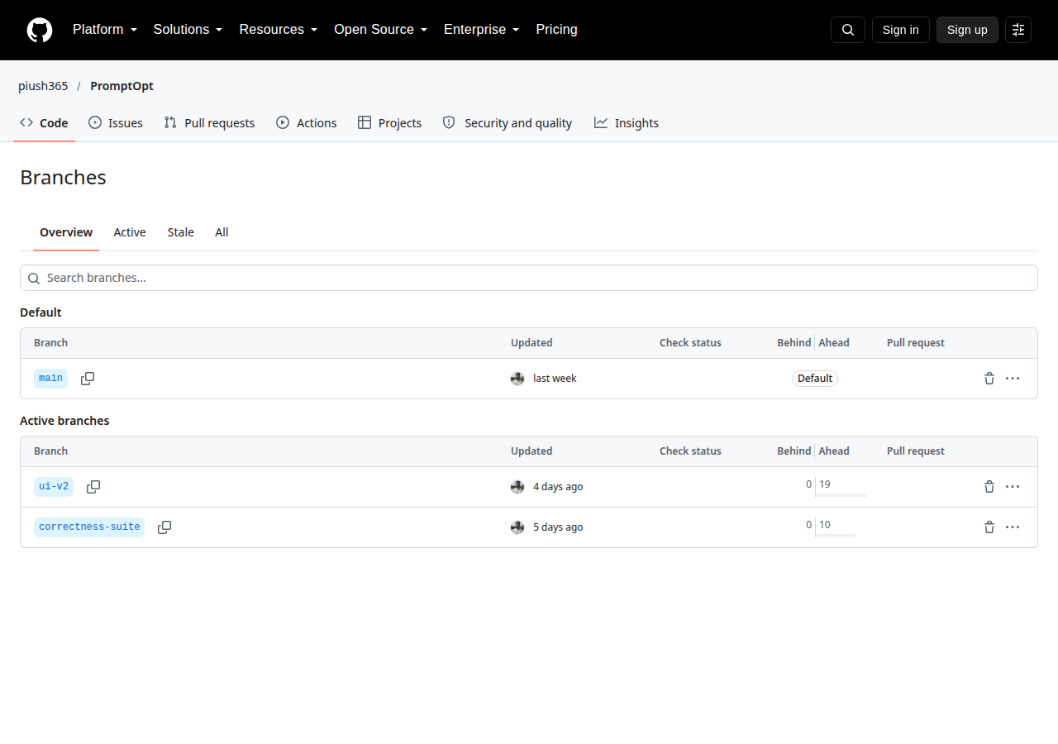  Figure 7.28: Branches: main (default), ui-v2, correctness-suite

7.7 Use of Git and GitHub
Table 7.10: Git and GitHub usage
Item | Value
Repository | github.com/piush365/PromptOpt (public)
Commits (all branches) | 92 (main 73; ui-v2 19 ahead of main; correctness-suite 10 ahead of main)
Branches | main (default), ui-v2 (React user interface), correctness-suite
Tags | frozen-for-test (code for the final numbers), final-for-test (test split run once), v1.0 (release), pre-ui-v2
Release | PromptOpt v1.0: Stage C adapter, Stage A category index, Stage C data manifest
Work tracking | roadmap and phase tables in the repository, tags as evaluation checkpoints, one release; GitHub Issues and Projects were not used

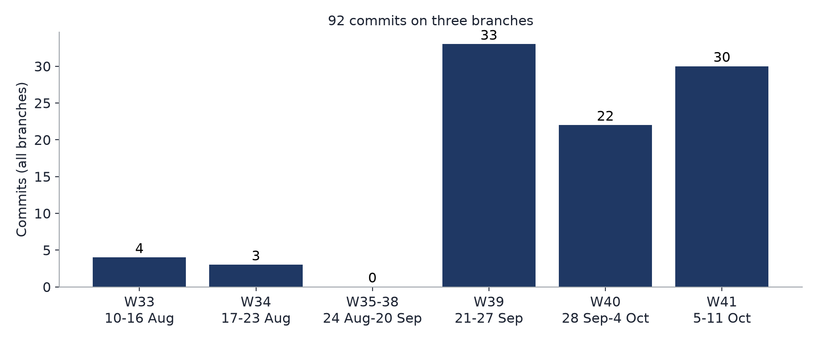
Figure 7.29: Commits per week (all branches)
Tags were used as evaluation checkpoints: frozen-for-test marks the code that produced the final test numbers; after it, no Stage A or Stage B rule, threshold or judge was changed, and the freeze check proves it.

7.8 Challenges faced and how we solved them
Table 7.11: Challenges and solutions
Challenge | What happened | How we solved it
Dataset quality | LLM-written optimized prompts dropped data from the instruction or changed the task | automatic checks, deterministic repair with a log, human rating and an LLM-assisted filter
Kappa paradox | raters agreed on 89-94% of rows, but Fleiss' kappa was near 0 because 96-98% of answers were yes | reported Gwet's AC1 (0.92-0.96) next to kappa and explained the paradox
Free API quotas | Groq 200,000 tokens per day per model; Cerebras 150 requests per hour | rolling 24-hour usage ledger, pacing, a 70% budget rule, resumable runs
Stage C hallucination | the zero-shot model passed the checks in only 5% of cases and could keep “this” | LoRA fine-tuning (98.2%), a strict JSON contract, the checker and a fallback to Stage B
Image mode v1 | default keywords turned a watercolor request into a photo | version 2: the user's words first, defaults only as suggestions
Regex edge cases | “thank you so much” inside a button text; “tell me X or Y” labels | a unit test per edge case; B16 wider label detection in the application
4 GB GPU | fine-tuning and serving on a laptop GPU | micro-batch 1 × 16, bf16, gradient checkpointing; models loaded once

Conclusion
PromptOpt shows that a cheap, explainable, rule-first optimizer can make vague prompts clearer and cheaper. The review example summarises the whole system: Stage A notices that the task type is uncertain and that no answer format is given, Stage B removes the filler without guessing, Stage C supplies the missing format and asks the user to confirm the category, and the same model then answers in 162 instead of 270 tokens. On 482 held-out test prompts, measured on OpenAI's GPT model gpt-oss-120b, optimized prompts reduce input + output tokens by 39.2% per prompt (95% CI 35.9-42.5%): input grows from 226 to 241 tokens, while output falls from 682 to 165. The output format is stated in 95.0% of prompts instead of 3.1%, and on the benchmark quality rises from 8.2 to 9.0 and task success from 67% to 85%. A small LoRA model, trained on a 4 GB laptop GPU, helps exactly where the rules stop (format stated on routed prompts 22.6% → 90.3%) and is kept out of everything else. The working application (FastAPI + React, ten-table database with one commit per request, Compare, History, image mode) is covered by 720 unit test cases (60 for each of 12 modules) and 16 browser tests, all passing.

Limitations of the proposed solution
• All output-token, quality and correctness numbers come from OpenAI's GPT model gpt-oss-120b on free tiers; Claude and Gemini were not run, and their input-token counts are approximate.
• Input tokens grow in every category; 87 of 482 test prompts cost more in total because their answer was already short.
• Stage A reaches 74.7% category accuracy; closed_qa, information_extraction and summarization remain hard to separate.
• Correctness suite: 42/50 vs 37/50 is not statistically significant (p = 0.267) and was not reproduced on a second provider (41 vs 43).
• Stage C is trained on LLM-written targets, and the routed test set is small (31 prompts).
• Attachment and image results are on developer-written prompts only; coding tests cover Python only (29 items).
• The kappa target for dataset validation was not met (the kappa paradox), although raw agreement and AC1 are high.

Future scope and possible extensions
• Lean mode for short-answer prompts: add only the format line, or nothing, when the expected answer is short.
• Send label-set and typo-heavy prompts to Stage C; spelling normalisation that the user confirms.
• Blind user tests with prompts written by people outside the team (the attachment and image test sets are ready).
• Compare and the full evaluation on GPT, Claude and Gemini through their paid APIs.
• A larger correctness suite, with more cases per category and more providers, to reach statistical significance.
• Deployment beyond the local network (PostgreSQL, HTTPS, login); coding tests beyond Python.

References
[1] K. Ramnath et al., "A Systematic Survey of Automatic Prompt Optimization Techniques," in Proc. EMNLP, 2025.
[2] L. Ngweta et al., "Towards LLMs Robustness to Changes in Prompt Format Styles," in Proc. NAACL Student Research Workshop, 2025.
[3] T. Zehle et al., "CAPO: Cost-Aware Prompt Optimization," in Proc. AutoML Conference, 2025.
[4] Y. Zhou et al., "Large Language Models Are Human-Level Prompt Engineers," in Proc. ICLR, 2023.
[5] C. Yang et al., "Large Language Models as Optimizers," in Proc. ICLR, 2024.
[6] H. Jiang et al., "LLMLingua: Compressing Prompts for Accelerated Inference of Large Language Models," in Proc. EMNLP, 2023.
[7] E. J. Hu et al., "LoRA: Low-Rank Adaptation of Large Language Models," in Proc. ICLR, 2022.
[8] M. Conover et al., "Free Dolly: Introducing the World's First Truly Open Instruction-Tuned LLM," Databricks, 2023 (databricks-dolly-15k).
[9] S. Chaudhary, "Code Alpaca: An Instruction-following LLaMA Model for Code Generation," GitHub repository, 2023.
[10] Qwen Team, "Qwen2.5 Technical Report," arXiv:2412.15115, 2024.
[11] N. Reimers and I. Gurevych, "Sentence-BERT: Sentence Embeddings using Siamese BERT-Networks," in Proc. EMNLP-IJCNLP, 2019.
[12] K. L. Gwet, "Computing inter-rater reliability and its variance in the presence of high agreement," British Journal of Mathematical and Statistical Psychology, vol. 61, no. 1, pp. 29-48, 2008.
[13] A. R. Feinstein and D. V. Cicchetti, "High agreement but low kappa: I. The problems of two paradoxes," Journal of Clinical Epidemiology, vol. 43, no. 6, pp. 543-549, 1990.
[14] J. L. Fleiss, "Measuring nominal scale agreement among many raters," Psychological Bulletin, vol. 76, no. 5, pp. 378-382, 1971.
[15] A. Radford et al., "Learning Transferable Visual Models From Natural Language Supervision," in Proc. ICML, 2021.
[16] R. Rombach et al., "High-Resolution Image Synthesis with Latent Diffusion Models," in Proc. CVPR, 2022.
[17] M. Chen et al., "Evaluating Large Language Models Trained on Code," arXiv:2107.03374, 2021.
[18] I. Loshchilov and F. Hutter, "Decoupled Weight Decay Regularization," in Proc. ICLR, 2019.
[19] B. Efron and R. J. Tibshirani, An Introduction to the Bootstrap. Chapman & Hall/CRC, 1993.
[20] F. Wilcoxon, "Individual Comparisons by Ranking Methods," Biometrics Bulletin, vol. 1, no. 6, pp. 80-83, 1945.

Scholarly contribution

Research paper
A research paper based on this project (the three-stage optimizer and its evaluation of input and output tokens on held-out data) is in preparation. [PLACEHOLDER: target conference or journal and status]

