Project :- +5 volt & -5volt Circuit

(using Regulator IC)

## Component Required:-

|  |  |  |
| --- | --- | --- |
| Serial number | Component | quantity |
| 1. | Transformer (12-0-12) | 1 |
| 2. | Diode(IN4007) | 6 |
| 3. | Electrolytic Capacitor(2200MF,25V) | 2 |
| 4. | 7805 regulator IC | 1 |
| 5. | 7905 IC | 1 |
| 6. | Electrolytic capacitor(22MF) | 2 |

**Description:-**

Op-amp need negative voltage and we often wonder how we can get it.

This project will help you in making -5volt and +5 volt in one circuit.

Two types of voltage regulator IC is used here:-

(1) 7805 positive voltage regulator

(2) 7905 negative voltage regulator

Both of them have different pin configuration

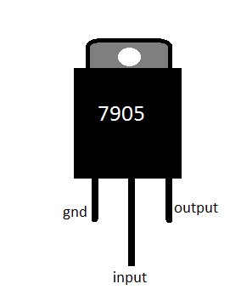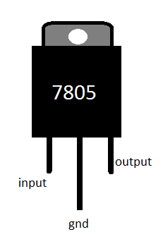  
shunted (12-0-12) transformer is used here .

Middle wire act as ground in this project.

The diode used here is 1n4007 .

AC on passing through the diode changes in pulsating DC.

The remaining pulses is then filtered by capacitor, output of capacitor then goes to regulator.

