Project :-Power control in AC appliances

# Components required:-

|  |  |  |
| --- | --- | --- |
| Serial no. | Component required | quantity |
| 1. | RESISTOR(3.3K) | 1 |
| 2. | POTENTIOMETER(250K) | 1 |
| 3. | CAPACITOR(0.1MF,270V) | 1 |
| 4. | DIAC(DB3) | 1 |
| 5. | TRIAC(BT136) | 1 |

**DESCRIPTION:-**

(1.)DIAC(BIDIRECTIONAL THYRISTER DIODE)

Its turn ON voltage is about 30 volt, when conducting its act like a low resistor with 3v drop across it .

When not conducting it act like open switch.

It allow flow of current in both the direction, diac simply means diode that work on ac.

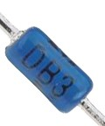

(2.) TRIAC(BIDIRECTIONAL THYRISTER)

It is extensively used for power control in ac circuit.

Triac is the word derived by combining the capital letter from the word TRIode and AC.

When in operation triac is equivalent to two SCRsconnected in anti parallel.

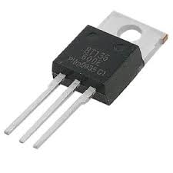

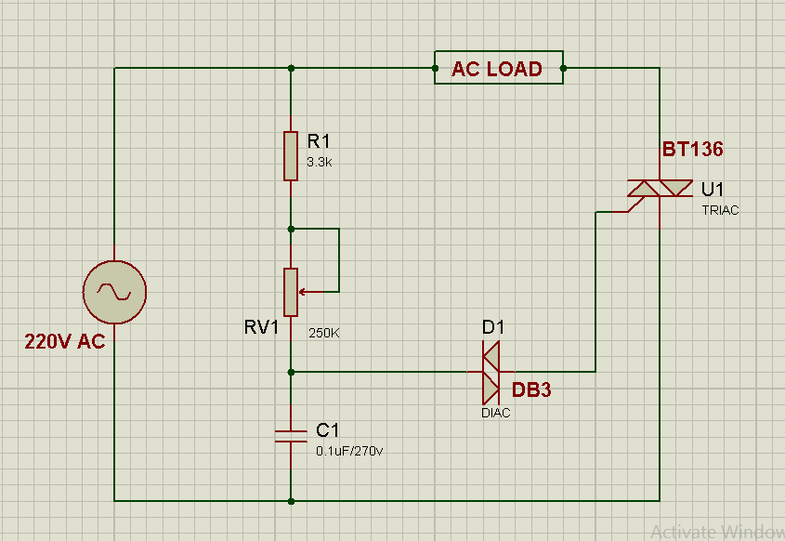

In this circuit the triggering at the GATE terminal of triac is done by diac.

The RC circuit is used here .

Variable resistor control the charging time of capacitor and therefore the firing angle of triac.

This circuit is commercially used for controlling the power in lamp dimmer,heat converter , speed control of fan etc.