Project :-Clap switch (appliances control).

# Components required:-

|  |  |  |
| --- | --- | --- |
| Serial no. | Component required | quantity |
| 1. | DC SOURCE(12V OR 9V) | 1 |
| 2. | CONDENSER MIC | 1 |
| 3. | BC547 OR BC548 | 2 |
| 4. | RESISTOR(1K) | 2 |
| 5. | RESISTOR(330ohm) | 2 |
| 6. | RESISTOR(47k) | 1 |
| 8. | 4017 IC | 1 |
| 9. | LED | 2 |
| 10. | DIODE(1N4007) | 1 |

**DESCRIPTION:-**

4017 (DECADE COUNTER IC)

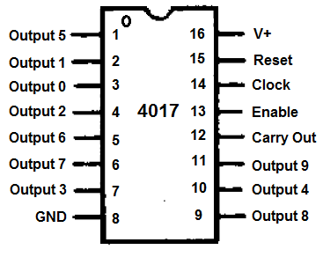

4017 is a decate coumter ic means it counts upto 10.

This ic have 10 output starting from(0-9).

We can reset the counting going on using reset pin .

As in this circuit the reset pin is connected to pin no 4.which is 3rd output

Means the pin no. 2 and 3 will keep on repeating based on the triggering it get.

Clock(triggering pulses) is given at pin number 14.

In this circuit the triggering is done by us. When we clap the condenser mike give small signal to the transistor , transistor provide strength to that signal and send it to clock pin. When 4017 gets its clock it switches its output to the other pin .

