Project :-Simple light detector circuit.

# Components required:-

|  |  |  |
| --- | --- | --- |
| Serial no. | Component required | quantity |
| 1. | DC SOURCE(12V OR 9V) | 1 |
| 2. | LDR | 1 |
| 3. | BC547 | 1 |
| 4. | BUZZER | 1 |

**DESCRIPTION:-**

LDR (LIGHT DEPENDENT RESISTOR) shows maximum resistance when no light falls on it.

LDR resistance decreases when light fall on it. Its resistances have inverse relationship with intensity of light.

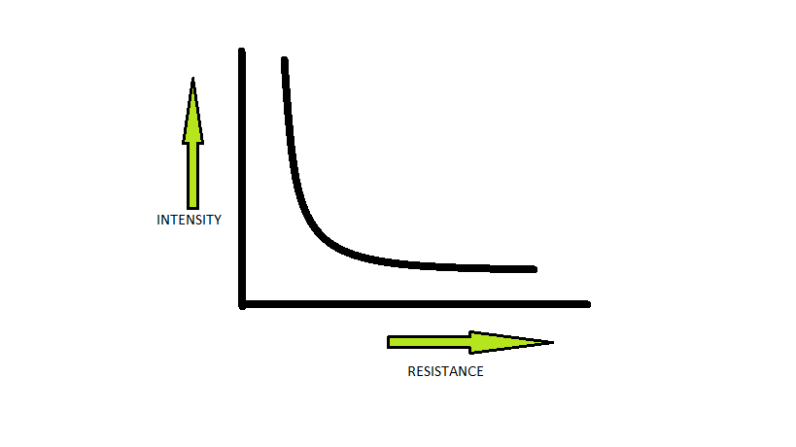

When there is no light on LDR , no current flows in base of transistor yhus transistor will be in OFF STATE .

When light fall on LDR its resistance decreases and current flows into base of transistor which makes transistor ON.

The buzzer will start because in ON state the collector and emitter behave as connected wire.

