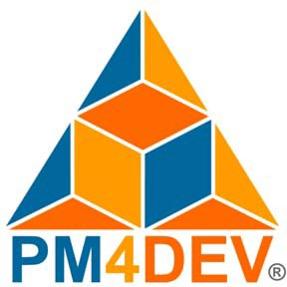Project Information Management Systems

**PROJECT MANAGEMENT FOR DEVELOPMENT ORGANIZATIONS**

Project Information Management

**PROJECT MANAGEMENT FOR DEVELOPMENT ORGANIZATIONS**

A methodology to manage development projects for international humanitarian assistance and relief organizations

© PM4DEV 2018

Our eBook is provided free of charge on the condition that it is not copied, modified, published, sold, re-branded, hired out or otherwise distributed for commercial purposes. Please give appropriate citation credit to the authors and to PM4DEV.

Feel free to distribute this eBook to any one you like, including peers, managers and organizations to assist in their project management activities.

[www.pm4dev.com](http://www.pm4dev.com/)

# PROJECT INFORMATION MANAGEMENT SYSTEMS

A Project Information Management System (PIMS) is the systematic process of creating, identifying, collecting, organizing, sharing, adapting, and using project information. Information management is a process for identifying all the information the project stakeholders need to make informed decisions. This book introduces the concept that project information is a strategic resource that must be managed with the same rigor as financial and physical resources. Development project managers need to improve the way they manage their information, by bringing the right information to the right people at the right time. It is through information management that they can improve their decision-making process, learn, and create new knowledge.

Information management places people and processes at the center, and technology as a powerful enabler. It has more to do with managing human behaviors than with managing technology. For projects to be successful in information management, a careful analysis is required on how the elements of the information environment need to be treated. It is not enough to see information as a product. Information should be treated in all its dimensions to avoid “tunnel vision” solutions. The management of a project’s information assets is essential to the long-term survival of the development organization. In the knowledge era, organizations will be measured by how they can tap this vast resource, and an organization’s ability to learn, adapt, and change will become a core competency.

With the right PIMS, project managers will be able to improve the processes through which they define, locate, collect, store, analyze, share, and use the information. Managing this process should be a critical project objective. Information should be managed within the context in which it matters the most, where the value is created to help achieve the goals of the project.

This book deals with the critical elements needed to design, implement and manage an information management system. PIMS is not only about technology, but the processes and procedures required to ensure the project manager is able to get the right information and

make it available to the right people at the right time. The quality of a PIMS is measured by how the project manager uses the information to guide and improve his or her actions.

The management of project information is a critical element and a key responsibility of the project manager, as it informs, educates, guides, and builds support for the project. The goal of this book is to present a series of techniques, practices, and processes to help project managers and project staff to manage information in a systematic way that will help improve the project interventions.

Providing key project stakeholders with the right information at the right time can significantly improve decisions to adjust, change and guide the project to improve its outcomes. A Project Management Information System serves five principal purposes:

* Provide information for decision-making.
* Improve project management.
* Demonstrate results through project evaluation.
* Empower communities and other project stakeholders.
* Increase opportunities to learn from experience.

A Project Management Information System is an integrated set of mutually supporting tools, processes, and methods for managing project information applied in a consistent way to support the decision- making and information needs of project stakeholders. Project managers use the techniques, processes, and tools to collect, organize, analyze, and share information through electronic and manual means.

A PIMS is also beneficial during the different project-management phases. During the planning phase, a project manager uses a PIMS to organize the project work, define the scope baseline, estimate the budget, and create a schedule. During the implementation phase, the project team collects progress information that is used to compare with the baseline and evaluates the accomplishment of each activity. It is also used to manage deliverables, collect financial data, and keep a record for reporting purposes. During the monitoring phase of the project, the PIMS is used to review the goals to check if the outcomes were accomplished or not. The goal of a good PIMS is to make the right information available to the right people at the right time.

## The Current Problem with PIMS

The goal of this book is to help project managers solve their problems with information management, problems that have been a source of complaints and frustration from information users as well as information providers. The following list details the most frequent problems reported by project managers:

* Isolated systems: one of the most consistent and recurring messages is that projects are creating and using systems that are too narrow and limited in scope. These systems are designed to manage the information needs of a specific component of the project, and, as a result, efforts to consolidate information are almost impossible.
* Drowning in data: excessive focus on collecting and reporting data, while giving little time to critically analyze the information and make sound decisions.
* High expectations: people involved in the collection of data are subjected to high expectations as to the value of the data requested from them, but never see the information come back.
* Low priorities for Information Management: IM is often relegated to outside consultants, or given to staff with inadequate skills or responsibilities. It is often that these responsibilities are not well-defined, and accountability becomes diffused.
* Technology myopia: the expectation that technology will be the final solution has led to an inappropriate focus that resulted in spending more time in managing the technology than managing the information.
* Systems disconnected from the Logframe: PIMS are developed but only to respond to the immediate needs of the project, reporting on project activities without creating the connections with the desired objectives. Systems designed to monitor progress do not show how the progress relates to what the project has set out to achieve.
* Report for reporting's sake: reports are not connected with the decision process of the organization. The goal is to produce a report without considering the process to make decisions.
* No standard processes: the lack of a standard process has led to the development of many systems, each with its own processes and all disconnected from each other. Organizations have to deal with information coming from different systems, making the

collection and consolidation of information impossible. Systems are tailored to the specific project and management needs.

* Duplication of efforts: each project develops its own IM system, which results in a duplication of efforts at a high cost to the organization.
* Training and maintenance costs for each system: costs to train and maintain the system is seldom considered in the design phase, resulting in unexpected expenses not budgeted by the project.
* Little or no experience in IM: lack of experience leads to poor systems or failures, both at a high cost to the organization. Low- quality systems require a dependency on consultants to keep the system running.
* Projects with little or no IT support PIMS perceived as a luxury that requires high IT investments. Certain development organizations have a low technology capacity that has not been structured to support complex PIMS requirements.

For all projects or organizations that have encountered any of the above problems, this book aims to provide guidance based on best practices that will help determine the best approach to define, design, build, and manage a Project Information Management System.

### Systematize Before Automatize

Systematization means the reduction to a purposefully regular method of organizing data and information. It is not about technology alone. The planning and organization of the information cycle are both independent of the development of technology solutions. An Information System does not always mean information technology. A small project with few information requirements and a small budget can have a successful project information system using low-technology solutions. Systematization of the information processes must preclude any effort to automatize.

Technology can only help in making a process faster, but one has to define and design the process first. Systematization is the organization of the project information management processes. A key element of systematization is to realize the hierarchy of data to knowledge as a central component of information management. Without the proper data, projects cannot have good information. Without good information, projects cannot create knowledge, to understand this relationship, the development organization needs to have a good

definition of data, information and knowledge, and how they relate to information management systems.

PIMS is the systematic management of project information systems. It is defined in terms of systems for processing and sharing information and not confined only to software and hardware.

## Definition of PIMS

A Project Management Information System (PIMS) is not necessarily the information technology, but rather the common practices that a project should follow to properly manage its information. This chapter will introduce some basic concepts, definitions, and characteristics that will help in the management of information.

### What is PIMS?

A Project Management Information System is a set of interrelated components working together to collect, classify, store, and distribute information to support decision-making. A PIMS is about how effectively the project manages the data, how it transforms data into information, and how that information eventually becomes knowledge.

A project management information system is not about technology alone. A good system has a systematized approach to managing information. It does not necessarily mean complex or expensive technology. It is more about designing the appropriate methods and processes and implementing a sound plan to manage the information cycle.

### Characteristics of PIMS

Establishing smart goals and objectives and selecting indicators for measuring progress are the elements that form the basis of a sound project-information management system. An important step in developing the system is the creation of an information-management plan that outlines how information will be selected, collected, analyzed, and shared during the lifecycle of the project.

The focus is on the systematization of the information-management processes. Once the project team has completed the design and planning for the information, the project should be able to move to a

systemized process designed to manage all the information maintained by the project. In order to have flexible and responsive interventions, a project-information system needs to be more than just a reporting mechanism, but serve as a powerful management tool for advancing an organization’s program goals of accountability, transparency, and partnership. A good project PIMS needs to contain the following characteristics:

* PIMS supply the necessary information and feedback so that potential problems are identified, and solutions are implemented early, before becoming constraints. The system should be able to generate timely information to initiate corrective actions.
* A PIMS is a tool to collect, analyze, store, and disseminate information useful for decision-making within a project. A good PIMS builds on a project's success while using lessons from earlier experiences to improve project performance.
* PIMS differ from other Management Information Systems (Financial, Payroll, etc.) because its demand-driven approach requires it to be flexible and adaptable to the changing conditions of the project.

A central to characteristics of PMIS is that provides an empowerment agenda that includes the includes the following:

* **Transparency**: the availability and access to information by all project stakeholders.
* **Accountability**: the use and application of information to monitor the progress of the project and correct deviations.
* **Inclusion and participation**: where project participants are given control over decision-making, including decisions on appropriate criteria and indicators to judge the performance of the services provided by the project.

## Definitions of Data, Information, and Knowledge

### Data

Data is defined as a base representation of a fact, represented in the form of numbers, letters or words. Examples of data include the number of visits to a community, the number of crop failures, and the number of farmers trained. Data is a discrete set of unorganized, scattered statements about reality. Data are raw facts.

### Information

Information is defined as data with context. Peter Drucker defines information as “data endowed with relevance and purpose.”1 Data becomes information when it is placed within a context. An example of information is 80 percent of the farmers who kept the same variety of coffee, lured by market prices, could not sustain three continuous crop failures and defaulted on their loans. Information organizes data, with a meaning and relevance. Information is facts with context and perspective.

### Knowledge

Knowledge is information in action, or the ability to understand the relevance of information and how to use it to advantage. The use of information leads to experience and new knowledge. Knowledge is information embedded in a context. It has a purpose and leads one to take action. Knowledge allows us to make sense of information, related information for a purpose, and know when information is irrelevant. For example, a farmer has learned that by rotating crops he is less exposed to crop failures. He tried different varieties using his previous knowledge about the soil and weather conditions in the region. With the technical information he received from project staff, he has come up with the right mix of crops and produced a good harvest that allowed him to pay his loans and provide for his family. Knowledge is information with guidance for action.

Knowledge requires human interaction with information. Information becomes knowledge when a person acts on it, makes it his/her own, conceptualizes it by placing it in relation to previous knowledge, and internalizes it by making it part of his/her beliefs.

1 Davenport T.H., Prusak L. Working Knowledge: How Organizations Manage What They Know. Harvard Business School Press, Boston, 199

### Keep it Simple!

The purpose of this book is not to complicate the project information process but rather to make it simple and achievable. This book concentrates on the minimum basic requirements that any project can follow. A good PIMS can be achieved by concentrating on the key elements required for proper information management, without adding complex systems and processes that only take away the time for analysis and decision-making.

## Levels of PIMS

PIMS does not necessarily require a state-of-the-art technology solution that tries to be everything to everybody. Every project has different information needs, both in quality and in quantity. Every project requires different levels of technology to satisfy its basic information-management needs. Simple technology will suffice for a small project with few needs, but large projects with many information needs can benefit from more extensive technology solutions.

A major imperative lies in the need for a coherent systematization of information-handling as part of the information-management process, and this must occur before automating as it implies adapting the technology to the process and not the process to the technology. The use of complex technology does not necessarily mean efficiency. A small project with few information needs will not benefit from a complex, integrated system. On the contrary, managing the system can be less efficient than a simple solution.

It is important for the project manager to identify and develop a PIMS that satisfies critical requirements for managing information, but avoid the creation of complex systems that are too expensive, take more time to develop, and require additional resources to manage it properly.

The information requirements of a project are divided into three levels:

* Level 1 – Information requirements are few. The project can use basic desktop computer applications to manage the project information.
* Level 2 – Information requirements are significant. The project can use a desktop or server-based system to manage a large volume of information.
* Level 3 – Information requirements are many. The project will require a fully integrated system to manage extensive amounts of data and information.

The following diagram represents the three levels of technology to consider when designing a computerized information-management system. The levels increase as the level of requirements increase. Each box represents a level. Boxes 1 through 3 refer to the three levels, progressing from easier (Level 1) to the more difficult (Level 3). Higher technical and information requirements are needed both for setting up an integrated information system and the ever-greater complexity of supporting and operating the system as a project shifts from Level 1 toward Level 3.

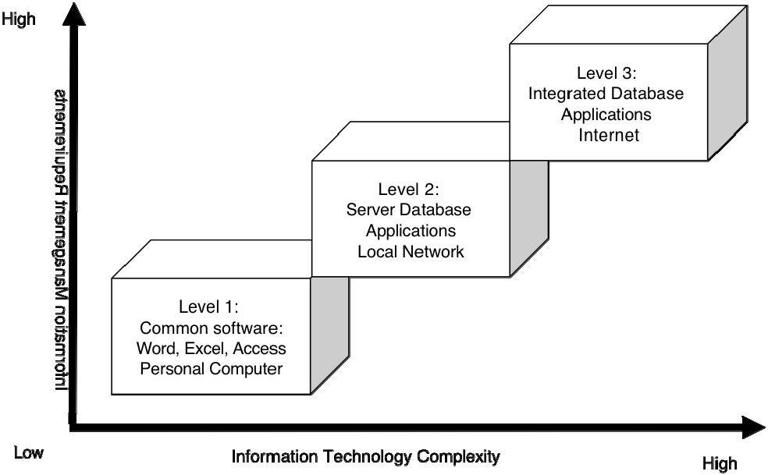

Figure 1 The PIMS levels of technology

This classification of levels is a guide to help project managers assess what they need to manage information and identify the right level of technology. During the life of a project, the levels may change: a project could start in Level 1 and progressively move to the next level. A development organization with several projects, programs and

sectors may have projects at each one the levels. Becoming more sophisticated (or automated) may not be appropriate or feasible in some situations, due to local conditions or external factors. It can be acceptable for a project to remain at Level 1, as long as it has a system that provides good and reliable information.

Once a project team determines its information requirements, it has to match them with the appropriate technology. As the amount of information increases, the efficiency in the use of a fixed technology solution decreases due to the time it takes to process, analyze and report the additional information. For example, a Level 2 system decreases in efficiency as the volume of information increases; this does not necessarily mean that a Level 3 is the ideal level all PIMS should seek quite the opposite, as a Level 3 proves inefficient when the volume of information is small. When a project is using a complex system to track small amounts of information, the effort to setup, manage, and use the system, and all its associated costs, make a Level 3 system less efficient compared with simpler solutions.

The following is a description of the three levels of information systems complexity, and suggested management and software support:

### Level 1: Desktop Applications

Level 1 implies few information-management requirements. The PIMS will rely on the use of computer desktop applications (like the MS Office Suite) to organize and store data and produce reports. At this level, the small volume of data requires a simple information technology setup: one or two computers to organize the information collected and produce the desired reports.

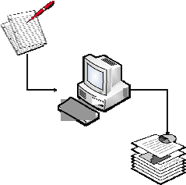

Level 1 assumes the volume of information to be small. All the data comes in physical form and a computer is used to produce monthly reports. All information is stored in the computer and in physical files, while reports and other consolidated information is stored on a computer disc. Typical software includes MS Excel, MS Access, and MS Word.

### Level 2: Network Server Applications

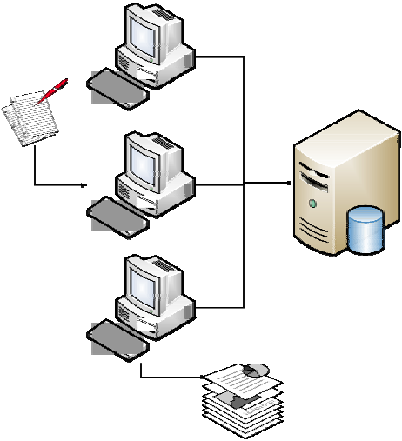Level 2 occurs when the project has significant information-management requirements. The PIMS requires the use of more computers to manage centralized databases that contain most, if not all, of project information. These databases may not be totally integrated but fill the need to organize large amounts of data collected by the project and generate the required reports.

The amount of data at this level is large and may come from different sources and project locations.

A central database may be used to consolidate data for reporting purposes. All data and reports are stored on computers connected to a local server. There is less of a need to store physical records. The database collects information and generates all required reports. This type of setup allows sharing of project information across the local network and a project team working from a single location.

### Level 3: Integrated Systems

Level 3 occurs when the project has large and complex information-management requirements. The PIMS requires an integrated view of project data and information processes. It requires a network where all computers are connected and sharing data from a central system that stores project data and information. The integrated system may contain other types of project data, such as the budget, human resources, and external or

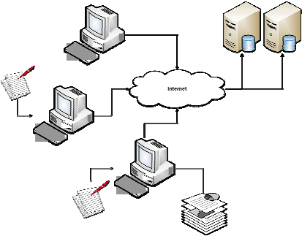

secondary data. This situation is typical of large projects disseminated in many locations and in a location with the required connectivity to link all systems with the central database.

The volume of data at Level 3 is quite large and requires dedicated resources to manage the technology. All data is stored in servers and accessed via the network or the Internet. Access to information is controlled by a central system and security features are implemented

to protect the data. This setup is needed when the project team is dispersed and works from many locations.

## Information and Technology Requirements

Determining the right level of PMIS depends entirely on the information requirements of the project. The list below can help project managers identify the information requirements to define and develop an information-technology solution for the PIMS. This step will help evaluate the complexity of the information the project will manage.

* The requirements of information from the project’s governance structure
* The requirements of information from the various project stakeholders
* The methods the project will use to collect and organize all the information
* The frequency with which the project team needs to analyze and report the information to key stakeholders
* The volume of information it needs to collect from beneficiaries
* The types of visual reports required, such as graphs, tables, maps, etc.
* The types of access, security, and controls to manage, modify and update the information
* The need to develop special reports in defined formats
* The need for complex analysis of the information collected

The next step is to evaluate the current Information Technology (IT) capacity of the project that will satisfy the information requirements.

* Available funds for IT resources dedicated to the project
* The current capacity of the project team to manage technology
* The need for voice communications, e-mail, Internet, and other online systems
* The number of staff members who will use computers during the project
* The computer literacy of the project staff
* The IT support required by the project

Once a project team has identified the information requirements, it needs to define its technology requirements and start designing a technology infrastructure that will provide the appropriate hardware and software needed to manage the information.

# PM4DEV.COM

Drawing from our deep understanding of the challenges and the needs for realistic solutions that can improve the way in which projects are managed and services are delivered, PM4DEV offers the only adapted Project Management Methodology for development organizations. Our services include:

* **Consulting,** to help organizations implement a project Management methodology that will increase the impact of their interventions.
* **On Site Training** on project management methods to increase and develop the skills of project managers
* **Online Learning** for project managers that want to develop their own competencies on a flexible online learning environment.

To get more information on these services, visit our web site at [www.pm4dev.com/services](http://www.pm4dev.com/services) or send us an email to [services@pm4dev.com.](mailto:services@pm4dev.com) We offer competitive prices and high‐quality material developed by international certified experts in Project Management.

[www.pm4dev.com](http://www.pm4dev.com/)

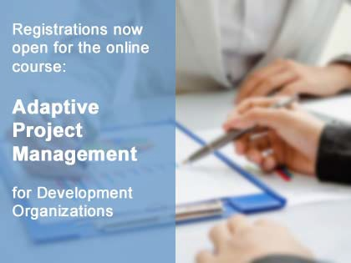**Adaptive Project Management Cycle**

In this comprehensive course, you will learn how to initiate, plan, implement, adapt and close a project that meets the needs of the beneficiaries and expectations of key stakeholders. The online course will introduce the elements of the project management lifecycle. You will learn the methods for the efficient management of a project using a phased approach and the concepts and practices necessary for project management success. In this course, an experienced Project Management Professional (PMP) will teach you the same techniques that experienced project management professionals rely on every day. You will learn how to apply the flexible adaptive management approach and learn to utilize the concepts of Monitoring, Adapting, and Continuous Improvement throughout the life of the project

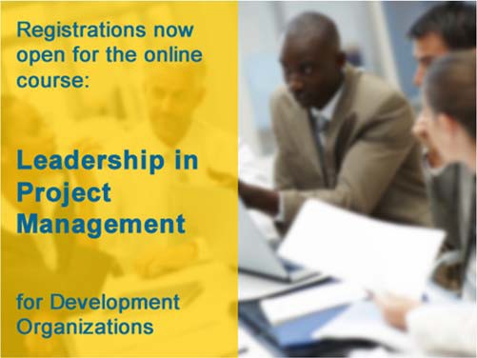

**Results-Based Project Management**

This course takes the concepts of RBM and applies it directly to the project management environment, using all the processes and methods that will help development projects achieve the desired results. It’s designed for people that have a responsibility to manage or contribute to the results of a project; especially project managers, team members and program directors. Participants will develop a complete understanding of the most common principles, processes, and tools that are necessary in the planning, implementation monitoring and reporting based on best practices in the RBM field. With a special focus on the application of the results chain, the logical framework and the performance measurement framework.

**Leadership in Project Management**

In this course, you will learn how to best resolve conflicts and manage agreement, and how to enhance communications effectiveness. You will develop the necessary skills to get the maximum performance from every member of the team, know how to apply the methods of leadership that are most appropriate for achieving project success and discover which forms of leadership and communication are best suited to the various stakeholders. You will learn techniques for resolving conflict and managing team issues, and gain a solid understanding in analyzing stages of team development and maximizing project team effectiveness.

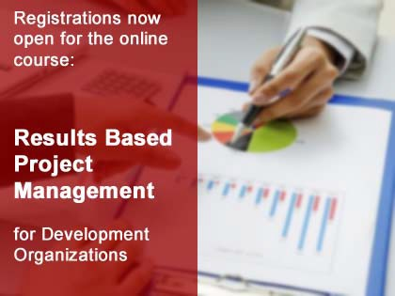

**Find out more about our online courses at** [**http://www.pm4dev.com/elearn.html**](http://www.pm4dev.com/elearn.html) **and start build your project management skills. 20% early registration discount on all courses.**

Copyright © 2018 PM4DEV All rights reserved.

Project Information Management Systems

PM4DEV, its logo, and Management for Development Series are trademarks of Project Management for Development, PM4DEV.

This point of view is intended as a general guide and not as a substitute for detailed advice. Neither should it be taken as providing technical or other professional advice on any of the topics covered. So far as PM4DEV is aware the information it contains is correct and accurate but no responsibility is accepted for any inaccuracy or error or any action taken in reliance on this publication.

This publication contains PM4DEV copyrighted material and no part of it can be copied or otherwise disseminated for commercial purposes.

This Point of view provides a summary of themes, that in PM4DEV's experience, have proved critical in the successful implementation of project management methodologies.

It draws on the expertise of

Project management professionals and provides a guide to deliver a methodology that increases the chances of project success.

For more information about PM4DEV services, contact us at: [info@pm4dev.com](mailto:info@pm4dev.com)

The Sustainable Development Goals (SDG) aim by 2030 to end poverty, protect the planet, and ensure prosperity for all.

PM4DEV is committed to provide resources and develop knowledge and expertise to support development organizations in their efforts to achieve these ambitious goals.



Project Management

For Development Organizations

[www.pm4dev.com](http://www.pm4dev.com/) [info@pm4dev.com](mailto:info@pm4dev.com)

[www.pm4dev.com](http://www.pm4dev.com/)