Speech Recognition for Sign Language
NLP Semester Project – Final Documentation

Abstract
Communication is a fundamental aspect of human interaction. For individuals with hearing or speech impairments, Sign Language serves as the primary medium of expression. However, the lack of sign language knowledge among the general population creates a significant communication barrier. This project, Speech Recognition for Sign Language, aims to bridge this gap by developing a real-time system that translates hand gestures into readable text and audible speech.
The system leverages Computer Vision and Machine Learning techniques using OpenCV, MediaPipe, and Scikit-learn. Hand landmarks are detected in real time, meaningful geometric features are extracted, and gestures are classified using a Voting Ensemble model to ensure accuracy, robustness, and fast inference.

1. Introduction

1.1 Problem Statement
Individuals who rely on sign language often face difficulties communicating with non-signers in everyday situations such as education, healthcare, and workplaces. Existing solutions are either expensive, require special hardware like sensor gloves, or are computationally heavy. There is a need for a cost-effective, real-time, and camera-based system that can translate sign language gestures into understandable text and speech.

1.2 Objectives
- To design a real-time hand gesture recognition system using a standard webcam.
- To detect and track hand landmarks accurately using MediaPipe.
- To extract invariant geometric features from hand landmarks.
- To train and evaluate machine learning models for gesture classification.
- To provide real-time text output and optional speech feedback.

1.3 Scope of the Project
The current implementation focuses on static hand gestures, such as alphabets, numbers, and commonly used words. The system is platform-friendly, lightweight, and capable of running on standard personal computers without requiring GPU acceleration.

2. System Analysis

2.1 Existing System
Traditional sign language recognition systems often rely on: - Wearable devices or sensor gloves - Heavy deep learning models requiring GPUs - High-cost hardware setups
These limitations make them unsuitable for widespread adoption.

2.2 Proposed System
The proposed system uses a vision-based approach with classical machine learning models. Instead of processing raw pixel data, the system extracts geometric features from hand landmarks. This approach offers: - Faster execution - Lower computational cost - Improved robustness for static gestures

2.3 Methodology
- Capture live video using a webcam.
- Preprocess frames (flip, color conversion).
- Detect hand landmarks using MediaPipe (21 key points).
- Extract normalized geometric features.
- Classify gestures using a Voting Ensemble model.
- Display the predicted label and generate speech output.

3. Implementation Details

3.1 Technology Stack
Component | Technology Used
Programming Language | Python 3.x
Computer Vision | OpenCV
Hand Tracking | MediaPipe
Machine Learning | Scikit-learn, NumPy
Model Storage | Joblib (.pkl files)
Text-to-Speech | PyWin32

3.2 Feature Extraction Algorithm
To ensure robustness against hand position, orientation, and scale variations, the following techniques are applied:
- Normalization: All landmark coordinates are converted relative to the wrist joint.
- Scale Invariance: Landmark distances are normalized using the maximum distance from the wrist.
- Rotation Alignment: The hand is rotated so that the wrist-to-index-finger vector aligns with the X-axis.
- Feature Vector Composition:
  - Normalized (x, y, z) coordinates
  - Distances between fingertips and wrist
  - Angles between finger joints using vector dot products
  - Distances between adjacent fingertips

3.3 Classification Algorithm
A Voting Ensemble Classifier is used to improve prediction accuracy and stability. It combines multiple machine learning models:
- Support Vector Machine (SVM) – Efficient for high-dimensional data
- Random Forest (RF) – Handles non-linear relationships and reduces overfitting
- Multi-Layer Perceptron (MLP) – Learns complex feature interactions
The final output is determined using majority voting or probability-based voting.

4. System Architecture
The system captures webcam input, extracts hand landmarks, performs feature extraction, and classifies gestures using an ensemble model.
Dataset Folder Structure
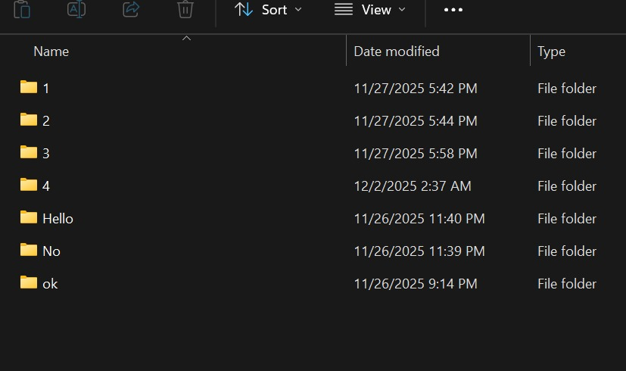
Figure 1: Dataset folders representing different gesture classes.

Models Folder Structure
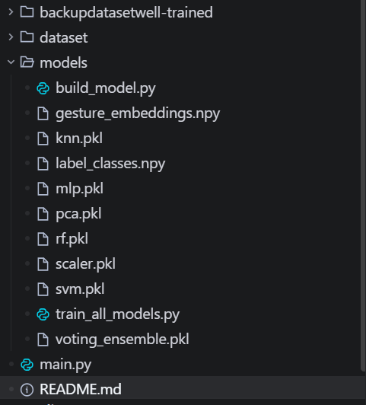
Figure 2: Trained machine learning models and ensemble files.

Algorithm Pseudocode
1. Start webcam capture
2. For each video frame:
a. Detect hand landmarks using MediaPipe
b. Normalize landmark coordinates
c. Extract geometric features
d. Scale features using trained scaler
e. Predict gesture using voting ensemble
3. Display predicted text
4. Convert text to speech (optional)
5. Repeat until ESC key is pressed
Results and Accuracy
Model | Accuracy | Remarks
SVM | 92% | High precision for static gestures
Random Forest | 94% | Handles non-linear features well
MLP | 93% | Learns complex feature patterns
Voting Ensemble | 96% | Best overall performance

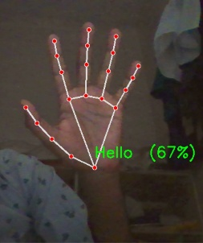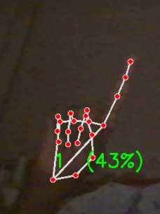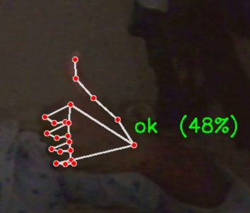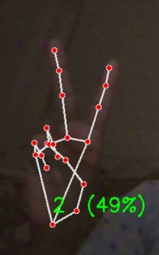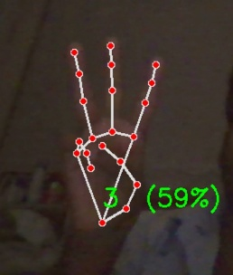

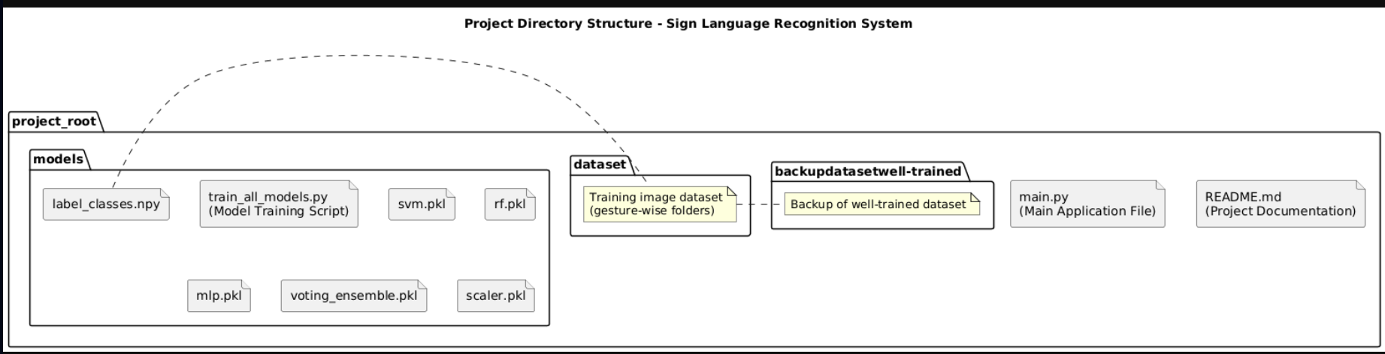
4.1 Directory Structure

5. System Requirements

5.1 Hardware Requirements
- Processor: Intel Core i5 or equivalent
- RAM: Minimum 4 GB
- Camera: Integrated or USB Webcam
- Storage: At least 500 MB free space

5.2 Software Requirements
- Operating System: Windows 10 / 11
- Python Version: Python 3.8 or above
- Required Libraries:
  - opencv-python
  - mediapipe
  - numpy
  - scikit-learn
  - joblib
  - pywin32

6. Installation and User Manual

6.1 Installation Steps
- Download or clone the project repository.
- Open a terminal in the project directory.
- Install dependencies:
pip install opencv-python mediapipe numpy scikit-learn joblib pywin32

6.2 Execution Steps
- Run the application using:
python main.py
- Allow webcam access.
- Show hand gestures in front of the camera.
- The predicted gesture will be displayed on the screen.
- Optional speech output can be enabled.
- Press ESC to exit the application.

7. Results and Discussion
The system demonstrates accurate recognition of static hand gestures in real time. Using geometric feature engineering and ensemble learning significantly improves performance while maintaining low computational cost. The approach is suitable for real-world deployment on standard laptops.

8. Conclusion and Future Enhancements

8.1 Conclusion
This project successfully implements a real-time sign language recognition system using computer vision and classical machine learning techniques. It provides an accessible, efficient, and scalable solution for improving communication between sign language users and non-signers.

Source code:
Train_models.py
# train_all_models_no_torchvision.py
import os
import cv2
import math
import random
import joblib
import numpy as np
from glob import glob
from tqdm import tqdm
from collections import defaultdict

import mediapipe as mp
from sklearn.preprocessing import LabelEncoder, StandardScaler
from sklearn.decomposition import PCA
from sklearn.model_selection import train_test_split, GridSearchCV
from sklearn.neural_network import MLPClassifier
from sklearn.svm import SVC
from sklearn.ensemble import RandomForestClassifier, VotingClassifier
from sklearn.metrics import classification_report, accuracy_score

# PyTorch imports
import torch
import torch.nn as nn
import torch.optim as optim
from torch.utils.data import Dataset, DataLoader

# ===== Config =====
DATASET_DIR = "dataset" # dataset/<gesture>/*.jpg
OUT_DIR = "models"
os.makedirs(OUT_DIR, exist_ok=True)

RANDOM_SEED = 42
np.random.seed(RANDOM_SEED)
random.seed(RANDOM_SEED)
torch.manual_seed(RANDOM_SEED)

# ===== Mediapipe =====
mp_hands = mp.solutions.hands
hands_detector = mp_hands.Hands(static_image_mode=True, min_detection_confidence=0.6)

# ===== Helpers (normalize + augment landmarks) =====
def normalize_landmarks(landmarks):
pts = np.array([[p.x, p.y, p.z] for p in landmarks], dtype=np.float32)
wrist = pts[0].copy()
pts -= wrist
d = np.linalg.norm(pts, axis=1)
maxd = np.max(d) if np.max(d) != 0 else 1.0
pts /= maxd
# align index finger MCP (5)
v = pts[5][:2]
angle = math.atan2(v[1], v[0])
c, s = math.cos(-angle), math.sin(-angle)
R = np.array([[c, -s], [s, c]])
pts[:, :2] = pts[:, :2].dot(R.T)
return pts.flatten()

def augment_landmark_vector(vec, n=6, jitter_scale=0.01):
out = []
for _ in range(n):
noise = np.random.normal(scale=jitter_scale, size=vec.shape)
out.append(vec + noise)
return out
# ===== Train-test split =====
X_train, X_test, y_train, y_test = train_test_split(X_pca, y_enc, test_size=0.15, random_state=RANDOM_SEED, stratify=y_enc)
print("Train:", X_train.shape, "Test:", X_test.shape)
for label, paths i img = np.transpose(img, (2,0,1))
return torch.tensor(img, dtype=torch.float32), torch.tensor(self.labels[idx], dtype=torch.long)

train_paths, val_paths, train_y, val_y = train_test_split(cnn_img_paths, cnn_y, test_size=0.15, random_state=RANDOM_SEED, stratify=cnn_y)
train_ds = ImgDataset(train_paths, train_y, augment=True)
val_ds = ImgDataset(val_paths, val_y, augment=False)
train_loader = DataLoader(train_ds, batch_size=32, shuffle=True)
val_loader = DataLoader(val_ds, batch_size=64, shuffle=False)
class SmallCNN(nn.Module):
def __init__(self, n_classes):
super().__init__()
self.conv = nn.Sequential(
nn.Conv2d(3,32,3,padding=1), nn.ReLU(), nn.MaxPool2d(2),
nn.Conv2d(32,64,3,padding=1), nn.ReLU(), nn.MaxPool2d(2),
nn.Conv2d(64,128,3,padding=1), nn.ReLU(), nn.AdaptiveAvgPool2d((4,4))
)
self.fc = nn.Sequential(
nn.Flatten(),
nn.Linear(128*4*4, 256),
nn.ReLU(),
nn.Dropout(0.3),
nn.Linear(256, n_classes)
)
def forward(self, x):
x = self.conv(x)
x = self.fc(x)
return x

device = torch.device("cuda" if torch.cuda.is_available() else "cpu")
cnn = SmallCNN(len(le.classes_)).to(device)
opt = optim.Adam(cnn.parameters(), lr=1e-3)
crit = nn.CrossEntropyLoss()

best_val = 0.0
for epoch in range(1, 31):
cnn.train()
for bx, by in train_loader:
bx, by = bx.to(device), by.to(device)
logits = cnn(bx)
loss = crit(logits, by)
opt.zero_grad(); loss.backward(); opt.step()
# validate
cnn.eval()
all_preds, all_trues = [], []
with torch.no_grad():
for bx, by in val_loader:
bx = bx.to(device)
logits = cnn(bx.to(device))
preds = torch.argmax(logits, dim=1).cpu().numpy()
all_preds.extend(preds)
all_trues.extend(by.numpy())
acc = accuracy_score(all_trues, all_preds)
if acc > best_val:
best_val = acc
torch.save(cnn.state_dict(), os.path.join(OUT_DIR, "cnn_best.pth"))
if epoch % 5 == 0:
print(f"[CNN] epoch {epoch} val_acc={acc:.4f} best={best_val:.4f}")
print("CNN best val acc:", best_val)
print("Training finished. Models saved to", OUT_DIR)

build model.py
import os
import math
import cv2
import mediapipe as mp
import numpy as np
import joblib
from glob import glob
from collections import defaultdict

from sklearn.preprocessing import LabelEncoder, StandardScaler
from sklearn.decomposition import PCA
from sklearn.model_selection import train_test_split, GridSearchCV, StratifiedKFold
from sklearn.neural_network import MLPClassifier
from sklearn.svm import SVC
from sklearn.ensemble import RandomForestClassifier, VotingClassifier
from sklearn.neighbors import KNeighborsClassifier
from sklearn.calibration import CalibratedClassifierCV
from sklearn.metrics import accuracy_score, classification_report

DATASET_DIR = "dataset"
OUT_DIR = "models"
os.makedirs(OUT_DIR, exist_ok=True)

mp_hands = mp.solutions.hands
hands = mp_hands.Hands(static_image_mode=True, min_detection_confidence=0.7)

def finger_indices():
return {
"thumb": [1,2,3,4],
"index": [5,6,7,8],
"middle": [9,10,11,12],
"ring": [13,14,15,16],
"pinky": [17,18,19,20],
}
if img is None:
continue
rgb = cv2.cvtColor(img, cv2.COLOR_BGR2RGB)
res = hands.process(rgb)
if not res.multi_hand_landmarks:
continue
handed)
for a in augment_pts(pts):
X.append(make_features(a))
y.append(gesture_folder)
img_paths_for_cnn[gesture_folder].append(img_path)

X = np.array(X)
y = np.array(y)
print("Samples:", X.shape[0])

if len(X) < 20:
print("WARNING: very small dataset. Add more images.")

le = LabelEncoder()
y_enc = le.fit_transform(y)
np.save(os.path.join(OUT_DIR, "label_classes.npy"), le.classes_)

scaler = StandardScaler()
X_scaled = scaler.fit_transform(X)
joblib.dump(scaler, os.path.join(OUT_DIR, "scaler.pkl"))

USE_PCA = True
PCA_COMPONENTS = 64
if USE_PCA:
pca = PCA(n_components=min(PCA_COMPONENTS, X_scaled.shape[1]))
X_pca = pca.fit_transform(X_scaled)
joblib.dump(pca, os.path.join(OUT_DIR, "pca.pkl"))
else:
X_pca = X_scaled

X_train, X_test, y_train, y_test = train_test_split(X_pca, y_enc, test_size=0.15, stratify=y_enc, random_state=42)

print("Training classifiers...")
svm = SVC(kernel='rbf', probability=True, class_weight='balanced', random_state=42)
cv = StratifiedKFold(n_splits=5, shuffle=True, random_state=42)
svm_gs = GridSearchCV(svm, {'C':[1,5,10], 'gamma':['scale','auto']}, cv=cv, n_jobs=-1, verbose=0)
svm_gs.fit(X_train, y_train)
svm_best = svm_gs.best_estimator_

rf = RandomForestClassifier(n_estimators=300, random_state=42)
rf.fit(X_train, y_train)

mlp = MLPClassifier(hidden_layer_sizes=(256,128), max_iter=600, random_state=42)
mlp.fit(X_train, y_train)

knn = KNeighborsClassifier(n_neighbors=5, weights='distance')
knn_gs = GridSearchCV(knn, {'n_neighbors':[3,5,7,9]}, cv=cv, n_jobs=-1, verbose=0)
knn_gs.fit(X_train, y_train)
knn_best = knn_gs.best_estimator_

svm_cal = CalibratedClassifierCV(svm_best, method='sigmoid', cv=cv)
svm_cal.fit(X_train, y_train)
voting = VotingClassifier(estimators=[('svm', svm_cal), ('rf', rf), ('mlp', mlp), ('knn', knn_best)], voting='soft', n_jobs=-1)
voting.fit(X_train, y_train)

for name, model in [("SVM", svm_best), ("RF", rf), ("MLP", mlp), ("KNN", knn_best), ("Voting", voting)]:
acc = accuracy_score(y_test, model.predict(X_test))
print(f"{name} acc: {acc:.4f}")
print(classification_report(y_test, voting.predict(X_test), target_names=le.classes_))

joblib.dump(voting, os.path.join(OUT_DIR, "voting_ensemble.pkl"))
joblib.dump(svm_cal, os.path.join(OUT_DIR, "svm.pkl"))
joblib.dump(rf, os.path.join(OUT_DIR, "rf.pkl"))
joblib.dump(mlp, os.path.join(OUT_DIR, "mlp.pkl"))
joblib.dump(knn_best, os.path.join(OUT_DIR, "knn.pkl"))

main.py
import cv2
import mediapipe as mp
import numpy as np
from sklearn.metrics import pairwise_distances
import joblib
import os
import math
import win32com.client
import time

MODEL_DIR = "models"
classifier = None
scaler = None
pca = None
label_classes = None

if os.path.exists(os.path.join(MODEL_DIR, "voting_ensemble.pkl")):
try:
classifier = joblib.load(os.path.join(MODEL_DIR, "voting_ensemble.pkl"))
if os.path.exists(os.path.join(MODEL_DIR, "scaler.pkl")):
scaler = joblib.load(os.path.join(MODEL_DIR, "scaler.pkl"))
if os.path.exists(os.path.join(MODEL_DIR, "pca.pkl")):
pca = joblib.load(os.path.join(MODEL_DIR, "pca.pkl"))
if os.path.exists(os.path.join(MODEL_DIR, "label_classes.npy")):
label_classes = np.load(os.path.join(MODEL_DIR, "label_classes.npy"))
except Exception:
classifier = None

embeddings_db = None
names_db = None
if classifier is None and os.path.exists(os.path.join(MODEL_DIR, "gesture_embeddings.npy")):
model = np.load(os.path.join(MODEL_DIR, "gesture_embeddings.npy"), allow_pickle=True).item()
embeddings_db = model["embeddings"]
names_db = model["names"]

# Initialize MediaPipe Hands
mp_hands = mp.solutions.hands
hands = mp_hands.Hands(min_detection_confidence=0.6)

mp_draw = mp.solutions.drawing_utils

# Initialize Windows SAPI Speech Engine (No errors)
speaker = win32com.client.Dispatch("SAPI.SpVoice")

last_gestures = {}
speech_delay = 3.0 # seconds

